The Book on Trading
The Secret Language of the Market

The reality of trading for a living

2008
Brian Latta
Trade Foreign Currencies.com
2/29/2008

Contents
DEDICATION 5
PREFACE 5
PART ONE - INTRODUCTION 7
Pros vs. Joes 7
Wrong! 8
Do You Have What it Takes? 10
The Determining Factor 10
Support or Resistance 11
CHAPTER TWO - Your Reasoning 13
Irrationality 13
The Natural 13
Track and You Control 13
Judgment Day 14
CHAPTER THREE - The Decision 15
Retro-active Gratification 15
In-Security? 15
Fear is a Four Letter Word 15
Action Figure 16
CHAPTER FOUR - Your Sacrifice 18
Six Degrees of Separation 18
Addicted to.. 18
“And the Truth Shall Set You Free!” 20
Can You Go the Distance? 20
CHAPTER FIVE - The Journey 22
No End in Site 22
Adapt or Die 22
Focus or Fade 23
Split Decision 23
Join the Ranks 23
The 13 Obstacles of Trading 24
PART TWO – TRADING IS A BUSINESS 25
CHAPTER SIX - Pros 25
Floor/Funds/Financial 25
Educated/Knowledgeable 25
Career 26
Exchanges/Prop Trading/Rooms 26
CHAPTER SEVEN - Markets 27
Equities 27
Futures 27
Bonds 27
Currencies 28
Options 28
CHAPTER EIGHT - Income/Profits 29
Investments 29
Returns 29
Hedging 29
Positioning 30
CHAPTER NINE - Floor/Electronic 31
Exchange 31
Internet 31
CHAPTER TEN - Hours of Operation 32
Market Specific 32
PART THREE – FINAL CHECK 35
CHAPTER ELEVEN - Applied Knowledge 35
How We Learn 35
Understand and Apply 36
Practice ‘til You Drop 37
Test and Test Again 37
Time Will Tell 38
CHAPTER TWELVE - Tools 39
Resource Vault 39
Vital Information 39
CHAPTER THIRTEEN - Measurability 41
Data for Dollars 41
Variables or Stability? 41
Re-live History 42
The Results are in the Bag 43
CHAPTER FOURTEEN - Connections 44
Six Degrees Revisited 44
The Guru Myth 44
Are You Truly Compatible? 45
CHAPTER FIFTEEN - Commitment 47
Do or Die 47
Try Everything 47
“The Holey Grail” 48
Test with Time Limits 49
PART FOUR – THE BASICS 50
CHAPTER SIXTEEN - Price 50
How Price is Displayed 50
CHAPTER SEVENTEEN 52
Charts 52
CHAPTER EIGHTEEN 53
Support and Resistance 53
Historical Support / Resistance 54
CHAPTER NINETEEN 56
Pivots (Daily/Weekly/Monthly) 56
CHAPTER TWENTY 60
Trend Lines 60
CHAPTER TWENTY ONE 66
Price Patterns 66
Reversal Patterns 68
Fibonocci Retracements 71
Multiple Fibs 73
Fib Extensions and Expansions 74
PART FIVE – ADVANCED SYSTEMS 77
CHAPTER TWENTY TWO 77
Candle Formations 77
CHAPTER TWENTY THREE – Indicators (Standard & Modified) 88
Moving Averages 88
Strategies Using Moving Averages 89
Bollinger Bands 99
Standard Deviation Bands 101
Relative Strength Index 104
Stochastic 108
Stochastic of RSI (Relative Strength Index) 112
Rate of Change (Price) 113
Trading Signals 113
Directional Movement Index 119
Williams %R 121
Williams Accumulation/Distribution 122
True Strength Index 122
Momentum of TSI (non-standard) 123
Average Range Channels - ARC (non-standard) 124
Chaikin Money Flow and True Money Flow 125
CHAPTER TWENTY FOUR - Non-Standardized Indicators 127
Proprietary Indicator Set-ups 127
The D3 Oscillator (Smoothed Momentum): 127
Fast Stochastic 132
FMA – (FIB) Weighted Moving Average 134
The Donchian Oscillator: 136
Modified Williams %R 139
Expansion Contraction 140
Curvilinear Regression and Slope 152
True Strength Oscillator 155
Daily and Weekly Projected Price Levels 156
Correlation of Cross Currencies 158
Bonus Section 165
Dual Time Frame Entry Strategy 166
Advanced Risk Control 167
Conclusion 171
The 13 Obstacles of Trading 171
CHAPTER TWENTY FIVE – Bonus Section 174
My Favorite Setups 174
SRSI Strategy 174
"Rolling Spreads" Strategy 182
Latest S&P E-mini Trade Strategy 198
Direction 201

DEDICATION

This book is dedicated to my family - my mother and father, my wife, daughter and son. I would also like to express my deepest appreciation for my closest friends and colleagues who have been there when I needed them the most, without their encouragement and contributions this book wouldn’t have been possible.

Brian Latta (73) is a Systems Analyst, the Director of Trader Development for Trade Foreign Currencies, Select FX, and CEO of The International Association of Traders. His experience as an analyst dates back 31 years in manufacturing, implementing Statistical Process Control (SPC) to failure analysis for an electronic product manufacturer. He also has over 26 years’ experience trading on his own behalf, has held a position as a Fund Trader for a private investment firm and has produced a weekly newsletter called “The Week Ahead” (a Forex focus on the US Dollar Index) for more than 15 years. His training programs at Trade Foreign Currencies cover basic and advanced trading practices in the Forex Market. The material revealed in this book is also available for private one-on-one instruction.

PREFACE

There have been many books written about trading. A quick search on Amazon.com reveals thousands of entries under “trading”. Most focusing on a single aspect of trading like The Complete Guide to Day Trading Stocks by Jake Bernstein or Trading in the Zone by Mark Douglas and focus on what to trade, how to trade or other specialties. Few books have ever been written about why you should be trading in the first place, what obstacles you’re about to face and what are the exact steps new traders should take in their effort to become consistently profitable. Even fewer books have been written exposing just how hard consistent trading really is (no one wants to hear this).
It’s reasonable to apply the “Pareto Principal” to trading results (that 80% of the money is made by 20% of the traders) and that most novice traders fail to ever make any money at all! Despite numerous studies researching the validity of this claim, most trading account results are personal and/or private and therefore impossible to validate the exact numbers. Releasing that kind of news isn’t beneficial to Brokerages either (they need new accounts). Private parties aren’t usually broadcasting to the public that they have just blown all the money in their trading accounts! There have been articles posted in leading publications (i.e. The Washington Post, The NY Times, etc.) suggesting that one out of every ten new day-traders survive their initial training period and go on to be “consistently profitable” traders. Even “consistently profitable” is impossible to prove because of the lack of information, but trading firms are always looking for new traders, suggesting a high rate of turn over! Why is it so hard for most novice traders to realize their dream of making a lot of money trading?
The Book on Trading looks behind the scenes at the complexity of trading: from the extreme commitment professional traders make to the dashed hopes of everyday people in pursuit of “easy money”. Everywhere you look, someone is revealing “the secrets” of trading.
The truth is – there are no secrets! The truth is that it’s not as simple or as easy as marketing and advertising agencies would lead you to believe. You cannot buy your success with signals or software; you will have to earn it.
That being said, trading can also become one of the most rewarding adventures available to the “work at home” business-minded individuals. Once a trader has developed enough discipline to consistently apply a clearly defined, written trading plan they will repeatedly pull money out of the financial markets, higher monthly returns are likely to be the result. Returns of 10-20% per month (more or less) are possible by consistently taking profits as they become available and more importantly by keeping losses small. Once enough experience and a level of competence are achieved, expert traders will be in complete control of their financial future by trading for their own personal gain or because of the high demand from proprietary firms seeking new traders for their abilities.
A great disservice, however, is done to the unsuspecting individuals as the marketing and advertising claims hook so many casual observers with the allure of easy “pickings”, simple systems and quick riches. After reading this book, you are not likely to be fooled again, and you will choose a path to a predetermined destination (take control).
Finally, this book exposes why most novice traders fail. It’s because they “put the horse before the cart”. In other words – they learn to trade out of order! Their tendency is to rush into live trading before they even know the basics of successful trading. The Book on Trading touches on every aspect of trading. From doing things in the right order to providing the hopeful traders a better understanding of what’s expected of them. The intent of this book is to help you make responsible financial decisions while speculating in the markets.

PART ONE - INTRODUCTION

Pros vs. Joes

So you are thinking about becoming a trader, why not. After all, the allure of easy money from the convenience of home is very attractive. Just follow these signals; trade this system or run that black-box and the big bucks will start rolling in is a mantra found in advertising everywhere. If it were really that easy, wouldn’t everyone be rich? The trouble is that the markets are supposed to be a “zero-sum” game. That means for every dollar won, someone has to lose a dollar.
If everyone was making money, who’s left to lose? All of a sudden the rosy picture has shown its thorns. Our markets would be in grave danger if the picture marketing agencies paint was true. The real truth about trading is that it is an extremely difficult ability to master! It’s likely that you are attracted to this market for all the wrong reasons and that will add up to failure (and a lot of money wasted chasing the Holy Grail). My recommendation in advance is - if you aren’t truly dedicated, don’t waste your time.
Choice is an amazing human ability. It’s the single most important action most of us ever take. So much so that marketing firms expend all of their resources coming up with new ways to entice you to spend your time & money choosing to buy their products & services over the competition. So what does this have to do with Pros and Joes?
Professionals take the long road, intentionally choosing to pursue their careers for the love of it. Joes take the easy way out; choosing to do whatever meets their needs to “just get by”. Both are choices, but with completely different results.
Pros delay gratification in their quest for competency and expertise; Joes look for instant gratification. In a world choked with Lottery’s, contests and giveaways, the hopes of so many are pinned on chance instead of choice. In fact, since the world of instant gratification is no longer fast enough, the next step Joes will take will be to try to enact “retro-active gratification” (learn to trade to solve every bad habit and limiting belief they’ve ever had!).
Pros know that even though the world calls our markets “efficient” and that trading is a “zero sum game”, the truth is that trading (and investing) is a “negative sum game”. The market makers (brokers) have their hands in your pocket on every trade (i.e. the commissions, spreads (the difference between the buy and sell price), and slippage (the difference between the price you thought you were getting and the price you ended up with) this “cost” happens before you collect any profits. This can be summed up in the following example: you make $100.00 on a winning trade, but the transaction cost (commission/spread) is $10.00 (just for example) and the party on the other side of your trade lost $100.00, he paid $10.00 for the cost, so the real results are – you made $90.00 net and the other side of your transaction lost $90.00 net. Joe’s miss this costly fact early in their trading and fail to realize that they must make more than the “cost to trade” before they are profitable (in this example, a trader has to make more than 10% before he realizes any profit). In all irony, the “efficiency of the market” favors the brokers as they make money on every trade regardless of the outcome.
We all start out as Joes (a unisex term – professionalism is the same for both sexes). The difference is choice and not chance. But it goes way beyond the first step, as tough as it is to make a decision; it’s far harder to stick with it.
Conviction reigns in number two, the out-pouring of wishful thinkers lack the perseverance to stick it out through every obstacle that clouds the path to expertise.
Finally, all great performers never quit. Failure is not an option! The length of time to master your chosen field will vary, but as long as you don’t quit, some level of mastery will be achieved by those willing to continue on (when everyone else is quitting).

Wrong!

The reality is that trading is not what it appears to be. The media is to blame for misleading you. The same psychology you must “feel at ease with” in trading is used against the unsuspecting novice with the deception of simplicity and short-cuts. It’s everything the Average Joe could hope for if you believe everything you read (or hear).
The surprise here is that even the pros don’t know in advance the outcome of a trade placed. All markets are unpredictable. Oh sure, sometimes prices fall into a neat uniform pattern and continue to play out as if some system picked the winner in advance, but the real truth is that no one can predict future prices with a high degree of probability.
Prices are in a constant state of change, driven by the decisions of large and small money market participants to collectively buy or sell at any given time. The decision to buy or sell usually has some sound reasoning behind it, but the fact remains that decisions are made by people and people are ruled by their emotions.
Sometimes stable, sometimes chaotic, human emotions change with the slightest hint of danger (fear) or greed and this determines pricing in the markets. So, the surprise is that market pricing is significantly affected for the most part by uncertainty and fear! OK, this is a pretty bold statement, so how can I step out on a limb and tell you something that no one else has?
This phenomenon is a part of “crowd behavior” (herd mentality). Individuals can and do think independently most of the time. Put those same persons in a crowd and their behavior will change dramatically. The crowd behavior will exert an over-whelming influence on an individual and an irrational “go with the crowd” mentality takes over. At any one time, every market is made up of a crowd of participants, even though not physically together, their influence over the price action is the ever present crowd behavior. The traders that take positions against the crowd and traders that consistently allow crowd influence to affect their trading decisions are both likely to fail. If that makes trading sound like it’s impossible to win, you’re almost right!
The reason you have never heard anyone tell you this before is that brokers need “money” (the term for new traders/investors) to continually flood the market in order to maintain their huge profit margins from commissions, etc. (like a pride of lions, some drive the unsuspecting herd into an ambush of others lying in wait). Another reason for this secrecy is our Government has to “look like” it’s maintaining some level of control over our economy. It needs to foster an illusion of stability to avoid outright panic during fearful news announcements (once a herd is spooked, they all instinctually panic without knowing why). Note: Greenspan proved to be much better at “crowd control” than Ben Bernanke (although with great blame).
Once again, emotions play a major role as our Government’s abilities to maintain a stable economy are mostly reactionary. That means that once something is affecting our economy adversely, such as the housing bubble, the Government takes steps to minimize the long-term effects. The problem with instant gratification (as in the case of the housing bubble – lowering interest rates to ease lending costs to banks) the actual affects on the economy won’t truly be known for at least six to nine months (it takes time for the impact of policy changes to show up in our economy).
To prove out how fear dictates market prices, just look at the rate market prices fall in reaction to “the bubble” news (check July 2007 and on). Studies have shown it’s a natural characteristic of human emotions to react twice as much to negative news as good to positive news. Look at all the words we have to describe fear: despair, worry, terror, nightmare, panic, and so on. In the dictionary, the synonyms for fear (words that means the same) outweigh the antonyms (opposite meanings) almost ten to one!
Now look back at the past market crashes. The rate and length of fall is far greater than any rally on good news. Here’s a weekly chart of the Dow Jones Industrial Average in 1987 during a rapid decline now known as Black Monday (See Fig. 1.1 courtesy of Trade Navigator):

Figure 1.1:
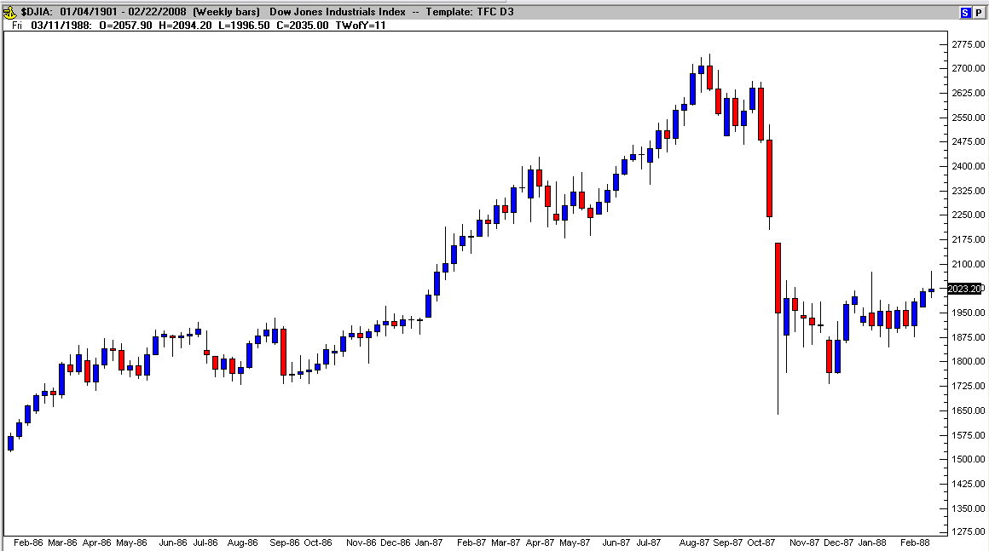

According to Wikipedia, the decline erased 31% of the Dow Jones Industrial Average’s value in just 5 days time (from Oct. 14th to Oct. 19th of 1987) and no “definitive conclusions” were ever reached regarding the reason for the crash! The chart above shows a year and a quarter of gains (from 1700 to 2746 points) obliterated in less than two months! The Dow lost over 50% of a 5 year up trend higher during the decline.
Do you still think the markets aren’t prone to be driven predominately by the herd mentality of fear?

Do You Have What it Takes?

After that dose of disheartening reality, the second decision to discover is what is your true motivation behind your decision to take up trading? Perhaps another way to look at your decision is what is attracting you to trading? Are you feeling a true fascination with the thought of trading you own investment money? Are you looking for a way to make easy money? The right motivation is an absolute requirement for achieving an expert status when it comes down to investing your own money.
This is one of the key components to entering into a career as a successful full-time trader. I’d suggest to you that for whatever reason you start looking at trading, you quickly determine your true motives (intentions) behind your decision. The sooner you determine that trading itself is attracting you and not the money then you’ll save time and money that you would have wasted chasing your personal self deception.
You are likely to deceive yourself here. Once again human nature takes over, logic and misleading advertising is likely to manipulate your thinking. You see the “after the fact” analysis (with 20-20 hindsight) in the ads and it looks so easy. Unfortunately live trading is more like a real war, than a video game (the difference between demo trading and…) It requires an innate instinctual reaction in the heat of the battle, not “after the fact” analysis. Your training needs to focus on reality (right now) and nothing in the classroom can prepare you for this. Oh sure you can practice and demo trade without risk, but that’s not trading (it’s the video game). The difference of simulated battle and real bullets flying over your head is frightening. After all death is the ultimate draw-down.
The right motivation is the difference between doing whatever it takes and giving up (when everything’s going wrong): questioning why you have subjected yourself to such a life and death struggle (your financial life that is). Intent is another way at looking at motivation; will you have a sustained unbroken commitment or purpose when it comes to learning the right way to trade? Quite frankly, this is another area left untouched by the deceptive practices of marketers and advertisers (most new traders are motivated by greed and advertisers feed that need!).

The Determining Factor

Emotional (Psychology) and financial stability (Money Management) are key areas that very few programs reveal let alone point you in the right direction.
- Psychology is the first key component of trading expertise because the loss of money is emotional. People that don’t track their money flow, never reach their retirement goals. According to the latest US economic statistics, 97% of all retirees will have to keep working in order to maintain their present lifestyle. A Director of Trader Development from an investment company revealed that some professional traders have had their personal lives implode when their edge vanished and the draw-down depleted their personal financial resources. This forced them to find another job or career with consistent income.
Emotional stability is an area that’s subject to deceit (your own personal deception and deception from others you interact with). The tendency is for people to believe they are stable when in fact they may be far from it. The term “emotional roller-coaster” comes to mind for many people in their personal life. Imagine the emotional effects of that chaotic ride if they were trading their own money. First up and then down, the markets seldom behave in a stable fashion for long periods of time. If you are not emotionally stable in the first place, the tendency is to let the market swings do a number on and magnify your own emotional imbalances.
My recommendation before you start trading is to read the book The Psychology of Trading by Brett Steenbarger. Brett has the credentials in both Psychology and in trading (his Doctorate, his personal experiences as a trader and he’s the Director of Trader Development at an investment firm). Analysis starts within. Before you can read the market, you need to read (and know) yourself! Deception is defined as the intentional concealment or distortion of the truth. How could you ever develop an expertise in trading (or anything else for that matter) if you are already leading a life of self-deception?
Financial stability is the second key to masterful trading. Money management is one of the most important components of consistency, but the right way of managing money is not taught to us early in life. Trading has a way of magnifying our problems (you’ll read more about gambling and addiction later), but if you don’t take care of your personal financial decisions first, chasing the money in the market will only make your financial problems worse.
Before you invest in any market it is critical that you have a solid understanding of the basics of financial literacy. The wealthy know and use the basics (along with advanced money skills), because without a basis for growth, accumulating wealth is virtually impossible. These principles should be learned very early in life because bad spending habits start young and are increasingly harder to change the older you get (this becomes debt accumulation, not wealth accumulation!). Do you keep meticulous and up to date records in your personal finances? Do you have a financial growth (retirement) plan? Are all of your financial needs in order?
Before going any further with your decision to trade (or even invest), you have to ask yourself if you are already completely in control of your personal finances! People that are out of control when it comes to spending their money will continue to be out of control when it comes to trading or investing their money. For this reason, your first priority should be to get your personal finances in order and under control.
A valuable resource for understanding the impact of what you “don’t know” about money can be found in the book Money – What Financial “Experts” Will Never Tell You, co-authored by Alan Williams, Peter Jeppson and Sandy Botkin. The 10 Principles of Money Mastery® cover the step by step process you must know how to apply, in order to gain control over your every aspect of your financial life. Your emotional spending habits determine the level of wealth accumulation in your lifetime. Only by developing a solid understanding of the true motion of money (from debt to taxes), will you will gain control over your wealth accumulation. Your decisions of how you will spend your money in the future will directly determine the level of success you will achieve with your investment or trading results. It’s for this reason that “before” you invest a dime; invest your time in the right education. More information about “money in motion” is available at http://MoneyMastery.com

Support or Resistance

An environment of support is also very important in the overall scheme of things. This means family, friends and associates know what you’re trying to achieve and are all supportive and helpful. This is an often over-looked factor in successfully achieving any goal (in this case, trading professionally), but it ranks right up there with the top reasons people fail at achieving their goals.
Think about it, what if your spouse doesn’t believe what you’re doing is the right thing for the family (remember the initial sacrifice in time and money to start a business). Money is the second most argued topic between couples. Trading is often a “home-based” business to start (unless you already have an office) and this means close proximity to the family. Expert traders will have a trading environment that provides complete privacy in order to remain completely focused on their methods; a home office usually comes complete with interruptions and disturbing “subliminal” sounds (such as phone ringing, dog barking, kids screaming, etc.).
A more subtle form of “non-support” is the communication others say about you behind your back. “That’s too risky…”, “It’s gambling…”, “He’ll lose all of your money”, are comments not directly spoken to you (or in some cases are) and the non-conscious communications between people are often more damaging than a direct insult (this is explored in psychology).
So, you are thinking about trading to make money and if you’ve read this far, you should start to see that the odds are stacked against your success before you even get started. You need to be keenly aware of all of the potential road-blocks ahead of you and have a way of dealing with them one–by-one as they appear. Becoming an expert trader is a constant struggle, not a whim. Its long hours of hard work, its sheer determination to not quit and it’s not a simple or easy way to make a lot of money as ads would lead you to believe.
The rest of this book will explore every facet of trading and if you’ve got the gumption to finish what you start, this book will prepare you to face the potential hazards, build your foundational knowledge and save you money in the long run by providing a sequential process to gain the expertise you need to become a professional trader.

CHAPTER TWO - Your Reasoning

Irrationality

Trading is so heavily dependent on having a firm grasp on human psychology that the first moment of truth for you to explore before you get too deep into the cost of education is your own emotional make-up. Trading has a way of amplifying existing feelings, good or bad. Take for example, how well you accept losing? If you are so competitive that you are a bad loser, then trading losses will multiply your negative reactions to losing. An out of control attitude will lead you into making irrational decisions and irrational decisions will result in further losses. Profits are directly related to the decisions you make so if you suffer from depression, if you fail to accept blame for the results of your actions or if you’re not brutally honest with yourself, then your emotional roller-coaster ride is in for some massive mood swings and that will completely erode your natural ability to make sound decisions.

The Natural

Trading is not for everyone. Just like rocket-science or brain surgery, you’re either a good fit or you’re not, you either fall in love with it or not; there is no in between (unless you’ll be satisfied with an account balance that goes up and down like a pogo stick). This is why the Pareto Principle exists and always will. Natural trading abilities or the ability to adapt to trading is not in everyone’s future. This doesn’t mean don’t try; it means have a plan to go as far as you can for as little capital outlay as possible until you find out if you are made of the right stuff. You have to meet the right people to help you in your process of discovery. Ask questions, get answers, read, investigate and find a new friend who will answer your questions honestly with the truth.

Track and You Control

If you were an inventor, then the best way to ensure that you actually finished something you started out to create would be to keep track of everything you do. In fact inventors know better than anyone that failure is the biggest part of success. You have to know why you failed in order to progress in the right direction. Without a way to measure your progress, how would you know if you are going forward, backward or making the same mistake over and over again expecting different results (a definition of insanity).
So at this point in your decision making process to become a trader you have to expect to make a lot of mistakes and accept nothing less than measurable progress. That means track what you do (or did) by keeping a log or a diary. Note the results and plan to make measurable steps toward minimizing making the same mistakes over and over again. Perfection is unattainable in trading, but you still have to purposely push the odds in your favor over time (creating a “measurable” edge).

Judgment Day

Unfortunately, you will be your own worst enemy although your loved ones will come in a close second. During your early discovery period of whether trading will fit right into your lifestyle and emotional make-up, the pressure to perform will be crushing. You (and everyone else) will have the tendency to judge your early results. In all honesty, that will be the most likely cause of failure. Surely you wouldn’t expect to compete on an equal playing field with Tiger Woods after a few months of intense golf practice!
You will need to learn to make the first change in your character right now before you go any further. If expertise is your ultimate goal, then you must read these two books: The Radical Leap and The Radical Edge (in that order) by Steve Farber. You’ll know why once you’re finished and come back to start in on the next chapter. (You could skip this required reading, but what is that saying about your commitment?)

CHAPTER THREE - The Decision

Retro-active Gratification

Is trading the right thing for you to do? Now that you’re enlightened with Steve Farber’s take on “Extreme Leadership” perhaps you’re better equipped to make that determination. If you think you are stable enough and can approach trading as a nonjudgmental observer, if you have unending patience and won’t quit once you’ve started, then here are a few more things to consider…
Patience is a virtue. You will require so much patience as you initially learn to fail at trading because in the beginning your results will not be pretty. Certainly, you don’t expect to hit homeruns the first time you ever swing a bat. Playing comes first, then the Little League, then school sports, then the Minor League and maybe, if you’ve stuck with it and practiced long enough, you’re ready for the Big League. The progression is similar for trading. This means that you’d better develop a real love and excitement for trading or all of the cumulative failures you’ll experience learning to become an expert will be too much to bear.

In-Security?

Do you have enough money saved up to go without income for your apprenticeship? Or do you have enough time to concentrate on your trading education while still juggling a full time life? These are definite musts when taking on a trading education. Initially you can learn the basics and get started while working 9 to 5, but eventually you will need to be available to trade during the active times of your market and this usually conflicts with normal working hours.
Enough money comes in two fashions; first of all, proper education costs money. Getting the right basic information and eventually finding a mentor will cost you thousands of dollars before you ever even place a live trade. If you expect to re-invent the wheel (develop your own system) you’re setting yourself up for failure. The correct way to learn is to mimic (copy) other working systems and eventually adapt that method to suite your natural abilities. Second of all, earning a living from your trading results takes a sizable starting account balance. How much depends on your personal or family expenses. The amount can be calculated depending on your risk tolerance but remember once you’re depending on profit to pay the bills, the psychology of losing will play a greater role in your trading decision process.

Fear is a Four Letter Word

Fear is defined as a distressing emotion aroused by the presence of danger, real or imagined (the feeling of being afraid). It is a survival instinct: when a person faces a possible life or death threat, the body’s chemistry (adrenaline) kicks into high gear for a “fight or flight” emotion. Just saying the synonyms of fear (dread, panic, terror, fright, horror) likely evokes some degree of apprehension in most people. What about the words describing fear like gripping or paralyzing? No matter what degree of fear you are experiencing, the mind reacts in a similar fashion every time, defensive. Is this the ideal approach to competent trading?
Like it or not, everyone has to deal with fear in their own way as fear manifests itself differently for everyone. There is no one solution to trading without fear, the mind oscillates from periods of relative control to times of emotional instability and it’s the ability to be aware of your “state of mind” that will make the difference between consistent or erratic results (most people experience varying degrees of both – even the experts). The experts have learned to be keenly aware of their emotional state of mind at any one time. It’s been described as “being in the zone” or “flow” and it’s one of the most over-looked components of competent trading (because it’s very hard to teach, but it can be learned). Check out the book Flow by Professor Mihaly Csikszentmihalyi. He describes what it feels like to be in the “zone”:
- Completely involved, focused, concentrating - with this either due to innate curiosity or as the result of training
- Sense of ecstasy - of being outside everyday reality
- Great inner clarity - knowing what needs to be done and how well it is going
- Knowing the activity is doable - that the skills are adequate, and neither anxious or bored
- Sense of serenity - no worries about self, feeling of growing beyond the boundaries of ego - afterwards feeling of transcending ego in ways not thought possible
- Timeliness - thoroughly focused on present, don't notice time passing
- Intrinsic motivation - whatever produces "flow" becomes its own reward
Accepting fear with flow takes time, practice and patience. It is said “that good things come to those who wait”. Well, if you’ve ever experienced the feeling of flow in anything you’ve ever done before, then you know that the reward is worth the wait.
So, by understanding that fear may be one of your greatest obstacles toward trading expertise you are ahead of the game. Having a solid understanding about the psychology of fear is as important as having a repetitive method to track and control trades.

Action Figure

Finally, no task is completed without acting. This is the most critical factor of success. Even a shoe manufacturer knows this concept – ‘Just Do It” by Nike. Once you have decided to act you become empowered to achieve “something”.
What kind of action should you take? If you take the time in advance to plan out the action steps necessary to accomplish an intended result, then you are far more likely to get that result. This is the long way to say “plan” – a word seemingly everyone “dreads” (a fear descriptor). The amazing thing is that everyone does it to some degree – write a shopping list, planning a trip or a vacation are easy to justify, after all you want everything to turn out OK, don’t you? What stops people from planning everything they want to do? Does it take the fun away, end spontaneity and stop their creative thinking?
Action is preyed upon by intentions (understand the psychology behind this). One definition of intention is: a course of action that one means to follow (but hasn’t yet). It’s the step before action. You could have “good intentions”, but that means you probably tried and screwed up. An intention is also characterized as having “purpose” (like the reason why you did something). “I didn’t do it on purpose; I had good intentions!” sound familiar? So, this leads to results (what an action accomplishes).
Are you getting the results you want? Let me put it another way: have you ever gotten the results you wanted? You may have good intentions, but this is not enough. You may have done something on purpose, but this is not enough. You may have intended to do something, but this still falls short of getting the results you want. To achieve “something”, you must be capable of taking true intentional action.

CHAPTER FOUR - Your Sacrifice

Six Degrees of Separation

What kind of people do you spend your time with? Will you become the crazy outsider no one understands? Are you willing to find new friends that are as heavily committed to trading as you are? If not, you will struggle. Just from an understanding level, few people will think or communicate on your level and unfamiliarity breeds contempt. You will need compassion from your peers in this market and you’re not likely to receive that from people that don’t understand exactly what you’re subjecting yourself to. Will your friends and family help you or hold you back?
The fastest way to advance your knowledge is to seek out those who already possess the knowledge you need. This means starting a new circle of influence. You don’t want to become them; you need their know-how to build your how-to. Because you don’t know in advance what you’ll need to know to become the eventual you (the trader), you’ll need to learn most everything you can in order to sift out the clumps. True friends help each other out and you’ll need friends in this business (be selective though, there are plenty of vultures in the trading marketplace).

Addicted to..

The cold hard facts are Trading is addictive! Trading is very closely related to gambling; the difference between the two is who has the edge. The casinos have an edge, and they got wealthy exploiting it. Even with huge jackpot payouts, the casinos have a consistent rate of return – for every dollar spent in the casino, they make a profit (sounds like the brokers again doesn’t it?). For an example of developing your edge, Table 4.1 displays a sample of casino odds:

Table 4.1 - Casino Odds (Sample)
Game | Bet/Rules | House Edge
Baccarat | Banker | 1.17%
Baccarat | Player | 1.36%
Baccarat | Tie (Pays 8:1) | 14.12%
Blackjack | Single Deck | 0.20%
Blackjack | Double Deck | 0.35%
Blackjack | Four Decks | 0.51%
Craps | Pass/Come | 1.41%
Craps | Don’t Pass/ Don’t Come | 1.40%
Craps | Pass + 1X Odds | 0.85%
Craps | Field (2:1 on 12) | 5.56%
Craps | Any Craps | 11.11%
Roulette | Single Zero | 2.7%
Roulette | Double Zero | 5.26%
Slots | $0.05 | 15.20%
Slots | $1.00 | 8.10%
Slots | $100.00 | 3.90%
Video Poker | 5/6/800 | 5.00%
Video Poker | 6/9/800 | 0.46%

The Casinos have painstakingly calculated the odds of gaming, and they have a procedure in place to take advantage of that edge for every bet made! This is the same process you will need to exploit in developing the edge in your method of trading.
Are there gambling addicts? You bet (sorry)! The thrill, excitement or in other words the chemical euphoria triggered by the instant gratification of winning is highly addictive and contagious! It will be possible for you to experience the same euphoria with trading. One of your toughest challenges will be to over-power the natural urges to “gamble” while trading. This can be accomplished by defining a strict set of trade rules (entries, exits and money management) and practice using them until they become second nature (you will be replacing bad habits with good habits over time).
Other signs of addictive behavior while trading are spending too many hours straight trying to trade. The brain has an attention span of about 90 minutes before focus drops off dramatically. Lack of focus (along with emotional instability and irrational thinking) leads to over-trading or over-managing trades, and your results will become erratic. If you can’t walk away from your trading without feeling as if you’re being torn away from some potential market move, or if you can’t resist the urge to “jump in” to a fast moving rally, then you are exhibiting addictive behavior. Remember that trading has a way of amplifying bad behavior; don’t ignore the warning signs. A “trade-oholic” trap catches every irrational decision to chase the market.

“And the Truth Shall Set You Free!”

Faith (and belief) is more of a prerequisite than a sacrifice, but it needs to be addressed early and with great emphasis. Without sufficient faith in yourself, your path toward trading is a dead-end. There is a subtle difference between faith and belief. Faith can be described as more of a hopeful expectation such as “I have faith in your abilities” and belief described as a personal conviction of reality like “I believe that I can do this”.
Hope is usually the last straw before failure. As long as you cling on to some hope, you still have a chance to get past the final barriers to success.
A strong conviction, an unwavering belief that you can do whatever it is that you set out to accomplish will also be very important to make it as a trader. Do you believe in yourself? Too many advertisers make trading look so easy “that anyone can do it”, but by now you’ve learned that that’s not the truth. People cling to hope, they want to believe, but in reality they don’t. The first obstacle is usually all it takes to stop them in their tracks and they give up. These people were hopeful (wishing), but they didn’t truly have faith in themselves.
Finally, there are no actual barriers stopping you from trading for a living (assuming you have normal physical and mental capabilities and available money to trade). Barriers are an illusion. There is no “wall of worry”, the market is not “out to get you” and there is no physical block to stop you. “Get over it!”

Can You Go the Distance?

This is what it takes for you to go the distance – this is the sacrifice that all people face. Commonly called “the wall” for runners, it’s that point where you want to give up, but instead push a little harder and get a second wind to keep on going.
If you’re one of those fortunate people that just never give up once their mind is made up, you’re indeed likely to become the best trader you can be. Have you ever watched a Triathlon where participants pushed so hard that their bodies were beginning to break down, but they kept on going? Their heart and brain were over-riding the body’s signals to give up, and they pushed until they dropped.
Will you have to go to such extremes learning to trade? Not likely, but your personality (character) must possess the qualities similar to the “achiever” – someone focused on a specific result until it is achieved!
Taking a look at Dr. Brett Steenbarger’s “Personality Traits of Successful Traders” as published in his book The Psychology of Trading. He asked several self-assessment questions whose answers would be helpful for novice traders to determine whether or not they possessed the right characteristics in advance for a trading career:

- When something goes against you in your trading, do you often find yourself venting your frustration?
- Do you enjoy (or as a child did you enjoy) roller coaster or other thrill rides?
- Do you find yourself procrastinating over work?
- Do you consider yourself to be moody, sometimes up and sometimes down?
- Would you prefer to go out and party with your friends rather than stay at home and read a good book?
- Do you often find yourself apologizing to others because you forgot to do something you were supposed to?
- Are you generally high strung, tense or stressed?
- If given the choice at a buffet, would you prefer to try exotic foods you’ve never heard of rather than familiar dishes?
- When you have a task that needs to be done around the house, do you tend to take the quick and dirty approach rather than a meticulous painstaking approach?
- After losing a trade, do you tend to feel guilty or get down on yourself?
- Have you experimented with or regularly used two or more recreational drugs (other than alcohol) in your lifetime?
- Are you often late for appointments or for social plans you’ve made?

If you answered yes to most or all of questions 1, 4, 7 and 10 then you most likely score high on a trait called neuroticism. It’s defined as the tendency toward negative emotional experience in response to circumstances and it shows up as anger, anxiety or depression.
If you answered yes to most or all of questions 2, 5, 8 and 11 then you probably score high on a trait called “openness to experience” and have a tendency toward sensation seeking and risk-taking.
If you answered yes to most or all of questions 3, 6, 9 and 12 then you potentially score low on a trait called conscientiousness and are less oriented toward duty, responsibility and dependability.
“Other things being equal, Dr. Steenbarger wrote that the ideal pattern to exhibit for positive trading results were a high degree of conscientiousness, a low degree of neuroticism and a lesser degree to openness. These traits would help traders stick to the rules of their system, not impulsively entering or exiting trades on a whim and they will trade for profits, not stimulation. Some of the best systems traders are less flashy people. They are meticulous and conscientious about their research and execution, and they don’t let their emotional needs pull them away from the discipline required to stay focused.” To be successful as a trader and to be successful in life, you must develop the ability to ask the right questions – well thought out in advance.
Know your “self”, be willing to explore your thoughts, feelings and behavior (psychology) because you will be your own worst enemy trading. While Brett’s questionnaire opens the door to characteristics of your conscious disposition, being acutely aware of what you are thinking and feeling while trading is as critical to your success as tracking your results. Track your actions and reactions to your trade decisions because they will reveal your true progress. You cannot ignore your emotions, nor can you control them, but if you are aware enough to use them to help instead of hinder, then you have surpassed a giant barrier that most people never get past.

CHAPTER FIVE - The Journey

No End in Site

The first question that most novice traders ask is – “how long will it take me before I’m trading live and making lots of money?” Unfortunately, the only correct answer is – “it’s impossible to tell in advance!”
Trading is not an ability that is quickly achieved one day and that’s it. The markets are always changing, the rules are always changing, regulations are always changing, so trading is always changing and the trader that fails to keep up will experience variable results, possibly even catastrophic results. There are plenty of historical results of systems meltdown – (just Google LTCM for a start).
Most training products and signal services fail to mention the most critical ingredient of repetitive positive trading results – “You”. It’s the old saying all over again – “Give a man a fish; you have fed him for today. Teach a man to fish and you have fed him for a lifetime”—author unknown. This means that buying signals or “black box systems” leads to failure for most unsuspecting novice traders. Face it – if you don’t know how or why your trading system works, how can you possibly believe in it at a crucial moment of decision? If you put your trust in someone else, are you truly a trader or just a typical investor? Automated systems have a way of working just enough for many unsuspecting novices to believe that this method of trading is consistently profitable – nothing is further from the truth. Systems on auto-pilot are as dangerous as flying a plane without a pilot, sure auto-pilot works great when everything is normal, but would you trust your life to “auto-pilot” in an emergency? When markets behave badly (and they do) trading systems collapse, there is no human intervention to prevent a catastrophe.
So trading is a journey, fraught with dead-ends, one-way streets, no “guarantee” map, no signs to follow, not even a red X to mark the spot. Should you put your trust in others to get you there or should you blaze your own trail? The real answer is yes to both! Start with guidance, achieve a level of competence and then set out on your own journey (be sure to mark the trail).

Adapt or Die

Adaptability, or the lack of it, has been responsible for survivability or extinction. Are you a survivor or are you waiting to become extinct? To what degrees are you willing to expose yourself to learn the methods of the expert trader and create your own unique style? The trader’s life-style is similar to that of the entrepreneur; you must be willing to risk everything for your desired outcome. You will have no one else to fall back on, it will be adapt or die.
You will have to expose yourself to many methods and systems in order to separate the wheat from the chaff. The most successful traders claim that they absorbed everything they could about trading before eventually modifying their experience into the method that they now use every day.
So you need to be a sponge and soak up everything you can until you are dripping with content. How adaptable is a sponge? Even dried out, it is still a sponge, it doesn’t cease to exist. It remains dry until there is moisture to soak up and then it begins the cycle all over again.

Focus or Fade

Like a sponge, you can only hold so much. A Harvard Business School study found that learning capacity (how much a person can absorb before they lose focus) is limited. After approximately 90 minutes of lecture, the ability of students to retain information begins to drop dramatically until continuing was useless (after all the purpose of learning is to retain the information). In fact, unless content was reviewed frequently, students forgot approximately 80% of their lesson material within a week!
Trading, even with a specific trading plan of exactly when to get in, when to get out and why, requires constant attention. The expert trader is constantly translating price movements (even subtle ones) in order to maintain their edge over the market (this is most critical in scalping methods).
Focus is an unwavering attention span with an instant reactive adaptation. That means that expert traders are instantly processing price movement and measuring price reaction with their method of entries and exits (and of course money management plays a major role).
So, to be consistently profitable, a trader must be able to stay in the present. Perhaps the reason you took a position yesterday (or even 5 minutes ago) is no longer valid today. To be successful you must be willing to act on today’s data, not yesterday’s decision or other influence. It’s also important not to mentally spend your profits, keep your focus on accumulation, not expenditure. Finally, it’s important not to draw false assumptions. Patterns of past market behavior do not mean the same results today.

Split Decision

All roads do not lead to the same destination. The road to success is often filled with the toughest decisions, such as when to abandon a system or a market. Fortunately, even though you may take a wrong turn (actually the better description is side-road), if you use a method to measure results (like GPS – navigation), the side trip is short, and you can easily return to your original path.
This may mean testing out an alternative market (other than your intended focus) to see how you fare or trying an adaptation to a tested method to see if you’re making an improvement. Remember, the process of creating your personal trading method is a lot like being an inventor. You will likely have to try many, many variations before striking a chord. It’s a lot like what an artist has to go through to create a masterpiece or what a musician must know to jam without effort.
Whatever forks lie ahead in your path to trading expertise, your adaptability and focus will keep you moving in the right direction, especially if you’ve prepared yourself in advance with the eventuality that your journey is a true fit with your natural talents.

Join the Ranks

So far this book has detailed characteristics of traders that few programs reveal. The price of admission into the ranks of expert traders is very high, not only in terms of money invested into education, but also in how much time it will take and how long you will have to delay gratification.
In deference to marketing and advertising schemes, trading is not easy! There are no magic trading systems, no black-boxes or signal services that can guarantee your success. There are no guarantees! You can (and most likely will) lose a lot of money chasing the elusive “Holy Grail of Trading”. The truth about trading is that technical, fundamental and intuitive trading methods all work, but the challenge is making any one of those methods work for you.
So how much will the admission into the ranks of trading experts cost you? Again, there is no way to calculate your eventual “out of pocket” or “time commitment” expenses. Everyone is different and the journey to trading proficiency is just as varied (how many roads lead the New York City?).
The bottom line is that traders I’ve read about and others I’ve spoken to, all say the same thing “I’ve spent a lot of time and money, perhaps thousands of hours and tens of thousands of Dollars getting to where I’m at now and it has been worth every minute/penny of it”! The road to trading expertise is also littered with burnt out “wanna-bees”, broke risk takers, crushed hopes and dreams as well as those that made it and then lost It (Google Jesse Livermore). Trading is not for the feint-of-heart, the un-committed or the emotionally challenged.
In conclusion, this introduction to trading, here is a reminder of the obstacles every trader’s faces:

The 13 Obstacles of Trading
- Traders have absolutely no control over themselves or their market – Regardless of their Intentions
- Their most formidable opponent in every trade – Their own Fear of Failure
- No method to their madness – Unrealistic and Irrational Expectations
- Trading for the wrong reason – Adrenaline Addiction
- Failing to accept losses – Unacceptable Emotional Implosion
- Over trading to excessive losses – Lack of Control
- Failure to abide by their rules – Develop, Test, Prove and Repeat
- Failure to track trades and analyze records – Measurable Progress
- Lack of support – Group Therapy (Traders Anonymous?)
- Temptation – Change without Reason
- Continuing education – Chasing the Market and not Cultivating Expertise
- Inability to read price without judgment – Inherent Interpretation
- Admitting defeat – The Ability to Stop Trading and Regroup

PART TWO – TRADING IS A BUSINESS

CHAPTER SIX - Pros

Floor/Funds/Financial

You may or may not aspire to become a professional floor trader or work for an investment company, but the same level of expertise required for the pros should be your ultimate goal (anything less would be hazardous to your account balance in the long run). Maybe this sounds extreme to you at this point of your training, but don’t settle for less. It is a great effort you are undertaking and just like any business, some struggle, some are mediocre and some are flourishing, where do you see yourself in a few years?
Again, the Pareto Principle (80% of the money is made by 20% of the people) applies to trading as well only the percentages are probably more like 90% - 10%. This is because so few of the uninitiated make the concerted effort to reach a high enough level of competent repetition (doing the right thing at the right time over and over again no matter what the situation).
Trading from the floor requires purchasing the position (seat) and, depending on the terms, requires a huge initial capital investment (seats on the various exchanges cost millions of dollars or lease for hundreds of thousands of dollars a year!). Think about the minimum positive returns that would be required just to “break even” after these expenses.
The “Pit” (or Open Outcry) as they are called is a chaotic mass of traders (the CME alone packs over 4000 traders together on two separate floors) yelling out orders in an instantaneous blurb of “buy/sell” decisions (based on an extreme level of education and experience in their respective market). It’s a flurry of hand signals and a blur of colored jackets scurrying around the floor in a form of organized chaos that must be seen firsthand to appreciate the innate abilities of the participants. It’s been called a “heart-pumping theatrical display” where millions if not billions of dollars change hands every day. Examples: The Chicago Mercantile Exchange (CME) and The New York Board of Trade (NYBOT) along with other major exchanges.
Fund Traders have positions with specific private enterprises (like having a job) and put their skills to test everyday trading capital for the business they work for. From private placement investment Funds (like the now infamous Long Term Capital Management - LTCM) to large Hedge Funds (such as Goldman Sachs Asset Management), traders go to work every day at the “Fund’s” offices and perform per their respective manager’s performance requirements (daily loses are capped and a consistent profitable performance is a requirement of keeping a trader’s position with the Fund).

Educated/Knowledgeable

There are individual traders that started out in other endeavors and eventually made it to the big-time with their own investment firm and having millions (if not billions) of assets (money) under management. Check out John W. Henry and Co. with assets estimated at over $275M. John was originally a farmer. He’s a long-term trend follower and his success eventually allowed him to branch out (he’s now the present owner of the Boston Red Sox). So, he is a “rags (as a farmer) to riches” story. Note: His journey started before 1982.
Some new traders have the opportunity to slip right into a position at an investment firm upon graduating with their degree in financing from a college or university. The stress to perform quickly and the stress of having to perform continually often leads to rapid turn-over at these firms, but those that can adapt quickly have the benefit of an insider’s education and “other people’s money” to trade.
The two main types of analysis are fundamental (economics/news related) and technical analysis. The truth is that both work equally well for the individuals that have mastered the individual techniques. The well-educated traders will know enough about each technique to enhance their trading method and establish a blend of the two for maximum efficiency. I cover technical analysis in this book because of its graphic nature (visual) and its mathematical measurability; fundamental analysis requires a detailed knowledge (and often insider information) if one wants to make trading decisions solely on economic data (some traders do this exceptionally well).

Career

Career opportunities in trading vary depending on an investment firm’s market of choice. Most firms specialize in certain markets, but every tradable market is tested by investment firms around the globe. Reliable traders are in high demand as their availability is extremely limited. Most firms look to recent college graduates majoring in finance to entice them into learning to trade for the firm, therefore opportunities to gain positions with trading firms is very difficult for most traders.

Exchanges/Prop Trading/Rooms

The Exchanges are the central locations where stocks, commodities, futures (and so on) are traded, such as The New York Stock Exchange (NYSE). They bring stability, delivery, liquidity and regulation to the marketplace. There are stock exchanges, commodity exchanges, and futures exchanges all over the world. Floor traders are unique in many ways. Theirs is a frantic dance of gestures, shouting and instantaneous decisions based on reading signals, signs and the body language of their counter parts. It is a dying art and will soon go the way of most manual methods - replaced by electronic platforms.
Prop rooms are usually found at investment firms and are in essence, office space used for the purposes of trading. They usually sport multiple monitor set-ups, news/wire services capable and as well as many trader cubicles that can fill the room. High demand for performance and low tolerance to failure, prop rooms seems to mix the good (all the resources a trader could ask for under one roof) with the bad (lack of training, pressure and demanding performance). As tempting as prop rooms look to be, a traders need to establish individuality in their methods before competent performance can be achieved.

CHAPTER SEVEN - Markets

Equities

Also known as the stock market, shares of stock (ownership in a company) are issued (at a specific value) and publicly or privately traded either through exchanges or over-the-counter markets. The size of the U.S. stock market has grown to over $51 trillion (collective value of the stock available to be traded). The equity market is one of the most vital areas of an economy as it provides companies with access to capital (the sale of their stock) and investors with a slice of ownership in the company. Investors get the potential of gains based on the company's future performance (growth).

Futures

The futures market is an auction market in which participants buy and sell commodity/future contracts for delivery on a specific future date. Trading has been carried on through “open outcry” in the pit and is now available through a broker’s electronic trading platform.
Holders of futures contracts have the obligation to buy or sell the specified commodity by a specific “settlement” date. As in the case of cattle futures, delivery of the physical product is required. In the case of a “cash-settlement”, the transaction results in a gain for one party (depending on positioning long or short) and a loss for the other party. Closing a position before the settlement date requires the trader to take a position equal and opposite to their initial position (exiting a short position by entering an equal long position).

Bonds

The Bond Market (also known as the debt, credit or fixed income market) is a financial market where participants buy and sell debt securities (basically secured loans). The size of the international bond market reached an estimated $45 trillion by 2006, of which the size of the US bond market debt was $25.2 trillion. The daily average trading volume in the U.S. bond market reached $923 billion (as of early 2007) and transactions usually take place between broker dealers and large institutions in the “Over-the-Counter” (OTC) market. A small number of bonds, primarily corporate bonds are listed on exchanges. Most references to the “bond market” refer to the government bond market because of its size, liquidity, lack of credit risk and sensitivity to interest rates. There is an inverse relationship (opposite) between bond valuation and interest rates, so the bond market is often used to indicate changes in interest rates (this is called the yield curve). The New York Stock Exchange (NYSE) is the largest centralized bond marketplace and represents corporate bonds.
The attraction to bonds by investors or speculators is that they’re relatively safe and provide a more stable income relative to other investments.

Currencies

Generally, the term given to this market is Foreign Exchange (FOREX). It is a global market and exists without a central exchange as do the other markets. Whether it’s a necessary part of doing business in another country (buying local products or services) or as a part of holding another country’s currency in reserve, the exchange of money between nations is a necessary function in a globalized world. It is the largest market in the world (topping $3 trillion a day) and also includes exchanges between banks, corporations, institutions, governments (central banks) and even speculators.
The Foreign Exchange market (Forex) is an electronic exchange business and before there were computers to aid in the transaction process, a “wire service” was developed to facilitate the rapid exchange of funds. The benefits of trading or investing in forex are liquidity and stability.

Options

Options are available in several markets. The option buyer has the right but not the obligation to own shares of stock at a specific value (strike) at any time during the contract expiration cycle. Options are trading in contracts (lots) and one option contract is 100 shares in the underlying (stock, index, commodity, ETF, etc.). Options may be used as a primary investment or to hedge existing positions or to neutralize risk exposure from an unexpected move against your overall position direction (bullish or bearish). Options are also commonly used by producers of commodities (grain, cattle, soybeans, etc.) to lock in prices in the future (before harvest) to satisfy lending obligations.

CHAPTER EIGHT - Income/Profits

Investments

No one invests without the possibility of reward. The very definition of investing (putting money or other valuable consideration into someone else’s pocket with the expectation of receiving a greater return in the future) is a concern to say the least. Most investment decisions are based on too little information from someone with too much to gain from your investing with or through them. Advice is only an educated guess at best and most of the time is not in your best interest, it’s based on the best interest of the company/corporation giving you the advice.
Investors could learn a lot from traders. Learning everything about your market, product or commodity before you invest your money is a much smarter beginning. Learning to trust yourself (your decisions) over others results in making decisions in your own best interest. Learning from your mistakes makes more sense than making the same mistake over and over again (letting someone else tell you what to do).
Unfortunately, most investors get what they deserve, hopeful gains (in times of economic growth) and depressing losses (during economic contraction). Why do they deserve this financial roller-coaster? Because they are not willing to learn what it takes to make intelligent investment decisions on their own, they let someone else do the work and they pay a hefty premium for this lazy attitude.

Returns

This is another area too many novices immediately skip to. The potential for huge returns is possible and it’s that reward that attracts the treasure hunters. But huge returns are not likely, certainly not without the hard work required to gain the level of expertise necessary for intelligent decision making when it comes time to invest!
It’s certainly possible to double your account balance in a month (I’ve personally experienced this), but it’s far more likely that you’ll drain your account several times before getting there (I’ve experienced this also)! The tendency for many novice traders is to expect to get the large returns and they’re willing to risk far too much on individual trades in the hopes of cashing in on the “big one” (this is gambling not trading).
The Pro’s do not focus on their profits; they focus on their method of trading. They follow the rules, take the trades, have the results (good or bad) and they know in the long run, the gains will outweigh their losses and result in decent returns (it’s the method not the madness).

Hedging

Hedging is primarily a method of minimizing risk for deliverable products. For example, the Farmer is in essence long in his crop (delivering to the market for future sale) and may take a position short in the corresponding futures market. If the price for his product drops dramatically before the time and date of delivery, the profit from his short position reduces the loss in his long position.
Hedging has also been used in an attempt to mimic arbitrage (riskless trading/investing). A trader takes both a long and a short position at the same time in the same product without regard for whether the price will go up or down. The theory is to close the loss position out and let the profitable position continue, banking the small difference in the two trades. Since no trade is without cost (commissions/spreads) and the there is no guarantee the market will continue to be profitable in the remaining open position, hedging in this manner becomes too costly to justify the risk (but that doesn’t stop traders from trying!).

Positioning

Positioning is a method of long term trading (buy or sell and hold). In the stock market, investors look to buy stock from a stable company fairly assured of long term growth. Their ownership through stock purchase is speculation at its best, there’s never any guarantee that a company will continue to grow for years to come. Markets move through periods of growth and contraction almost as regular as clockwork and overtime (called cycles). The stock market in general has grown at a relatively decent rate (around 8 to 9% annually). The problem with that published return is that is fails to consider the transaction costs (commissions) and the impact of inflation (the cost of living). The net return of such investing is a paltry 2-3% at best and at those rates, substantial retirement goals take decades to accumulate.
Another devastating impact to a long-term position is market crashes (like the Dot Com crash). Slow long-term growth is wiped out in a matter of months leaving stunned investors to start over and substantially lengthening retirement goals. Traders on the other hand can take advantage of long term positioning while reducing the impact of crashes. By trading in liquid markets with position stops in place trailing behind their increasingly profitable position, a sudden turn in the market only marginally affects the traders’ overall account balance, instead of wiping it out.
In the Forex market, a carry trade is a long-term position. It seeks to earn interest in addition to the potential profits from an increase/decrease in value (depending on the direction of the currencies and the difference in interest rates of the pairs). Interest is earned when one central bank offers a higher rate than the paired currency, for example the Royal Bank of New Zealand currently offers 8% and the Bank of Japan offer .5%, a difference of 7.5%. The more time a long position can be held in the NZD/JPY the more interest is earned in addition to the potential for that pair to appreciate (go up). Most position trading is institutional in origin and leverage is minimal (not anywhere near as much as retail), but the return (provided market conditions continue) is very good. The carry trade has become so attractive that several currencies have deviated from past behavior. The values of the Swiss Franc and the Japanese Yen have remained below their respective counter-parts (other G7 currency pairs). This change in participant behavior has altered the way the Forex market has performed from the past, validating the fact that the rules of the game are always changing.

CHAPTER NINE - Floor/Electronic

Exchange

Exchanges were created to provide regulation and to ensure that the market participants fulfilled their contractual obligations (price and delivery).

Internet

Brokers have accommodated “laptop” investors with the advent of trading platforms connecting traders to the markets with fast, accurate execution in the last decade. The days of “open outcry” (pit) trading are quickly coming to an end as the world has fully embraced the speed and ease of trading through an internet connection to the broker’s platform. The efficiency of the markets has vastly improved with computer based platform trading. Although errors still occur, the lightning fast price changes in the market can be rapidly verified through recorded backup data.

CHAPTER TEN - Hours of Operation

Market Specific

The hours of operation depend on the market(s) you trade and sometimes the broker you trade with. Forex (spot FOReign EXchange) for example is open from just after 7pm Eastern Time (ET) on Sunday and stays open 24 hours a day until the Friday close at 4pm ET (excluding Holiday schedules).
The New York Stock Exchange (NYSE), the NASDAQ and AMEX trading hours are as follows:
The New York Stock Exchange is open from Monday through Friday 9:30 a.m. to 4:00 p.m. ET
The NASDAQ Stock Market regular trading hours are from 9:30 a.m. to 4:00 p.m. ET.
(After Hours trading is from 4:00 p.m. to 6:30 p.m. ET.)
The Amex Stock Market is open from Monday through Friday 9:30 a.m. to 4:00 p.m. ET.
(Pre-Market Trading Session is from 8:00 a.m. to 9:30 a.m. ET)

The futures market hours are a little more complex and are product specific, Hours also depend on the location (open auction or electronic). Table 10.1 is a recent table listing the Commodity Futures Trading Hours by product:

Table 10.1
CONTRACTS | HOURS | AFTER HOURS | AFTER HOURS DAY
SOFTS
Coffee | 8:15am-11:30am | none | none
Sugar | 8:00am-11:00am | none | none
Cocoa | 7:30am-10:50am | none | none
Cotton | 9:30am-1:15pm | none | none
Orange Juice | 9:00am-12:30pm | none | none
Lumber | 9:00am-1:05pm | none | none
METALS
Gold | 7:20am-12:30pm | 3:00 pm - 7:00 am  7:00 pm - 7:00 am | Access Week No Friday Evenings  Access Sunday
Silver | 7:25am-12:25pm | 3:00 pm - 7:00 am  7:00 pm - 7:00 am | Access Week No Friday Evenings  Access Sunday
Copper | 7:10am-12:00N | 3:00 pm - 7:00 am  7:00 pm - 7:00 am | Access Week No Friday Evenings  Access Sunday
Platinum | 7:20am-12:05pm | 3:00 pm - 7:00 am  7:00 pm - 7:00 am | Access Week No Friday Evenings  Access Sunday
Palladium | 7:10am-12:00N | 3:00 pm - 7:00 am  7:00 pm - 7:00 am | Access Week No Friday Evenings  Access Sunday
ENERGY
Crude | 9:00am-1:30pm | 3:00 pm - 8:00 am | Access Week No Friday Evenings
Unleaded | 9:05am-1:30pm | 3:00 pm - 8:00 am  6:00 pm - 8:00 am | Access Week No Friday Evenings  Access Sunday
CONTRACTS | HOURS | AFTER HOURS | AFTER HOURS DAY
ENERGY – Cont.
Heating Oil | 9:05am-1:30pm | 3:00 pm - 8:00 am  6:00 pm - 8:00 am | Access Week No Friday Evenings  Access Sunday
Natural Gas | 9:00am-1:30pm | 3:00 pm - 8:00 am  6:00 pm - 8:00 am | Access Week No Friday Evenings  Access Sunday
MEATS
Live Cattle | 9:05am-1:00pm | none | none
Feeder Cattle | 9:05am-1:00pm | none | none
Lean Hogs | 9:10am-1:00pm | none | none
Pork Bellies | 9:10am-1:00pm | none | none
CURRENCIES
Euro Currency | 7:20am-2:00pm | 2:30 pm - 7:05 am  5:30 pm - 7:05 am | Globex Week No Friday evenings  Globex Sunday
Swiss Franc | 7:20am-2:00pm | 2:30 pm - 7:05 am  5:30 pm - 7:05 am | Globex Week No Friday evenings  Globex Sunday
Japanese Yen | 7:20am-2:00pm | 2:30 pm - 7:05 am  5:30 pm - 7:05 am | Globex Week No Friday evenings  Globex Sunday
British Pound | 7:20am-2:00pm | 2:30 pm - 7:05 am  5:30 pm - 7:05 am | Globex Week No Friday evenings  Globex Sunday
Canadian $ | 7:20am-2:00pm | 2:30 pm - 7:05 am  5:30 pm - 7:05 am | Globex Week No Friday evenings  Globex Sunday
Australian $ | 7:20am-2:00pm | 2:30 pm - 7:05 am  5:30 pm - 7:05 am | Globex Week No Friday evenings  Globex Sunday
Mexican Peso | 7:20am-2:00pm | 2:30 pm - 7:05 am  5:30 pm - 7:05 am | Globex Week No Friday evenings  Globex Sunday
Dollar Index | 7:05am-2:00pm | 6:00 pm - 9:00 pm  2:00am - 7:00 am | Globex Week No Friday evenings  Globex Sunday
INTEREST RATES
T-Bond | 7:20am-2:00pm | 8:00pm-4:00pm (next day) | Sunday-Friday
T-Note (10) | 7:20am-2:00pm | 8:00pm-4:00pm (next day) | Sunday-Friday
T-Note (5) | 7:20am-2:00pm | 8:00pm-4:00pm (next day) | Sunday-Friday
Muni Bond | 7:20am-2:00pm | 8:00pm-4:00pm (next day) | Sunday-Friday
T-Bills | 7:20am-2:00pm | 2:10 pm-7:05 am  5:30 pm-7:05 am | Globex Week No Friday evenings  Globex Sunday
Eurodollars | 7:20am-2:00pm | 4:30pm-4:00pm (next day)  5:30 pm - 4:00pm | Globex Week No Friday evenings  Globex Sunday
INDEXES
S&P 500 | 8:30am-3:15pm | 3:45 pm - 8:15 am  5:30 pm - 8:15 am | Globex Week No Friday evenings  Globex Sunday
NYSE Index | 8:30am-3:15pm | none | none
Nasdaq 100 | 8:30am-3:15pm | 3:45 pm - 8:15 am  5:30 pm - 8:15 am | Globex Week No Friday evenings  Globex Sunday
CONTRACTS | HOURS | AFTER HOURS | AFTER HOURS DAY
INDEXES – Cont.
E-Mini Nasdaq | 24 hours | 3:30 pm - 3:15 pm (next day)  5:30 pm - 3:15 pm | Globex Week No Friday evenings  Globex Sunday
E-Mini S&P | 24 hours | 3:45 pm - 3:15 pm (next day)  5:30 pm - 3:15 pm | Globex Week No Friday evenings  Globex Sunday
Dow Jones Futures | 8:30am-3:15pm | 8:15 pm - 4:00 pm (next day) | Sunday - Friday
Value Line | 8:30am-3:15pm | none | none
Nikkei | 8:00am-3:15pm | none | none
CRB | 8:40am-1:45pm | none | none
GRAINS
Soybeans | 9:30am-1:15pm | 8:30 pm -6:00 am | Sunday - Friday
Soy meal | 9:30am-1:15pm | 8:30 pm -6:00 am | Sunday - Friday
Bean Oil | 9:30am-1:15pm | 8:30 pm -6:00 am | Sunday - Friday
Wheat | 9:30am-1:15pm | 8:30 pm -6:00 am | Sunday - Friday
Corn | 9:30am-1:15pm | 8:30 pm -6:00 am | Sunday - Friday
Oats | 9:30am-1:15pm | 8:30 pm -6:00 am | Sunday - Friday

The Spot Forex market is open for banking virtually 24 hours a day 7 days a week, although most brokers usually close down operation from Friday afternoon (at the close of the New York markets) until Sunday afternoon (with the open of the Asian markets). The Forex market is broken into three main sessions based on the Asian, London and New York opens (this covers the 24 hour day).
It’s very important to know the hours of operation for the markets you are trading. It’s equally important for a trader to be aware of the schedules of major economic news announcements that may affect your positions.

PART THREE – FINAL CHECK

CHAPTER ELEVEN - Applied Knowledge

How We Learn

It’s at this point I’d like to say that whatever catches your attention may well be intentional education. By that I mean any help in establishing your own unique trading method should be researched. You won’t know in advance what it is, so you’d better prepare to check out most anything in case it’s the one added component to your method that causes the tipping point (competency).
Learning any new subject quickly is a matter of fascination, intent and application. In trading the financial markets, the first obstacle to surpass is you (yourself).
“Behavioral Finance” is the study of how and why people and financial markets behave in relation to each other. It was developed to learn why there is a marked contradiction between the classical economic theory (which assumes that people will act and make decisions rationally when they are provided with enough information) and the reality that most people make irrational decisions and lose their money trading or investing.
The roots of Behavioral Finance were traced to human “instinctual” behavior and reside deep in the non-conscious mind. It revolves around uncertainty (the state of not knowing the outcome of an immediate threat). For animals it’s often a life or death decision and has been called “fight or flight”. For humans it’s still seated deeply in our non-conscious minds and because of that, your reaction to the uncertainty of a critical moment affects your decision making process (you have no control of your non-conscious mind). Peter L. Bernstein, in his book Against the Gods documents results from an academic study and the evidence revealed patterns of inconsistency, irrationality, and even incompetence in the way humans arrive at decisions when faced with uncertainty. Note: this is a critical factor that impacts every trading decision.
Education and its by-product knowledge, helps combat the natural inclination of traders (or investors for that matter) to “over-manage” their positions (based on natural instincts). Explicit learning (as taught in school) is the “active process” of students attempting to understand the meaning of information that is presented to them. The field of “implicit learning” is a passive process, where individuals are exposed to information and they retain knowledge of that information simply through repeated exposure (* remember this!). Some psychologists suggest that much of the knowledge learned during the normal course of life is learned implicitly, not explicitly. They cite activities such as language, driving a car and other second nature activities as examples of implicitly learned abilities. These are activities that people do all the time, but they don’t have to think about them and often cannot even explain how they are done.
A trading education should be both explicit and implicit. Taking trading courses, workshops and/or reading books on all of the parameters involved in trading are crucial to gaining the explicit knowledge you will need to possess to be competent. The courses or workshops you participate in should be thoroughly checked out in advance of spending money, traveling and consuming yourself with data that may or may not be valid. For example: a course designed on signals to enter and exit the market, leave out “how” and “why” the signals work. This is critical non-conscious information your mind needs to faithfully believe that by following a signal, the results will be net positive over time. Without knowing exactly how and why, you will likely feel the grip of doubt (fear), especially during a time of several trading losses in a row. This doubt will cause you to change how you react to price and in the long run, leave you with erratic results, not consistency.
Implicit learning is perhaps best understood through studies performed by Arthur Reber. Reber was the first to use artificial language (FSG – “finite state grammar” – a simple form of language using letter strings like “FHBD”), which involves repeatedly presenting a simple set of letters to people and then later testing them for what they remember. In order to understand the difference between implicit and explicit learning, Reber studied how people figured out how to recognize the simple letter strings. Before the study, subjects are either told that the letter strings were formed from a set of rules (explicit instructions), or not (the implicit instructions). After different sets of letters were repeatedly viewed by the subjects, they are asked to answer if the strings followed the original set of rules, or not.
Reber's results from experiments proved that both implicitly and explicitly instructed subjects accurately classified new letter strings, even though the implicit subjects had no rules (or grammar) to know the classification of the strings. Reber's explains his results as the subjects unconsciously figuring out the rules (or grammar) from the letter strings they saw. According to Reber, the fact that the implicitly instructed subjects were able to figure out the rules is evidence for non-conscious learning.
Reber's argument for a non-conscious learning process is further supported by results showing that when a letter set is changed from the set used during study (e.g., using the letters NRSYF rather than MQTXG) implicitly instructed subjects immediately figured out the new rules just as well as when the letter set was not changed. This result indicates that subjects' knowledge transferred from one letter set to another and suggested that they knew the underlying grammar. This transfer of data is an integral part of the argument for human non-conscious (implicit) learning and a key focus for aspiring traders to understand and put to use trading.

Understand and Apply

The intent for sharing the preceding information is to give substance to the possibility that almost anyone can learn to trade, but knowledge does not guarantee success! Why is that? Have you ever known anyone that was a genius (or close to it) in their field, but failed to apply that knowledge in a related area (like the math major that is always financially broke)?
Not applying knowledge is common among advanced minds when their focus is so narrow that they simply fail to see the need to give their attention to an unrelated problem. Perhaps eccentricity is associated with genius for a reason. In order to reach that level of knowledge, the mind has to be trained to be completely absorbed in that goal for an extended period of time (years for Doctorates) and that means habitual rituals. Bad habits have to be intentionally replaced with good ones, and most people simply fail to make that change (it comes from the “Law of Familiarity” – people tend to gravitate to all things familiar) and change is often viewed upon as a bad thing
OK, some people know what to do; they simply fail to do it. What about all the people that learn to do something and try as they may, they still fail? The answer is really quite simple. People tend to want the end results before finishing all the steps in the right order. It’s like we expect or are somehow entitled to get the results we want without all the hard work it takes to get there. What is this about entitlement? Teenagers seem to feel entitled right now to everything their parents took a lifetime to acquire (I confess to this myself and it was perhaps the most damaging thinking of my entire life!).
America is among the richest nations in the world and yet 97% of its adult population will have to keep working at retirement in order to maintain their standard of living. That is a deplorable statistic. We could do something about it, but what the heck, “I’m entitled to receive Social Security and that‘ll take care of me”. We have a life-time to take the right steps, in the right order, at the right time, but as a nation we fail miserably at doing this. So right now, is “gut-check” time and if you’re ever going to accomplish what you want to, now’s the time to chuck out your bad habits and replace them with the proper habits at the proper time!
There’s no magic to applying your knowledge or your abilities to meet your goals, just commitment, determination, order and “won’t quit” focus. Personally, when someone told me “You can’t do that!” I had to prove them wrong. Perhaps an injection of “I’ll show them” is also beneficial to getting what you want, it has been for me.

Practice ‘til You Drop

Unfortunately, there’s no getting around this part of achievement, although everybody tries. Just remember that every short-cut you try to take is going to set you back that much further. You can’t reach the necessary level of expertise without putting in your time. It’s been said that 10,000 hours of education, experience and practice are required to reach an appropriate level of competence in any field and with that I add that “intentional focus on order” is an absolute requirement.
Would you trust your life to an intern or a surgeon? Does the High School Band sound like the Philharmonic? Would you want the Boy Scouts or the Marines to serve you in a war? You will undoubtedly prefer to skip this step, but to do so is failure assured. The good news is, when practice is combined with measuring progress and testing results over time, the likelihood of successfully realizing your intended goal is dramatically improved.
Most chart services have a simulation mode that allow you to mimic real trading (in a fraction of the time). Every new trader needs to be practicing in simulation, not the real market! This is because you can speed up time and get two or three times more experience than in real time (simulation data come from real data so you are experiencing real trading). More trades in less time means speeding up your learning curve. Simulated trading also helps test out strategy variations quickly and efficiently (what-if scenarios) and the irony here is that almost no one does this! The attraction to the “real” market is too great to pass up, even at the expense of more experience and more experience is the key, not time in the real market.

Test and Test Again

Testing should be one of those new habits that last a lifetime. Standing still is not progress, and progress means checking out new opportunities that may present themselves. People have the tendency to skip the step of constantly testing out new things, but this is one of the most critical functions every trader needs to perform regularly. An example that comes to my mind happened when I learned of a new method (to me) in another market that instantly attracted my attention and I dove right into my market trying it out without testing first. When it came time to apply the rules I froze, unable to act. Looking back, I realized that I failed to test the strategy in advance in my market and consciously locked up because of fear.
That helped me realize that testing (and knowing the results of the testing) helped minimize the fear of action and uncertainty (not knowing in advance if the results will be good). If the test results were good, then new trades had a higher probability of being positive and acting became easier (I still have losses, but the fear of losing is reduced dramatically). So, mark this section as critical to your new habitual rituals – the more testing you perform, the less fear you will experience!

Time Will Tell

Time is one of those questions that most novice traders leap forward to. “How long will it take before I can make a lot of money trading?” is perhaps one of the first questions out of novice trader’s mouths once they realize the potential for income. Again, this is an impossible question to answer because the simple fact is that everyone learns at different rates and has different abilities. This makes the variables too great to pinpoint in advance the length of time each person will take to be competent at trading. The tendency is to do things out of order!
So when will you know you are ready to go live? When you are ready, you will know and that’s the plain and simple truth. Sorry, there’s no peek into the future here, just the reality that time heals all wounds (and when you’re healed you know it). Don’t try to force time, the results are never worth it (like pulling the rip-cord on your parachute before you jump from the plane!).

CHAPTER TWELVE - Tools

Resource Vault

All craftsmen need the right tools to perform their job quickly and efficiently. Trading is no different. The tools you will need depend on the method of trading that suits your style and abilities. Technical traders need charts, data feeds and spreadsheets or analysis programs to interpret pricing, develop their methods and measure their progress. Depending on the individual news services, market research or other supportive information services may be helpful. For the technical trader, charts are a picture of the past and present market. The right chart service can be affordable, beneficial and an effective tool for advanced analysis. Not all services are created equally, and some research and free trials are needed to find the service that suits your needs. I’ve settled in with Trade Navigator (by GenesisFT), the ease of use, simple yet comprehensive programming abilities, price and reliability have been the perfect combination in a competitive market.
To be able to place trades, you’ll need a computer, a high speed internet connection and a personal space to work in. I’ve seen trading stations comprised of multiple monitors, complex support software and rooms packed with traders. The truth is you only need a reliable desktop/laptop computer with newer high speed chip-sets and at least 2 gigs of ram. Your display (monitor) should be big enough, so you don’t strain to see everything, but I’ve seen traders using a 13” monitor on a laptop and perform satisfactorily. I trade off of my 1 year old laptop (a Sony Vaio with a 15” monitor) and use my desktop (computer/monitor) for supporting tasks. By regularly trading with my laptop, I’m comfortable continuing to trade even while traveling (provided I have connect ability). The tools don’t make you a better trader, they just make trading easier, so expensive equipment, complex systems and formidable desks are more a show of ego than anything else. Back-up power is important (battery) and a back-up internet connection is important (I have high-speed and Dial-up (just in case) because failures do happen and open positions that can’t be tracked can be costly. My cordless phone system has a backup with an old corded style (cordless are useless in a power failure without your own battery backup). Worst case scenario, I can call my brokers and have them manually flatten all of my positions (catastrophic stops are always in place but why take the chance!).
Privacy is just as important as your equipment. Distractions take your attention away from the task at hand – focusing on the market. Phone and family need to be absent during trading hours (as do other distractions likely to divert your attention).

Vital Information

Advisory bulletins and newsletters are everywhere and are the opinions of the authors. As you’ll read shortly about Guru’s, the opinions of others have no place in your eventual trading method (they’ll only serve as a distraction). The attraction to this kind of information stems from the appearance of the forecasting ability of the author. Most analysts, newsletter writers and published authors are right some of the time and by dramatizing those periods, unsuspecting reading can be enamored by the appearance of true predictions. Unfortunately, the time will come when the forecasting abilities of the analysts will be inaccurate and the results of following their advice will not be expected. If you must seek the information provided by analysts, use the knowledge cautiously; it’s likely no better than your own analysis.
Watching the news on TV, reading it in the papers and online is also a distraction to technical traders. Charts provide us with all of the information we need and if it happens in the news it will show up in pricing. The problem with allowing the news to affect your decision making process is that it’s not based on your method, it’s based on the emotional interpretation you make of that news. Anyone trading long enough has experienced price moving opposite of the “supposed” direction based on good or bad news. The bottom line with information is – keep it to times when you’re not trading. Read it with non-judgmental observation. There is no place for blind faith in trading!
The best information to arm yourself with comes from reading books and watching videos on trading produced by reputable, experienced traders. Whether the information is beneficial to you or not depends on you! Some books that I’ve read, I couldn’t put down (I’ve been recommending these books throughout this book), others were OK but not riveting. Some of the best books I’ve read weren’t even about trading, but they really could be applied directly to improving trading results. Your quest for knowledge should always be geared toward your own fascinations. Perhaps the surprise for me was reading The Tipping Point by Malcolm Gladwell. It’s a book relating to business and how the little things one does really makes the difference to finally get ahead. It helped me realize that everyone has a personal tipping point. By taking care of the little things one by one, you finally stop doing the same old things over and over again, expecting different results!

CHAPTER THIRTEEN - Measurability

Data for Dollars

Data collection is available to almost everyone and yet almost no one takes advantage of this benefit. At investment firms, ask any Director of Trader Development however, and this “must do” step is incorporated into every trader’s daily routine. The simple fact is, how do you expect to know exactly how you are progressing if you don’t keep track of your results (and I don’t mean just profits or losses)?
Brett Steenbarger, PhD. (author of The Psychology of Trading, Enhancing Trader Performance and a Director of Trader Development at a private trading firm) has been actively involved in the financial markets since the late 1970’s. Along with the system to track every trader’s trades, his research has led to the common ingredients of successful traders independent from the rationale (technical or fundamental analysis, Fibs, indicators or chart patterns) that they employ in taking and managing trades. In other words, a trader can be successful no matter what techniques they employ, but most of the time they exhibited the following common ingredients: Note: This list is relevant to the stock market but is still adaptable to other markets.
  - Generating favorable risk/reward with price targets and stops;
  - Proper allocation of assets to trades (position sizing) to avoid large draw-downs and risk of ruin;
  - Diversification of capital to spread risk and reduce fluctuations in P/L;
  - Superior reading of supply/demand patterns (regimes; see previous entry) to enter trades at prices that incur little heat during the trade;
  - Superior reading of supply/demand patterns to exit trades at prices that take meaningful pieces out of market moves;
  - Trading with the market's directional (or non-directional) bias;
  - Holding winning trades longer than losers to create a favorable risk/reward balance;
  - Reducing the frequency of trading during periods of low opportunity (low volatility);
  - Quickly recognizing shifts in market regimes (trend changes; volatility changes) and changing trading patterns based on this recognition;
  - Consistency: trading similar markets similarly.
Most trader education focuses on revealing setups specific to a trading method (such as a signal service) and not to these basic, core skills. Becoming a competent trader means doing the right things, in the right order--and these are the things all good traders do. So, reading Brett’s second book, Enhancing Trader Performance is your next outside resource. His proven strategies from the cutting edge of psychology are performance building blocks every trader should know. This book is the most dog-eared, highlighted and referenced book in my library.

Variables or Stability?

Variables, by their very definition, are always changing. Every component of any trading method is built on variables – price, time and so on (even indicators, news, etc.). The more variables a trading system incorporates, the more random the results will be; it’s that simple.
Complex trading systems have been around for a long time. Take for example the story of Long Term Capital Management. In 1973, three economists “discovered” a mathematical formula, marketed as a revolutionary method to modernize finance. Dubbed “The Black-Scholes Option Pricing Formula”, it actually earned a Nobel Prize and attracted the attention of elite Wall Street investors. In the early years, LTCM reaped fantastic results as the market neatly conformed to the formula’s model and they attracted more than $100 billion in borrowed assets. Eventually LTCM had more than $1 trillion worth of leveraged exposure in the markets. Ironically enough, the collapse of LTCM was due to a belief that the market behaved in a uniform manner (normal distribution, we’ll talk about later) and the formula was built entirely around this premise. Despite historical evidence opposing their assumption, the three economists also omitted another critical feature in their model - risk management. In the late summer of 1998, the walls of LTCM came crashing down as they lost $1.9 billion as the wild fluctuations in the market at the time rendered their mathematical models useless. The market does not behave in perfect order because it is directly influenced by the random psychological behavior of its participants. LTCM’s failure to account for human psychology cost its investors dearly.
So, if you focused on the negative outlook of the last paragraph (collapse, money lost), instead of the nugget of gold that even the best of systems work only some of the time, you’re missing the one fact that the best traders hold on to dearly – their edge and knowing when to apply it to their market! This is the stability in a chaotic market that everyone is looking for, but in the wrong places. It’s not discovered; it’s measured, tested, measured again and tested again much like an inventor creating a new product. The result of the effort means eventually the expert traders have developed their edge.
Novice traders are enamored by being in the trade, competent traders wait patiently to apply their edge and accept that only some of the time their method will be successful. Novice traders often feel that they can impose their will on the market. They hang on to the belief that they can be right most of the time. Success is not about being right or wrong; it’s about taking the necessary action at the appropriate time over and over again without regard to ego.

Re-live History

Being able to consistently read the market means first collecting data and then applying the strategy’s rules to historical pricing. The art of interpreting the data is a learning skill that requires time to practice until placing trades (based on the rules) becomes second nature, but without the benefit of knowing exactly why the method works, the novice traders are likely to continually change how they trade when the profits aren’t what they expected (the irony here is that they have no basis for that expectation).
To be a valid test, it’s important that you test one new change to your trading strategy at a time. The second critical step for you to consider in this section is to test for a sufficient amount of time to smooth out the variables. These two steps are most often overlooked by traders and the main reason for most traders’ variable results. The greatest example I can share with this section in mind is the W. Edwards Deming story.
W. Edwards Deming was a professor and statistician prior to WWII, teaching statistics to graduate students. After WWII, Deming continued his teachings to Asian engineers, statisticians and Japanese businesses (they had everything to gain after defeat by completely changing the way they did business). By then Deming had proven that the quality (of products) can only be improved if, in addition to engineers, top management is actively involved in the quality program. The results are by now obvious, the quality of Japanese products is superior to other nations, including the US.
Why is this so important to trade results? The truth is that traders do not keep track of every detail of every trade. They unconsciously alter their decision process or their reasoning to enter the market with the excitement of trading and then wonder why they have variable results. They exit out of profitable trades too early without figuring out why and how to avoid doing that. If you were critical of yourself, the one rule you are avoiding following is to track everything, record keeping is not on everyone’s “love to do” list! However, this information is vital to address whether or not what you’re doing is working. Isn’t that interesting, “The one thing we know we must do to be successful, is the one thing that we fail to do!”
Only making incremental adjustments to your trading plan is also very important. Once results have been compiled (get enough data to be valid), an expert only adjusts one aspect of their system at a time and starts the whole testing process over again. The novice is often chasing the need to be right, right now and fails to take the time to validate one change at a time and the results are still going to be useless. Once again, the need for instant gratification has the novice wasting an opportunity to advance one step ahead.

The Results are in the Bag

Most every novice trader misses this concept (yes, concept - not profits or losses). This is because new traders just want to make money! Most every new trader I’ve had the pleasure of instructing has started out with the unreasonable expectation that making money trading in the markets is easy and an objective (goal). By now, at this juncture of the book, you should know better – making money is the result of a clearly defined written plan proven to be consistently profitable and validated by tracking every action within your control.
Results are valuable information that can be used to improve future trade results. Win to loss ratio, profit to loss ratio, draw-downs, profits left behind and time in your trades are critical measurements of your abilities. The distribution of the individual bits of data tells you where improvements could be made in future trades. For example, if your average gain is 50% of the maximum possible gain, your limits could be increased and that means more profitability based on your existing trading decisions. If your draw-down average is too high, you are entering too early and an adjustment to delay your entry pricing (and better entries) will improve your results. More on this later…

CHAPTER FOURTEEN - Connections

Six Degrees Revisited

Speeding up your learning curve definitely depends on who you know that already trades and is willing to share information with you. The best scenario would be to have a friend in the business willing to share his approach to trading without cost. Unfortunately, there are not too many competent traders with the time to give so the next best approach would be to check out who trains professionally in your market. Best find someone with nothing to gain (no salesman) from sharing their experiences with you. Despite their feed-back, there exists a possibility that the individual doesn’t have a credible position to help you with (the training may not have fit their developing style but may match yours).
Unfortunately, there’s no quick and easy way to weed out the charlatans without doing your own investigation into the benefits of their program. Things to be on the lookout for are: proof (do they have results), measurability (track historical and real time data), and success stories (have average people been able to apply the methods) and a warranty (of course no one can guarantee success, but will someone stand behind their method and offer some kind of restitution from incompetency).
Robert Kiyosaki wrote in Rich Dad Poor Dad that his own father (as accomplished as he was) failed early on to help Robert learn the basics of intelligent investing (it wasn’t an interest shared by his father). It wasn’t until Robert met his “Rich Dad” that he began to learn the methods of sophisticated investing. Reading his book series is a “must add” to your library of beneficial information. Its perspective will help you build a foundation of shared experience.
My connection with Kevin Hogan D.Psy., has perhaps been my greatest resource. Wanting to understand “why” things happen to us is a part of human nature (even though most people don’t take the time to find out). His books on psychology and his audio products like Time for Love-Time for Money contain essential thinking tools to help each of us relate to and cope with the day to day struggles in life. Even his writings on “Body Language” have helped me discover the “body language” of the markets I trade. I use the knowledge in an implicit application, making instant trade decisions more accurately. Check out all of Kevin’s resources (more free articles here than anywhere else) at www.kevinhogan.com/. I have almost everything he’s ever published and I’m constantly amazed at the high level of “life-altering” information Kevin produces; he’s an inspiration.
Brett Steenbarger has written two must have books for your library – The Psychology of Trading and Enhancing Trader Performance. Read them in that order and highlight any section that has relevance to your way of thinking. The short versions are – “trader, know thyself” and “trader, measure, track and control your methods = positive results”. Brett also offers many articles on the Web, but more than anything, he proves that psychology plays a major, major role in the life of a trader.

The Guru Myth

Although there are many self-proclaimed “Gurus”, the truth here is it doesn’t mean you will learn any faster or better or know something new that will propel you instantly into trading success (nothing does). Since trading is a personal skill developed to suit your abilities, chances are pretty good that the guru’s style or methods may not work for you in the long-run and only trial, testing and time will determine if the guru will be of any help to you.
The attraction to Guru’s comes from personal doubt, usually after a period of losing. Traders experience enough doubt in their abilities so they reach out for help (the uninitiated always look outside when they should be looking inside). Traders are drawn from time to time during their progression in trading toward some advisory service, some hot new program – system – indicator - black-box or whatever, that sounds better than what they are currently experiencing (the truth is they probably don’t know why they are experiencing it). Remember that even though it may be beneficial to your trading (or not, remember only testing and time will tell), the creator will always have a biased opinion of the product/service’s abilities and that is dangerous. Opinions have no value in trading, to spend money on them and then to risk your account balance on them is not worth the cost.
This doesn’t mean you should turn a deaf ear, but be careful to test, measure and prove out the benefits separately (and subjectively) before adding any new feature to your trading repertoire.
The problem with replication of a guru’s method (especially with discretionary trading) has to do with implicit learning. Discretionary trading relies on a trader deciding when to get in and out of the market without using a systematic (calculated) approach to his reasoning; it’s more like an intuitive judgment. This could be likened to an artist describing the concept of his next piece of art to you before it’s even started, you don’t see it with the same eyes, the same level of experience or a similar ability to visualize as the expert artist does. Trading has often been compared to artistry, each trader seeing a unique view of the market and composing personal results every day based on the presentation of pricing and the trader’s ability to interpret the data throughout the day. You can learn from a master, but you never become that master, you must be your own master (often the student outperforms the master!).

Are You Truly Compatible?

In the beginning, you will have to experiment with connections in education in order to gain enough knowledge (about the market and yourself) to find a suitable way (and market) to trade that is comfortable for you. Just like some people who become and remain permanent friends and some fall out over time, you are looking for connections that stick, but until you try them out, you’ll never know. Just like in your personal life, some people will support you, some will resist you and some people could care less.
By now you should begin to see a pattern emerging in the process of learning to trade it’s just like experiencing everyday life! You don’t know what tomorrow will bring, but you still live it out, good or bad. Surround yourself with people, places and events that are compatible with your “self” and life will seem pretty good (despite the obstacles). Live every day without purpose or intention and in looking back at your life someday, you’ll wonder “what happened?” Compatibility happens by design, with intention and without judgment.
Steve Farber’s books (The Radical Leap and The Radical Edge) should have been absorbed by your brain by now. If so, the preceding statement would make perfect sense, if not, go back and follow the steps in order. Remember; don’t be tempted to dive in before you know how deep the water is!
There are also no constants in trading. Remember that price is determined by the prevailing decisions of the market participants to buy or sell at any one time. Number one, the participants are always changing (some in some out), number two, market conditions are always changing (news announcements, economic swings, etc.). So, price is always changing the main measure of technical analysis.
This is also true of the method by which you trade. Even the best system has to adapt when the market conditions you optimized your system in change. Personally, I’m set against optimizing a method if the rules are too closely tied to the exact conditions of time and price. Traders attempting to optimize a strategy often find themselves constantly adjusting their method (chasing the market) instead of devising a method that is specific enough to label entry and exit prices and general enough to work most of the time (more than 50-50). An edge is the goal of competent traders, not perfection.
Some examples of over-optimized trading systems include those designed to work in a single market (a specific currency, a single commodity or even a specific time frame, etc.). They may be designed to be traded during a specific market condition like an economic announcement. Some optimized trading systems are so complex that it’s nearly impossible to tell what part is no longer optimized! Expert traders spend their time applying their rules to their market, not chasing algorithms, indicators or software. Nothing works all the time so stop looking!

CHAPTER FIFTEEN - Commitment

Do or Die

If any of this so far sounds like repetition, you’re darn right it is. The Harvard Business School has studied how students learn, and repetition is crucial to helping them not only retain more of the information learned, but repetition helps them change their old personal habits and actually apply the new information with greater consistency. Without repetition, tested students were discovered to forget 80% of their course work within two weeks (memory loss increased over time)!
At this point you should be alert to the attraction factor of a market. Are you attracted because it looks like you can make a lot of money, or because of a genuine pull? My suggestion is you try a market (and method) that takes advantage of brief price movements that you can learn to dip in and out of. You’ll experience the initial apprehension of taking a stand and the near instant gratification of reward (or the agony of defeat). This helps teach you to read the body language (flow) of your market in short segments (like learning phrases in a new language), until you gather enough experience to read fluently.
Ultimately you are experimenting with time and money, and how to get a feel for what you are attempting to do (consistently make decisions that follow your rules). I know from experience that you’ll get flustered, frustrated, frantic and even pissed off at your results in scalping situations (I liken it to “guerilla fighting” – hiding in ambush and surprising your victims, only at first, early on in your trading, you will be the victim!).
There have been comparisons of expert trading skills being similar to those required of hardened combat solders. I would have to agree on many levels, because you will be initially broken down (drawn down in your learning curve), retrained with new instinctual habits and learn to instantly apply your skills to the market on your terms (a novice will chase the market; a guerilla will let the market come to him). The rapid fire nature of scalping may be the fastest route to experiencing the good, the bad and the ugly of trading without proper training.
Once you have enough information to decide to really commit to learning to trade, you have to be “all in”. There can be so much pressure from within yourself and from all around you that your only chance of surviving is to commit to “never quit! This is the final phase before diving into the water (up until now you were finding out if the water was deep enough), before committing money to your education, before committing to the connections you will need in order to grow to the level of expertise that labels you “a competent trader”. You have read how most new traders fail by not testing the water and jumping in before truly knowing what they are about to experience (doing things out of order).
So, commit to a plan of attack, be in control of your thoughts and actions with a particular outcome in mind, decide to proceed with purpose and intention and never forget the last commitment – don’t quit. Those novices that make it to expertise will experience something few people can relate to – an enveloping feeling of ecstatic accomplishment.

Try Everything

Unfortunately, there’s no way in advance to narrow down your initial search for trading knowledge (except of course sticking to reputable sources). I bought everything that caught my attention and some was still complete junk, while others contained gems. This is another benefit of knowing a trusted advisor; someone whose experience may help you with the process of elimination when it comes to crap.
By everything, I mean check out all of the markets and methods of trading from options to futures and equities to currencies. Once you have mastered a reasonable skill set in trading, applying it to different markets should require only minor adjustments. Personally, I have gravitated to swing trading the spot currency market (Forex) and scalp the Emini market (Emini Russell 2000 Futures). Each market has proven to fit into a specific method I’ve developed (from trial and error) and although similar in nature, minor modifications were made to the rules specific for each trading environment.
Personally, I never burn any bridges. This has been beneficial time and time again in the past and when it came time in my trading to look for another opportunity (scalping the Forex seemed futile for me) I remembered an instance at a trade show where I was momentarily struck by a presentation in different market than the one I was familiar with. At the time I shrugged off the opportunity because I was so focused on one thing; I failed to see the relevance at the time.
Fast forward five years and I returned to the scene of the crime (I say crime because I let so much time go by before opening my eyes). What struggled in the spot Forex market was perfectly suited to the Emini market and I was stricken with scalping once again. The lesson here is to always be open to the opportunity (non-judgmental) and see the benefits in all things (sometimes we’re so focused; we miss the forest for the trees).
Temptation will always be present. Exploring temptation with purpose (staying focused on developing your ultimate trading method) can be beneficial. The attraction of temptation can be called “the grass is always greener” myth. It’s just natural to want to explore seemingly “better” programs. “Have I missed something extremely beneficial?” is always lurking around the corners of our minds. Its roots rise out of doubt and whether it’s for our own protection (keeping us from going too far in the wrong direction) or diverting our attention from our purpose (fear of being wrong), the grass you fertilize with intention is always the greenest!

“The Holey Grail”

There’s no misspelling here. There is no such thing as a magic indicator, study, program, system or anything else in trading. The biggest myth in trading is that somewhere a Holy Grail (works all the time) exists and all you need to do is find it/buy it/use it in order to rake in the big bucks.
Ask any seasoned trader and they’ll tell you the same thing “if it’s too good to be true, it probably is!” That doesn’t stop most novice traders from looking – it’s sort of like the treasure hunt scenario – the hope that one exists keeps someone ever vigilant, searching for the one system that is perfect. Don’t forget that human sentiment drives prices up and down and no system has ever been created that can predict human reactions.
The point here is – don’t bother! Your trading method should not be based on hopes and dreams, but on a sound measurable progression from initial learning to focused preparation, thoroughly designed to your abilities and tested for potential long term repeatable results.

Test with Time Limits

Personally, I will demo (practice) everything for at least 30 days (although 90 - 120 days would be better) in order to test the historical results from the rules I’ve developed (simple but specific, no variables allowed). I gather at least 5 years of data to apply my rules to, deriving hypothetical results in the future (although past performance is no guarantee of future performance, it’s better than winging it!). Then I demo trade the rules in the live market to test for unseen variables. If the live demo results are similar to the historical results, then I’m willing to apply the rules to the live market (with strict money management rules attached).
This may seem like a lot of work before trading, but the results of trading after developing and testing are more reliable than trading without controls in place. An added benefit: knowing how and why your method works, which gives you the confidence to go ahead and take the trades (lessening the negative psychological influences). This is especially beneficial during times of draw-down (when the market isn’t conforming to your rules) and you are trading anyway. This is where most inexperienced traders abandon their method (without merit) and change the rules (without first testing them). Do not fall into this trap. If your results aren’t up to tested expectations, go back to demo/test/control before risking any more capital.
Getting a feel for a market, method and time frame requires however much time it takes for you to recognize either futility or enamor. Since everyone is different, the time to get there will vary, but if you’re honest with yourself (Hogan-ized) and non-judgmental (Farber-ized), you will just know! This will have to be something that you experience for yourself.
Being “fair” to your self is another sorely over-looked area when new traders are learning to trade. Expectations ride high once the right amount of new knowledge is possessed and the tendency is to expect big time profits (after all trending markets are very rewarding). You must be aware that this over-expectation is natural and yet be willing to fight the tendency to succumb to the temptation of over-trading. Knowing when not to trade is equally as important as knowing when to trade and over-exuberant novice trader’s fall into this trap frequently.
Another tendency for the uninitiated trader is to think that one workshop, class course or service is all it’ll take for their success. Nothing is farther from the truth. Unfortunately, the marketing and advertising claims once again strike their unsuspecting victims and frustration ensues when your results aren’t living up to the expectation of the claims. The truth is that almost any properly tested method can work, but can you make it work for you is a matter of testing it out and practicing, practicing, practicing. Only time will tell (along with accurate tracking/measure) if the method fits (like trying on clothes without size labels, you don’t know if it fits unless you try it on and even worse, you can’t tell if it’s your style until you’ve worn it long enough).

PART FOUR – THE BASICS

CHAPTER SIXTEEN - Price

How Price is Displayed

Price is displayed several different ways on charts. There are bars, candlesticks, even unusual methods called Point and Figure, Kagi and Renko. Their purpose is all the same, to give us a visual representation of price over time. For this publishing, I’m going to focus on candlesticks because they give enough basic information and reveal some advanced information once you learn how to read the body language of candles. There are four components of price – the open, the high, the low and the close. No matter what time frame you are looking at (daily, hourly, etc.) these four pieces of data are always represented and what you need to read the markets activity. Here’s an example of a candle that closed lower than it opened (also called a bear candle):

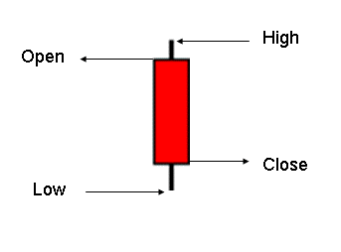
…And an example of a candle that closed higher than it opened (also called a bull candle):

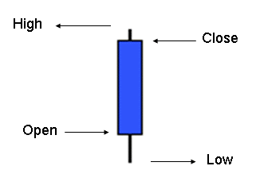

As you can see the high and low of each candle are the same (at the top or bottom of the candle), but the open and the close location depends on the direction (up or down of the market during that time the candle is formed). The color of the candle is user specified (I like red and blue, others like different colors).
The parts of a candle are the body (between open and close, represented by the colored section. The bigger the body, the more strength price action had during that time. The smaller the body, the more indecision the market had about strength.
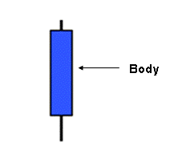
The points on top of and below the body are commonly called wicks, tails or shadows (they all mean the same thing). The longer the wicks or tails, the more price was pushed initially in that direction (up or down), but failed to hold that price until close, indicating a lack of continuation strength. The smaller the shadows, the more significance that price may continue in the direction of the body (up or down).
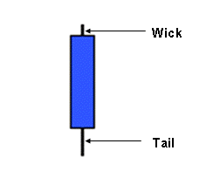
…or shadow

...or shadow
I’m going to cover more about the language and theory behind candles in depth in a later section. There are educators that specialize only in candlestick theory, and I think every trader needs to know what the candles are revealing at any one moment in time in order to interpret price action more accurately.

CHAPTER SEVENTEEN

Charts

Chart services range from simple to complex and from free to expensive. The serious trader needs to have proper tools to perform his (or her) tasks and although you can start with free charts, be prepared to invest between $100.00 to $200.00 per month in the chart service that provides you with real time price data, high reliability and ease of use (including advanced tools).
There are other things to consider along with your chart purchase, higher price does not always equal better chart, in fact there is so much competition for our business that even though exchange and feed fees keep rising, some providers know that over-charging their clients means high turn-over (as clients get fed up with paying close to $200.00 every month when lower priced options exist).
I had used eSignal for years when I got started and thought it was well worth the price (they are at the high end) until a little research for alternatives led me to Trade Navigator (http://genesisft.com). Even though they are nearly half the cost of other premium providers, their platform is so easy to use (for programming, testing and analysis) that they have been my number one choice for the last few years. It was an easy decision to partner up with the Genesis platform and when you research their site, you’ll notice the other traders/developers who also recommend Trade Navigator. (See Fig. 17.1 for a screenshot of their platform):

Fig. 17.1:
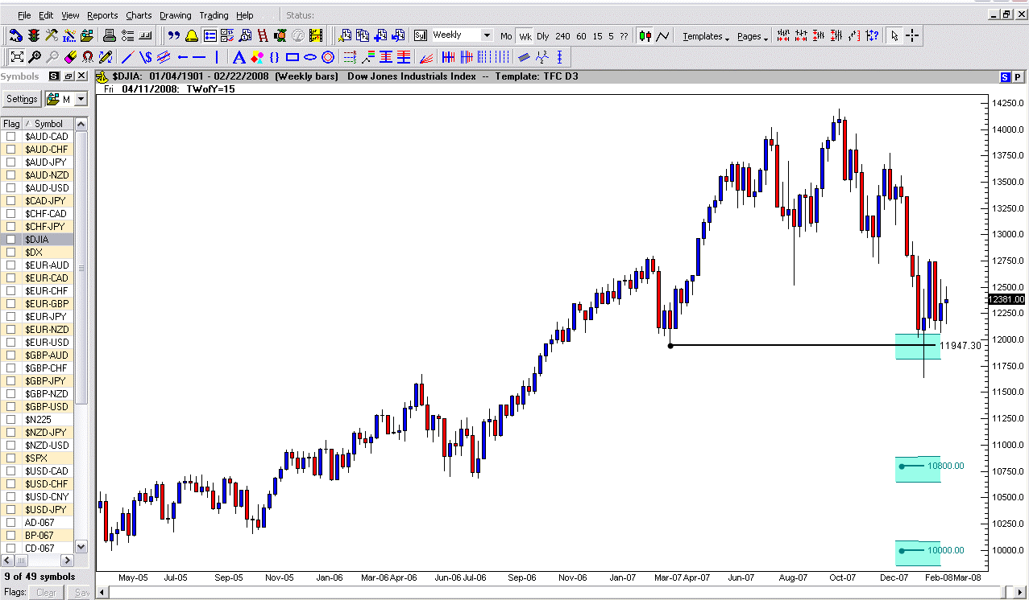

CHAPTER EIGHTEEN

Support and Resistance

“Support and Resistance” is the foundation of where you will begin to identify when to get into and when to get out of the market. Although support and resistance can be a very simple concept to understand you will always want to keep it in the back of your mind and it will become second nature.
Support and resistance are areas of price; at the top (peaks) and bottoms (valleys). Tops are the price areas of resistance and bottoms are the price areas of support.
Think of support as the floor in a building, when you walk in you are standing on the first floor (Support). You look up to the ceiling; you see resistance (you can’t go higher until you break through this level). If you go upstairs, again you have the floor you are standing on (now new support – which was previous resistance) and look to the ceiling (new resistance).
Identifying support and resistance on a chart is done the same way. The market will reach levels of exhaustion or weakness (no new buyers or sellers) and start to form a layer of support or resistance. The market will go back up in a period of strength until it runs out of steam and then forms an area of resistance.
See Fig. 18.1 for a Daily chart identifying some basic support and resistance levels. Notice that there are some areas that poke through those levels slightly and other times there is a defined level at which the market stays in. There are more levels of support and resistance than are labeled, can you identify them?

Fig. 18.1
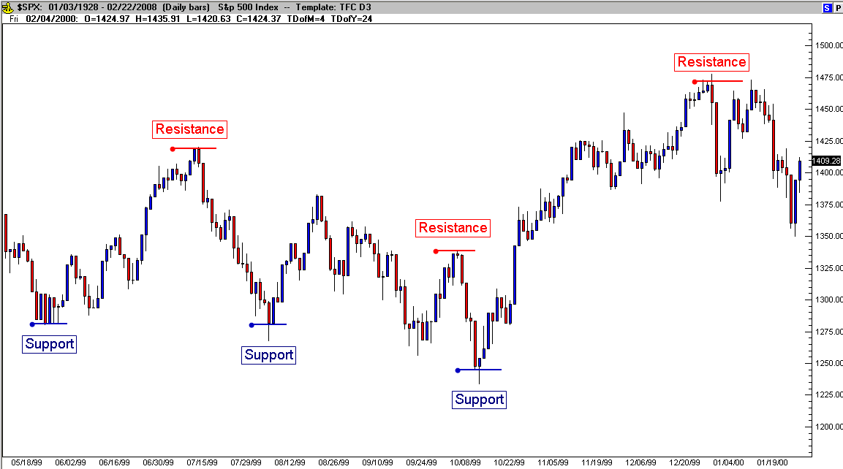

In any market, the way to define support and resistance is that support is a low price area (price doesn’t drop lower – no new sellers) and resistance is a high price area (price doesn’t rise higher – no new buyers). Note: even though price eventually traded through these levels, at that time and for a period after that, price turned and traded in the opposite direction until turning again at a new support or resistance level. This means that there are “short-term” support and resistance levels as well as “long-term” support and resistance levels. In any time frame, it’s where price turned and traded in the opposite direction.

Historical Support / Resistance

We all know of many times in history where events have repeated themselves. Support and resistance will also repeat itself. Look at a Fig. 18.2 of the Weekly USD/CHF chart and notice that the support area back in Mar. 2003 (1.3200) was hit again in Sept. and then in May 2004 became resistance, remaining a resistance level in July 2005 and again in Mar. 2006. When support becomes resistance (or vice versa) it’s called Role Reversal. Role reversal is very common in the currency markets (in other markets as well) and is an extremely important occurrence to watch for, because the market has changed its mind about these levels. This means once support is broken and used as resistance – the trend should continue lower and when resistance becomes support the trend should continue higher. So as you look at your chart and decide what a good level of support or resistance is remember to go back in time to look at historical data to make a better trading decision. Also utilize the tools in your chart service to draw horizontal lines at levels of previous support and resistance. This will make it easier to take a visual picture of historical support and resistance.
I’d like to share an observation with you here in regard to historical support and resistance. As I added long term levels (with permanent lines on my charts), I started to notice regular spacing between the major support and resistance levels (initially seen in the Forex pairs, I’ve since confirmed this phenomenon in other markets).
Further study of these levels revealed that support and resistance repeated themselves at historical average daily range levels in that market. See Fig. 18.2 for an example of the USD/CHF pairing in the Forex market:

Fig. 18.2
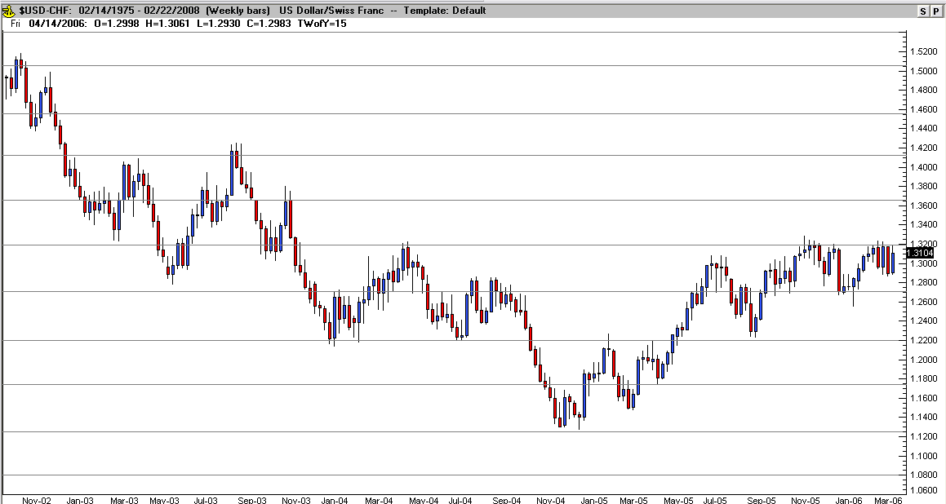

CHAPTER NINETEEN

Pivots (Daily/Weekly/Monthly)

The “Pivot Points” are a tool originating from the floor of the CBOT and represents mathematically calculated levels of support and resistance calculated from the previous days (or weeks, or months) trading. They are not perfect (nothing in trading is) but are beneficial in labeling specific profit targets as your trades progress (of course the same is true for a stop if a trade is breaking down). The following charts plot the pivots on the various time frame charts, daily pivots for intra-day charts 60 minutes or less, weekly pivots for time frames less than daily and monthly pivots for daily charts. I don’t actually advocate the use of the Pivot Points for targets in longer term trades, but for scalping strategies the Pivots label decent short term limits.

Here are the formulas for pivots:

(High + Low + Close) / 3 = Pivot Point
(Pivot Point - High) + Pivot Point = S1
Pivot Point - (High - Low) = S2
S1 + (High – Low) = R1
Pivot Point + (High - Low) = R2

Where S1 and S2 are support points and R1 and R2 are resistance points

The medians (M1, M2, M3 and M4) are all ½ of the distance between the main Pivots (this is the set-up from the Chicago Board of Trade origin. Here are examples from the different time frames.

Fig. 19.1 – Monthly Pivot Points
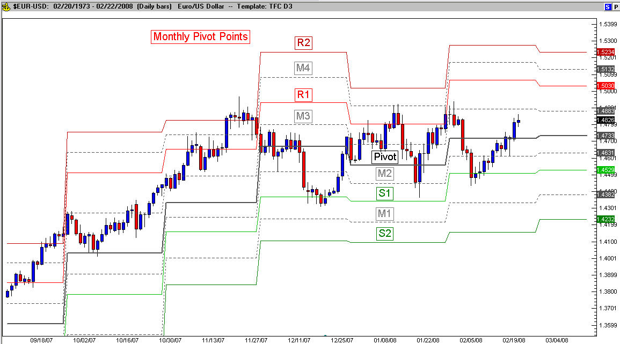

Fig. 19.2 – Weekly Pivot Points
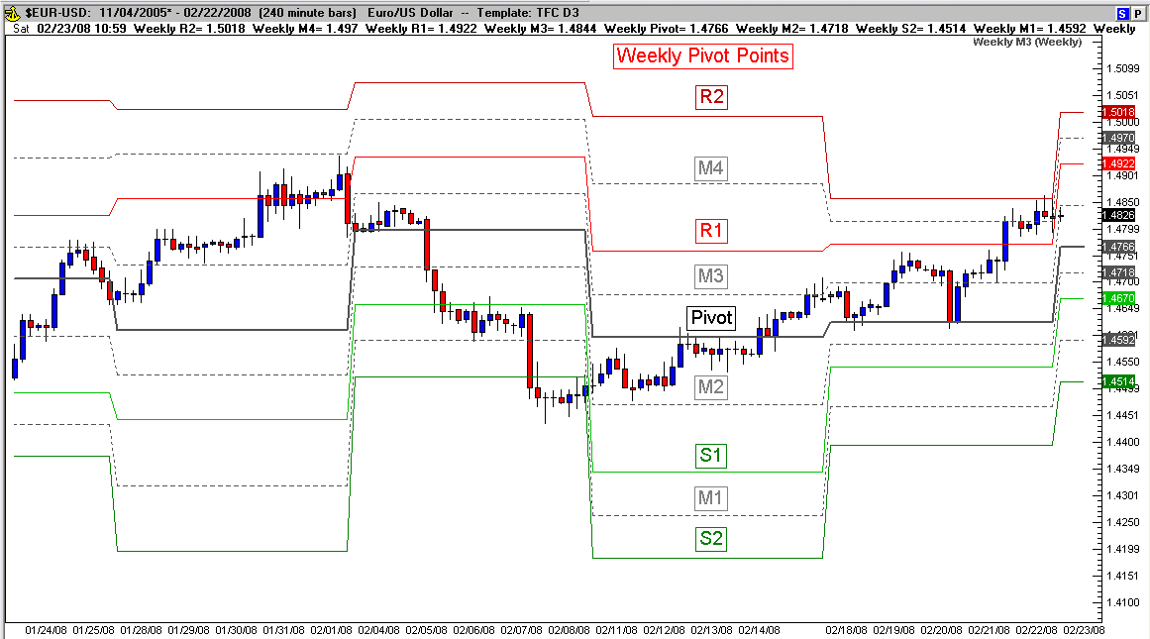

Fig. 19.3 – Daily Pivot Points
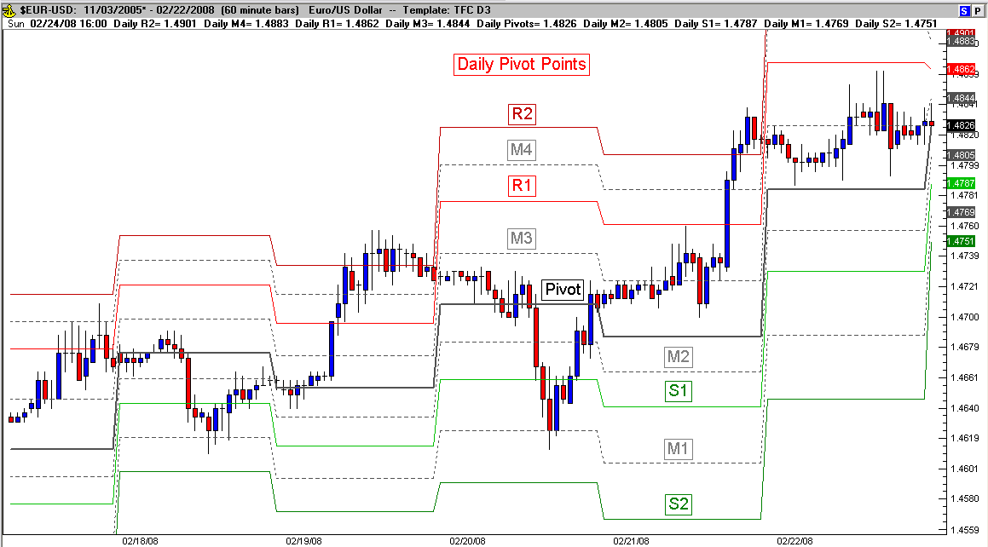

Price certainly acts independently of any of the pivot levels, but the pivots are still beneficial because they are widely used by professional traders and become significant when enough participants stop trading beyond them (confirmation). They also label smaller profit targets, stops and even trending price movements (when price exceeds the outer pivots, R2 or S2). There will also be times when price levels defined as pivots will cluster from the monthly, weekly and/or daily levels. We’ll explore this more in the workshops for members as we start putting it all together.

CHAPTER TWENTY

Trend Lines

Remembering the definition of a trend (higher highs and higher lows or lower highs and lower lows), the use of trend lines is a significantly beneficial tool in a trader’s arsenal. If a series of higher lows (in the up trending market) should be broken, it sends out a warning to a trader that the trend may be getting exhausted. A decision is nearing to either exit long positions or at least tighten up stops! Trend lines are deceptively simple yet extremely powerful. The time frames aren’t important; they should be used everywhere (how you interpret trend lines depends on your method of trading – scalping/swing trading/position trading). The rule is: a minimum of two points (higher lows or lower highs) to start a trend line (from a high or a low) and three points to validate a trend line.
See Fig. 20.1 for an example of the right way to plot trend lines:

Fig. 20.1
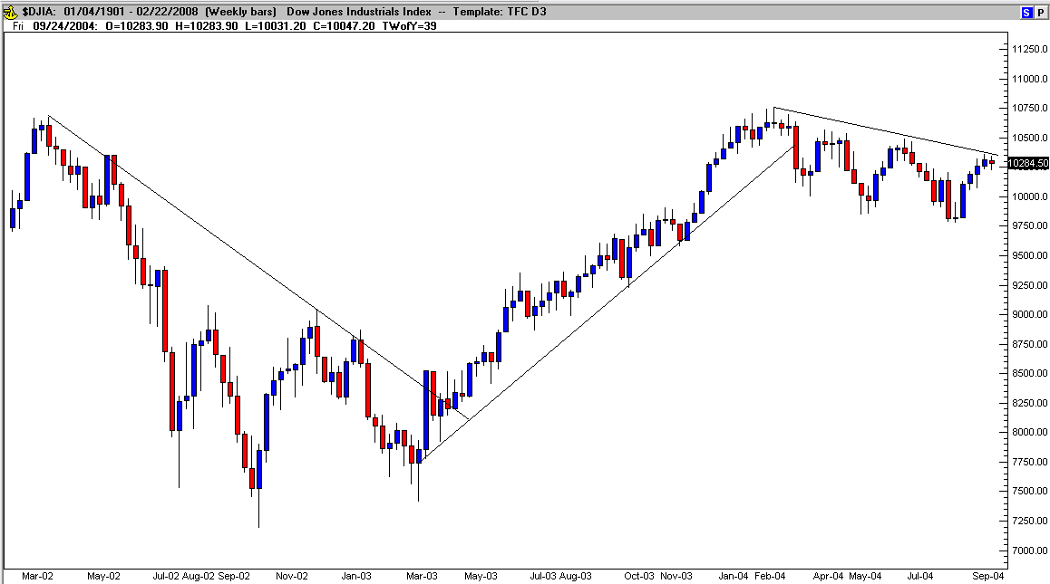

Whether you use the highs or lows (wicks/tails) or the opens or closes, isn’t as significant as the number of times a trend line is tested (not previously broken). All trend lines will eventually be broken; it’s a matter of learning exactly where the turning signals are potentially strongest. I still use confirming candle patterns, previous support/resistance and oscillator divergence for more significance.

A variation of trend lines that I absolutely love are trend regression lines (this tool is available in most charting services). It represents the long term trend as measured between the average price action and not the highs or lows. I add multiple parallel lines measuring one standard deviation above and below the trend regression line to pin-point levels of long term pricing that are mathematically over-extended (there’s more on standard deviation later in the book). The further price gets from average, the more over-extended (and therefore likely to turn) price is. As price exceeds two standard deviations from average (due to the construction of standard deviation), the market is more likely to reverse and at three standard deviations (in run-away trends) the market is extremely over-extended and ready to reverse. Here are some example long term charts displaying this phenomenon.
See Fig. 20.2 for an example of the S&P’s 30 year trend regression chart. Note: Just the last 12 years are displayed:

Fig. 20.2
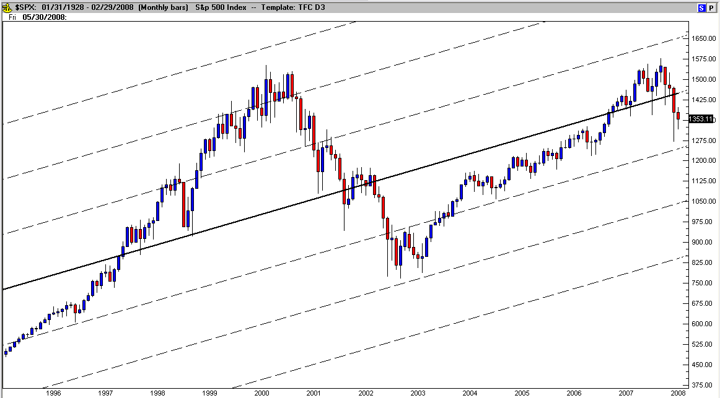

Fig. 20.3 the GBP/USD:
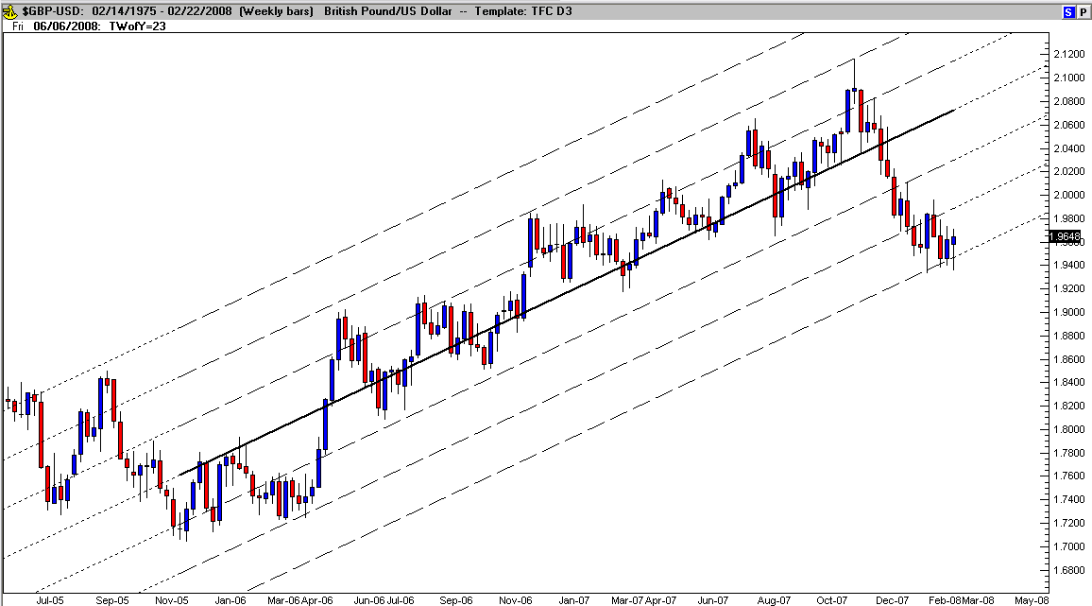

Notice as price nears the one, two or three standard deviation limits that the price finds trouble pushing through (most of the time). I love Trade Navigators’ function of keeping the trend regression lines up to today’s date (it moves automatically with each new candle). Even though the regression average has fluctuated up and down during the trend, the deviations are still relative (showing over-extended levels) throughout the move.
See Fig. 20.4 for the six-year Canadian Dollar (against the US Dollar) trend regression on a monthly chart:

Fig. 20.4
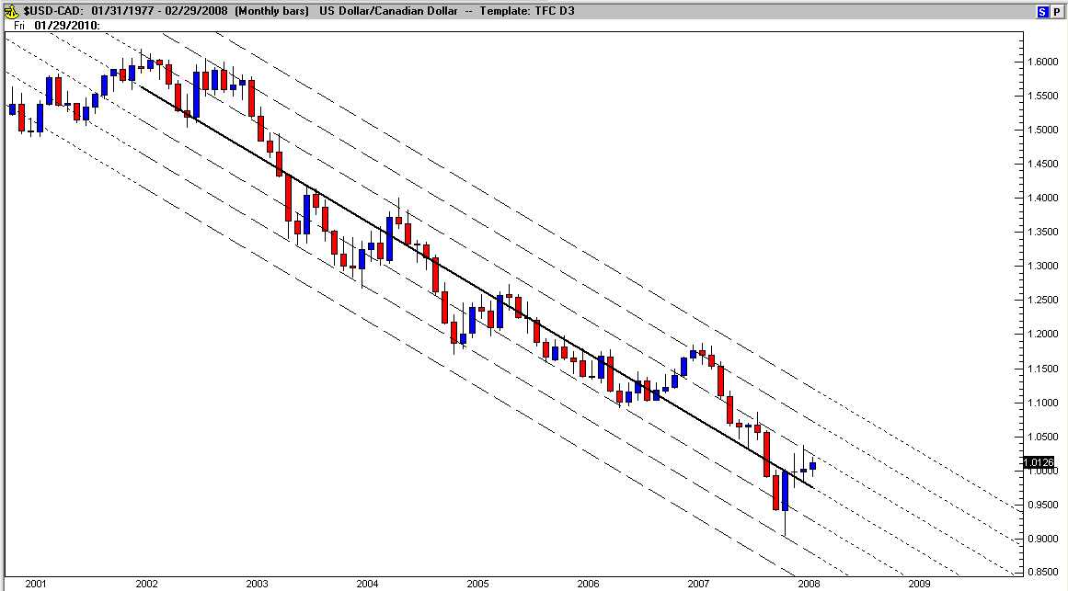

Fig 20.5 is the same pair with the same regression, but switched to the Weekly chart:

Fig. 20.5
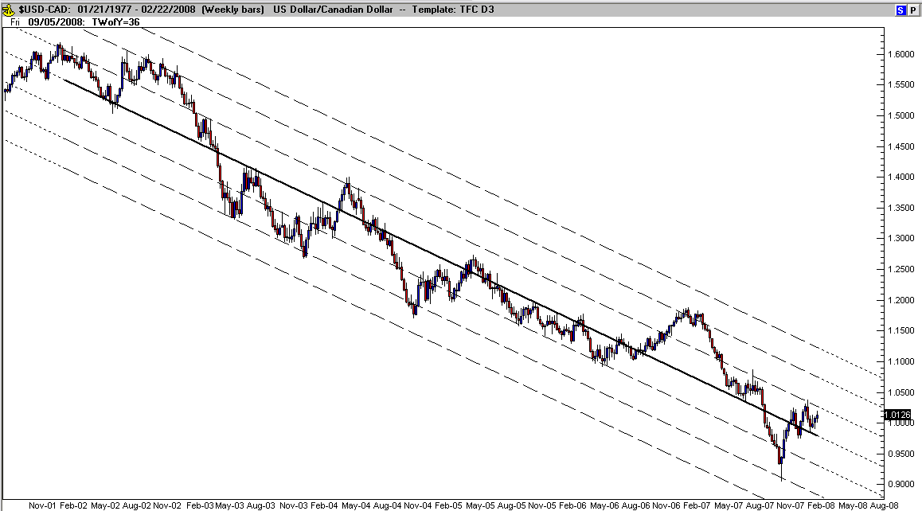

And Fig. 20.6 is the same regression changed to Daily charts (I couldn’t get the entire time frame squeezed into a daily chart, but you’ll still get the picture):

Fig. 20.6
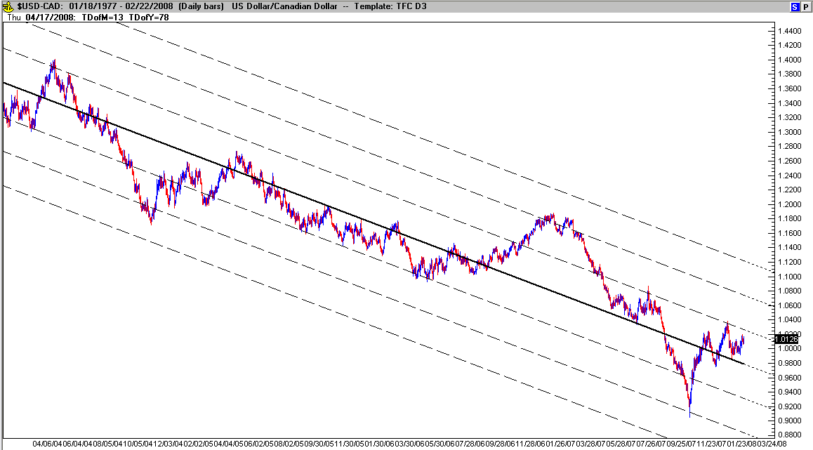

I include a more detailed explanation later in this book about Standard Deviations.

CHAPTER TWENTY ONE

Price Patterns

Over time, price collectively repeats similar patterns (in all time frames) that can be grouped into two categories to help trader’s project possible price direction. They are continuation patterns (the previous price direction will resume) and reversal patterns (the previous price direction will stop and reverse). Table 21.1 represents the different patterns:

Table 21.1
Trend Continuation Patterns | Trend Reversal Patterns
Channel | Head & Shoulders
Flag | Inverted Head & Shoulders
Triangle | 1-2-3 Top
Pennant | 1-2-3 Bottom
 | Double Top
 | Double Bottom

It’s important to add here that although patterns by themselves are relevant, it’s still necessary to accumulate confirming signals such as candle patterns and oscillator divergence to increase the significance of the price pattern). An example of a continuation pattern:

Continuation Patterns:

A Channel is a pattern in which parallel lines can be drawn through price highs and lows. Channels can be:

- Horizontal
- Inclining
- Declining

This pattern is easy to spot and can be viewed as a brief sideways price action. If it occurs within an uptrend and breaks out on the upside, it is called a “bullish channel”. If the consolidation occurs within a downtrend and then breaks out on the downside, the formation is called a “bearish channel”, see Fig.21.1.

Fig. 21.1
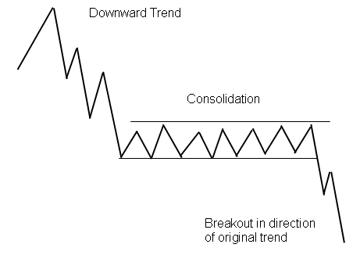

The higher probability trade options are on break out of the channel, or at a retest of the breakout (either higher or lower). Upon breakout, the original trend is the most likely direction the market will move.
When a channel is a part of a rally, it’s called a “Flag” formation since the formation resembles a flagpole (the rally) and a flag (the consolidation channel). A flag pattern is very easy to see in the early stages of its formation. Fig. 21.2 is an example of a flag displayed below. Since the overall trend is up, there is a bias toward an upward breakout. Although there was a false breakout initially (this is a reality when trading – patterns aren’t perfect), the continuation did play out and eventually price moved higher.

Fig 21.2
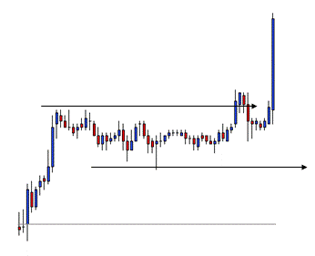

A Triangle is a pattern in which the slope of price highs and lows move together to a form a price point in the shape of a triangle. Triangles can be either:

- Symmetrical –Downward sloping top line and upward sloping bottom line with the base of the triangle next to the original trend.
- Ascending – Flat top line and upward sloping bottom line
- Descending – Flat bottom line and downward sloping top line

The higher probability trade is on the breakout of a triangle (either higher or lower) or at the retest of the breakout. Fig. 21.3 is an example of a symmetrical triangle.

Fig. 21.3
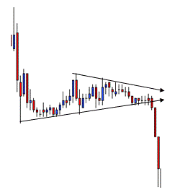

- A Pennant formation happens when a triangle follows a strong rally phase (in this case the triangle is not necessarily symmetrical). Similar to the flag, a rally forms a flagpole (either an uptrend or a downtrend before the triangle). The consolidation that follows forms the pennant that tapers to a point (a triangle). The example above displays the continuation of the trend lower after breaking out of the pennant.

Reversal Patterns

No trend continues forever. Prices are constantly rising and falling with supply and demand. Price often reveals that it’s about to change directions when certain patterns appear and traders often take advantage of this repeatability. A major reversal pattern often signals the beginning of a new trend, or at the very least, a strong counter-trend move recognizing that fact is very important for trade decisions.
There are 3 primary Trend Reversal patterns. When the market is moving higher (called a bullish trend). These patterns occur at the top of pricing and indicate a potential reversal is possible very soon. These patterns are known as “Head & Shoulders”, “1-2-3 Top” and “Double/Triple Top”. Conversely, when the market is moving lower (bearish trend) these patterns appear inverted and indicate price is about to change direction and move higher. These same patterns are then named “Inverted Head & Shoulders”, “1-2-3 Bottom” and “Double/Triple Bottom”.
A “Head & Shoulders” pattern signals a potential trend reversal. In an uptrend, the market begins to slow down, and the forces of supply and demand are generally considered in balance. Sellers come in at the high (left shoulder) and sell until the buyers take over again at the left neckline. Buyers ultimately push through to new highs (head). However, the new highs are quickly turned back by the sellers, and the downside is tested again (right neckline). Short-term buying re-emerges and the market rallies once more but fails to take out the previous high (right shoulder). Buying dries up and the market tests the downside again. The pattern is complete when the market breaks the neckline. Fig. 21.4 is an example:

Fig.21.4
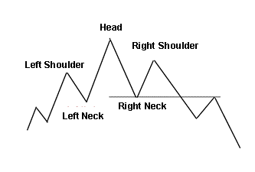

A “1-2-3 Top” or “1-2-3 Bottom” is a pattern that signals a potential trend reversal. In an uptrend, the market hits a new high (#1 Top), pulls back to a short-term low level (#2 Bottom), resumes an upward move to a high that is below the #1 high point (#3 Point) where it reverses once again. In a downtrend, the preceding definition is inverted. The pattern is complete when the market breaks the #2 point. Figure 21.5 is an example:

Fig. 21.5
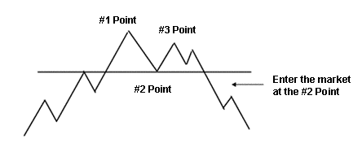

A “Double Top” or “Double Bottom” pattern is the third price pattern that signals a potential trend reversal. In an uptrend, prices rally to a new high, pull back for a period of time, rally to the same high price area again, where they fail to move beyond the previous support or resistance. This move and pull back action can occur two, three, or more times forming a double or triple top. Fig. 21.6 is an example:

Fig.21.6

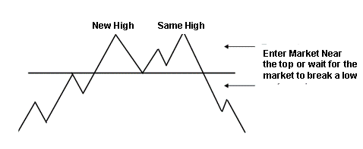

There are many more patterns and variations to the patterns than I’ve shared with you so far, but these examples should be enough to get you started. In order to increase your ability to interpret the market price patterns and make high probability trade decisions, remember these rules of pattern interpretation:

- Rule #1 – Patterns take on significance from their size and depth. The larger a pattern becomes, the greater its significance. Remember that patterns provide a visual picture of the price battle between buyers and sellers. The longer the battle, the more exhausted the losing side is likely to become and the greater probability for a new direction. For example, it’s important if the Dow rallies to 14000 three times within a three-hour period. However, it’s more significant if the same pattern happens over a three-day period.

- Rule #2 – Patterns are not perfect. It could be easy to miss out on a great trade when the opportunity is there if a trader is waiting for a perfect match to a pattern. Pattern interpretation is not an exact science because market movement is not an exact science. Pattern interpretation is a subjective technique that must be adapted. There are no perfect patterns.

- Rule #3 – Combine pattern trading with other techniques. A trader can be successful trading high-probability patterns alone. However, when combined with other techniques such as Candle patterns, trend analysis and Fibonacci ratios, the probability of making better trading decisions is increased.

Fibonocci Retracements

The Fibonacci sequence was named after mathematician Leonardo Pisano Bigollo (c. 1170 – c. 1250). He derived a series of numbers, 0, 1, 1, 2, 3, 5, 8, 13, 21, 34, 55, 89, 144, etc. as an assumption to solve a problem involving the growth of a population of rabbits. Each of these numbers is simply the sum of the preceding two numbers (i.e. 5 + 8 = 13, 8 +13 = 21 and so on). The amazing thing about his number sequence is that each number is approximately 1.618 times bigger than the preceding number as found in the “Golden Ratio” (an arithmetic proportion).
The important thing here is not so much the numbers or the sequence but the ratios (38.2% 50% and 61.8%). There is a lot more information about Fibonacci Ratios on the internet. You are encouraged to explore how Fibonacci ratios (Fibs for short) appear in Art, Science, Math, etc., but for this book I will explain how to use Fibonacci Ratios to improve finding entry and exit points in your trading.
The correct use of this tool is to start at one of two extreme points such as a top (significant resistance) to a bottom (significant support) or vice versa. Then the calculation is automatically made for us on the screen displaying the multiple fib levels. Typically, anywhere between .382 (38.2%) to .618 (61.8%) is considered a “retracement” of the previous range (high to low or vice versa). As shown in the first example Fig. 21.7 below:

Fig. 21.7
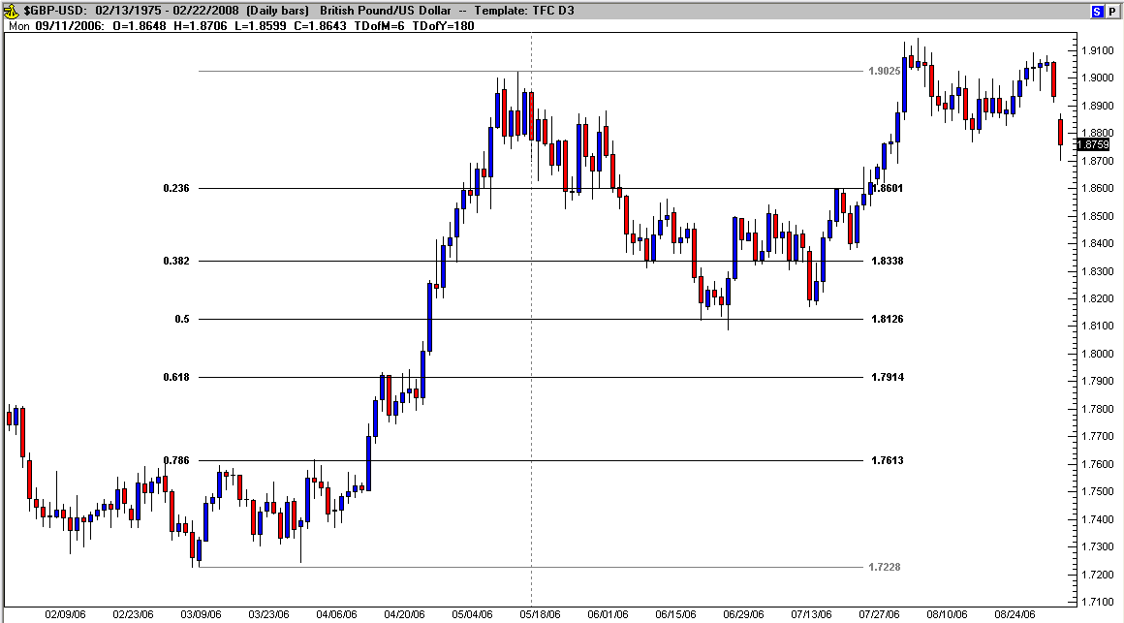

Here’s another example, this time Fig. 21.8 is a fib pull from a high to a low:
Fig. 21.8
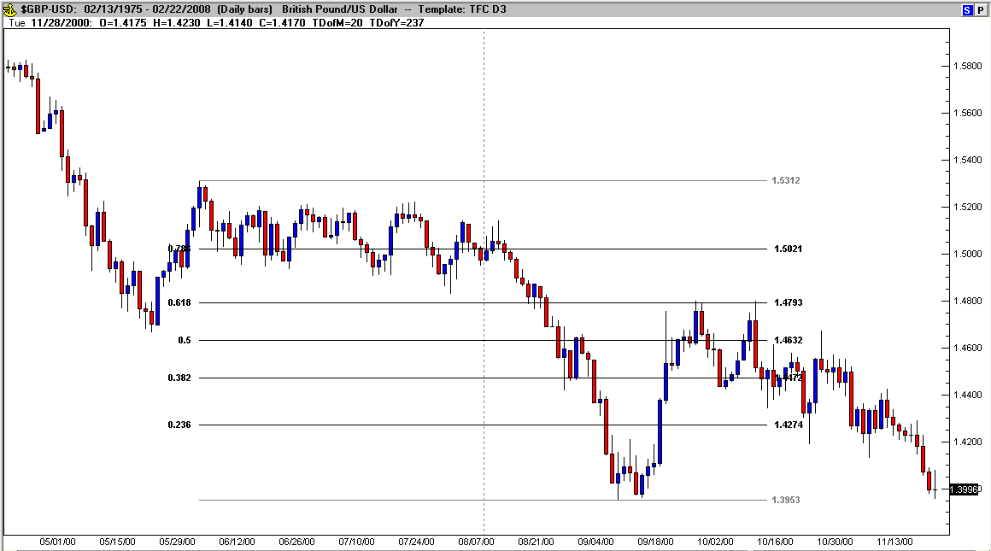

Since Fibs are so widely used amongst a majority of traders around the world, they have a “self-fullfiling” nature. In other words, price has a habit of seeking out or stalling at or near the common Fib levels. The basic principle here is: 3 steps forward, 1 or 2 steps back. It is a fact that it’s human nature to seek out patterns in everything we do, so logically these ratios are repeatedly played out over and over again every day in any time frame of pricing in any market.
In order to address the zone between 38.2% and zero (previous high or low), 23.6% is commonly used (an actual ratio) and the accepted terminology of a pull-back that does not reach at least 38.2% is “a correction”. To address the zone between 61.8% and 100%, 78.6% has become popular although it is not an actual ratio (it is the square root of .618). The .786 level has become popularized as outlined in a “Gartley Pattern” (see Investopedia).

Multiple Fibs

Pulling several fibs is a great way to find a concentration of price. In the next chart notice the fib levels on the bigger time frame, the red .382 and on the small time frame the green .618 and how the two lines are almost on top of each other. Also notice the price did eventually come down to that level. As you go from one currency pair to another you will find that as you layer fibs on top of each other, certain fibs ratios will coincide on top of each other, lending greater significance to this price level and a higher probability of that level being retested in the near term.

Take some time in your platform and practice this concept, pull a Fib on the big picture and then one on a smaller area of the chart. You will find the results very interesting.

Fig. 21.9 is an example of a multiple fib pull:

Fig 21.9
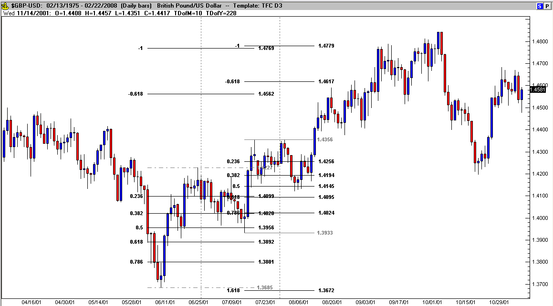

The first Fib pull is from lowest low to the first high and then second Fib pull is from the pull-back low to the next high. Each retracement was at least 50%. Notice that several fib levels converge from the two different Fib pulls, especially the Fib extension up at minus one (very close to the rally’s high near 1.4800). Fibs help define relevant price levels in retracements and even eventual limits (using the extended Fibs – levels above or below support and resistance).

Fib Extensions and Expansions

Where Fib Retracements measure a potential price movement back into a previous range (below the most recent high and above the most recent low), Fib Extensions and Expansions measure where price may move outside of the current range of price (above the most recent high or below the most recent low). A Fib Extension is determined by using the same Fib retracement starting points and adding ratio levels above or below the range. Fig. 21.10 is an example.

Fig 21.10
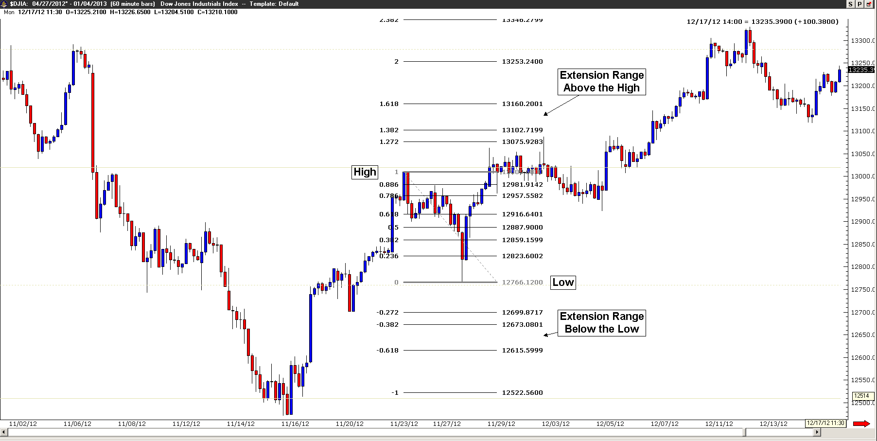

Fib Expansions are also outside of the range of a recent high to low (or vice versa), but are calculated differently. This time starting at a low (for a bullish expansion) and then connecting the next significant high, the third point to connect is the next low (typically a retracement of the first range). This is a 123 bottom as identified in the price pattern section. Fig. 21.5 on page 70 shows a 123 top as a part of a “Head and Shoulders” pattern, a 123 bottom is just the opposite, low, high and then a higher low than 1 (right section of an “Inverted Head and Shoulder” pattern). The levels beyond point 2 are high probabilty targets, at a minimum 61.8% and typically 100% once point 2 is broken.
Although Elliott Wave won’t be covered in this book (there are plenty of existing books and programs that thoroughly cover EW), it should be noted here that these “Expansion” measuments are key to measuring whether or not a rally has enough momentum to become a strong trend (as in a 5 wave impulsive pattern). A 123 pattern is labeled as an ABC in Elliott Wave and is considered a corrective pattern (not a part of a trend, but a counter-trend move). Every 5 wave trend starts with a 123 top or bottom, but not every 123 top or bottom becomes a trend! Because of this frequently repeated sequence, my favorite pattern to trade is a 123 top or bottom – the trade may become a part of a very profitable trend. If I had to boil the “secret to my success” down to two factors – 123’s and Fib Expansions would be the answer. Fig. 21-11 is an example of a Fib Expansion.

Fig 21.11
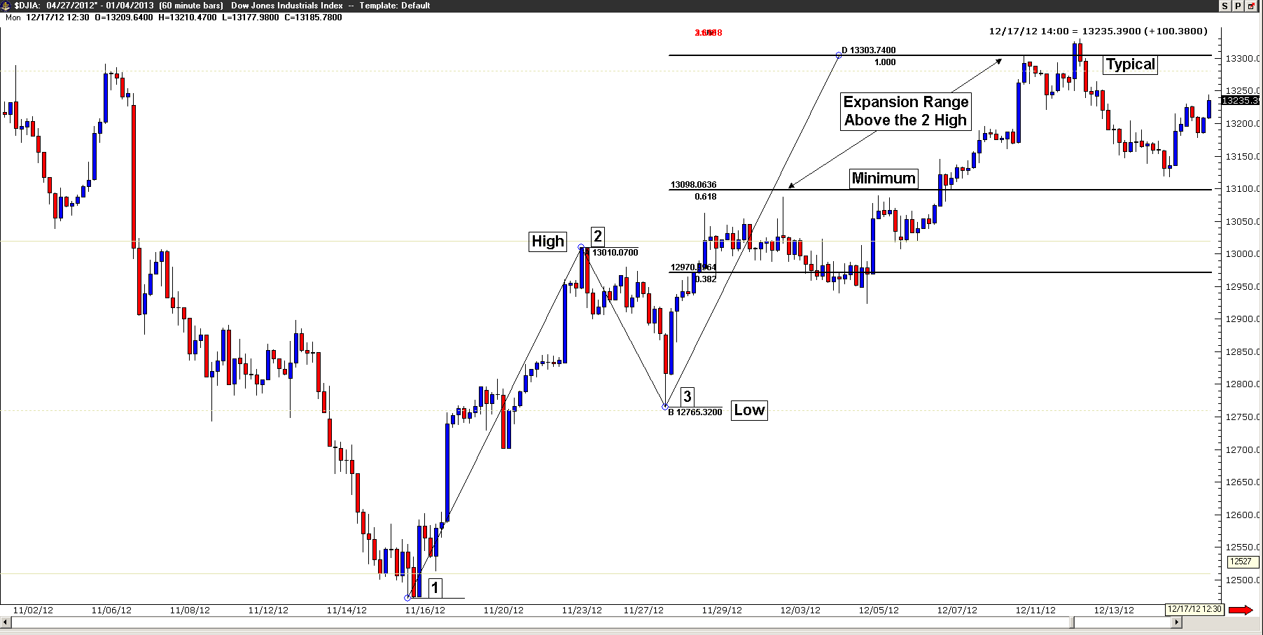

As you can see in Fig. 21.11 above, after price breaks above the number 2 high, it continues to progress higher into the projected minimum to typical price expansion range without trading below the point 3 low. It should also be noted here that this breakout pattern fills most of the time, but certainly not all of the time! The key is identifying point 3, because the earlier you can enter this pattern after point 3, the smaller the stop loss and the greater your profit potential.
I use this method of calculating the potential breakout range to determine a reasonable risk to reward for each trade whether it’s short term or swing. However, to be honest, calculating profit to loss/risk to reward is truly a best guess scenario because anything can happen including inaccurate pattern recognition all the way to “Black Swan” events (unanticipated externally driven price reversals).

PART FIVE – ADVANCED SYSTEMS

Now it’s time to dig deep into the vault of trading tools and explore advanced techniques that’ll be very helpful to know, understand and apply to your trading decisions. This section is the result of years of examination, testing, trial and error. It’s almost impossible to know everything about trading, but after reading through the following chapters, you’ll have a head start.

CHAPTER TWENTY TWO

Candle Formations

Candle formations and patterns have long been taught as a functional part of Japanese trading philosophy. Each candle tells a particular story in its final formation and traditional Japanese traders say the formation of specific candles dictate a probable outcome.

There are numerous courses on candlesticks, and they are an excellent resource of knowledge in any trader’s arsenal. Steve Nison’s candlecharts.com courses are well known for being a beneficial resource as has Stephen Bigalow’s candlestickforum.com video arsenal. Our goal here is to provide you with the same content and detail as these (additional cost) resources and even though you may be familiar with this information already, it’s still necessary to review it again. After all, people learn by layering information in a repetitive fashion and you will likely pick up valuable strategies to add to your repertoire.

Here are a few of the major candlestick formations:

Doji Formations

Fig. 22.1
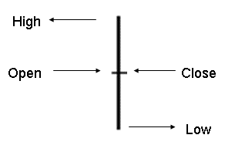
A Doji (fig. 22.1) is formed when the open and the close are the same. The length of the shadows tells another story (longer wicks and/or tails means more volatility – without direction). The Japanese interpretation is that the bulls and the bears are conflicting equally. The appearance of a Doji should alert the investor of major indecision (the larger the time frame – the more significant the lack of direction).

Fig. 22.2
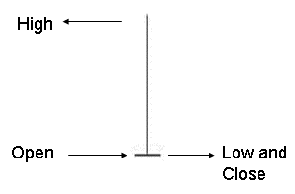

The Gravestone Doji (Fig. 22.2) is formed when the open and the close occur at the low of the day. It is found occasionally at market bottoms, but its strength is calling market tops. The name, Gravestone Doji, is derived by the formation of the candle looking like a gravestone.

Fig. 22.3
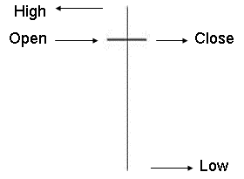
The Long-legged Doji (Fig. 22.3) has one or two very long shadows. Long-legged Doji's are often signs of market tops. If the open and the close are in the center of the session's trading range, the signal is referred to as a “Rickshaw Man”. The Japanese believe these signals to mean that the trend has lost its sense of direction.

Reversal Formations

Fig. 22.4

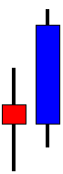
The Bullish Engulfing Pattern (Fig. 22.4) is most significant at the end of a downtrend. A bullish engulfing candle is formed when it opens equal to or lower than the previous candle close and closes higher than the open of the previous candle. This complete engulfing of the previous day's body represents overwhelming buying pressure taking over from the recent selling pressure (rally or trend lower).

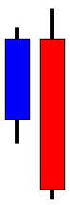
Fig. 22.5

The Bearish Engulfing Pattern (Fig. 22.5) is directly opposite to the bullish pattern. It is most significant at the end of an uptrend. The bear candle completely engulfs the previous candle's price activity. This shows that the bears are now overwhelming the bulls.

Fig. 22.6
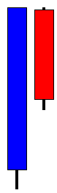

The Dark Cloud Cover (Fig. 22.6) is a two-candle top reversal pattern found at the end of an uptrend or at the top of a congested trading area. The first candle of the pattern is strongly bullish. The second candle's price opens higher (or equal to) than the previous candle’s close and closes in the lower half of the previous candle’s body.

Fig. 22.7

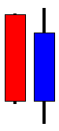
The Piercing Pattern (Fig. 22.7) signifies a bottom reversal. It is a two-candle reversal pattern at the end of a downtrend. The first candle is a bear candle. The second candle is a long bull candle that opens below the close of the previous candle (better if it opens below previous candle low). The price comes up and closes in the upper half of the previous candle.

Fig. 22.8

A Hammer (Fig. 22.8) and Hanging-man (same shape, but a bull candle) are candlesticks with long lower shadows and small real bodies at the top of the time frame. This candle pattern at the bottom of the down-trend is a Hammer and signals a potential support level (it is “hammering” out a base). The Japanese word is “Takuri”, meaning "trying to gauge the depth". The Hammer or Hanging Man at the top of a trend is not as significant (by now you should be reading the price activity during the candle’s formation to get an idea of importance). It’s important to have confirmation after the pattern.
Fig. 22.9
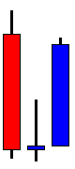
The Morning Star (three candle pattern – Fig. 22.9) is a most significant support (bottom) reversal signal. According to Japanese candle theory, “like the morning star, the planet Mercury, it foretells the sunrise or the rising prices”. The pattern is similar to a bullish engulfing pattern, but with a somewhat directionless day in between. The last bear candle in the down trend and the strong bull reversal candle. Long tails (shadows) signal exhaustion of the bear activity.

Fig. 22.10
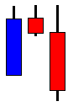

The Evening Star (Fig. 22.10) is the exact opposite of the morning star. According to Japanese candle theory, “the evening star, the planet Venus, occurs just before the darkness sets in”. The evening star is most significant at the end of an uptrend. The actual size and shape of the candles will vary depending on the price activity during trading, but as long as the overall bullish movement is quickly consumed by the bears, the direction of price should be reversing.

Fig. 22.11

A Shooting Star (Fig. 22.11) sends a warning that the top is near. It got its name by looking like a shooting star. Price usually extends above recent resistance (in the near past) during the candle’s formation and then fails to close higher. The Shooting Star pattern at the bottom of a trend is a bullish signal. If this occurs it is known as an inverted hammer. A trader armed with candle pattern knowledge needs to be patient and wait for the bullish or bearish confirmation.

Fig. 22.12
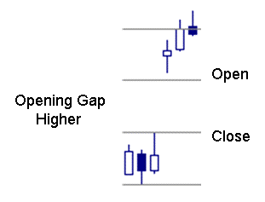
Gaps (Fig. 22.12) can occur in candle formations. They look like an opening between candles. This happens when either price changes overnight (those markets are closed to trading, but orders still flow in to brokers for execution upon the opening of that market) or when a surprise news event causes pricing to instantly spike to levels beyond current pricing (like during 911 for instance). Another name for gaps is “window” (from candlestick theory) and they can be rising (opening higher) or falling (opening lower). Fig. 22.13 is an example of an opening gap higher in the Emini Russell.

Fig. 22.13
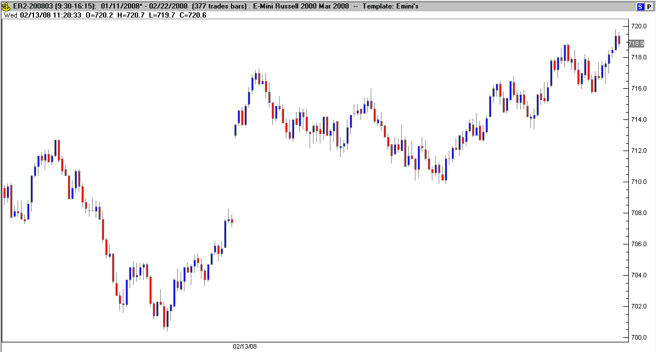

An important rule to remember is that opening gaps are almost always filled! That means that even though in the example, the Emini Russell gapped higher at the opening, during the immediate trading session price rose higher at the beginning of the session and then retraced to nearly fill the gap. Note: the example in Fig. 22.13 above actually failed to completely close the gap, it came within 2 points and buying took over for the rest of the day. The Emini Russell pays/costs $10.00 per tick, so this rally of 4 plus points, equaled $400.00+ per contract!
Fig. 22.14 is another example of the Emini Russell, this time gapping lower at the open; rising in the morning session to fill the gap (the resulting rally long ran for over 8 points in filling the gap). The rally presented over $800.00 per contract in return (minus commissions) in a little more than 7 minutes!

Fig. 22.14
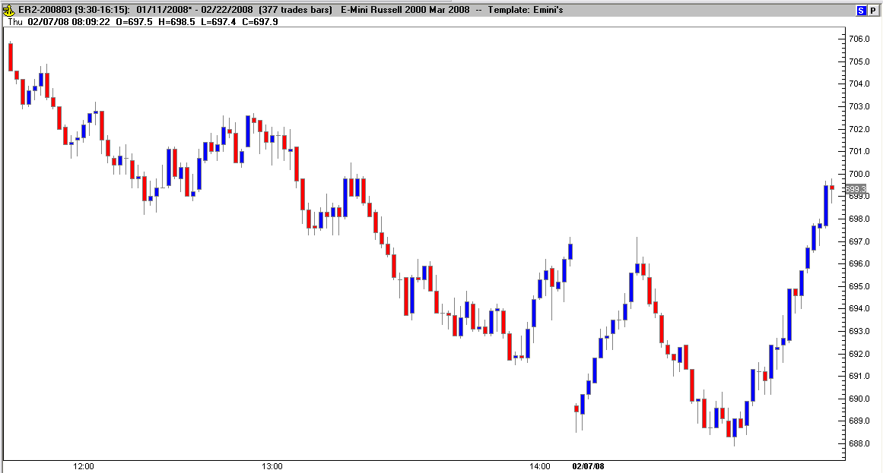

Gaps (like in Fig. 22.14) also come near the end of a trend (exhaustion gap) and reveal one last attempt of the bears to push the trend into continuing but fail.

More Candle Pattern Charts:

Back to candle patterns. Let’s look at some common price reactions (and patterns) around various formations; Fig. 22.15 displays a shooting star combo (also a Double Top):

Fig. 22.15
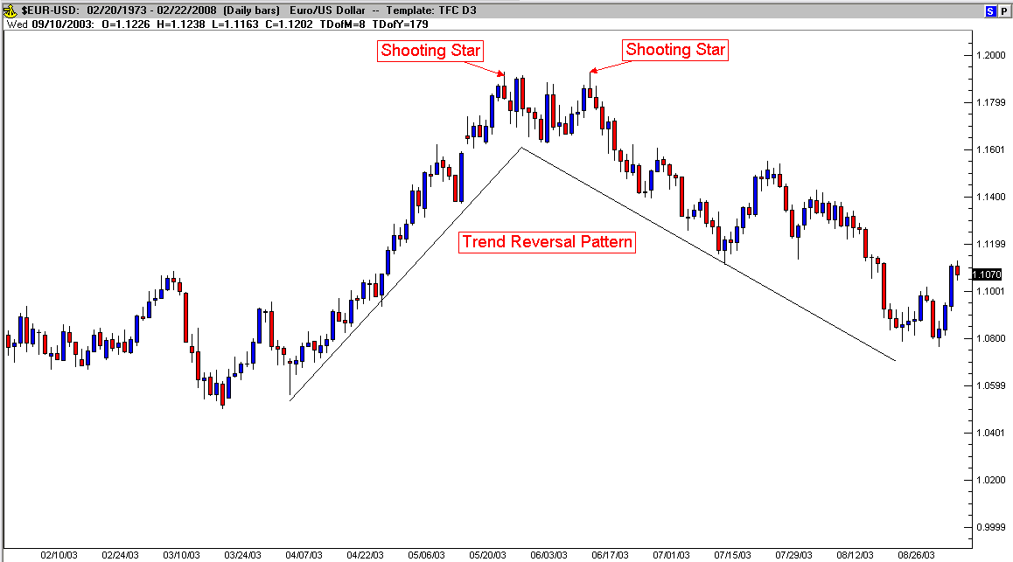

The uptrend was getting exhausted as first signaled by the shooting star and was eventually confirmed by the second shooting star and then the trend reversed.
Fig. 22.16 demonstrates how candle patterns sometimes combine (a hammer is a part of a morning star) with the same results shortly afterward, trend reversal (apart of an eventual Inverted Head and Shoulders).

Fig. 22.16
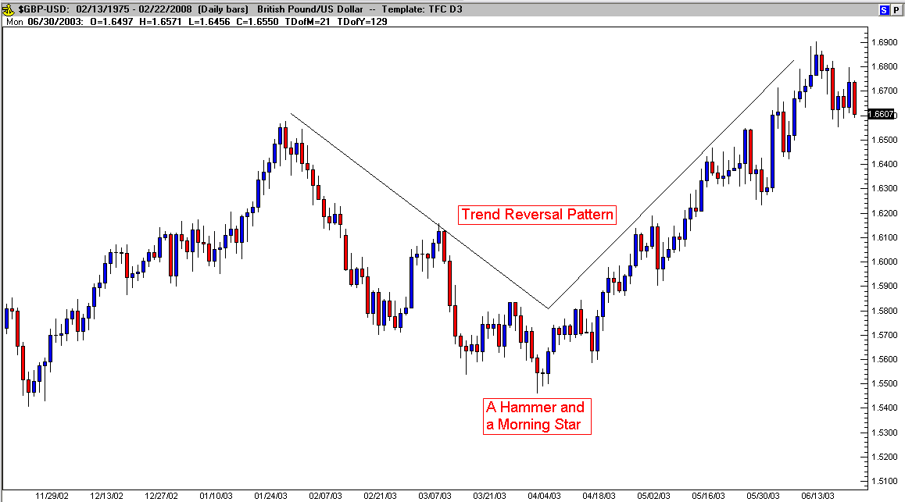

Fig. 22.17 shows a bearish engulfing pattern with the trend reversal following.

Fig. 22.17
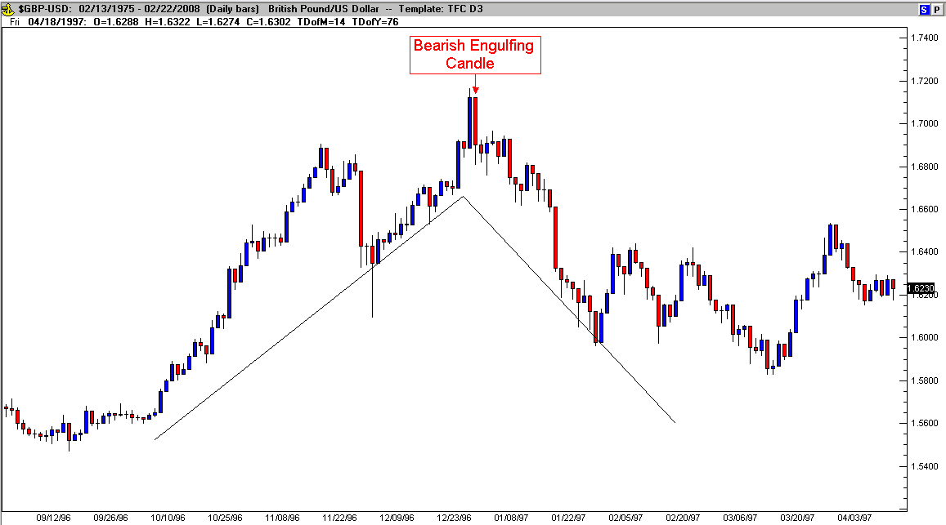

Fig. 22.18 shows 2 engulfing patterns, the second was confirming support at that price level and the trend reversed.

Fig. 22.18
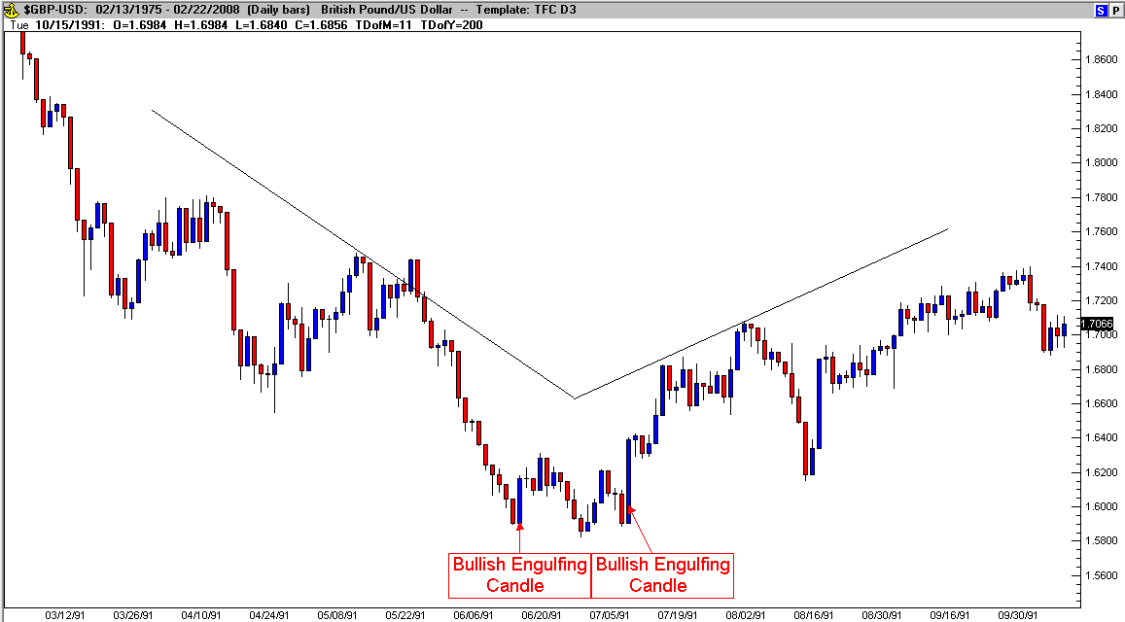

Fig. 22.19 shows a continuation after a reversal pattern. Despite the candle patterns signaling reversal, all the market could muster was a retracement, before an eventual breakout and continuation (of a consolidation Channel).

Fig. 22.19
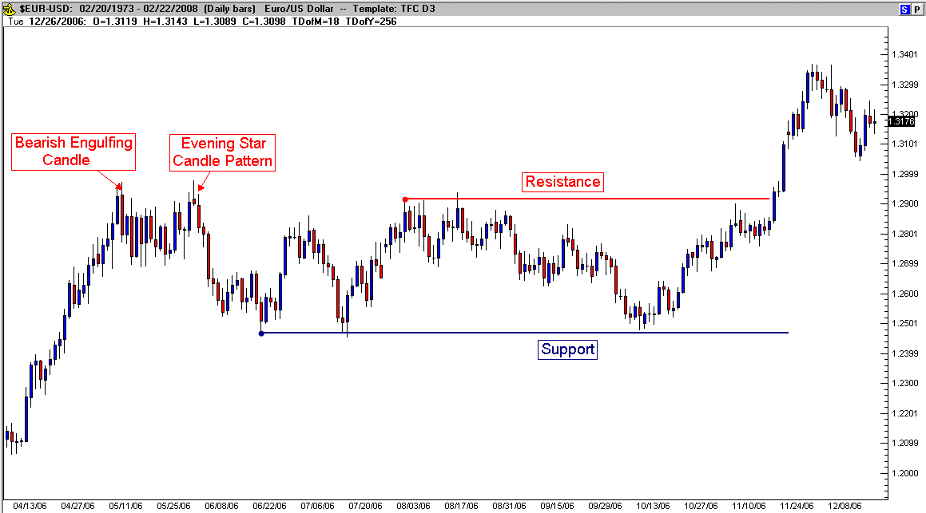

Are candle patterns relevant on all time periods? Yes, but the longer the time period, the more significant the pattern’s results are likely to be. We’ll explore more in subsequent modules as we begin to put it all together.

CHAPTER TWENTY THREE – Indicators (Standard & Modified)

Moving Averages

There are four important indicators that fall under the category of moving averages: simple, weighted, exponential and adaptive. I will focus here on simple moving averages, but before I go any further, I must say a word or two about trend lines. Currencies move in upward, downward, and sideways or horizontal directions. These directions are called trends. Markets tend to move in their respective directions for long periods of time.
To better understand the trend line, technicians in the late 1930 had looked at pricing data over a set period of time (for example, 10-day, 50-day, or 200-day). They discovered that this helps one to understand better the short-term trends of the more long-term trend line.

Construction of Moving Averages:

To do the mathematics for a 50-day simple moving average, add the closing prices of the last 50 days of the currency you are following. Then divide by 50 to obtain the average price over the last 50 trading days. This number is then plotted on a chart, and one then needs only to connect the dots to develop a moving average line. The following day, the technician will take off the first day of the equation and add the present day’s data and repeat the addition and division process. Fortunately, modern chart services automate this process for traders.
The longer the moving average, the more likely it will suffer from what one could refer to as “the tail tending to wag the dog.” Simply put, this means that the effects surrounding the currency six months to a year ago have no real effect on the condition of the currency today.

What is the Moving Average?

The moving average is an indicator that shows the average value of a currency’s price over a period of time. Remember, to find the 50-day simple moving average based on the close you would add up the closing prices from the past 50 days and divide them by 50. And because prices are constantly changing it means the moving average will move as well.
The most commonly used moving averages are the 20, 30, 50, 100, and 200-day averages. Each moving average provides a different interpretation on what the currency price will do. There really isn't just one "right" time frame. Moving averages with different time spans each tell a different story. The shorter the time span, the more sensitive the moving average will be to price changes. The longer the time span, the less sensitive or the more smoothed the moving average will be. Moving averages are used to emphasize the direction of a trend and smooth out price and volume fluctuations or "noise" that can confuse interpretation.

So what do the different days mean?

The general assumption behind all moving averages is that once the currency price moves above the average that it may have substantial momentum behind it and is worth buying. The opposite is true if the price of a currency moves below the moving average. It's a pretty simple approach to technical analysis, perhaps the simplest of them all, but if applied consistently, it works and it is the basis for many other much more complicated indicators.

20 period - provides a very volatile, choppy line. It isn't the most accurate but is probably the most useful for short-term traders.
30 period - similar to 20 period but provides a bit more certainty for the trend.
50 period - moving averages provide a much less volatile, smooth line. This can be used to detect somewhat longer-term trends.
100 period - similar to the 50 period, it is less volatile, and one of the most widely used for long-term trends.
200 period - even less volatile, more of a rolling chart or smooth line. It doesn't react to quick movements in the currency price therefore it is rarely used.

Again, there isn't just one "right" time frame. Moving averages with different timespans each tell a different story. The shorter the time span, the more sensitive the moving average will be to price changes. The longer the time span, the less sensitive or the more smoothed the moving average will be.

Strategies Using Moving Averages

Different investors use moving averages for different reasons. While some use it as their primary analytic tool others simply use the moving average as confidence builder to back their investment decisions. Here are two other moving average strategies:
Filters: Filtering is used to increase your confidence about an indicator. There are no set rules or things to look out for when filtering; just whatever makes you confident enough to invest your money. For example you might want to wait until the currency crosses through its moving average and is at least 10% above the average to make sure that it is a true crossover. Remember, setting the percentile too high could result in "missing the boat" and buying or selling the currency at its peak. Setting the percentile too low could lead to frequent poor quality trades.

Fig. 23.1
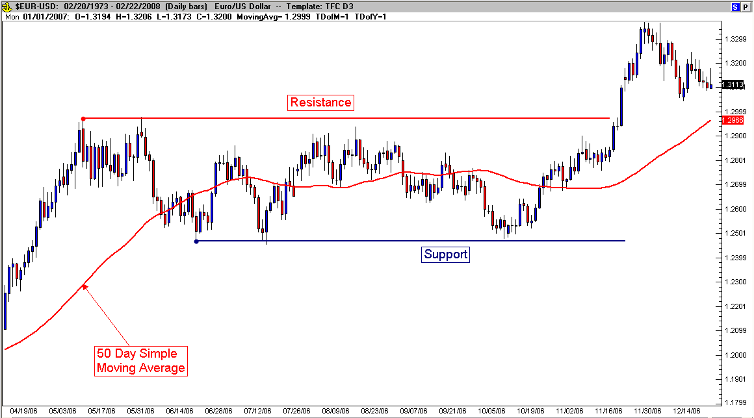

Another filter is to wait a period or two after the currency crosses over, this can be used to make sure that the rise in the currency isn't a fluke or a “fake-out break-out”. Again, the downside is that if you wait too long then you could end up losing out on some profits. (See Fig. 23.1)

Crossovers: Using Crossovers isn't quite as easy as filtering. There are several different types of crossovers, but all of them involve two or more moving averages. In a double crossover you are looking for a situation where the shortest MA crosses through the longer one. This is almost always considered to be a buying signal since the longer average is somewhat of a support level for the currency price.

Fig. 23.2
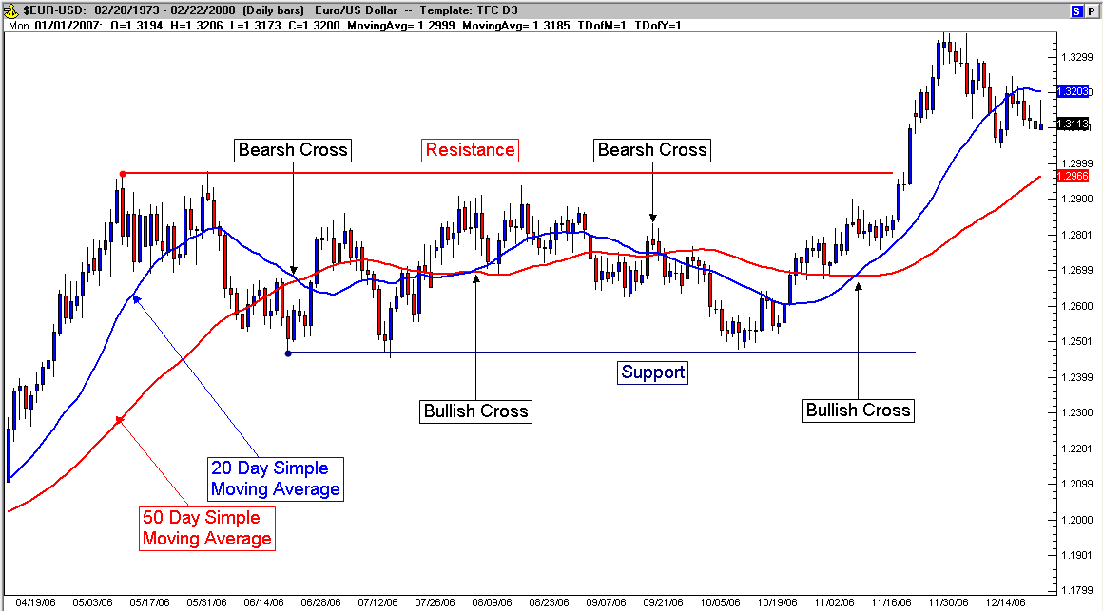

For extra insurance you can use a triple crossover, whereby the shortest moving average must pass through the two higher ones. This is considered to be an even stronger buying indicator but is still a lagging entry (not the best possible price). Although generally thought of as late entries (the moving average cross-over that is), patience in entering a rally can often mean fewer stops being hit when price tests but fails to break (and hold) above (or below) a moving average. There remains a fine line between trying to be perfect (buying or selling as close to support or resistance as possible) and sound entry rules. The difference is measured in how much profit (what is your exit strategy) you are targeting. The trader that is satisfied with 70-80% of a price swing (top to bottom or vice versa) will experience far less frustration than those attempting to be prefect in picking tops or bottoms.

Fig. 23.3
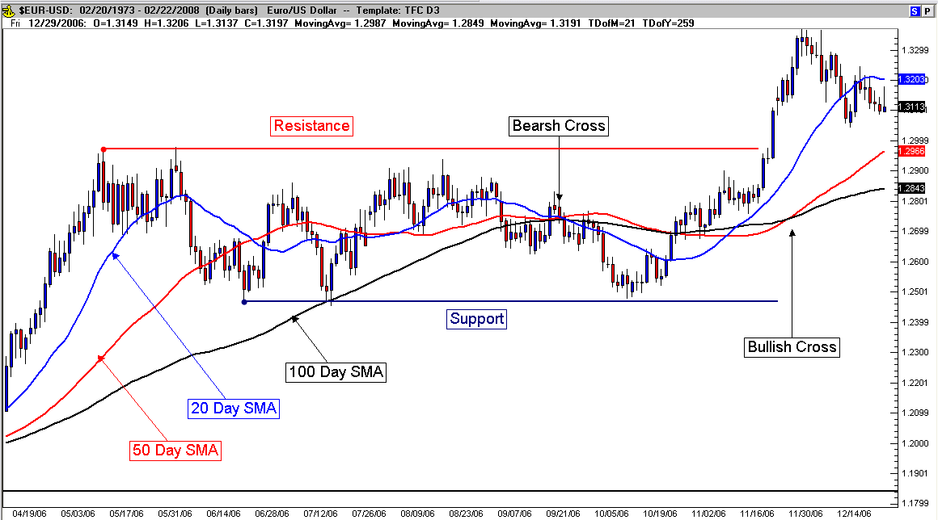

The Different “Flavors”:

Of course, the simple moving average that we've discussed is the most popular, but there are different modified versions of the moving average that attempt to reduce the lagging nature inherent in moving average entries and exits.

Exponential Moving Average (EMA) - Is calculated by applying a percentage of today's closing price to yesterday's moving average value. Use an exponential moving average to place more weight on recent prices.

Moving Average Convergence Divergence (MACD) – is quite common, but unlike other moving averages plotted over price, the MAC ”D" is a trend following momentum “indicator” (plotted in a separate pane) that shows the relationship between two different moving averages. To calculate the MACD subtract a 26-day EMA from a 12-day EMA. A 9-day EMA of the MACD called the signal line is then plotted on top of the MACD. The histogram is a plot of the difference between MACD and the signal line. There are 3 common methods to interpret MACD:

            - Crossovers - When the MACD (blue line) falls below the signal line (red) it is considered a signal to sell and vice versa when the MACD rises above the signal line it’s considered a signal to buy.

Fig. 23.4
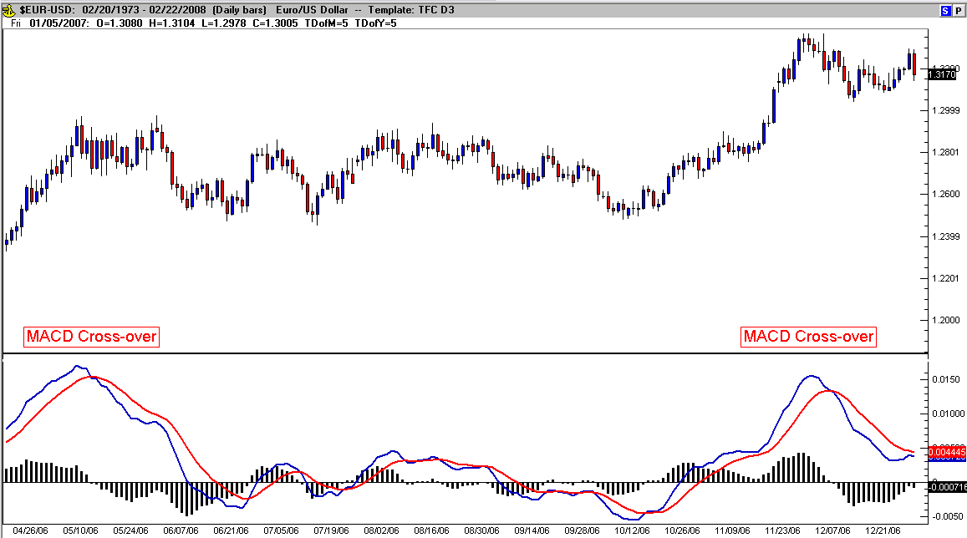

2. Divergence - When the currency price diverges from the MACD it signals a possible change in the current price direction.

Fig. 23.5
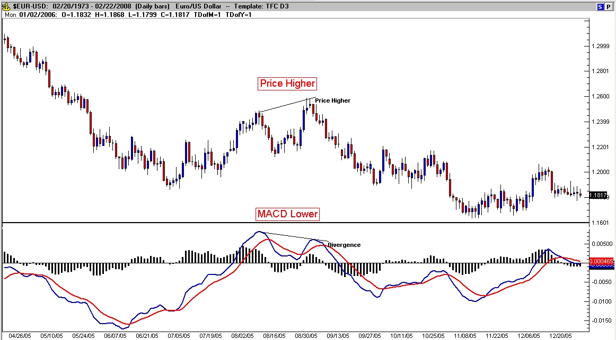

- Overbought/Oversold - When MACD rises dramatically (shorter moving average pulling away from longer term moving average) it is a signal the currency is overbought (or over-sold) and will soon return to normal levels.

Fig. 23.6
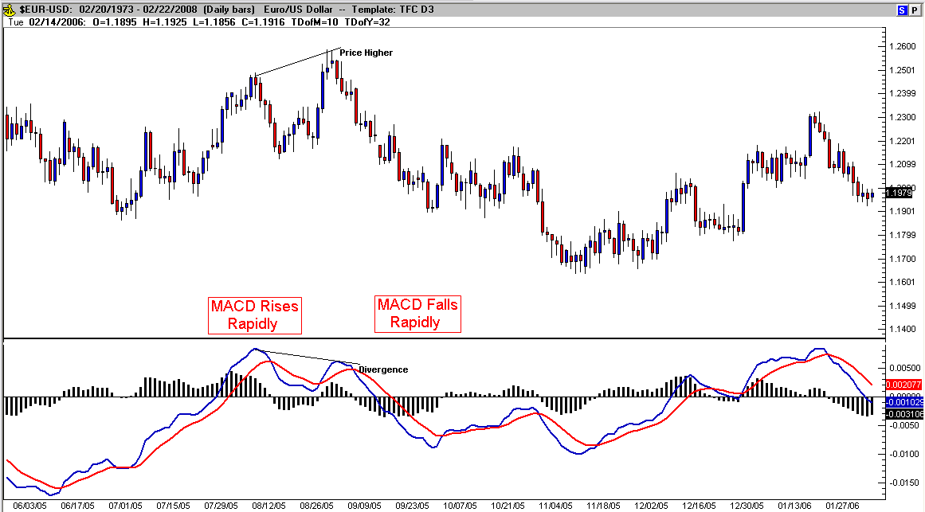

Other less common moving averages include weighted or double weighted moving averages as well as adaptive moving averages. All of them being slight deviations from the ones above and are used to detect different characteristics such as volatility and weighting different time spans.
The moving average is one of the most popular and easy to use tools available for technical analysis. By using an average of prices, moving averages smooth a data series and make it easier to spot trends. This can be especially helpful in volatile markets, it smoothes out any noise and gives you a strong trend for the currency price.
There are several different moving average varieties and timespans. They are subjective depending on who you talk to. Many technicians prefer the 50 or 100 period average, but short term traders prefer the 20 period average. I hope this has helped shed some light on the wide range of uses for moving average and that it will help you pick better performing currencies.
Technicians over the years have found two problems with the simple moving average. The first problem lies in the time frame of the moving average (MA). Most technical analysts believe that MA crossovers (the opening or closing currency price) are not enough to create reliable buy or sell signals. To solve this problem, analysts now assign more weight to the most recent price data by using the exponentially smoothed moving average.
For example, using a 10-period MA, an analyst would take the closing price of the 10th period and multiply this number by ten, the ninth period by nine, the eighth period by eight, and so on to first period. Once the total has been determined, the analyst would then divide the number by the addition of the multipliers. If you add the multipliers of the 10-period MA example the number is 55. This indicator is known as the linearly weighted moving average.
Most technicians are firm believers in using the exponentially smoothed moving average (EMA) to reduce the lag. Unfortunately, this indicator has been explained in so many different ways that it often confuses traders and investors alike.

Fig. 23.7
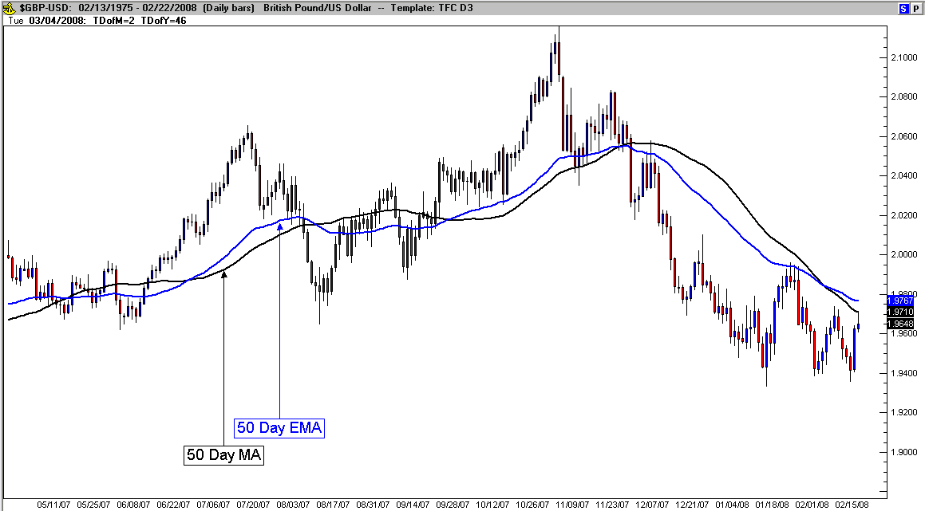

The exponentially smoothed moving average addresses both of the problems associated with the simple moving average. First, the exponentially smoothed average assigns a greater weight to the more recent data. Therefore, it is a weighted moving average. But while it assigns lesser importance to past price data, it does include in its calculation all the data in the life of the currency. In addition, the user is able to adjust the weight to give greater or lesser weight to the most recent period’s price, which is added to a percentage of the previous period’s value. The sum of both percentage values adds up to 100.
Fig. 23.8 is a comparison chart of both WMAs’s and DWMA’s (Double Weighted Moving Average) compared to simple and exponential moving averages:

Fig. 23.8
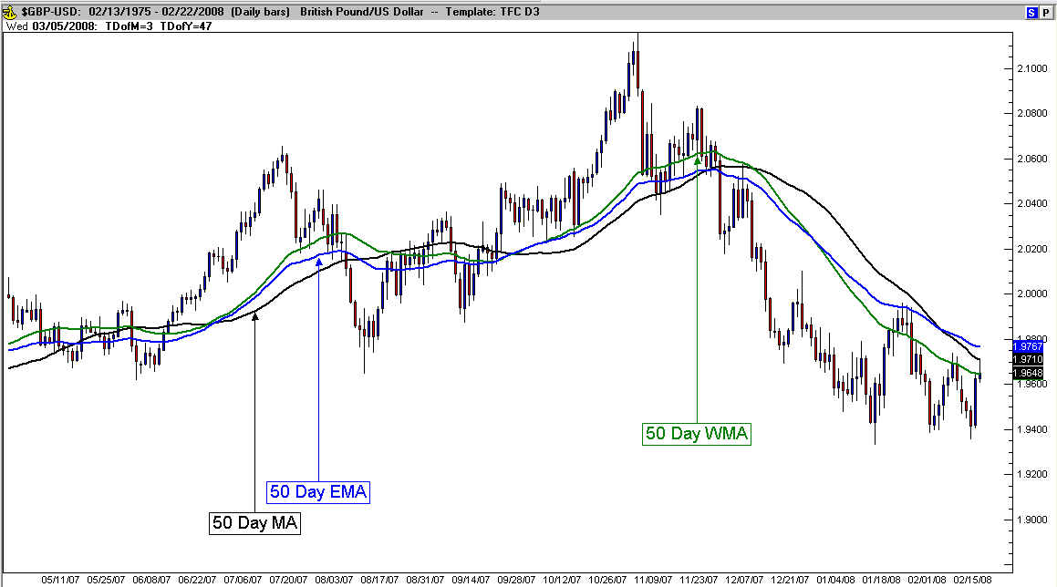

And…

Fig. 23.9
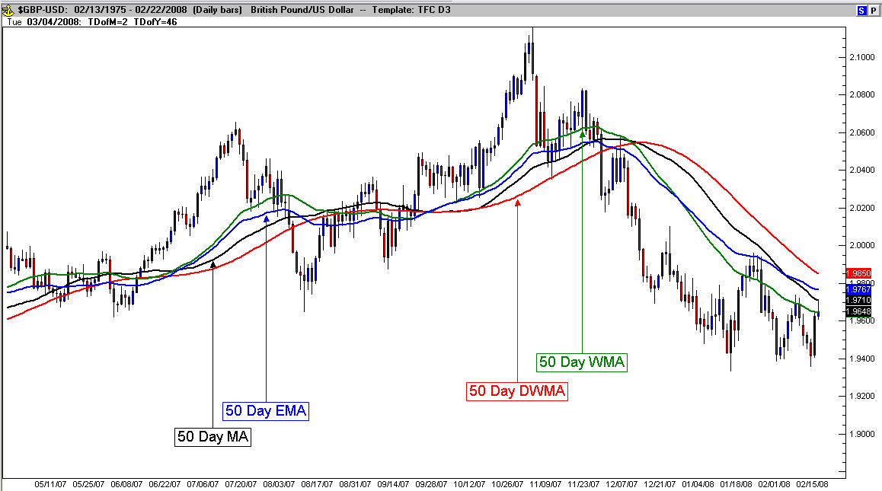

Custom moving averages have been created by developers seeking to minimize the lagging nature of standard moving averages. Perry Kaufman (mathematician and developer) created the “Adaptive Moving Average” where the formula smoothes out consolidation (by flat-lining) and then during faster moving price changes, the moving average quickly adapts to the change and plots a faster average (adapting so to speak with the different characteristics of price changes).
Fortunately Trade Navigator also has this indicator as a stock component and Figure 23.10 is an example of different time frames of the adaptive moving average (AMA or sometimes called the KAMA for Kaufman moving average). Compare the previous chart of the British Pound and the different averages plotted over price to Fig. 23.10 with the Adaptive Moving Averages to see how the AMA rapidly adapts to trending price and then levels off in periods of consolidation.

Fig. 23.10:
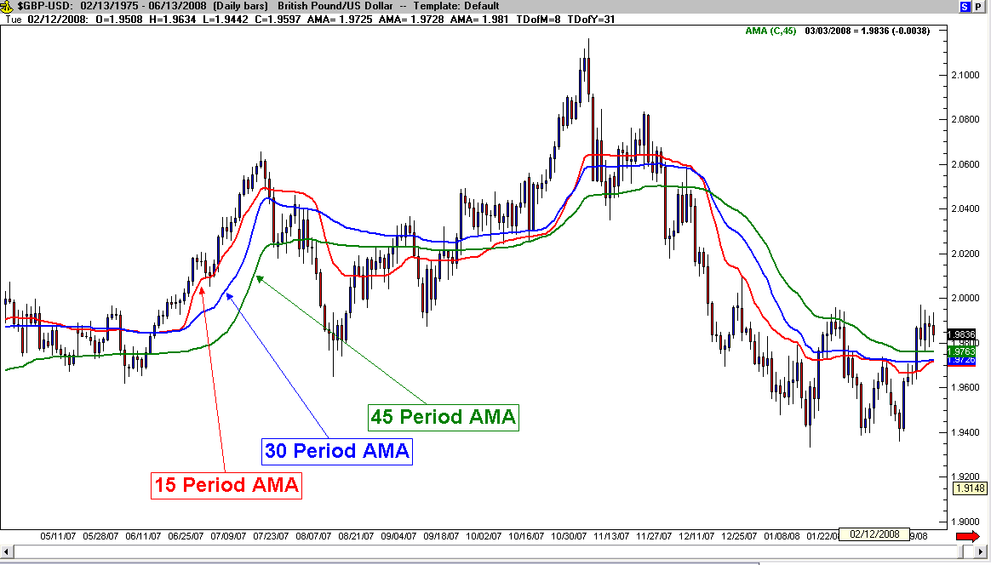

Bollinger Bands

Bollinger Bands is a technical trading tool created by John Bollinger in the early 1980s. It combines a moving average envelope with the volatility of the currency (measured by standard deviations). It arose from the need for adaptive trading bands and the observation that volatility was dynamic, not static as was widely believed at the time.
The purpose of Bollinger Bands is to provide a relative definition of high and low. By definition, prices are high at the upper band and low at the lower band. This definition can aid in rigorous pattern recognition and is useful in comparing price action to the action of indicators to arrive at systematic trading decisions.

Construction of Bollinger Bands:

Bollinger Bands consist of a set of three curves drawn in relation to securities prices. The middle band is a measure of the intermediate-term trend, usually a simple moving average that serves as the base for the upper and lower bands. The interval between the upper and lower bands and the middle band is determined by volatility, typically the standard deviation of the same data that were used for the average. The default parameters, 20 periods and two standard deviations, may be adjusted to suit your purposes:

- Middle Bollinger Band = 20-period simple moving average
- Upper Bollinger Band = Middle Bollinger Band + 2 * 20-period standard deviation
- Lower Bollinger Band = Middle Bollinger Band - 2 * 20-period standard deviation

Fig. 23.11
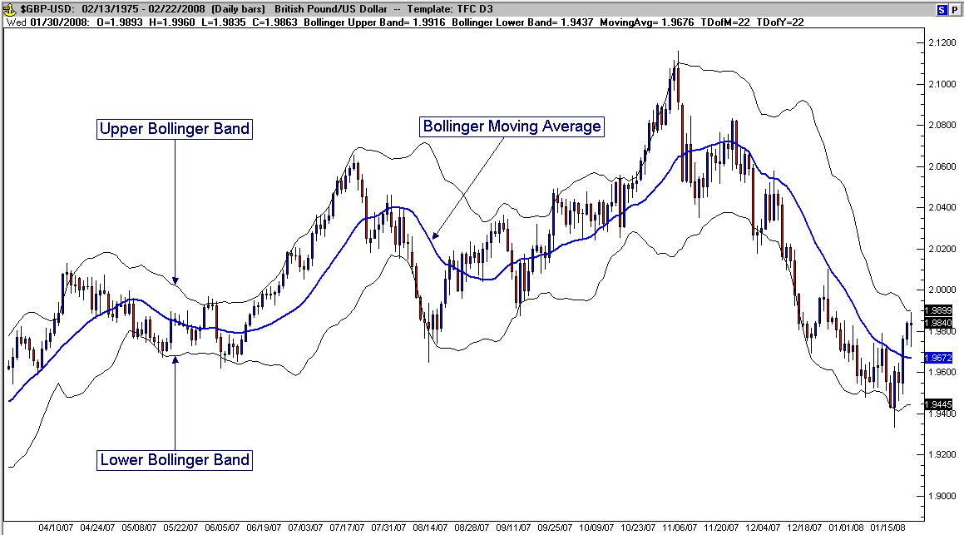

Two important tools are derived from the Bollinger Bands: BandWidth, a relative measure of the width of the bands, and %b, a measure of where the last price is in relation to the bands.

BandWidth = (Upper Bollinger Band - Lower Bollinger Band) / Middle Bollinger Band

%b = (Last - Lower Bollinger Band) / (Upper Bollinger Band - Lower Bollinger Band)

BandWidth is most often used to quantify “The Squeeze”, a volatility-based trading opportunity. %b is used to clarify trading patterns and as an input for trading systems.

For currency trading, when the bands are contracting (coming together) they are signaling a period of consolidation. This period will likely be followed by a breakout (a build up of pressure by either buyers or sellers) of one group over the other. The pattern displayed by the bands shows a rapid expansion between the bands (see the previous chart).
An additional signal is a succession of two tops, with the first one being above the upper band, followed by one inside. This signals taking a short position (aggressive). Conversely, a succession of two bottoms, with the first one below the lower band and the second inside, signals taking a long position (aggressive).
Another application of the Bollinger Bands is to add a second set of bands at 1 Standard Deviation. This delineates a potential zone of price contraction prior to continuation or eventual breakdown of a rally. We’ll explore uses of this set-up in later modules.
Bollinger Bands are often used in consolidating markets to define limits of price movement (from one band to the other), but John Bollinger also used them to indicate when price may be trend ready (trading outside the bands). Both methods have their merits and should be used with confirming candle patterns and momentum oscillators to determine limits. Caution should be taken to not enter a new trend while price is outside the bands (this price is extended) and patience should be taken to let price unwind back in between the bands.

Fig. 23.12
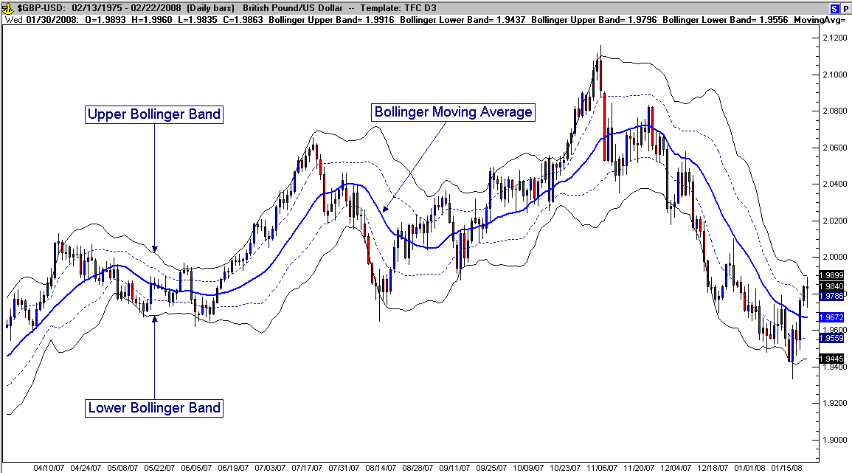

Standard Deviation Bands

Although variable standard deviation bands are not a part of most charting packages, I’m including them here because of the similarity to Bollinger Bands. The bands are one, two and three standard deviations above and below (in Fig. 23.14), the 200 period simple moving average.
Built above and below a long term moving average, Standard Deviation Bands take the benefits of labeling pricing extremes away from average prices (the further away from average – the more likely to return to average). Fig. 23.13 is a graphic example that shows most of the data should fall one standard deviation above or below the mean, then significantly less data between two above or below and finally very little data above or below three standard deviations:

Fig. 23.13
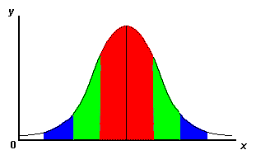
The red portion means price is between the “mean” and one standard deviation. Green shows the data was between one and two standard deviation and blue between two and three. The further price gets from the mean, the more likely it is to return to the mean (based on a moving average means the “mean” moves). This is why the chart shows rising and falling bands.

Somewhat of my own device, these versions of this indicator variation have been helpful with confirming exit or even entry decisions and I want traders to be aware of the benefits of measuring price extremes. Fig. 23.14 is an example of Standard Deviation Bands built from a 200 period moving average in the Dow Jones Industrial Average:

Fig. 23.14
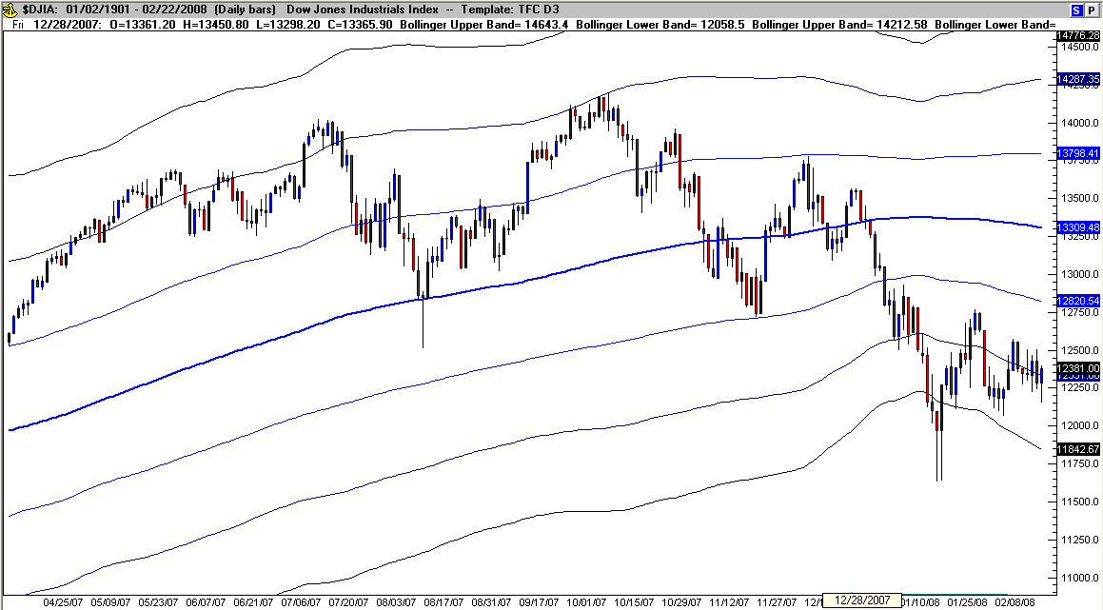

Fig. 23.15 is an example in the Forex market of the British Pound:

Fig. 23.15
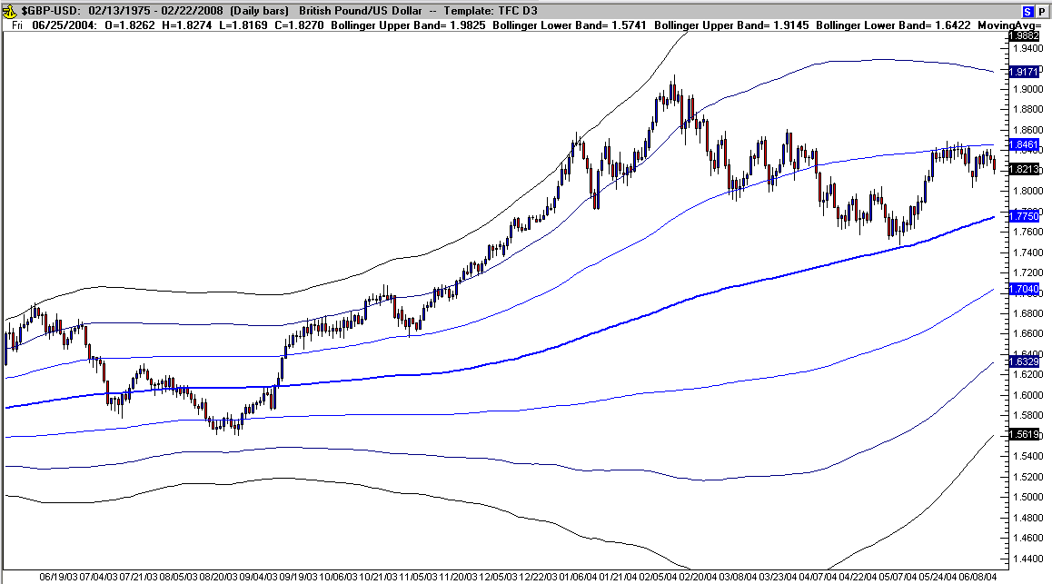

I’m also keeping an eye on the 100 period simple moving average. Fig. 23.16 is the same chart and similar time frame:

Fig. 23.16
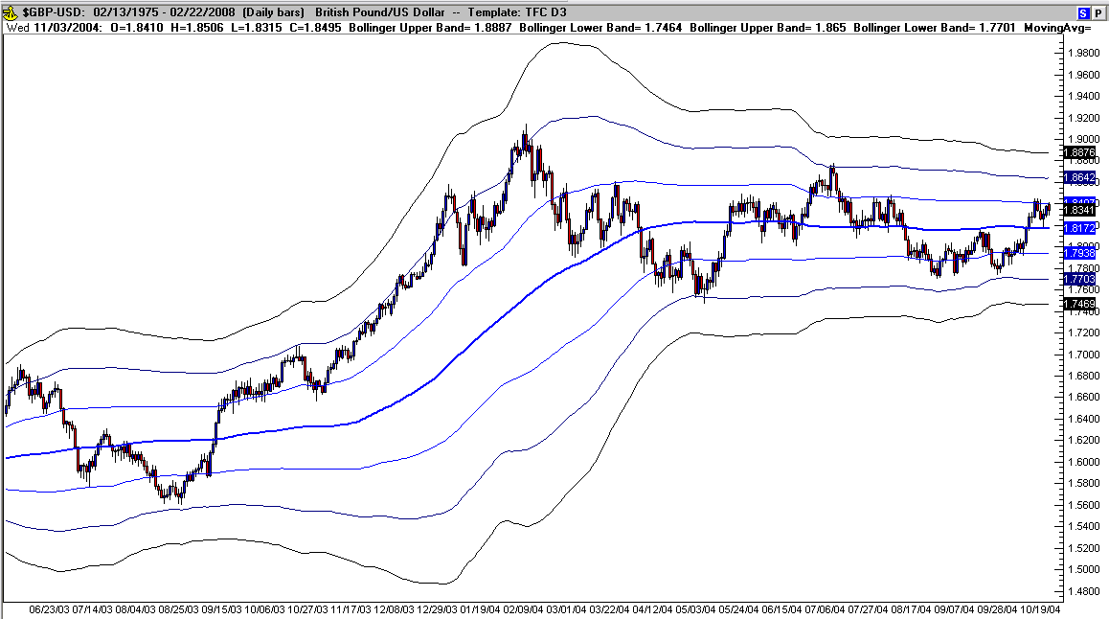

Each time frame tells a similar story – watch out for price extremes at deviation levels. Sometimes trend following, sometimes trend reversing, along with other added confirmation signal (mentioned within this book), the deviation bands are a useful tool to keep an eye on every day (I save specific charts to refer to while analyzing the big picture). Note: again, fortunately, Trade Navigator makes this task easy, but you can fool Bollinger Bands into behaving like the deviation bands by increasing the moving average from 20 to 100 or 200 and adding more bands at one and three standard deviations (2 is usually default for Bollinger Bands).

Relative Strength Index

RSI is an oscillating indicator (created by Welles Wilder) that compares the periods of time that a currency finishes higher against when it finishes lower.
The Relative Strength Index compares upward movements in closing price to downward movements over a selected period.
The Relative Strength Index is smoother than the Momentum or Rate of Change oscillators and is not as susceptible to distortion from unusually high or low prices at the start of the window (detailed in Momentum Construction). It is also formulated to fluctuate between 0 and 100, enabling fixed Overbought and Oversold levels.

Construction
The steps in calculation of the Relative Strength Index are:

- Decide on the RSI Period, based on the time frame that you wish to analyze.
- Compare Closing price [this period] to Closing price [previous period].
- For the RSI Period, add all upward movements in Closing price.
- For the RSI Period, add all downward movements in Closing price.
- Calculate the exponential moving average of price movements:
- Average Upward Price Move = Exponential Moving Average of Upward Movements
- Average Downward Price Move = Exponential Moving Average of Downward Movements
- Calculate Relative Strength (RS):
- RS = Average Upward Price Move / Average Downward Price Move
- Calculate the Relative Strength Index (RSI):
- RSI = 100 - 100 / ( 1 + RS )

Fig. 23.17
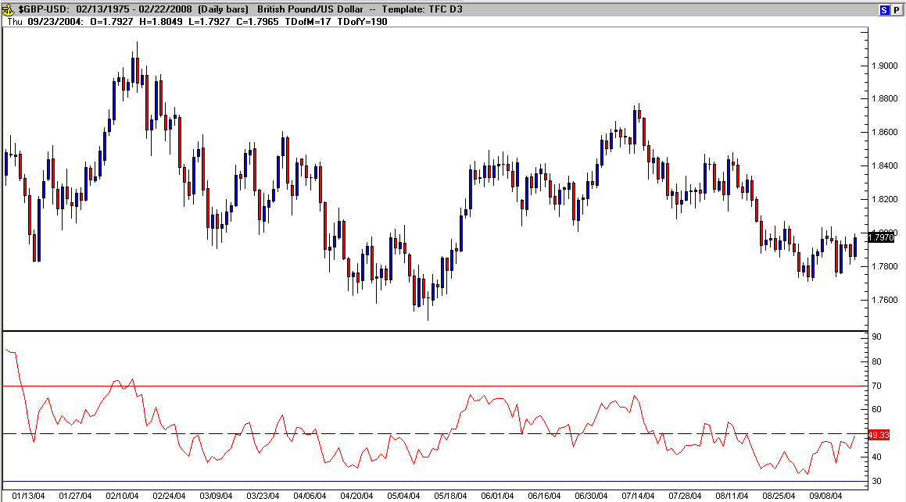

With most markets, an RSI below 50 indicates a bias toward a short position. An RSI above 50 indicates a bias toward a long position, the 30% and 70% levels are warning signals that prices are becoming over-sold or over-bought. With high probability, 10% and 90% indicate extreme over-sold and over-bought conditions and could warrant taking an aggressive position (due to pending reversal). Be wary of false signals however, because the RSI signal can remain very low (or high) for periods of time and falsely signal an entry point.
Double tops or bottoms often form in the indicator and when they touch or breakthrough the 30% - 70% levels on the first peak, wait for the break past of the level of the first through to signal a potential entry point.

Fig. 23.18
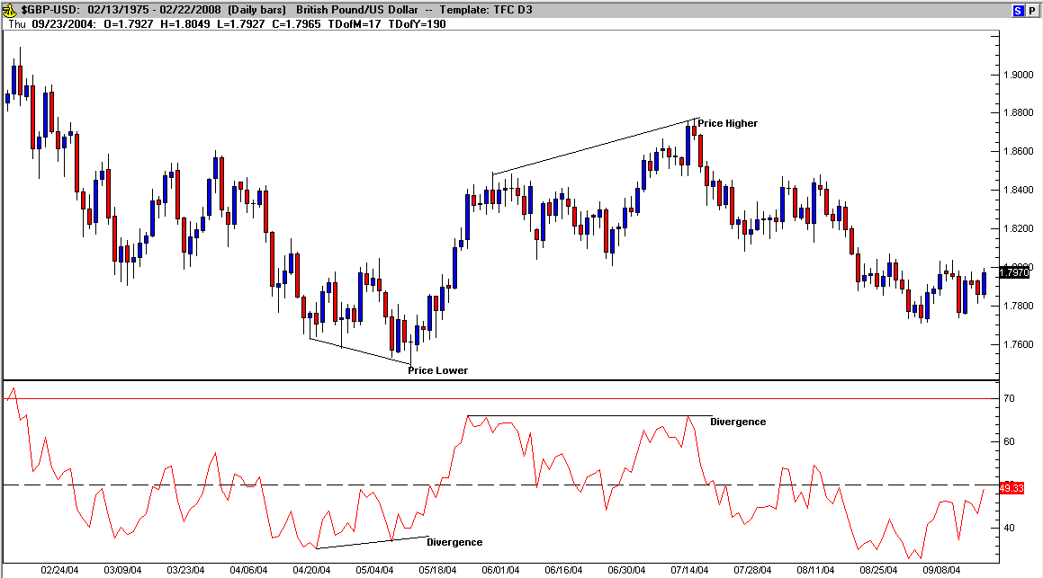

In meeting and talking with other traders, Lee Gettess (a highly sought after and often copied developer) devised a variation of RSI by including a moving average of RSI to the longer measure trend (compared to the default RSI). I’ve used a 34 period Exponential Moving Average of the 14 period RSI plotted together in the same pane and an example is below (RSI above the EMA – long, especially above 50 and RSI below the EMA – short, especially below 50) as seen in Fig. 23.19. Jurik Research offer another variation called RSX (a smoothed and responsive version) that I have emulated with an 8 period EMA of RSI. The tops and bottoms of this RSI EMA more accutrately turn with price swings making an excellent confirmating indicator (remember though, no indicator is perfect and false breakouts may still occur from time to time). Another look at the 34 period EMA of RSI in Fig. 23.19 shows that it also smooths out RSI although there is more lag.

Fig. 23.19
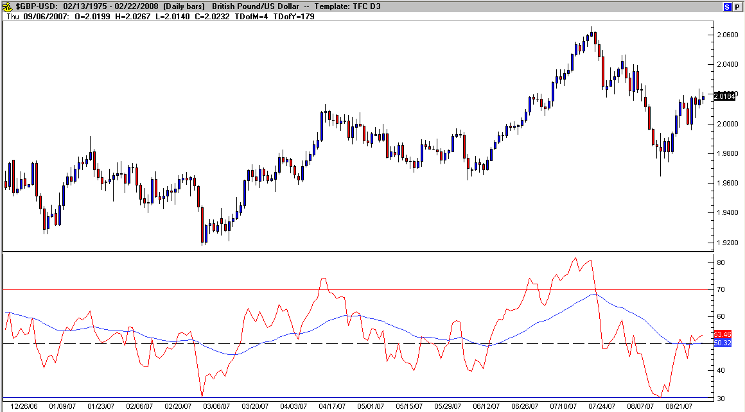

I’ve also seen variations of this set-up that included applying Bollinger Bands to the moving average in an attempt to identify imminent break-outs (similar to the Bollinger Bands over price. This uses the same settings (2 standard deviations above and below, but instead of price use the RSI EMA):

Fig. 23.20
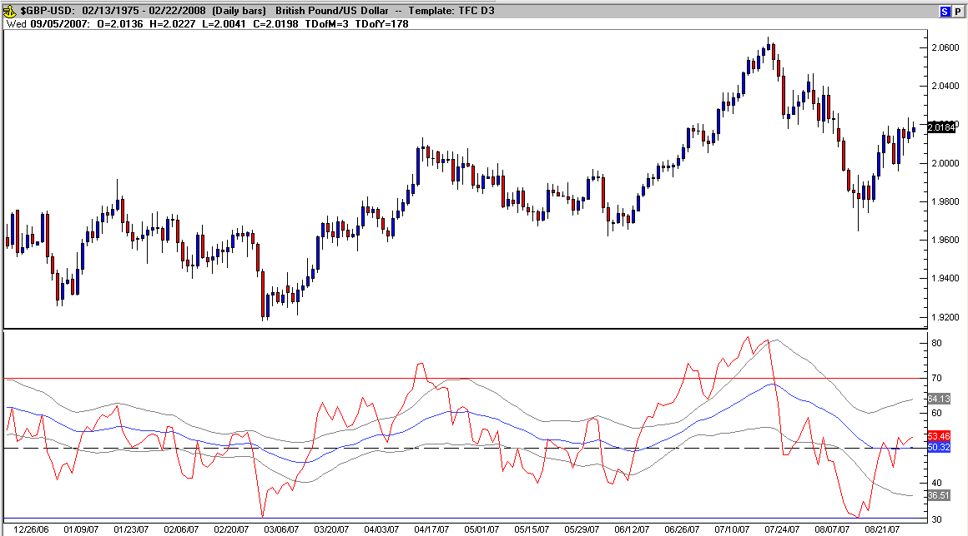

The narrowing bands signify that consolidation is over-extended but doesn’t really help pin-point the direction of the breakout. The benefits of using such indicators are that they will often help us stay in a trade longer once the cross-over is confirmed. The challenge always is anticipating the cross before it’s confirmed for best entry pricing (this is also a riskier position to take because price has yet to follow through – a necessary risk in trading).

Stochastic
The Stochastic is a technical indicator that is based on the premise that the closing prices of a time period tend to cluster near the bottoms of consecutive bar prices when the trend is reversing from long to short. Alternately, they will cluster near the top of consecutive price bars when the trend is reversing from short to long. These readings show as an over-bought or over-sold condition in the indicator (usually 80 and 20).

Construction
To calculate the Stochastic Oscillator:

The first step is to decide on the number of periods (%K Periods) to be included in the calculation. The norm is 14, but this should be based on the time frame that you are analyzing.

Then calculate %K, by comparing the latest Closing price to the range traded over the selected period:
CL = Close [this period] - Lowest Low [in %K Periods]
HL =Highest High [in %K Periods] - Lowest Low [in %K Periods]
%K = CL / HL *100
Calculate %D by smoothing %K. The original formula used a 3 period simple moving average, but this can be varied, based on the time frame that you are analyzing.
The default settings in most charts services for stochastic is 14, 3, 3 and fortunately chart services usually automate this function for us.

Slow Stochastic Oscillator
Construction
Some traders find the Stochastic Oscillator too volatile and prefer to use the Slow Stochastic settings:
The %K [Slow] is equal to the %D [Fast] (from the formula above).
The %D [Slow] is calculated by smoothing %K [Slow]. This is normally done using a further 3 period simple moving average. The setting I prefer with slow stochastic are 5 , 3 , 1 (a single line), more in a bit…

Ranging Markets
- Signals are listed in order of their importance:
- Go long on bullish divergence (on %D) where the first trough is below the oversold level.
- Go long when %K or %D falls below the oversold level and rises back above it.
- Go long when %K crosses to above %D.
- Short signals:
- Go short on bearish divergence (on %D) where the first peak is above the overbought level.
- Go short when %K or %D rises above the overbought level then falls back below it.
- Go short when %K crosses to below %D.
- Place stop-losses below the most recent minor Low (or above the most recent minor High) when going long (or short).

Trending Markets
- Only take signals in the direction of the trend and never go long when Stochastic is overbought, nor short when oversold. Generally, stochastic are over-bought above 95% and over-sold below 5% (very over-extended).
- The shape of a stochastic bottom gives some indication of the ensuing rally. A narrow bottom that is not very deep indicates that bears are weak and that the following rally should be strong. A broad, deep bottom signals that bears are strong and that the rally should be weak.
- The same applies to stochastic tops. Narrow tops indicate that the bulls are weak and that the correction is likely to be severe. High, wide tops indicate that bulls are strong and the correction is likely to be weak.
- There are also left–hand and right–hand crossings to look for. The left–hand crossing occurs when the %K line crosses over the %D line and the %D line has not yet rolled over (reversed). In the right–hand crossing, the %D line has already reversed (the curve remains inside the %K curve). Wait until the hinge (curve out of the straight line) occurs to look for an entry point.

- Long:
- If the Stochastic (%K or %D) falls below the oversold line, place a trailing buy stop. When you are stopped in, place a stop loss below the Low of the recent down-trend (the lowest Low since the signal day).

- Short:
- The Stochastic rises above the overbought line, place a trailing short stop. When you are stopped in, place a stop loss above the High of the recent up-trend (the highest High since the signal day).
- To simplify, for currency trading when the %K line falls above the %D line, it’s confirming a buy signal and when the %D line is above the %K line it confirms a sell signal (when confirmed by multiple indicators). Since Stochastic is an oscillator, divergence still signifies a potential reversal.

Stochastic Modification:
The Stochastic as traditionally used can be confusing even for seasoned traders. To simplify, I have adjusted and optimized the default settings to give a fast visual representation of price direction and whether the market is more over-bought or over-sold at any one time.
Change the default settings to: The first %K = 5, the second %K = 3 and %D = 1. Note: To overlay the Stochastic over another indicator or price just left-click and drag the study title into the desired pane and release. If this result is skewed, you will have to adjust the scaling (check box in the edit study window) by checking “Overlay: settings not fixed to pane”. This will adjust the conflict between scaling features of the different indicators. If using fast and slow stochastic in the same study pane, then no adjustments to scale will be necessary. (This is used in Trade Navigator)
Personally, I have also used a setting of 13, 8, 1 (another single line) for a slow stochastic setting. While the fast stochastic follows price closely, the slow stochastic follows the trend.
The following chart represents the new stochastic settings:

Fig. 23.21
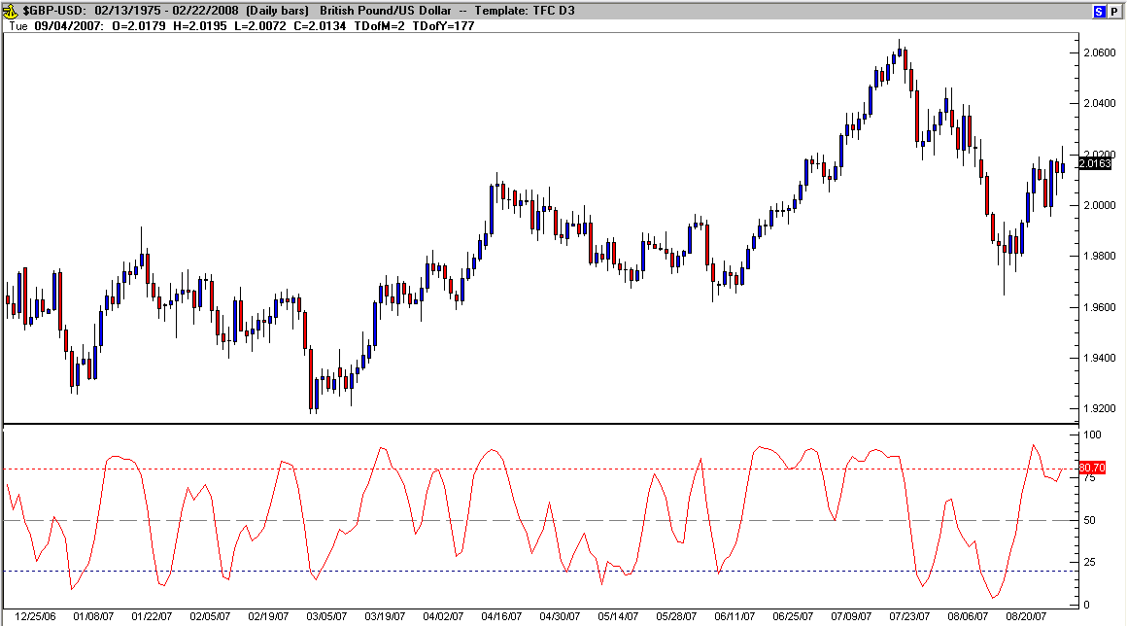

Fig. 23.22 displays the Fast and Slow Stochastic overlaid in a single pane:

Fig. 23.22
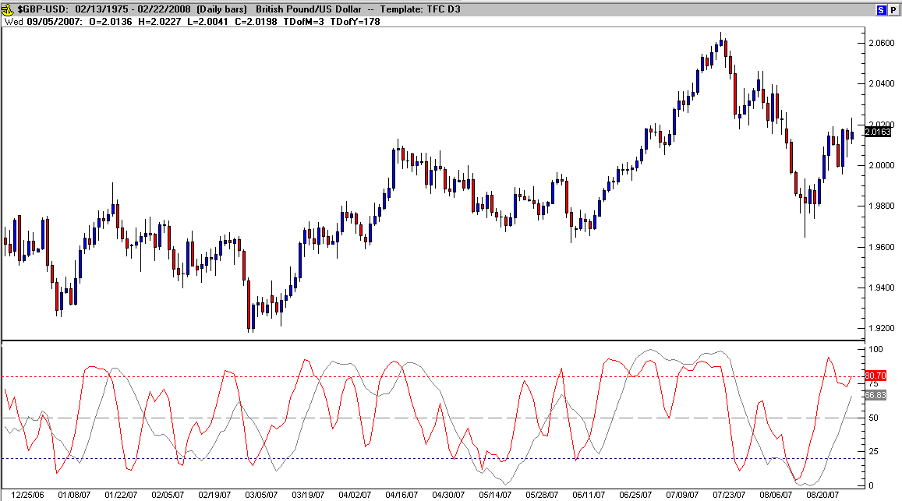

I’ve used the fast stochastic reading from a weekly chart to help pinpoint daily trend changes and the slow stochastic to aid in signaling over-bought/over-sold areas. The Stochastic is one tool that needs to be used with other indications. An example of how to interpret the signals follows in the “non-standardized indicators” section.

Stochastic of RSI (Relative Strength Index)

Robert Miner of Dynamic Traders uses a variation of the traditional Stochastic by applying the stochastic formula to Welles Wilder’s Relative Strength Index instead of the “Close” of price. The result is a smoother plot that more frequently toggles between overbought and oversold (in this case reset to 75 and 25 respectively) and exhibits fewer “false” crossovers of %K and %D.
The benefits of using two time frames of Stochastic of RSI (SRSI) to identify price action that more likely is over-bought or over-sold becomes evident in a side-by-side comparison of charts (an example of follows in the “non-standardized indicators” section).

Fig. 23.23
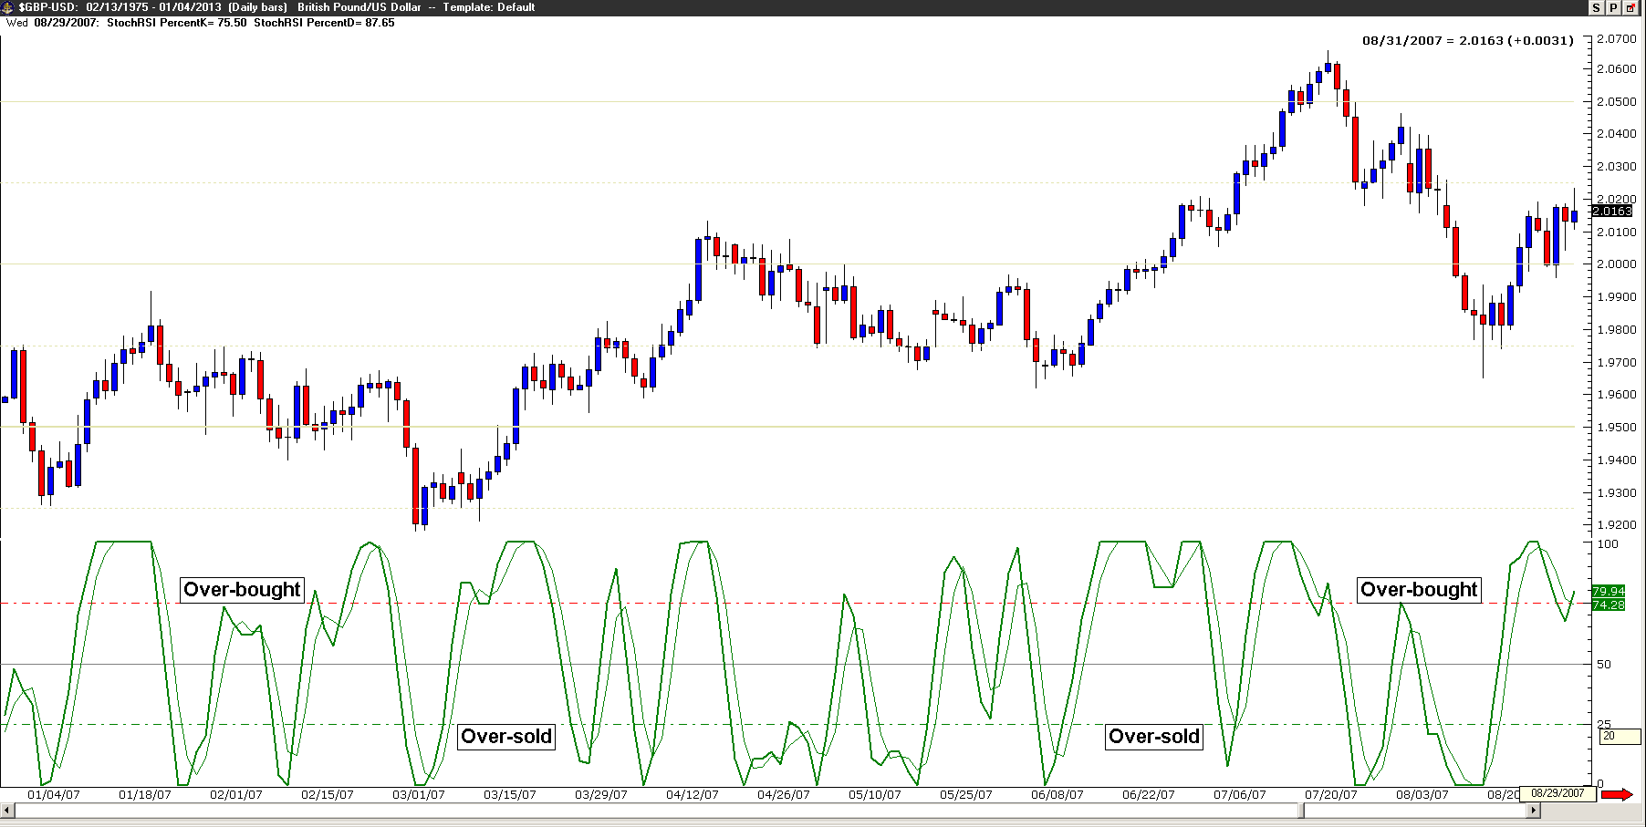

Rate of Change (Price)

ROC is a refinement of Momentum: readings fluctuate as percentages above and below the zero (neutral) line.

Construction:
Momentum is calculated as:
      - Closing Price [today] - Closing Price [n days ago]
Rate of Change is calculated as:
      - Momentum / Closing Price [n days ago] * 100
This causes the indicator to fluctuate as a percentage around the zero line

Trading Signals
ROC trading signals and Momentum signals are identical.

Ranging Markets:
First, you will need to set overbought and oversold levels based on your observation of past ranging markets. The levels should cut across at least two-thirds of the peaks and troughs.
- Go long when ROC crosses to below the oversold level and then rises back above it.
- Go long on bullish divergences - where the first trough is below the oversold level.
- Go short when ROC crosses to above the overbought level and then falls back below it.
- Go short on a bearish divergence - with the first peak above the overbought level.

Trending Markets
First, identify the trend direction using a trend indicator. ROC tends to stay above zero during an up-trend and below zero during a downtrend.

- Only take signals in the direction of the trend.
- In a downtrend, go long if ROC turns upwards when below zero.
- In an uptrend, go short if ROC turns downward when above zero.
- Use trailing buy and sell stops to time your entry and exit. Take profits on divergences and trend line breaks. Exit using a trend indicator.

Trend lines are sometimes drawn on ROC. A break in the trend line often occurs in advance of a similar break on the price chart.

Fig. 23.24
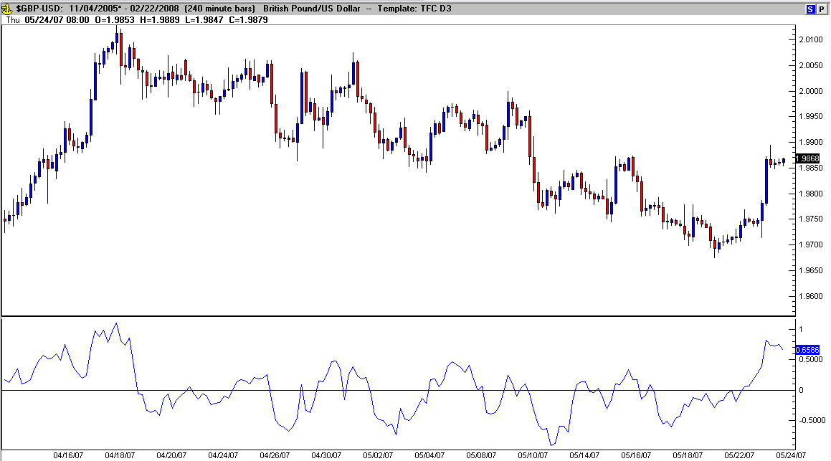

At this point, I’d like to share excerpts from a presentation I’ve given on trend lines and patterns in ROC. Using a 4 hour chart in the Forex market, I use these rules:

Long:
- By connecting the tops in a down trend from a significant high to each new high (back above the neutral line)
- As the momentum of a trend stops…
- …the breakouts up through the trend line trigger trading opportunities long

Short:
- …and by connecting the bottoms – from a significant low to each new low (back below the neutral line)
- As the momentum of a trend stops…
- …the breakouts back below the trend line trigger trading opportunities short

Fig. 23.26 is the first chart example:

Fig. 23.26
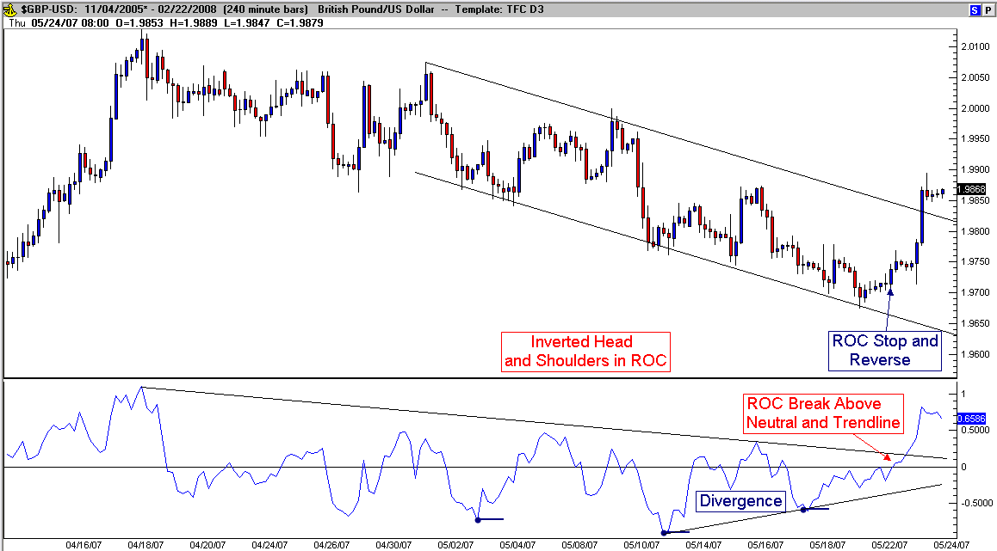

Notice that by connecting the highs (in ROC) and observing the inverted head and shoulders pattern, a trading opportunity becomes apparent (the trend line break in ROC happened before the trendline beak in price).

Fig. 23.27 is the second example chart:

Fig. 23.27
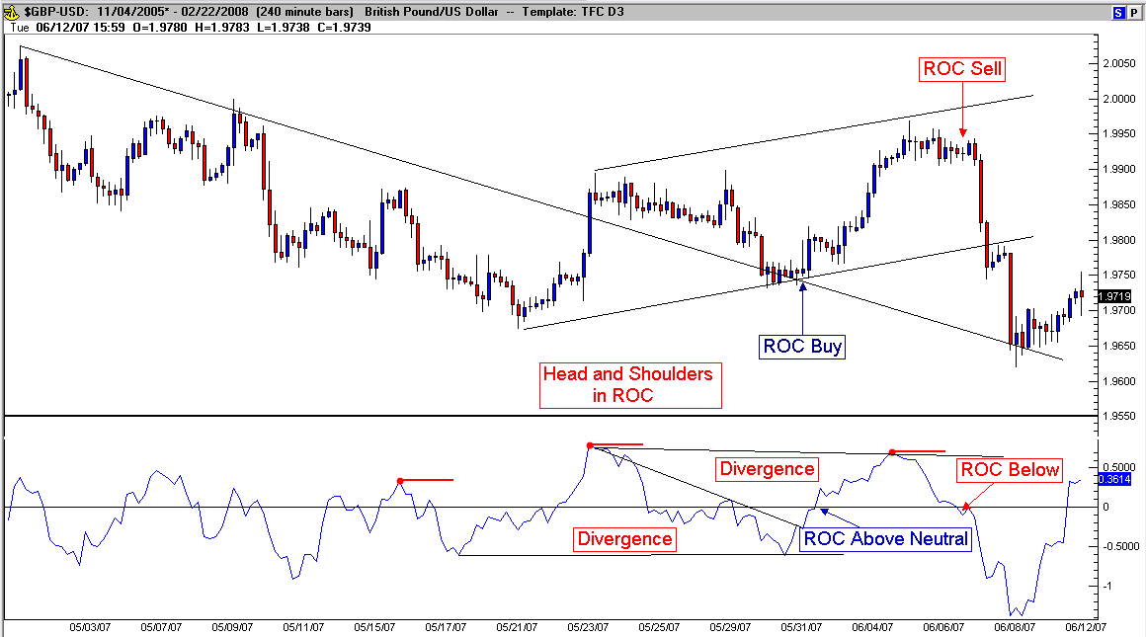

Notice that in Fig. 23.27, even though the previous break signaled higher pricing and then price failed to continue at previous resistance, after the retest of the price trendline and the subsequent return to previous resistance, this time ROC (the trendline and pattern) suggested that resistance will hold, not break-out and then price dropped.
By using the break in the ROC trendlines, earlier entries (and exits) can be taken than by waiting for conventional trend lines breaks. Watching for patterns in ROC (similar to price patterns) is also leading price movement and helps project near term price movement. Following the previous examples, there were four trading opportunities and moves of 130 pips in the first bounce higher, 100 pips in the fall from resistance back to the trend line, 120 pips back up to the higher high and finally a drop of 270 pips in the last sell off back to the old trend line for a total of 630 pips in less than three weeks.
Perhaps the biggest surprise with observing the trend lines in ROC is seeing price action at the intersection of two trend lines (look at Fig. 23.28 for an example with multiple trend lines to see this). I’ve used the phenomenon to project possible turning points in price. While this works frequently, you should be reminded at this point once again that nothing is perfect and all methods will experience their losses. This example is made on 4 hour charts but seems to have moderate success on every time frame I’ve tested (being a swing trader in the Forex, the longer time frames produce larger limits (and of course require larger stops).

Fig. 23.28
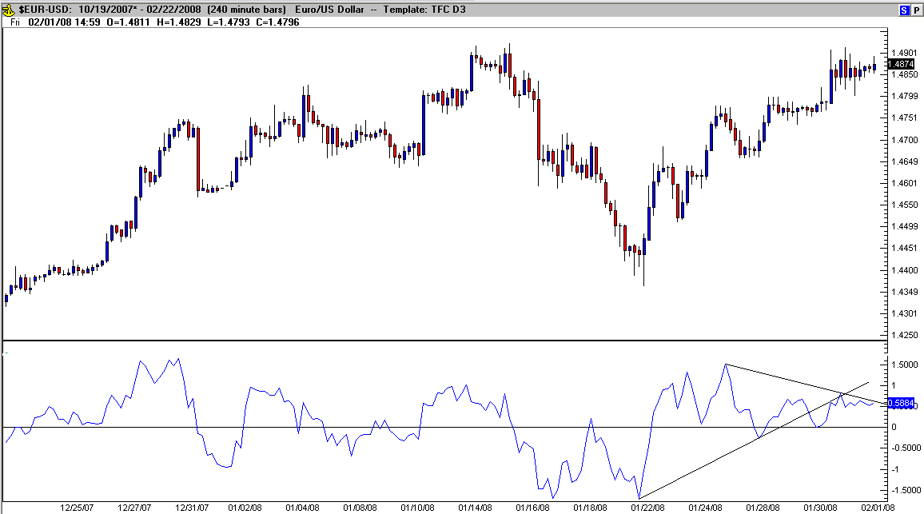

An outside bearish candle traded at the crossover of the two trend lines in ROC and after a few more hours of consolidation including divergence…

Fig. 23.29
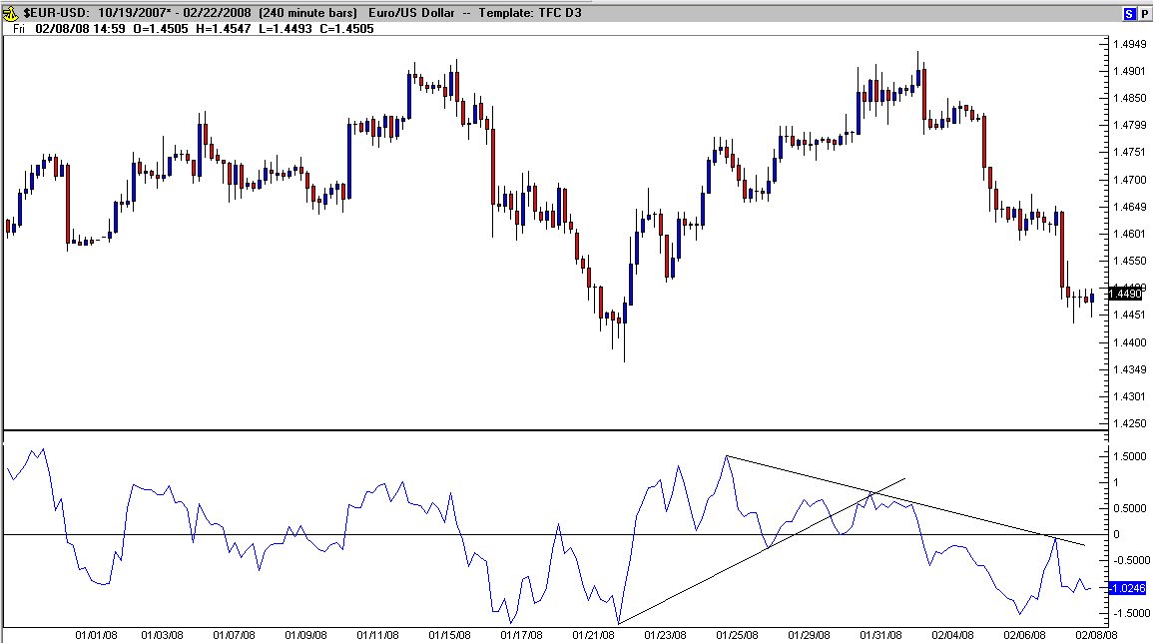

…a nice sell-off near resistance as ROC broke neutral that dropped over 250 pips.

Directional Movement Index

The Directional Movement Index provides a signal of trend presence in the market. The DMI (or Average Directional Movement Index, ADX, as it’s sometimes called) consists of three lines. The first, +DI measures positive movement (purple line in Fig. 23.30) or upside movement, the second line (blue), -DI measures downward, or negative movement and the ADX (red).

Fig. 23.30
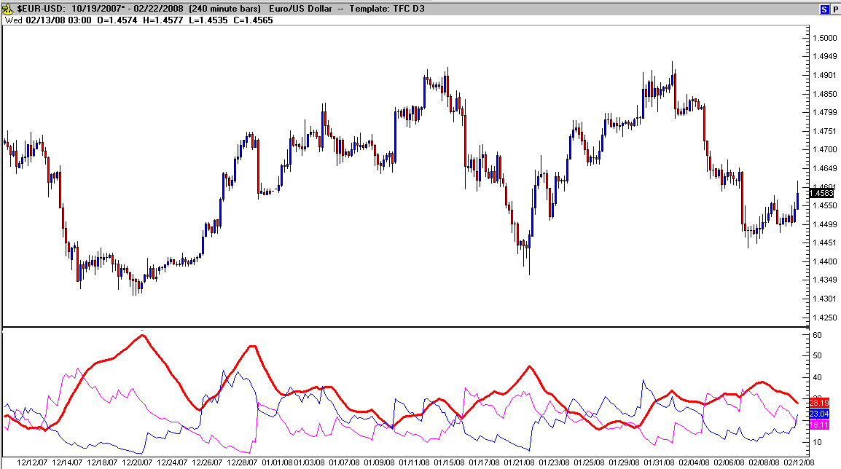

The buy signal occurs when the +DI line crosses over the –DI line, and the sell signal occurs when the +DI crosses below the –DI line. The strength of the trend is represented by the increase in the spread between the DI lines and when you add Welles Wilder’s ADX line to the equation, the results get really interesting.
The ADX line measures the directional change or movement of a currency on a scale of 0 - 100. If the currency you are following has a rising ADX, then the market in trending, and thus, the studies from Wilder are going to be more effective than when the ADX is declining. For all intents and purposes, the ADX line is merely a smoothed difference between the +DI and –DI lines.
When the ADX line begins to drop below the 40 level on the scale of 0 – 100, it is time think about selling your position if long in the currency, as this is a clear signal of the trend breaking down. Then as the trend comes to an end, the ADX line rising above the 25 levels is an indication that an uptrend is now in the early stages of development and a reading above 40 is a strong trend indicator. Readings below 20 are a strong warning to stay out. Also, the change of direction in the ADX when it floats above both of the DI lines, signals a trend reversal. Welles Wilder used a period of 14 days and a smoothing of 25.
Personally, I don’t use ADX, but it is very popular among consistent traders that have adapted their trading methods to incorporate the ADX into their entry and exit rules.

Williams %R

Percent Range (%R) was developed by well-known futures author and trader Larry Williams. This indicator measures overbought and oversold market conditions as a range between 0 and 100 (similar to Stochastic) by calculating the difference of recent highs and lows in relation to the close. Here is the Trade Navigator formula: 100 * (Close - Lowest (Low , Bars used in calculation)) / (Highest (High , Bars used in calculation) - Lowest (Low , Bars used in calculation)). The original formula was designed with an inverted scale (over-sold levels nearing 100 and over-bought levels nearing zero (100-0), Trade Navigator uses a relative (inverted) scale (0-100). There are several ways to interpret the reading of Williams %R levels of over-extension, I prefer to use 10 and 90 for over-sold/over-bought (some use 20-80) and I add a line at 50 because it indicates a level to watch for increased momentum in price direction or a possible stalling point. Fig. 23.31 shows the traditional settings for Williams %R (14):

Fig. 23.31
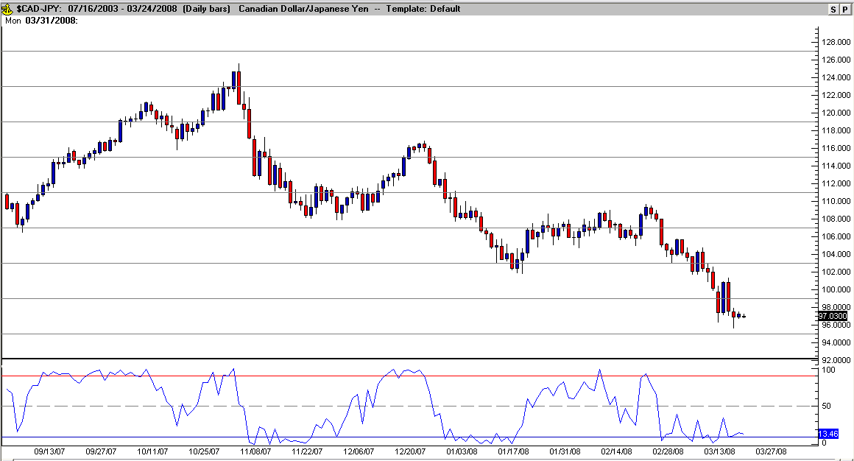

I’ve modified the traditional settings to smooth out the fast readings and have added both an exponential moving average of %R and standard deviation bands of the average to further define levels of increased momentum and break-out from consolidation. This is described in detail in the next part of the book.

Williams Accumulation/Distribution

Larry Williams popularized a variation of “accumulation/distribution” (A/D) based solely on price. A/D uses price and volume to calculate a value to track for bullish or bearish market swings. Retail currencies, for example have no centralized market, so there is no volume for tracking.
Larry altered the equation using true high and true low instead of volume, added a long term moving average to clearly mark when trends are bullish or bearish, and the intended use is a trend direction indicator.
Genesis Code: CumulativeSum (Iff (Close > Close.1 , Close - True Low , Iff (Close < Close.1 , Close - True High , 0))).
I have color coded the indicator to display clear bull markets in blue and bear markets in red. The secondary moving average is designed to indicate corrections within a trend and is based on a 20 period simple moving average of Williams Accumulation/Distribution.

Fig. 23.32
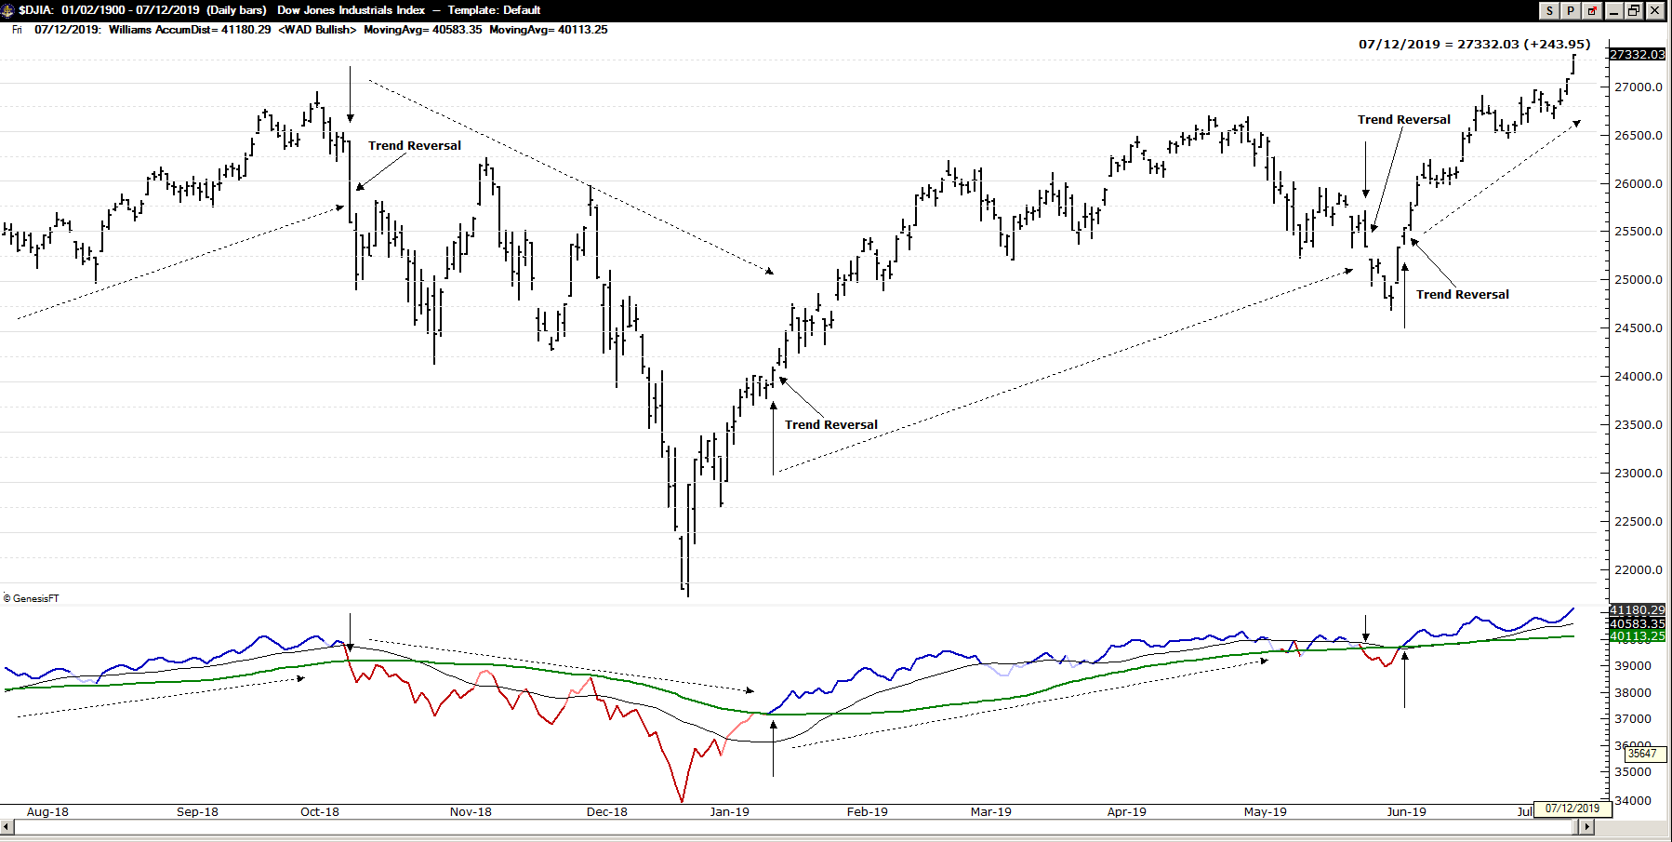

True Strength Index

Originally designed as a smoothed swing filter based solely on price (today’s close minus yesterday’s close). Similar looking to MACD, there is a leading signal line and a trailing moving average. Above 0 (zero) is generally bullish and below 0, bearish. The bullish swings are true during periods where TSI is greater than its average line and vice versa, bearish swings are when TSI is below its average.
I displayed the indicator below as a line (like MACD) and below that as a histogram. Changes in momentum are warning signs of a possible swing direction change for alternative profit targets, trailing stop placement and divergences can be used for alternate entries.

Fig. 23.33
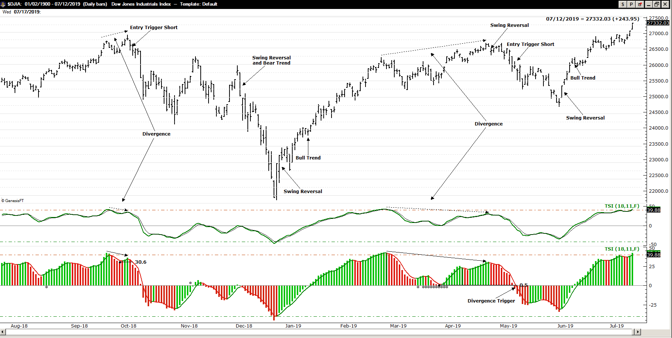

Momentum of TSI (non-standard)

Since the True Strength Index acts as a swing filter, tracking the momentum of a swing filter can indicate an early warning in changes to momentum readings sooner than waiting for a clear momentum reversal. There are of course benefits and problems with early warning signals; they may be spot on or a fake out. The preference is to use the warning to either set or tighten trailing stop values or scale out of existing positions or scale into new positions.

Fig. 23.34

Average Range Channels - ARC (non-standard)

Taking into consideration that initiating a bear trade near resistance in a down-trend (or at least a bearish swing) or a bull trade at or near support in an uptrend, then plotting the average highs and lows over time should help identify low risk setups near swing lows or highs. I have calculated the average range channels to account for typical expansions (based on the Fib theory that ranges often expand by 1.27 to 1.62) and based on the True Strength Index double smoothed average of price change, calculated the double smoothed expansion in the change of the highs and lows of price to create an average range channel (similar to Keltner Channels).

Fig. 23.35

Chaikin Money Flow and True Money Flow

Mark Chaikin created an indicator called Money Flow to identify institutional buying or selling behavior. It includes taking price action and volume into account for determining when there is a higher probability of follow-through in the current direction of the current trend due to strong price and volume (intimating institutional trading). Fig. 23.36
I have also taken Larry Williams cue to edit Money Flow for markets without centralized volume to create True Money Flow (based on true high and true low). Fig. 23.36
Each indicator has clear bullish or bearish conditions and both can also be out of sync with price action, so Money Flow is better suited to be used as additional information, not necessarily entry and exit signals.

Fig. 23.36
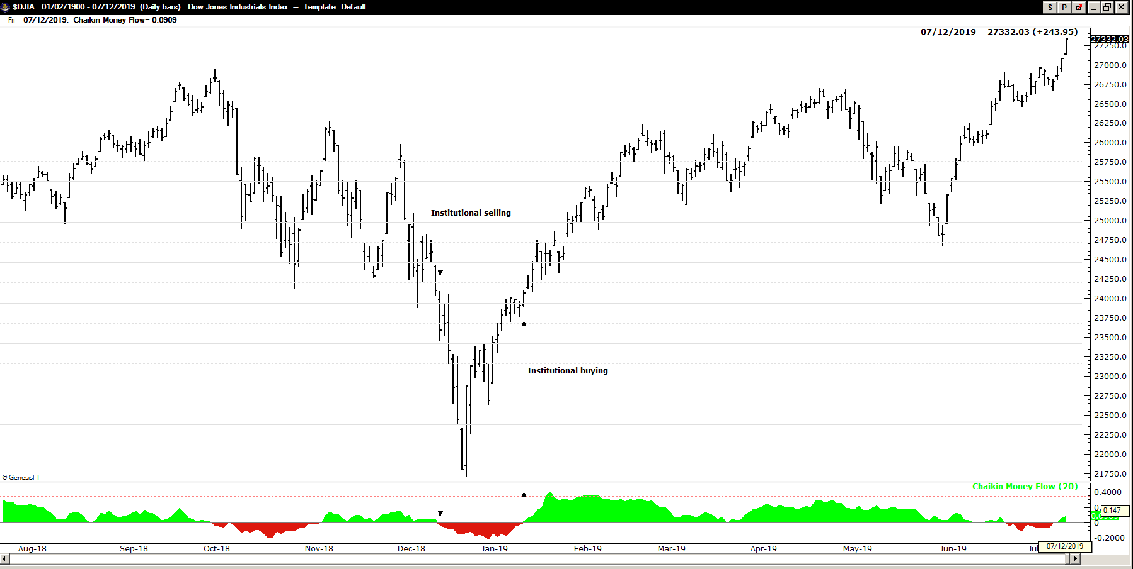

Fig. 23.37
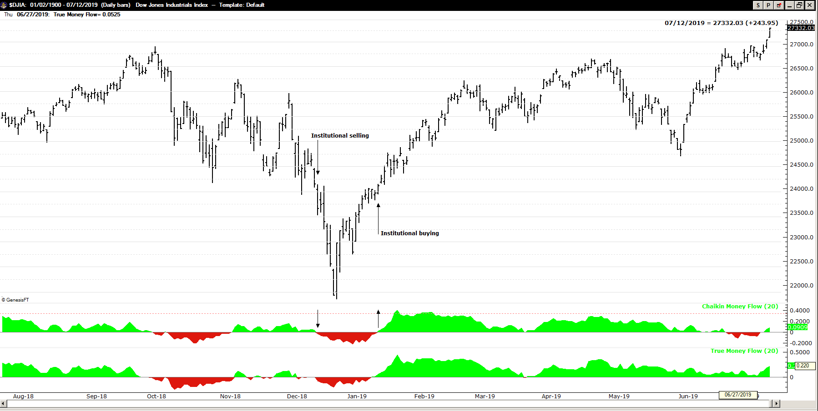

CHAPTER TWENTY FOUR - Non-Standardized Indicators

Proprietary Indicator Set-ups

Through my online training workshops I’ve created proprietary indicators and add them here for your use. They consist of a smoothed momentum oscillator I call D3, a fast and slow stochastic single line indicator (seen previously) and two moving averages, the FMA (Fib Weighted Moving Average) and the Tillson’s T3 (of the FMA). All of the calculations are included here.

The D3 Oscillator (Smoothed Momentum):

D3 was built to compensate for the jerky action in momentum (or Rate of Change) and to provide clear buy and sell signals. It’s an oscillator, ranging above and below a neutral or zero line. It calculated from two exponential moving averages, plotted as a single line and then weighted for the cross-over signals. Fig. 24.1 is an example:

Fig. 24.1
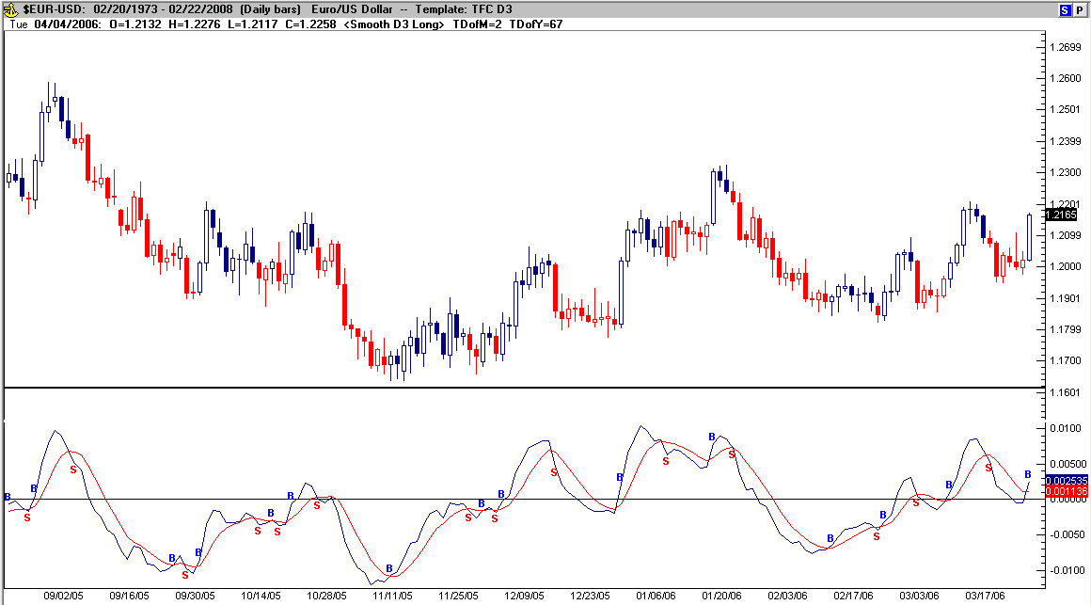

Fig. 24.2 is the visual comparison of the D3 Oscillator and Momentum:

Fig. 24.2
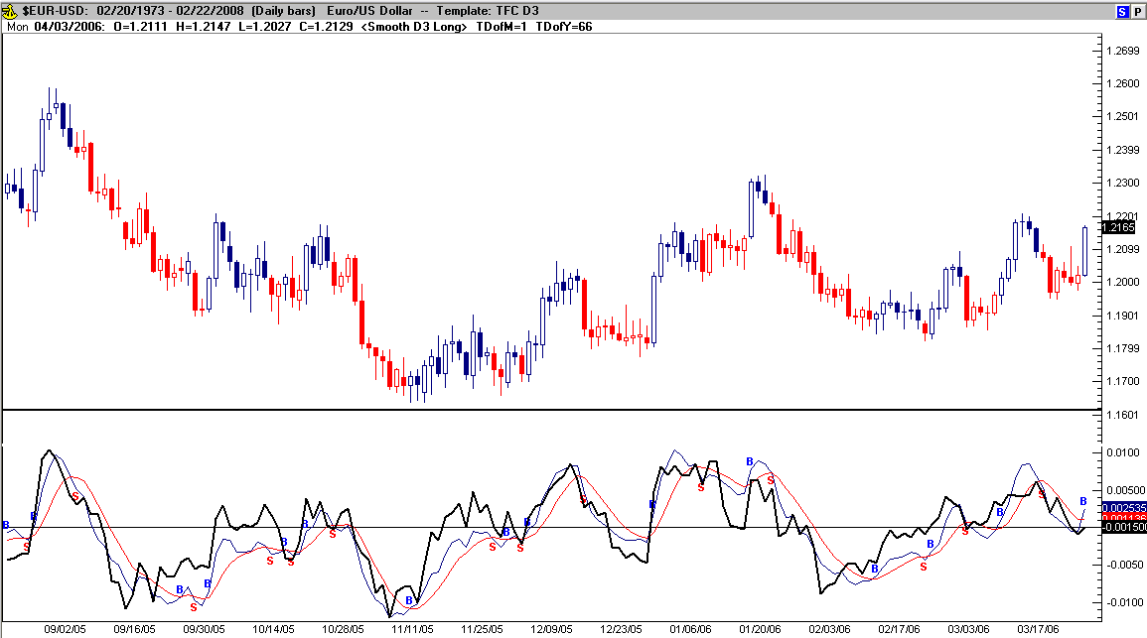

As you can see in Fig. 24.2, the D3 Oscillator emulates momentum (in black), but smoothes out the jerky action. D3 tends to confirm that price will move higher as the oscillator breaks above the neutral line and remains above it (above neutral and moving higher signals a stronger rally in prices is taking place). D3 also then tends to confirm that price will move lower as the oscillator breaks below the neutral line and remains below it (below neutral and moving lower signals a stronger rally in prices is taking place). D3 also accurately displays divergence from the price action (positive or negative divergence) and works the same in all time frames. See examples of positive divergence in the Fig. 24.3 below:

Fig. 24.3
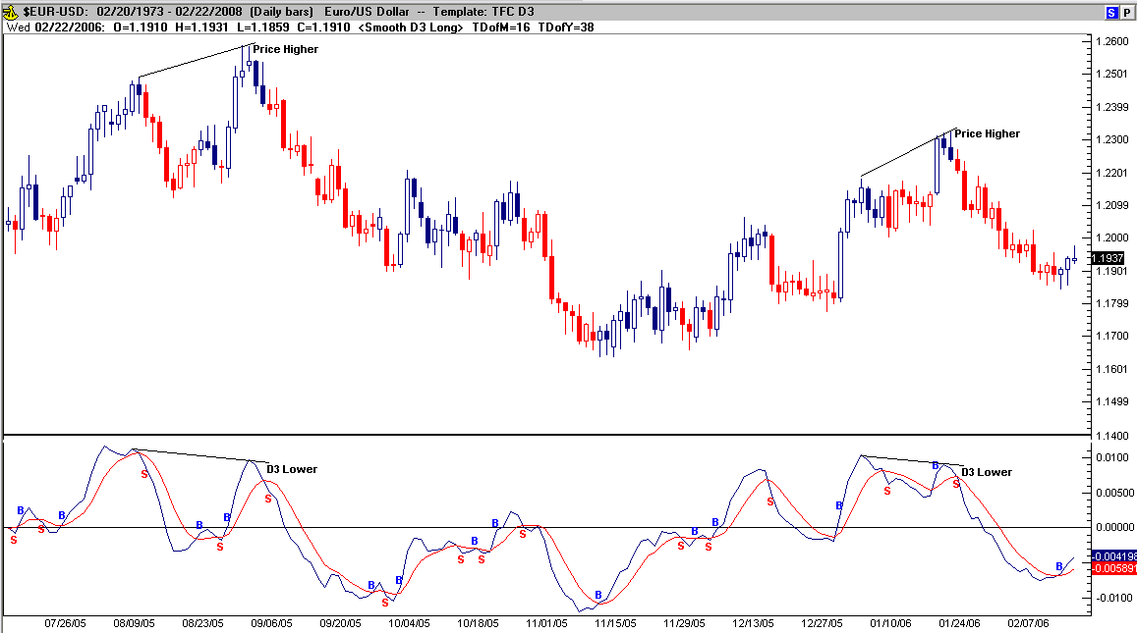

Fig. 24.4 is an example of negative divergence (where the lines get closer, not separate as with positive divergence):

Fig. 24.4
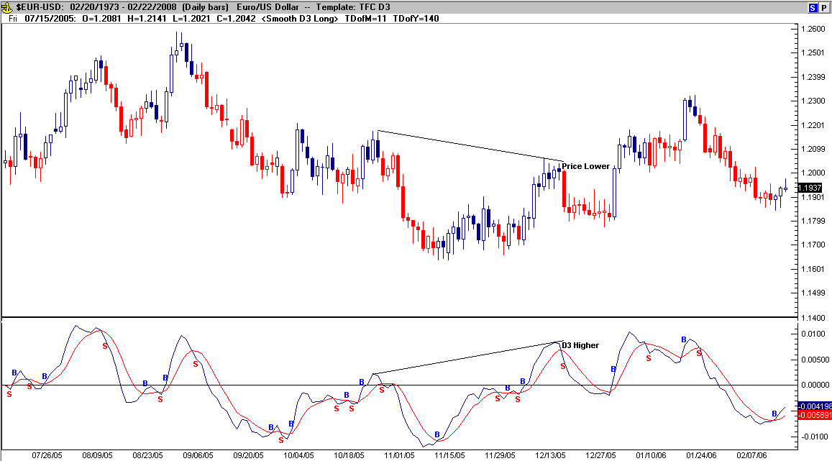

Delta (the blue signal line) is calculated as the difference in two moving averages plotted in a single line (a 5 period EMA and a 3 period EMA). I have been able to trick MACD into these setting by changing the default settings to 5 and 15, instead of 12, 26. The second line (the red line is a weighted average of Delta) and is calculated with the following formula: (((Delta) * 0.85394) + ((Delta).1 * 0.78612) + ((Delta).2 * 0.61904) + ((Delta).3 * 0.5000) + ((Delta).4 * 0.38235) + ((Delta).5 * 0.23636) + ((Delta).6 * 0.14606) + ((Delta).7 * 0.09027)) / 3.618.
The points at which the two lines cross give a signal to either buy or sell in conjunction with being above or below the neutral line and whether or not divergence appears (this was explained previously).
Recently, I’ve modified the D3 oscillator to give you a few bits of information:

Fig. 24.5
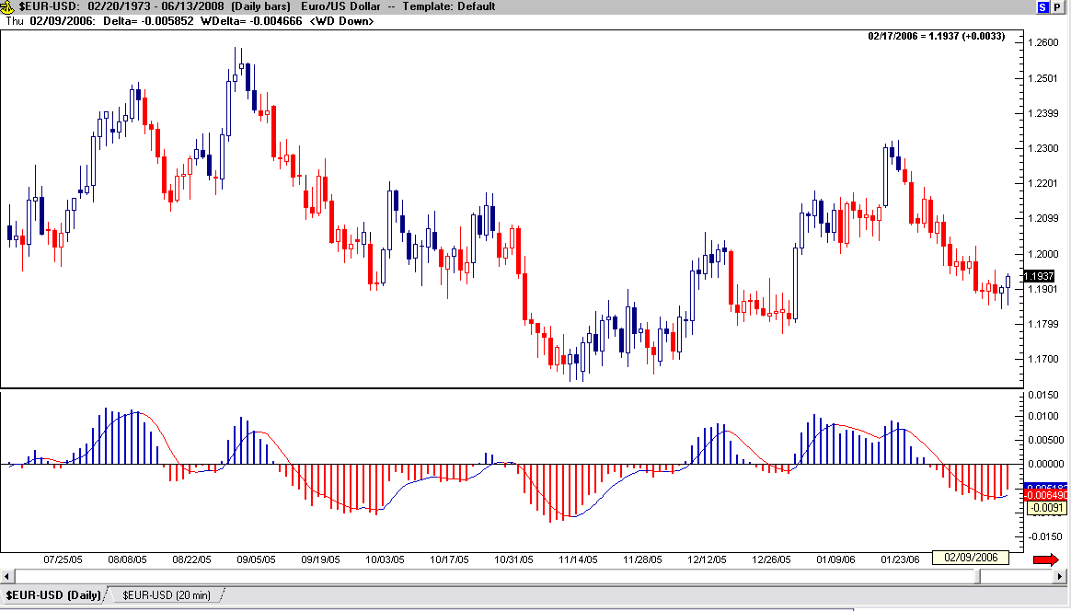

By adding a histogram representation of the signal line and colorizing the bars, I’ve labeled rally areas (either red or blue) and display the oscillator staying above or below its weighted average (line) and above or below neutral (trend continuation) more visually.
I’ve also tested other moving average combinations and have seen similar results with using 10 and 21 period EMA’s for the oscillator’s calculations (I call this version “Smooth Oscillator”). Even though the historical trading results are almost the same as the D3 Oscillator, the visual action is smoother than D3. Here are the formula and the chart comparing the two versions: MovingAvgX (Close , 10 , False) - MovingAvg (Close , 21) = Smoothed Delta, weight Smooth Delta with the same Fib application as in D3:

Fig. 24.6
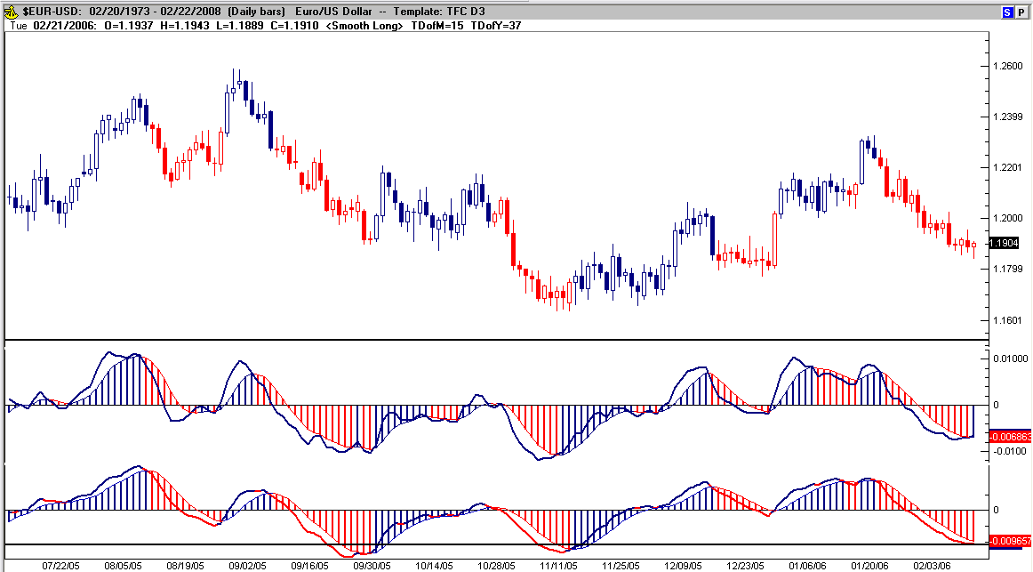

As you can see in Fig. 24.6, the Smooth Oscillator is just that, smoother than D3, but the signals are nearly the same. Note: I’ve back-tested these oscillators in the currencies over the last 5 years of Daily data and although the win to loss ratio was near 50-50, the profit to loss ratio was anywhere from 2 to 1 to 3 to 1, acceptable risk to reward. (In fig. 24.5 the histogram leads the signal and in fig. 24.6 the signal leads)

Fast Stochastic

Let’s add another component of our trading tools. The fast Stochastic is used to help visually represent the over-bought or oversold nature of price at any one time. Since this indicator is fast, it rapidly designates the tops and bottoms of price action and often eliminates the weakness of the traditional stochastic settings (where the indicator says over-bought, but the rally keeps on going!). On the smaller time frames, it may confuse the o/b – o/s issue, but on the larger time frames (especially the Weekly charts) it’s excellent at picking out resistance or support. The settings for fast Stochastic are (5 , 3). Let’s put them together on the charts, see Fig. 24.7:

Fig. 24.7
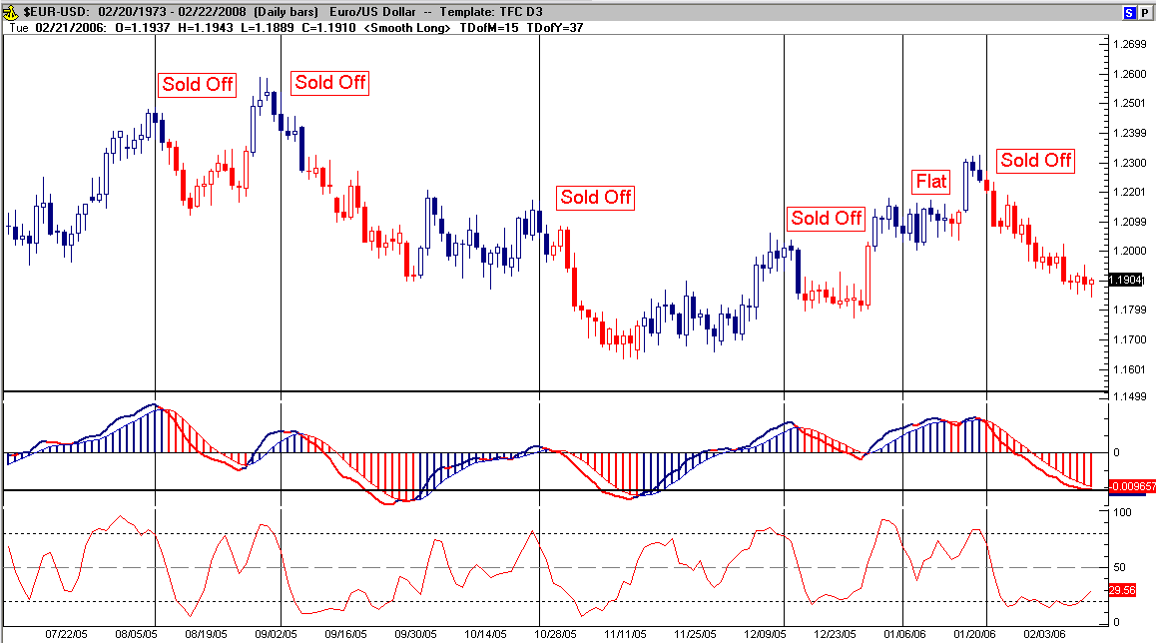

The red oscillating line in the lower pane is fast stochastic, and I’ve labeled 6 circumstances on the chart where stochastic show that the market is over-extended long (over-bought - dropping lower from above 80). In all but one instance the market sold-off after the signal from Stochastic. Below is a chart showing stochastic over-extended short (over-sold) and the resulting market moves higher each time.

Fig. 24.8
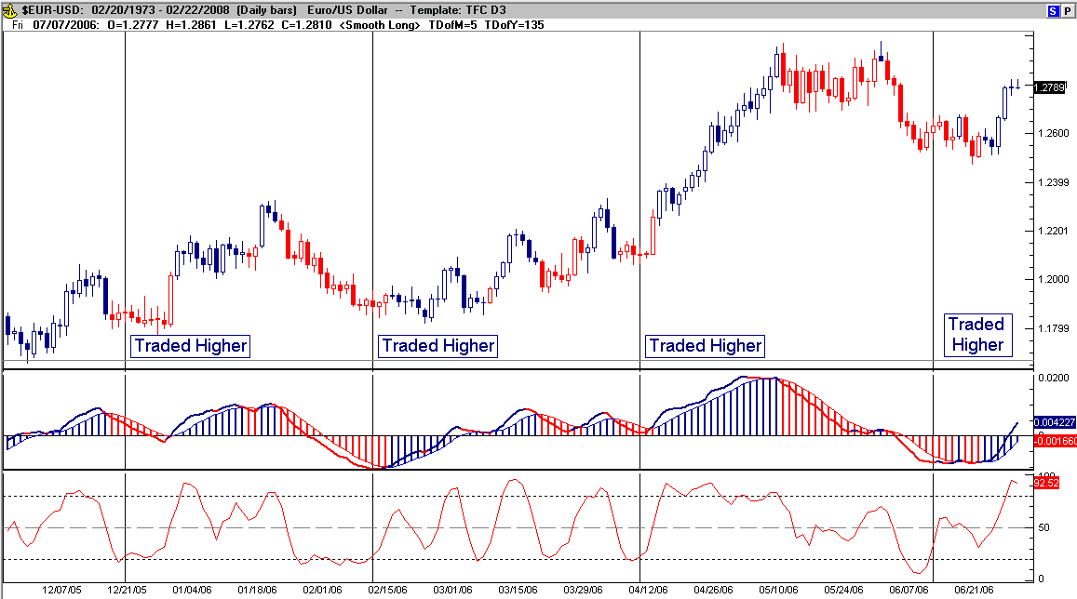

FMA – (FIB) Weighted Moving Average

The FMA is a weighted moving average (based on Fib numbers) built to follow candle support in an uptrend and candle resistance in a down trend. The following chart (Fig. 24.9) adds the FMA over price:

Fig. 24.9
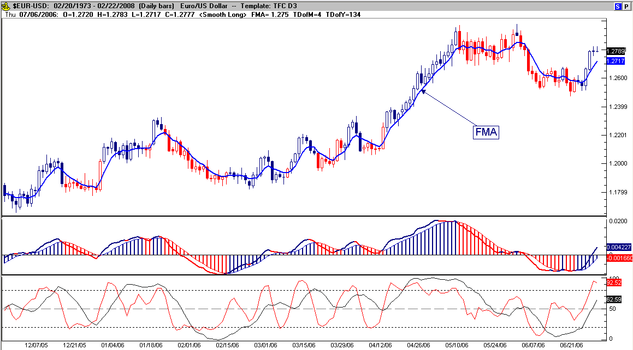

The formula for the Fib weighted moving average is as follows: ((Close * 0.85394) + (Close.1 * 0.78612) + (Close.2 * 0.61904) + (Close.3 * 0.5000) + (Close.4 * 0.38235) + (Close.5 * 0.23636) + (Close.6 * 0.14606) + (Close.7 * 0.09027)) / 3.61414. As you can see I’m using Fib numbers to weight the MA and not the standard 1 up through 8 methods. This leads to a moving average that acts more like support in an uptrend and resistance in a down trend.

- T3 (Tillson’s Smoothed Moving Average of the FMA)

The next component overprice is the T3 (of the FMA). This time represented in red, the T3 is a secondary moving average crossover defining trending prices or a change in the trend.

Fig. 24.10
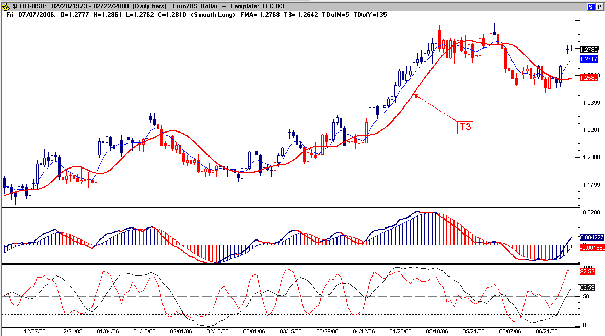

The formula for this indicator is: Tillson T3 (FMA , 8). This math is automated in Trade Navigators Chart service making the creation of this indicator (and others) very simple, but I can provide the actual math behind Tillson’s T3 in a spreadsheet if you don’t have this capability.

The Donchian Oscillator:

I’ve been using components of the Donchian Channels (by Richard Donchian) over price in the E-mini market for buy and sell signals. This led me to experiment with applying his theory to an oscillator (a leading indicator) and have the following to share:

Fig. 24.11
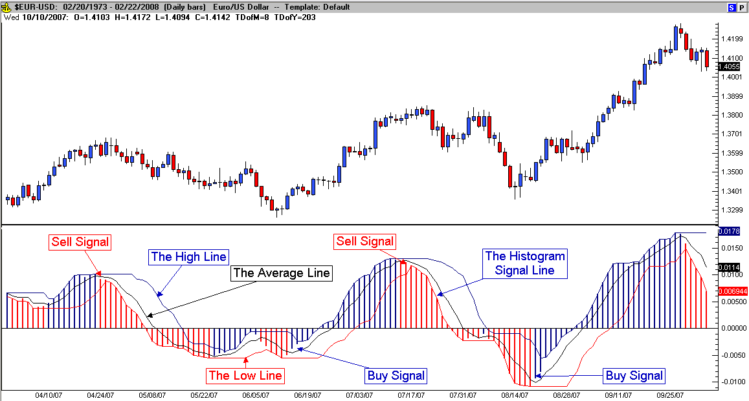

The buy and/or sell signals come on the crossover of the histograms (Smooth Delta) and the Donchian Average (black MA – center). Like the Donchian theory, if the oscillator is breaking above or below a previous higher high or lower low (outside lines) then a stronger rally may be forming. Divergence and momentum are also graphically displayed when price action and the oscillator move in opposite directions. I use the Donchian Oscillator in conjunction with the Donchian Channels over price to get a double perspective of possible price action. The channel is a 20 period over price.
The Donchian Oscillator also displays momentum (separation between the average and the high or low line); momentum change (the color changing histogram bars), strength of the trend - above neutral and moving higher, below and moving lower – strong; above and moving lower, below and moving higher – consolidation or trend change; divergence (positive and negative) and false spikes (histogram bar(s) breaking above a lower Signal Line or below a higher Signal Line).
As price returns to the average in a trend, it signals an excellent price (lower risk) to add on to winning positions and as the oscillator dips above or below the average without breaking the neutral line (opposite of the trend), then price is only correcting and should continue (keeping divergence in mind to long for either scaling out of the position or tightening stops).
Like all technical tools, the Donchian Oscillator requires time for you to become fluent with its use and time to learn to read subtle price action with a certain degree of competency. It is by no means perfect, nor is it any better (or worse) than any other technical analysis tool available, but it does provide an accurate translation of the present price and its probable movement when applied properly. My application of the Donchian Oscillator (in multiple time frames) is a part of a trading process that defines strict entry/exit and money management rules and provides measurable results over time. I use intermediate levels in conjunction with the oscillator signals at the .382 and .618 of the Donchian Channel (instead of the Donchian Average) here as they are reached before the average and signal improved entries and exits over the original Donchian rules. Note: the Turtle Traders (most people won’t know who they are) used Donchian Channels as an integral part of their trend trading strategy. Fig. 24.12 is an example chart of my set-up:

Fig. 24.12
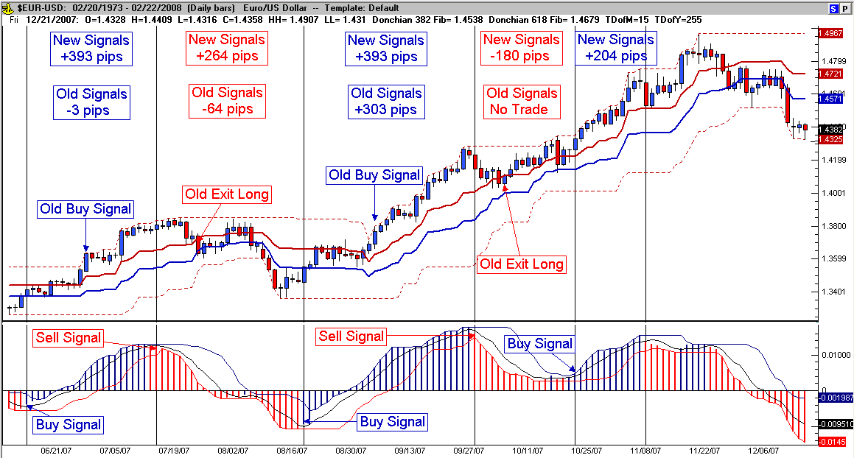

Modified Williams %R

Fig. 24.13
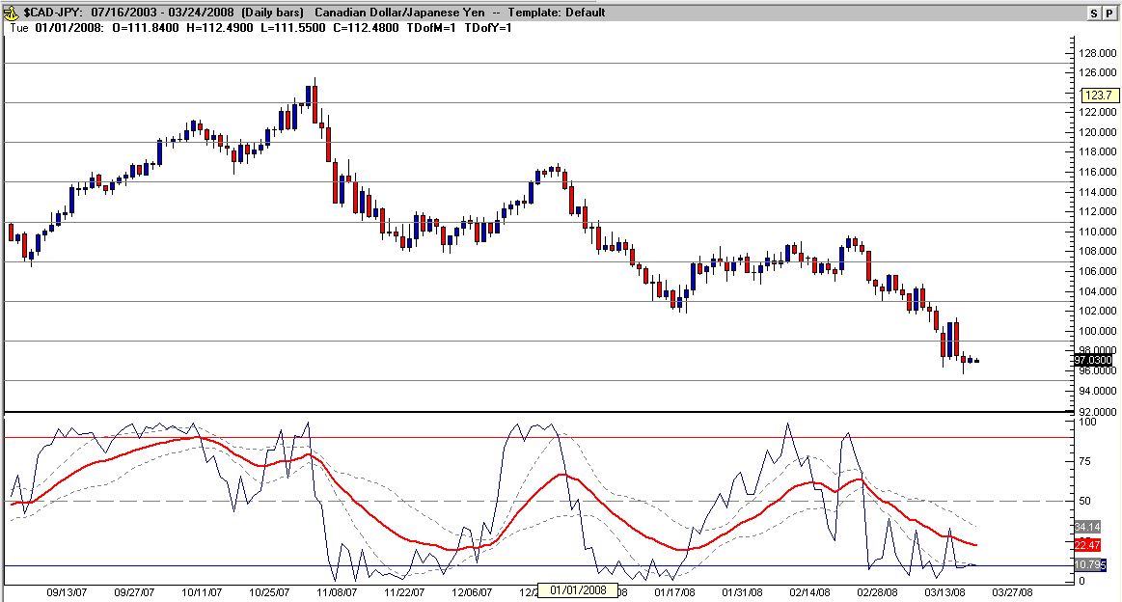

The modifications I’ve made reduce false break-outs by choosing a larger look-back period for %R (20) and add cross-over signals based on the break-down in recent average price activity. The standard deviation bands of the exponential moving average contract during consolidation and signal a stronger move potentially in price. Separation in the bands without a strong price movement signals weak momentum. Finally, divergence in either %R and/or the EMA are a strong indication of a change in price direction. I personally like to see the cross-over of %R and it’s EMA move beyond the deviation bands on the break-out for a sign of increased strength in a signal (as long as %R stays within normal distribution as measured by the standard deviation bands, the timing for entering the market based on the price breakout maybe early).
Here are the formulas: %R period 20, the exponential moving average is MovingAvgX (PercentR (20) , 34 , False), the upper deviation band is MovingStdDev (APR , 13) * 1.618 + APR (where APR is the EMA) and the lower band is APR - (MovingStdDev (APR , 13) * 1.618). Notice that I use the normal distribution of the faster %R (where the rest of the market likely is). The raw results of trading every signal (for example only without stops) in Fig. 23.13 was still +2035 pips – five gains (3300) and six losses (-1265).
Another variation using Williams PercentR focuses on the EMA’s position above or below it’s 50 level. The settings are the same but by changing the EMA to a histogram the emphasis turns to the bigger picture (generally above 50 and moving higher suggests a stronger move up and below 50 and dropping suggests a stronger move lower. Fig. 24.14 is an example of the modification.

Fig. 24.14
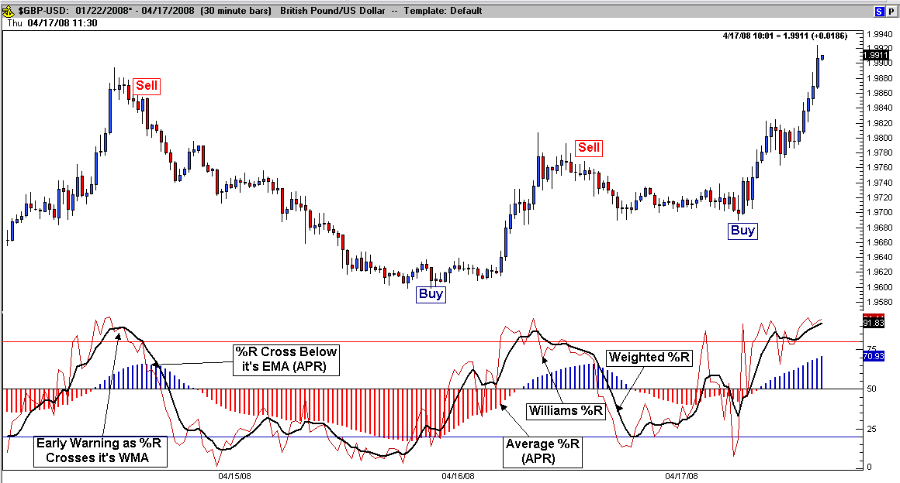

The previous figure labels the components of the oscillator and shows entry pricing based on the cross over of PercentR and its average. Because %R has erratic movement, I smoothed it out with a weighted average using the same Fibonacci sequence in the FWMA indicator previously described. The average %R (APR) will display divergence as well as over-extended levels as it gets the closer it gets to the 20 and 80 levels. I’ve used this set-up on all time frames.

Expansion Contraction

A new indicator I designed to measure range expansion and contraction in order to quantify the strength or weakness of a swing in price or even in a trend.

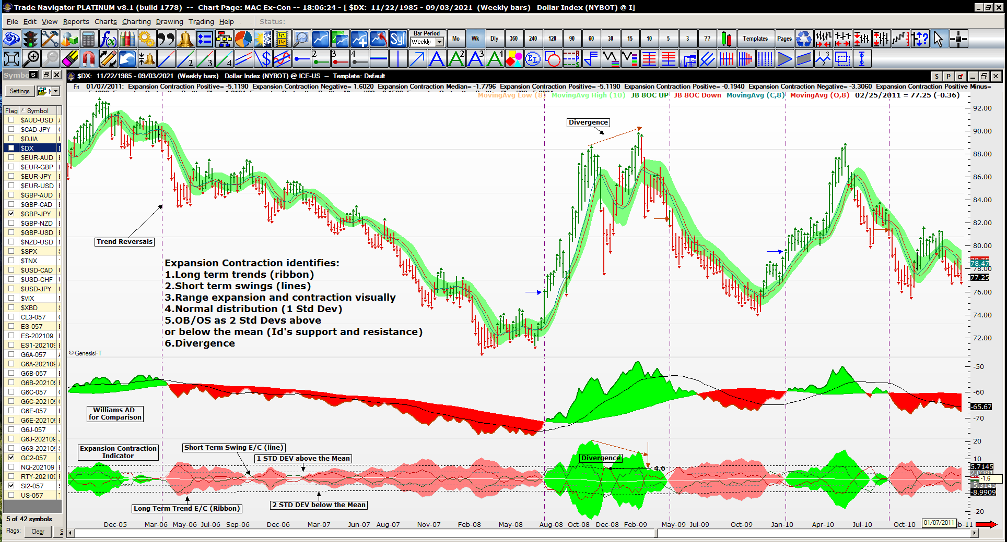

Expansion Contraction identifies 30 tradable conditions including:

1. Long term up trends, downtrends (ribbon), strong or weak and not trending (5)
2. Short term up swings, down swings (lines) – strong or weak and consolidation (5)
3. Range expansion and contraction, strong or weak and alternating swings (6)
4. Strong short term breakouts up or down from the long term trend (2)
5. Minor support and resistance (based on short term Ex-Con) and major (long term) (4)
6. OB/OS as 2 Std Devs above or below the mean –trends or swings maximum range (4)
7. Bullish and bearish divergence with triggers, short term and long term (4)

Expansion Contraction measures short term swings of multiple price points up or down through the moving average channel settings. A second version includes the long term trends of price using a longer look-back moving average channel trend filter. In this case the short term settings are emulating Jake Bernstein's 8 open/close settings (8 period short term) and adding long term settings (32 period) that are a “factor of 4” trend “MAC” definition Note: Ideally, this ratio usually produces a condition where a 2 standard deviation short term move (strong swing) equals approximately a 1 standard deviation long term move (trend strengthening).
Basically, if both the short term swing is expanding higher and the long term trend is expanding higher, then that signals the strongest part of the current swing higher (dark green bars). The strongest part of the current swing lower (dark red bars) occurs when both the short term swing is expanding lower and the long term trend is expanding lower.
Light green bars occur when the short term swing is expanding lower however; the long term trend is still bullish. Light red bars occur when the short term swing is higher however; the long term trend is still bearish. These indicate weakness in the current swing and Jake’s trailing stop rules should be considered.
When both the short term swing and the long term trend are within 1 standard deviation based on the short term swing, the resulting narrow range indicates a “not trending” or range bound condition.
When the short term swings are at or beyond +2 standard deviations, this setup is a leading indicator of the trend direction most of the time (not how long the trend will last).
When the long term trend, up or down exceeds a 2 standard deviation move higher, the condition is considered over-bought or over-sold, respectively. Trade Navigator programming appears as a colored triangle (red/green).

Note: I used the TN code: moving standard deviation to determine a 500 bar “normal distribution”

Trade Navigator Code:

Expansion Contraction Positive:
(High - MovingAvg (Expression , Period)) + (Low - MovingAvg (Expression , Period)) Note: Default expression: High, default period: 8

Expansion Contraction Negative:
(MovingAvg (Expression , Period) - Low) + (MovingAvg (Expression , Period) - High) Note: Default expression: Low, default period: 8

Expansion Contraction Median:
MovingAvg ((Expansion Contraction Positive (Expression1 , Period) + Expansion Contraction Negative (Expression2 , Period)) / 2 , 8)
Note: Default expression: High, default expression2 Low, default period: 8

Expansion Contraction Plus 1 Std Dev: (1 Standard Deviation above the mean)
MovingStdDev ((High - MovingAvg (Expression , Period)) + (Low - MovingAvg (Expression , Period)) , 500) + Expansion Contraction Median (Period , High , Low)

Expansion Contraction Minus 1 Std Dev: (1 Std Dev below the mean)
Expansion Contraction Median (Period , Expression1 , Expression 2) - MovingStdDev ((High - MovingAvg (Expression , Period)) + (Low - MovingAvg (Expression , Period)) , 500)

Expansion Contraction Plus 2 Std Dev: (2 Standard Deviations above the mean)
(MovingStdDev ((High - MovingAvg (Expression , Period)) + (Low - MovingAvg (Expression , Period)) , 500) * 2) + Expansion Contraction Median (Period , High , Low)
Note: Default expression: High, default period: 8

Expansion Contraction Minus 2 Std Dev: (2 Standard Deviations below the mean)
Expansion Contraction Median (Period , Expression1 , Expression 2) - MovingStdDev ((High - MovingAvg (Expression , Period)) + (Low - MovingAvg (Expression , Period)) , 500) * 2
Note: Default expression: High, default expression1: High, default expression2: Low, default period: 8

Expansion Contraction Bullish:
Expansion Contraction Positive (High , Period1) >= Expansion Contraction Negative (Low , Period1) And Expansion Contraction Positive (High , Period2) >= Expansion Contraction Negative (Low , Period2)

Expansion Contraction Bullish Correction:
Expansion Contraction Positive (High , Period1) >= Expansion Contraction Negative (Low , Period1) And Expansion Contraction Positive (High , Period2) < Expansion Contraction Negative (Low , Period2)

Expansion Contraction Bearish:
Expansion Contraction Positive (High , Period1) < Expansion Contraction Negative (Low , Period1) And Expansion Contraction Positive (High , Period2) < Expansion Contraction Negative (Low , Period2)

Expansion Contraction Bearish Correction:
Expansion Contraction Positive (High , Period1) < Expansion Contraction Negative (Low , Period1) And Expansion Contraction Positive (High , Period2) >= Expansion Contraction Negative (Low , Period2)

Expansion Contraction Support:
Consecutive ((Expansion Contraction Negative (Low , Period) < Expansion Contraction Negative (Low , Period).1) And (Expansion Contraction Negative (Low , Period).1 >= Expansion Contraction Negative (Low , Period).2)) = 1

Expansion Contraction Resistance:
Consecutive ((Expansion Contraction Positive (High , Period) < Expansion Contraction Positive (High , Period).1) And (Expansion Contraction Positive (High , Period).1 >= Expansion Contraction Positive (High , Period).2)) = 1

Expansion Contraction OB:
Expansion Contraction Positive (High , Period) > Expansion Contraction Plus 2 Std Dev (High , Period)

Expansion Contraction OS:
Expansion Contraction Negative (Low , Period) > Expansion Contraction Plus 2 Std Dev (High , Period)

Major Note:
Ideally the short term 2 std dev move is equal to a long term 1 std dev move. This relationship between the short term move being strong (a 2 std dev move would be measurably “big”) and the long term trend filter starting to trend strongly (more than a 1 std dev move) can lead to larger moves (trending).

Additional chart examples are included here to show all of the tradable conditions with this versatile indication:

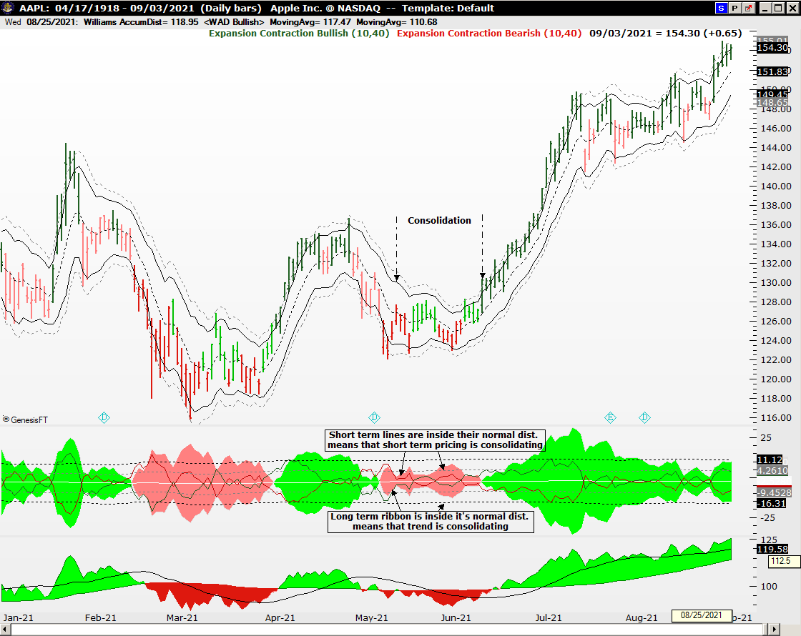

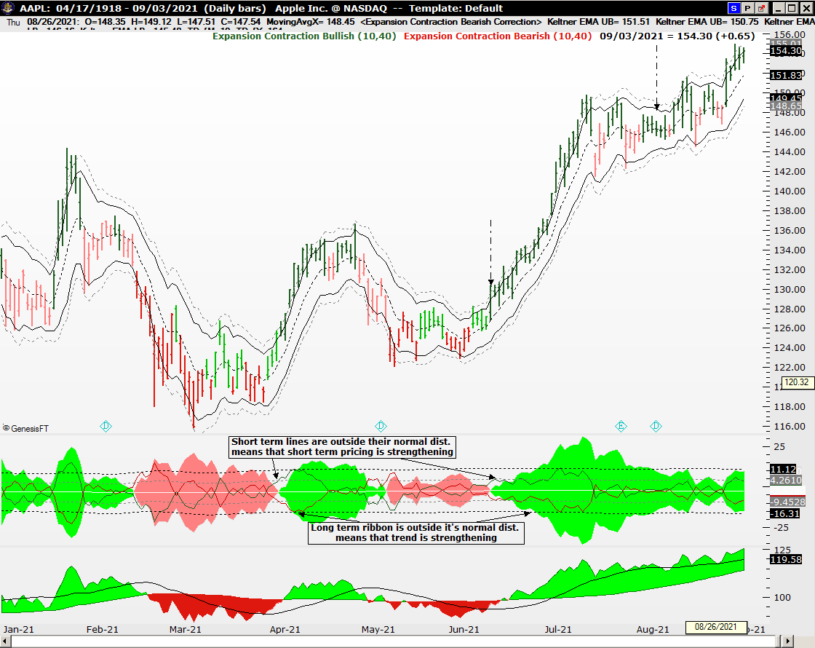
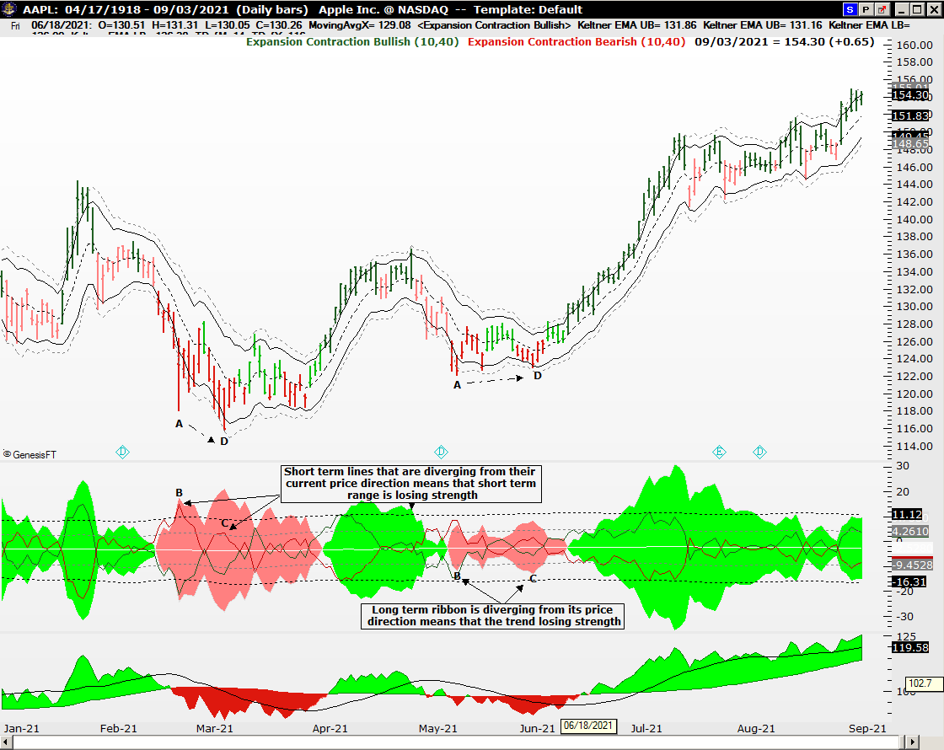
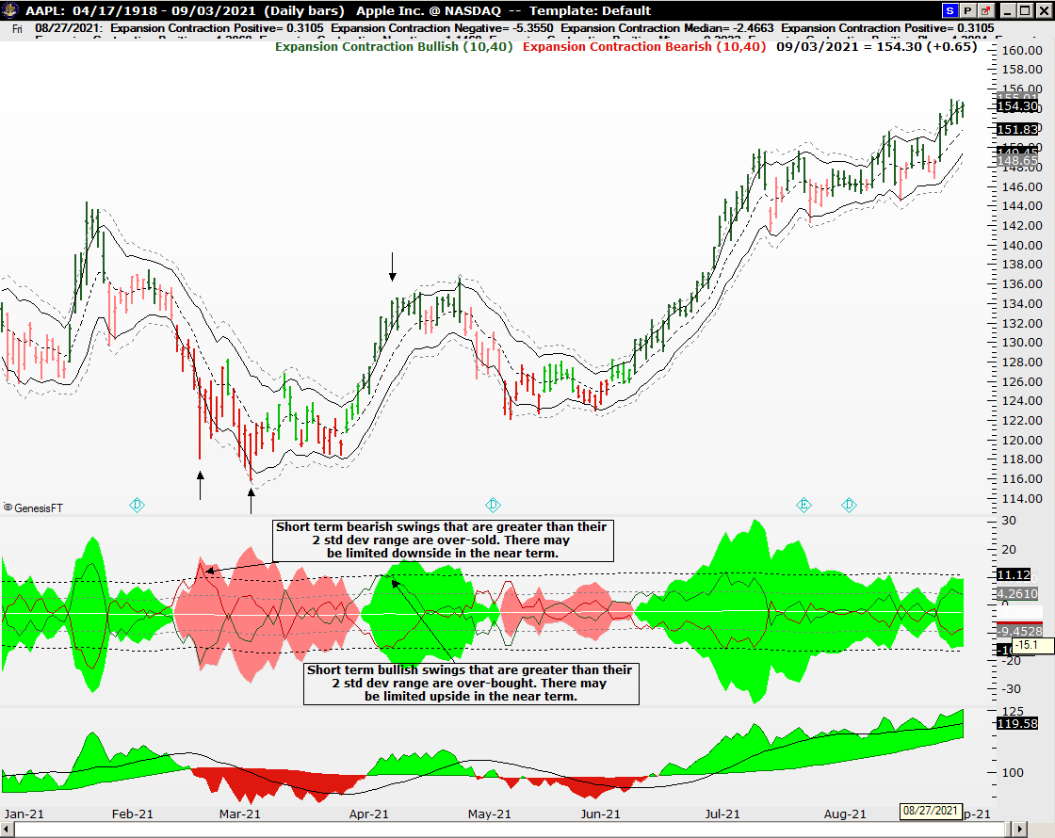
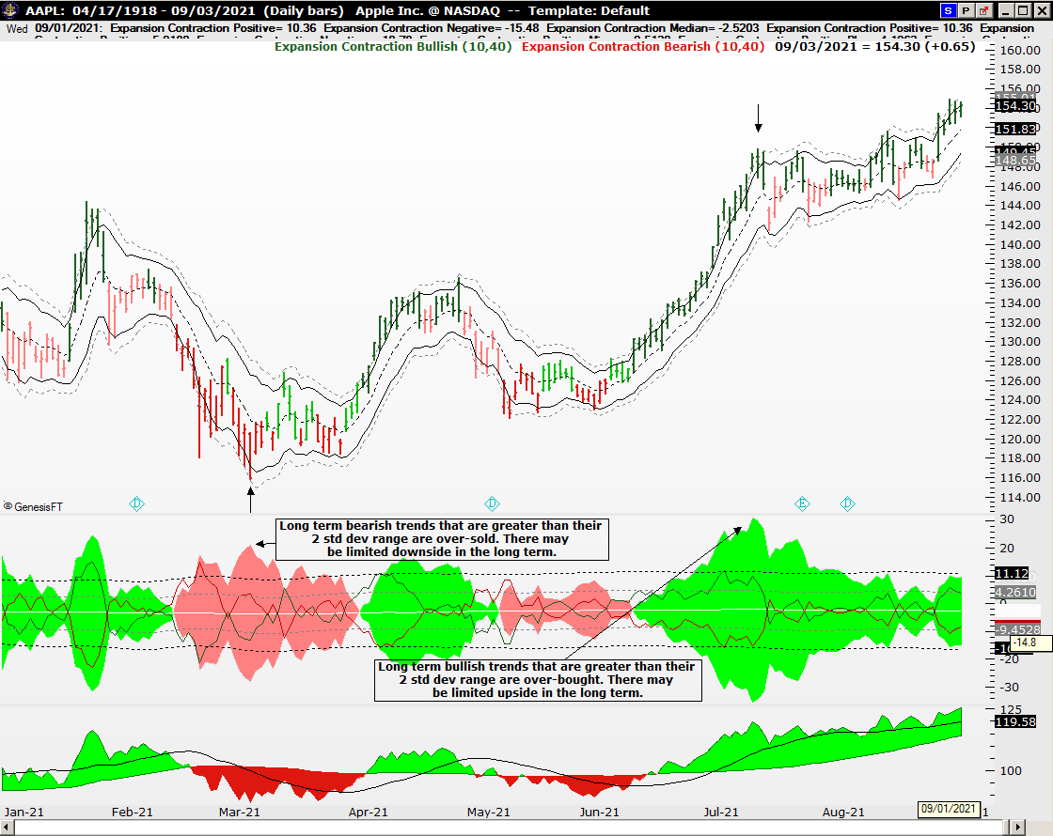
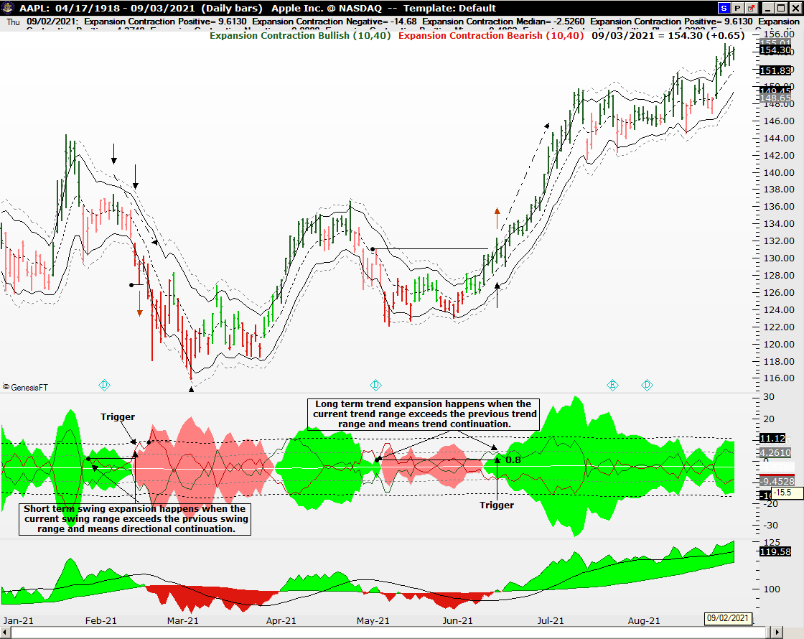
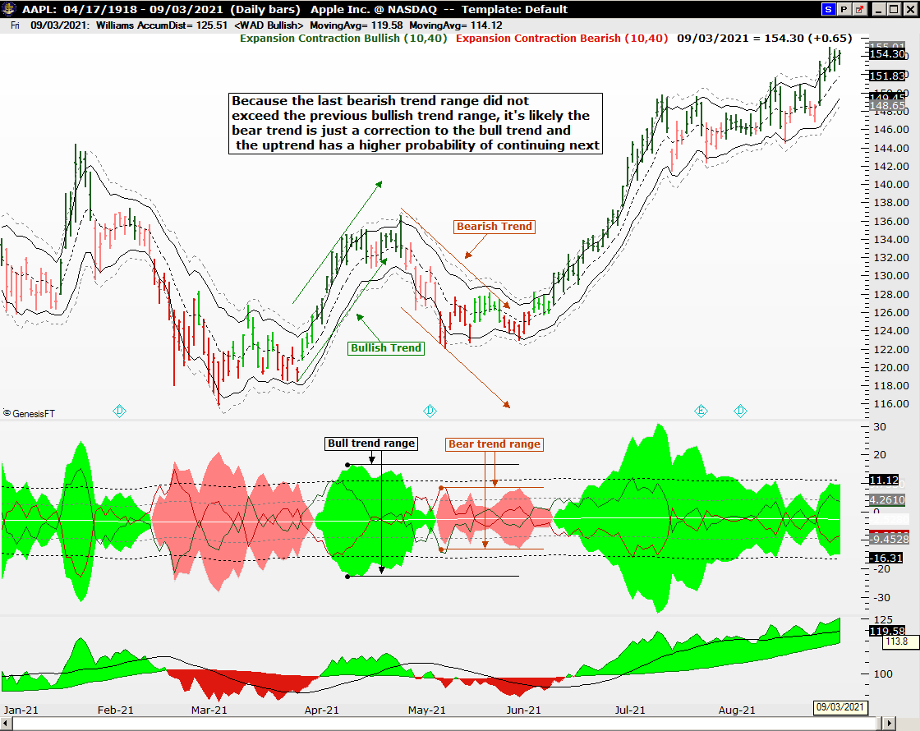
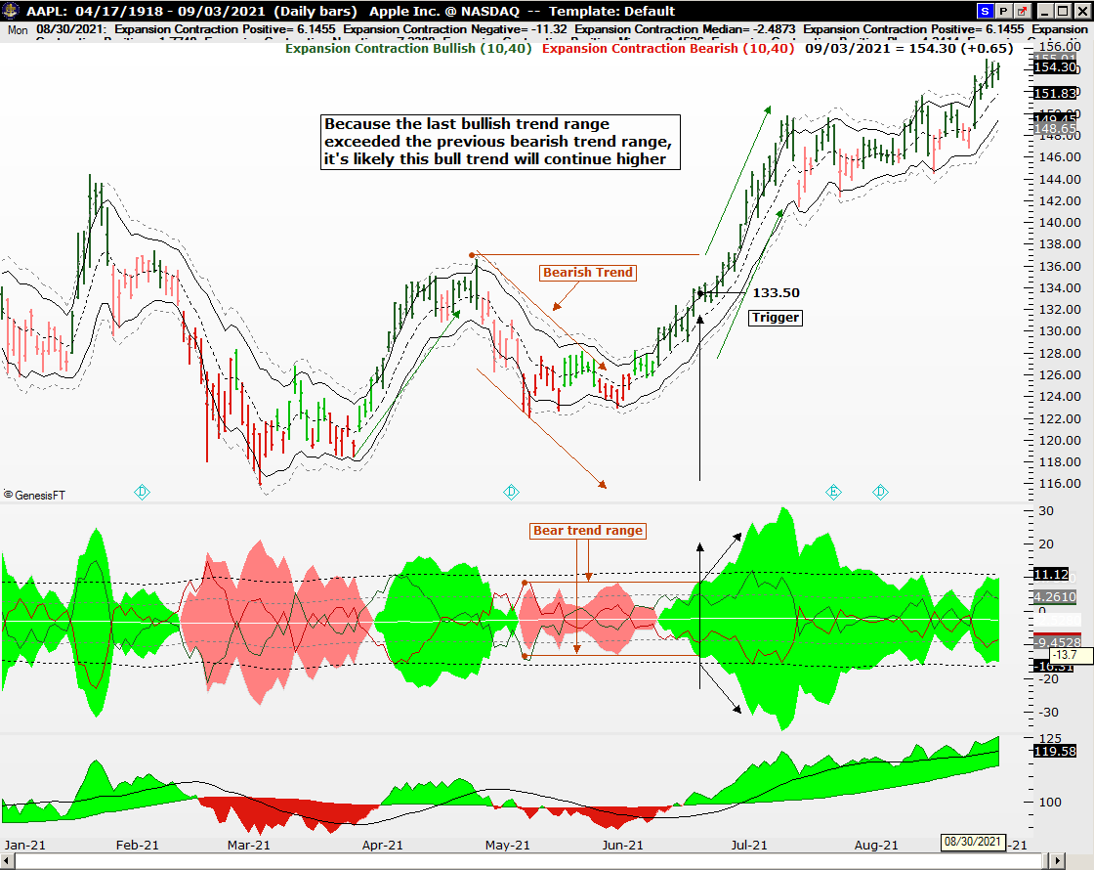
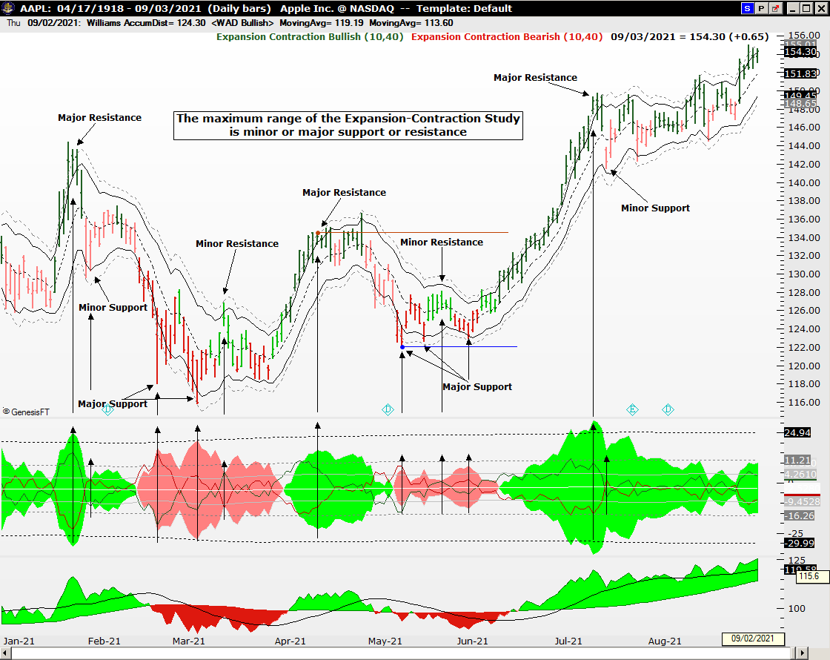

Curvilinear Regression and Slope

Another advanced mathematical representation of price is Curvilinear Regression. Unlike the Regression Trend studied in Chapter 20, (Trend Lines) which plot a straight line average of all of the data analyzed, the “curve” as it’s called looks more like a moving average (hence non-linear or curve) of the data analyzed. Rather than bog down in a complex description of the math behind the differences, let’s look at the different ways the formulas plot on the following chart of the EUR/USD. See Fig. 24.15.

Fig. 24.15
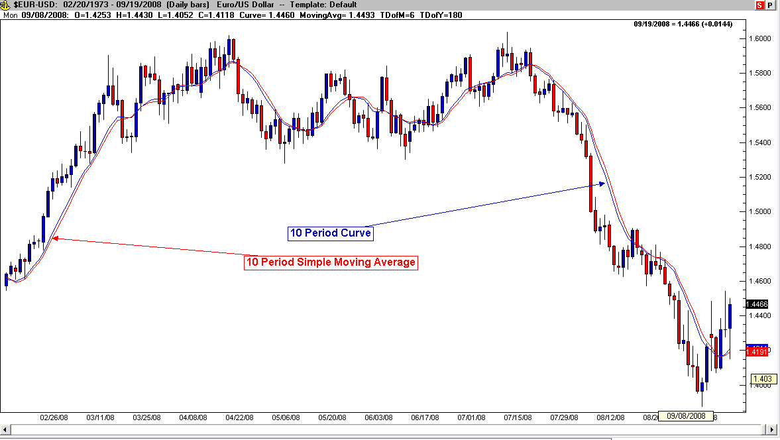

The curve is faster than the simple moving average of the same length and turns sooner. Is it better or not, that is subject to interpretation. The way I incorporate the curve into my trading philosophy is that the relationship between price and the curve, while similar to being above or below average, is nonetheless a closer relationship (faster/sooner). Another mathematical calculation derived from the curve is the slope (or rise/ fall to run) In other words, are how steep is the price move (higher or lower). This angle is another measurement of momentum and here is a chart comparing slope to momentum (of the same periods). See Fig. 24.16 below:

Fig. 24.16
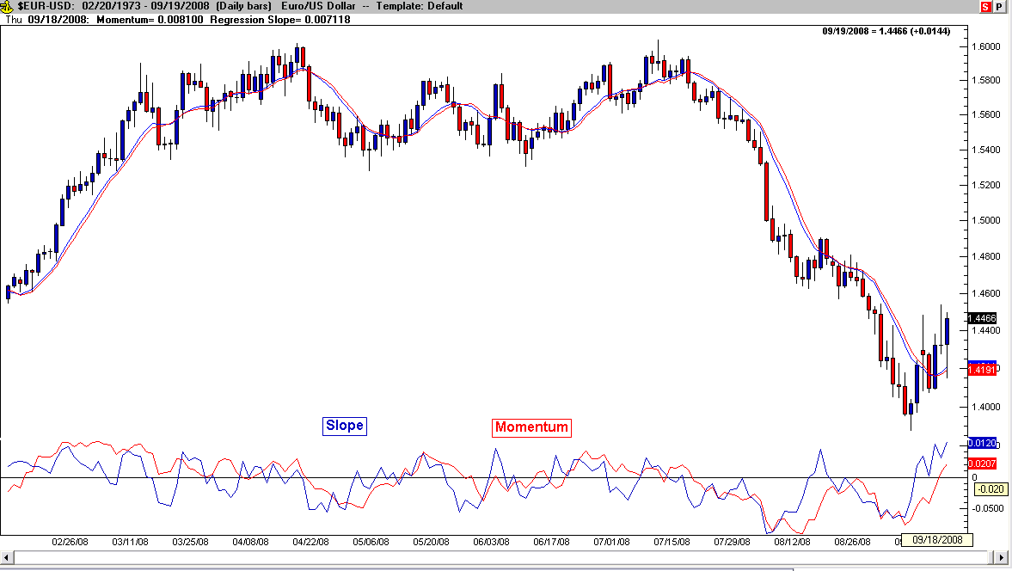

Once again, slope is faster and changes sooner allowing for earlier signs of divergence and potential direction changes. I have adapted the use of longer term curve and slope to shorter term trading strategies to smooth out some of the lagging nature of the moving averages. The next chart is an example of the Euro on a 4 hour intra-day chart displaying price above or below the daily curve (red) and the weekly curve (black). The additional levels above and below the weekly curve are percent bands displaying price levels one or two percent above/below the curve.

Fig. 24.17
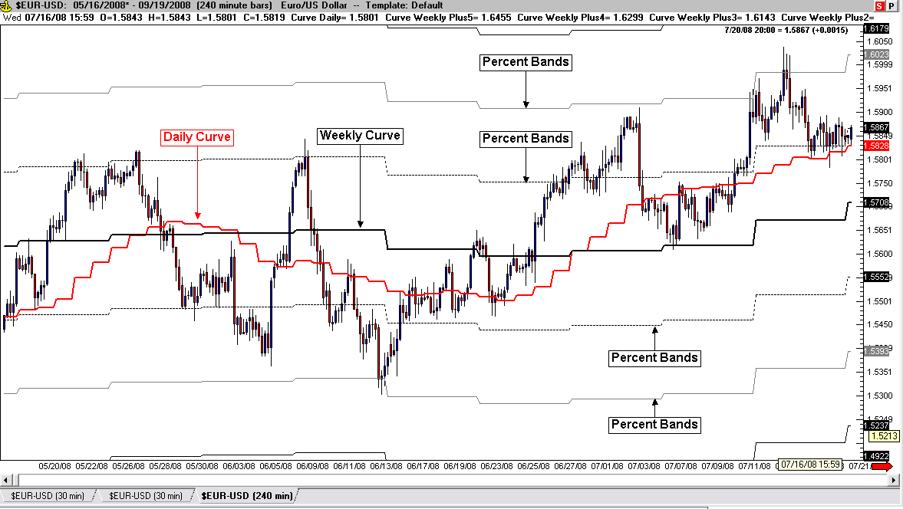

True Strength Oscillator

The True Strength Index originally published by William Blau is a momentum indicator. Calculations look at the difference between today’s price and yesterday’s price and smooth out the plot with a double Exponential Moving Average. It is similar to The Relative Strength Index (RSI) but the main difference in True Strength is that it does not compare up days to down days over “x” number of periods, but just today with yesterday. That plot would be too reactive, so the double smoothing minimizes this erratic nature. Over-bought and over-sold levels are +25 and -25 respectively and the scale is +100 to -100.
The default EMA settings are 25 and 13, but I like to see more reactive changes so have modified the setting down to 20 and 10, while adding an EMA “cross-over” line to help identify bullish or bearish reversals in momentum. Remember momentum direction is not trend direction, but when trend and momentum are both bullish or bearish at the same time, stronger patterns usually emerge. Fig. 24.18 is a comparison of the True Strength Index (top with modified settings – 20 and 10) and the variation (bottom indicator) that I’ve programmed as an oscillator (The True Strength Index Oscillator). The oscillator captures faster momentum swings within the overall trend and when both trend and momentum are bullish or both are bearish, the strongest part of the trends can be identified and traded.

Fig. 24.18
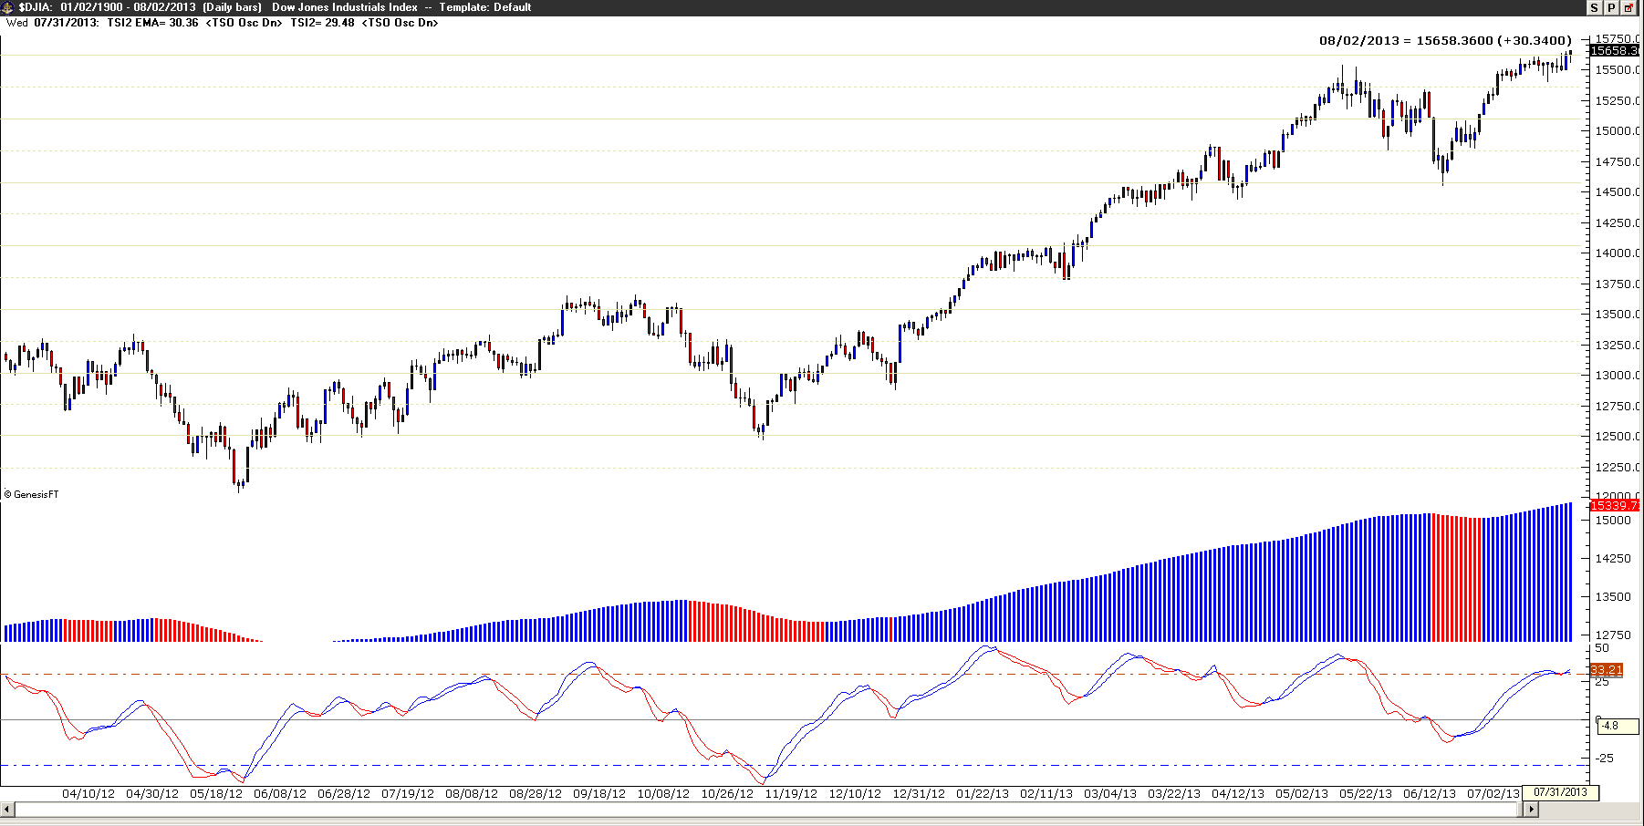

Daily and Weekly Projected Price Levels

The latest addition to my arsenal of tools originally started out as an attempt to find option targets (one touch, double touch, no touch…) and quickly changed when I back-tested the values to intraday and weekly price targets. I’ve combined two day/week weighting of prices with candle theory logic to plot projected prices for the next day and the next week.
The Daily Projected high and or low hit an average of 84.4% of the days and the Weekly Projected high and or low are hit 83.5% of the weeks in all of the majors (against the Dollar). This has created high probability price targets for exit potential. I’ve plotted the Fib levels between the high and low and have included some Fib extension levels for breakout days. Figure 24.19 is an example of the Daily Projections and Fig. 24.20 is an example of the Weekly Projections.

Fig.24.19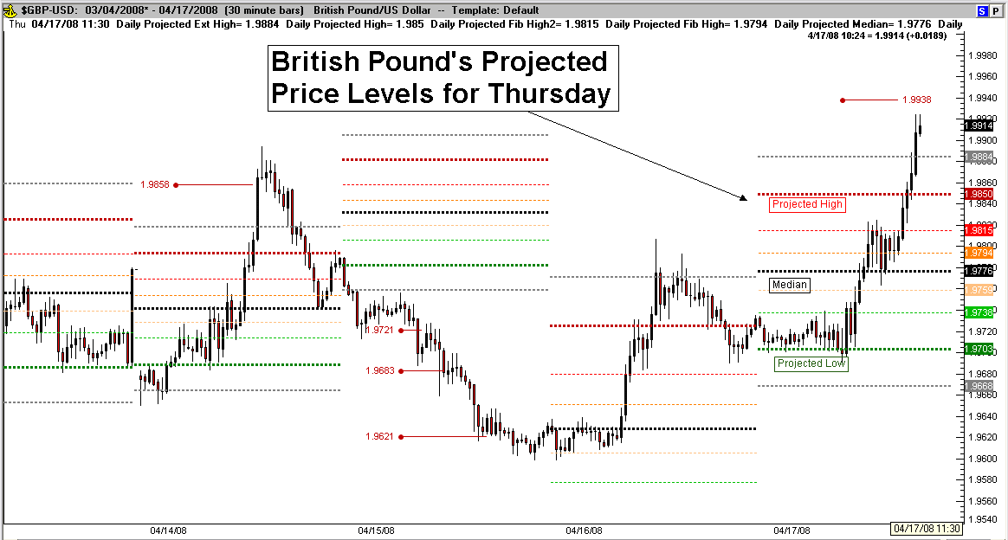

Note that on the breakout days (trading out of the projected range) that the Fib extensions are subsequent high probability targets (using the -.618, -1.0, -1.618, 2.618 and so on). The confluence of daily and weekly fib levels is significant also as they project a common target and increase the probability of price following through to those levels.
Fig.24.20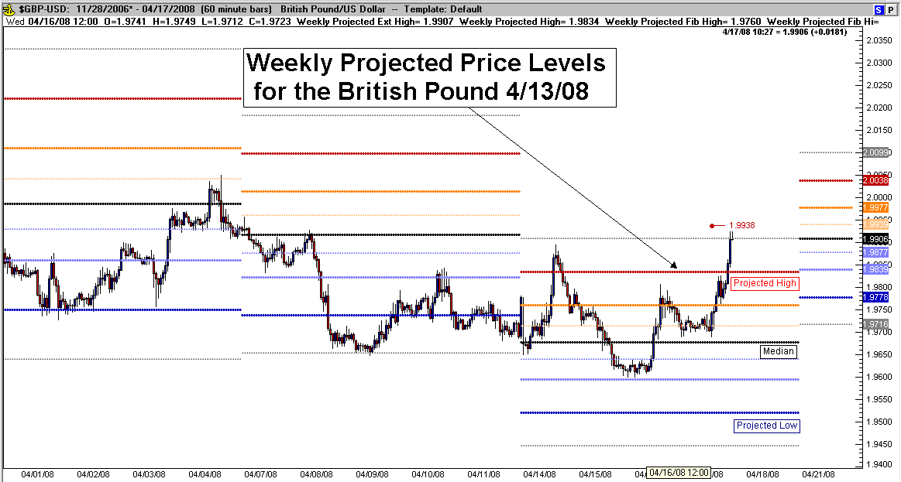

I’ve programmed these projections into Trade Navigator and they are available as a “Library” download for TN users but also post these levels on http://TradeForeignCurrencies.com for everyone to have. I’ve also tested the projected levels in the equity indexes (S&P Emini, Emini Russell 2000, Emini Dow and the Emini Nasdaq) with equal results.

Correlation of Cross Currencies

In the Forex Market, currencies move up and down in relation to each other (For example, as a general rule, as the Euro goes up, the Pound should go up also). This is due to their relationship with the US Dollar (EUR/USD & GBP/USD – both are quoted in US Dollars). This called a “positive correlation” (they generally move in the same direction). On the flip side are the Euro and the Swissy, they generally move in opposite directions (as the Euro goes up; the Swissy goes down). This is called “negative correlation” (EUR/USD & USD/CHF – they are quoted in different currencies). Figure 24.21 is a 20 minute chart of the Euro (on top in black) and the Swissy (bottom, blue):

Figure 24.21
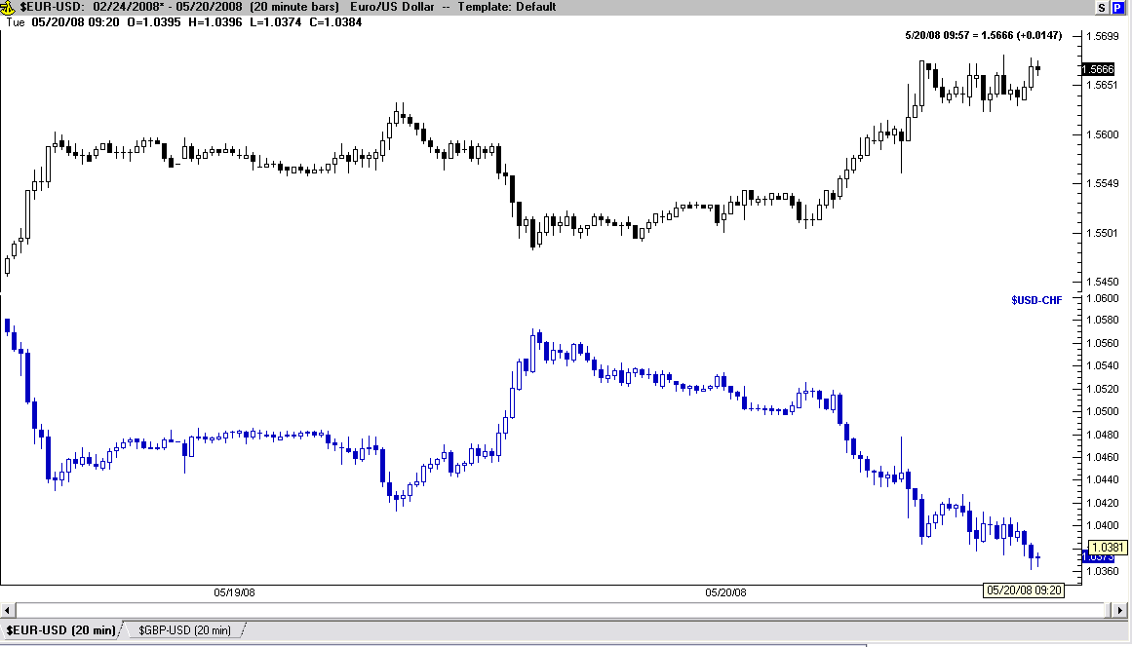

You can clearly see the negative correlation (movement in opposite directions) as plotted in Figure 24.21. TradeSense has a function which allows us to see this relationship as an indicator [Correlation (Open , Close) for example, which measures the relationship between two functions]. This relationship is measured by a mathematical formula called the “Correlation Coefficient” and it plots a number between positive 1.0 and negative 1.0. A positive correlation (moves the same) is measured the closer to positive 1.0 the coefficient gets and a negative correlation is measured the closer to negative 1.0 the coefficient gets.
Figure 24.22 displays the Correlation Coefficient of the Euro/Swissy (EUR/CHF) from figure 24.21 and, as expected, the indicator registers closer to minus 1.0 most of the time:

Figure 24.22
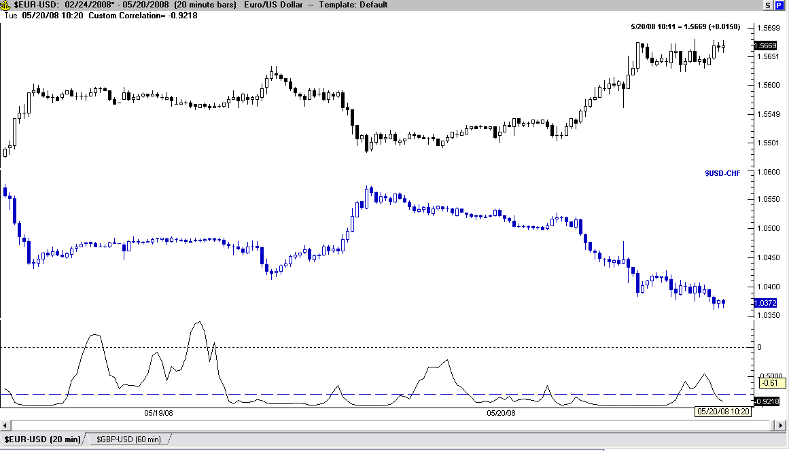

So what are the spikes you ask? They are measuring small changes in the movement (momentum) between the two majors. Between the two majors the difference isn’t obvious, but in the Forex Market this change becomes visible in the price of their cross currency (in this case the EUR/CHF). Figure 24.23 is the example:

Figure 24.23:
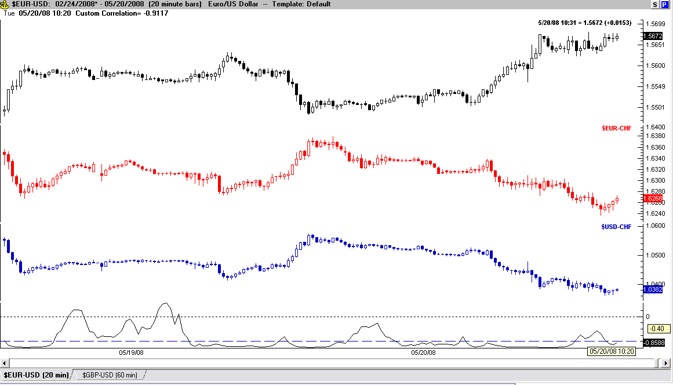

Despite the consolidation of the Euro and Swissy on the left half of the chart, the EUR/CHF jumped from 1.6300 to 1.6340 during the first spike (closing out a Friday’s trading session) and the second spike revealed a counter-move short down to 1.6275 (after the following Sunday’s open). See Figure 24.20 for the resulting trades as two more opportunities this week, a NY session break higher from 1.6310 to as high as 1.6377 and then later that same session a counter move lower from 1.6365 to as low as 1.6250 (Tuesday – based on lower highs and lower lows).

Figure 24.24:
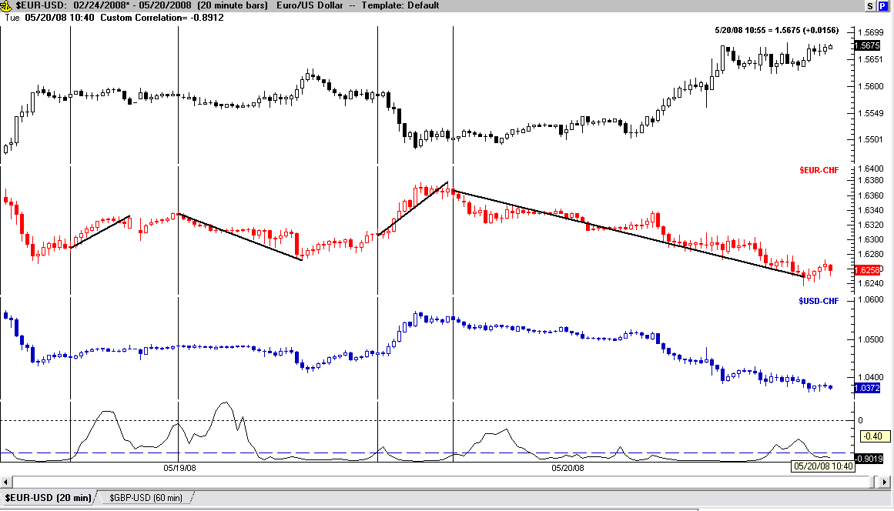

The Correlation Coefficient won’t tell you which direction to trade but it will reveal a pending change in the dynamics of the two majors. By using multiple time frames and some simple “over-bought/over-sold” indicators (I use Stochastic 13,8 and two MA’s) pinpointing entries and direction with the correlation coefficient become easier after observing how it reacts over time.
Figure 24.25 is an example with Stochastic added and the trade channels.

Figure 24.25:
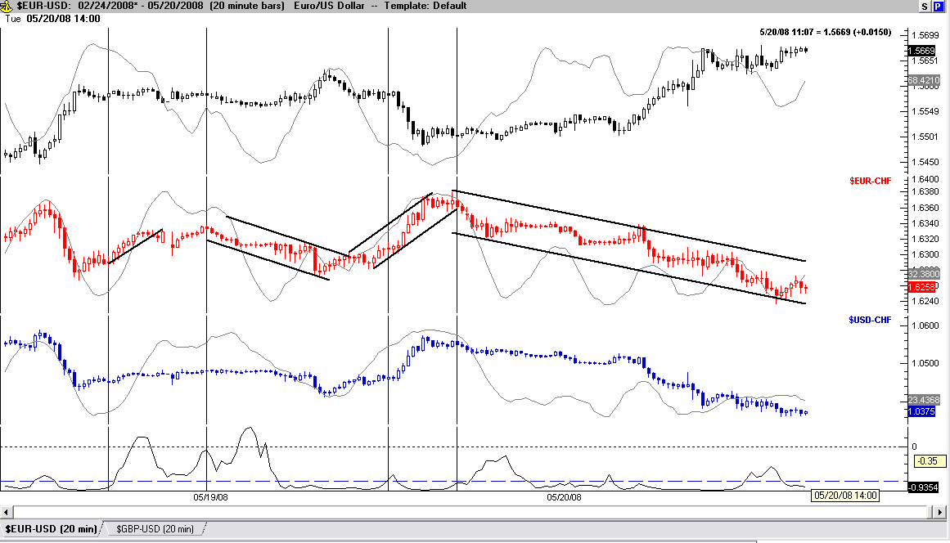

It has been my observation that over time the cross currencies frequently mirror their quoted pair (in this case – the Swissy). This often helps with the decision of which direction to trade. Figure 24.26 shows the EUR/JPY in two different time frames using Stochastic as a filter along with the Correlation Coefficient and the tradable channels that resulted.

Figure 24.26:
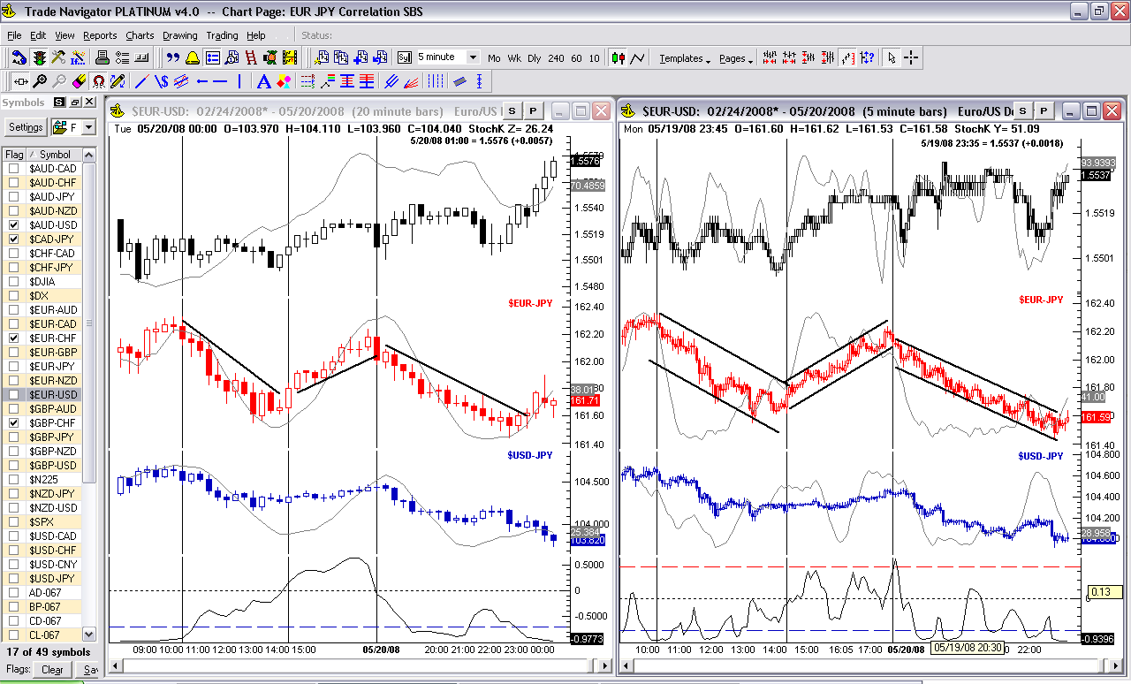

Notice that in the 20min chart on the left, the coefficient jumps off of -1.0 the whole time the cross jumps and then dumps, this shows that change is still present and the direction is a separate measurement. Using the cycles of Stochastic helps confirm the rising and falling channel changes. The second rising cycle (of Stochastic) reveals that all three pairs are rising and therefore the rapid change in direction of the cross. At the end of the second cycle in the cross, the smaller time frame (5 minutes) shows the Stochastic (in the cross) diverging from the price in advance of the price change and the third cycle shows in the 20 minute chart that the Stochastic is starting to turn lower again. The coefficient is returning to normal in the 20 minute chart, but in the 5 minute chart, the coefficient is jumping and the Stochastic has already started dumping.

The TradeSense formula for the Correlation Coefficient as I have outlined here is:
Correlation (Close Of Symbol X , Close Of Symbol Y , 10)

I would suggest you observe how this indicator works over time and adapt it to your method/style of trading. The look back period is adjustable and depending on whether you scalp, swing or position trade, test the parameters to fit how you trade. The TradeSense Library for the Cross Currency Correlation Coefficient is available for “Import” to Trade Navigator Clients upon request.

Bonus Section

I’d like to share with you a condition in price that, to my knowledge, has never been discussed before. In over 10 years of research, programs, classes, books and courses, I have not seen this observation repeated at any time and I’ve included this information to add to your trading arsenal.
The condition was observed from studying “role reversal”, a common occurrence in the market where previous support becomes resistance and/or previous resistance becomes support. Fig. 24.27 is an example:

Fig. 24.27
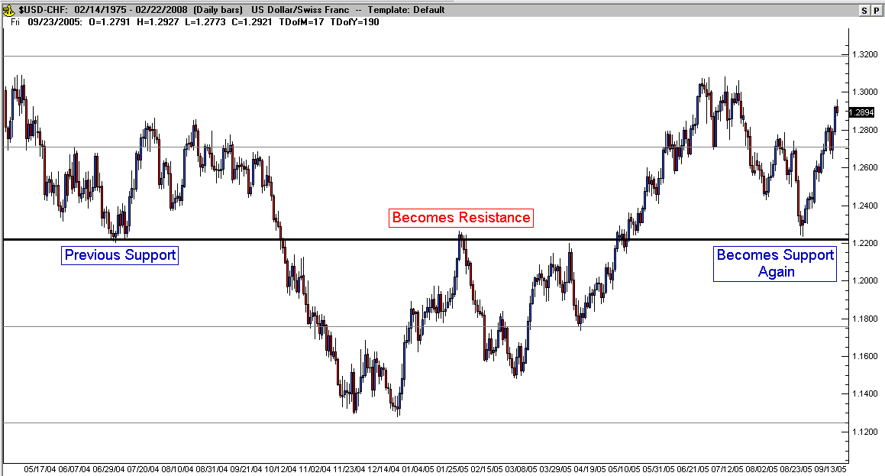

The collection of these role reversal levels made over an extended period of time and the plotting these levels building up on the charts, led to the observation that these role reversal levels exist at equal distances! Further observation of this occurrence with different instruments led to the discovery that these measured levels are equal to multiples of their respective average daily range. The distance between these horizontal “role reversal” lines occur at the average daily range (drawing every level made the chart too cluttered).
Furthermore, this observation is true for every currency pairing and to date, I have already calculated the levels of 25 currency pairings: AUD/CAD, AUD/CHF, AUD/JPY, AUD/NZD, AUD/USD, CAD/JPY, CHF/JPY, EUR/AUD, EUR/CAD, EUR/CHF, EUR/GPB, EUR/JPY, EUR/NZD, EUR/USD, GBP/AUD, GBP/CAD, GBP/CHF, GBP/JPY, GBP/NZD, GBP/USD, NZD/JPY, NZD/USD, USD/CAD, USD/CHF and the USD/JPY. The same solutions are seen in other markets as well. I’ve calculated them in some of the E-mini futures and Equity Indexes as well. Fig. 24.28 is a weekly chart of the Swiss Franc displaying its measured support/resistance levels (role reversal).

Fig. 24.28

Dual Time Frame Entry Strategy

Using Stochastic of RSI (SRSI) to identify a specific condition where two different time frames are considered “over-bought” or “over-sold” at the same time, we can identify high probability – low risk trades. I’ve used this concept for years with the traditional Stochastic settings of (Close , 8 , 3 , 3), until discovering the SRSI variation through Robert Miners Dynamic Trading Program. I’ve taken his process one step further to account for variable risk (simplified “Optimal R”). Trades taken in the direction of a confirmed trend (more on that later in the book) will take maximum acceptable risk (personal – I use 2%) and counter-trend trades half risk. This simplified method of risk calculations is extremely effective and takes the “complex” out of single most important aspect of trading (“how much risk do I take?”). Figure 24.29 is an example of the British Pound over a year of “with the trend” trades only using SRSI settings of (AvgHLC , 8 , 5 , 3 , 3) for both time frames:

Fig. 24.29
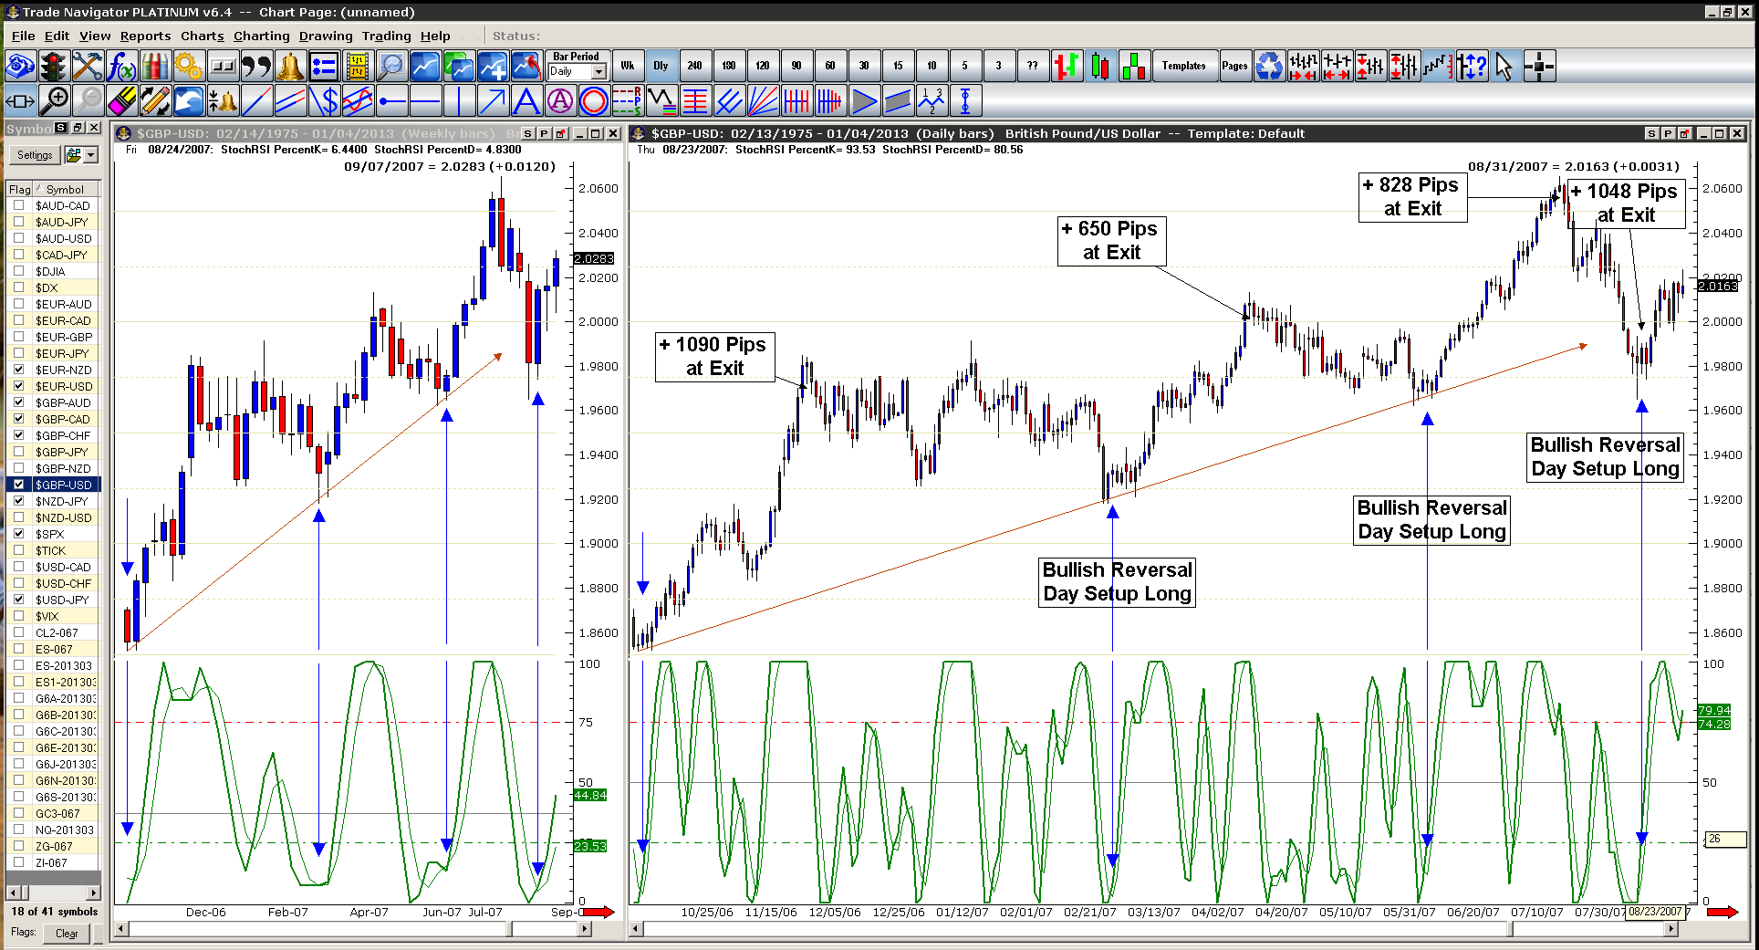

As you can see, each set-up in the uptrend exhibited clear signs of both the Weekly and the Daily charts being over-sold at the same time. The set-up signal to buy occurred once the Daily chart has a “Bullish Reversal” (cross-over) in the SRSI (remember the Weekly chart is still over-sold). Specific entry orders, entry price, risk calculations and exit conditions are apart of a complete Swing Trading Strategy Program available through Trade Foreign Currencies. By the way, this strategy’s success is not limited to the currency market. It produces low risk – high probability setups in multiple markets swing trading and day trading.

You can see the pips gained in the Pound labeled for each trade (in Fig. 24.29) and the total was 3616 pips. More importantly, the net gain based on 2% risk on each trade totalled 47.28%. Note: This example did not include counter-trend trades or a small 2% loss in May on an early setup, as the bulk of the gains were made on these “trend trades” and the net result including all trades was only minimumally greater.

Advanced Risk Control

Minimizing Risk

The entire reason for trading is to make money! This should be engrained into your thinking so that every decision is tempered with the realization that if the results are not profitable we should abandon the position. Minimizing risk is the hardest thing to do because if you remember the module on psychology, it goes against human nature! We always trade with stops and the placement of the stops is crucial for maintaining this principal.
For general purposes, in the Forex market we look for trading opportunities that conform to having 40-60 pip stops (for long term swing trading??). Statistically with the strategies I have employed, this should be all you need, or the trade doesn’t conform to the model I am laying out (it will be obvious shortly). Note: I know that small stops will be taken out more frequently than large stops. The difference with this strategy is that the market will be set up for taking advantage of the small stops if the timing is right and we’ll put the whole thing in perspective as I lay out the next segments, “Multiple Lot Strategies” and “Trend Trading”.

Multiple Lot Strategies

The truth is that the market will offer smaller profitable trades more frequently than large trending trades. However, the large trending trades are the “bread and butter” that lead to excellent absolute returns as proven with the most successful trend traders. So this strategy will combine the best of both worlds and harvest smaller rewards as they are offered and leave some of your position open to take advantage of the large moves when they happen. This will be accomplished by using multiple lots for every trade while still maintaining a reasonable risk to reward ratio and a set of absolute pre-defined rules to manage every aspect of your trades (you’ll always know what to do and when to do it!).
You’ll be employing a 5% risk factor maximum on every trade. This may seem high (if you are conservative), but let’s examine a reasonable view of what your monthly trade report may look like. If your starting capital was $2500.00, a 5% risk factor would equal $125.00 at risk in any one trade. With a 40 pip stop that would allow you to trade 3 lots. The formula to follow is: Total pips at risk times the $ value per pip divided into your maximum risk Dollars, in a mini account example: (2% of a $2000.00 balance = $40 risk capital / (300 pips risk calculated stop * .85 cents per pip Swissy) = .15 lots – 1 micro lot and 5 nano lots total). The multiple lot strategy that you will employ is based on taking profit at defined levels with 1/3rd of your position initially and then taking profit with another 1/3rd of your position at another predefined level and then allowing the last 1/3rd of your position the opportunity to trend with the market by trailing a large stop and having a set rule for how much profit you’re willing to give back before closing the position.
So let’s look at an example of a how a trade might play out using this strategy. First let’s assume it’s a profitable trade in the Euro and that the market moves a total of 60 pips in a rally (without taking your stop out first) before coming back and reversing. If you traded 3 lots (5% risk on your $2500), then at 40 pips of profit (you’ll find out how to know when to take profit in the last module) you would close out 1 lot and set your stop to equal a free trade (if the market turned immediately, your stop would only take back your profit). This actually means that your stop isn’t set to your original entry, but at a level that equals your first closed lot’s profit (still beyond your entry) and gives you room to breathe at the same time you’re not reducing your exposure to zero!
Here’s an example: Long Euro at 1.3200 with a stop at 1.3160, when price reached 1.3240 you close 1 lot and leave 2 open. If you set your stop to 1.3180, then even if the market turns on you in a heartbeat, the loss on the remaining position (2 lots X 20 pips =$40.00) only consumes your profit and the net result is no gain (more importantly - no loss). This effectively reduces the length of time that you are at maximum risk in the market (your entire position with a full stop). Then at approximately plus 60 pips you look for signs to close another lot and set your stop to your original entry for your remaining lot. The last lot will be allowed to either be stopped out or follow the trend with a large trailing stop (although you may set rules to protect some of your remaining lots profit).
If you were placing 2 trades per week, that would total 8 per month. We’ll assume for the moment that it’s likely that half (50%) of those trades may be losses. So your 4 losing trades would equal a total of minus $480.00 (4 X $40.00 X 3). Using the multiple lot strategy, if 3 of your winning trades only went 80 pips in your favor and one trade in that month actually did rally for 120 pips of profit, then the net result would return approximately 47 pips per lot of profit (we’ll go over the math together).
While this may not seem overwhelmingly successful, the fact remains that this $140.00 profit on your $2500 account balance equals 5.6% return for the month and that compounds out rather nicely for the year to be just over 92%.

The following spreadsheet is an example of the first year using these figures:

Table 24.1
Account | Exposure | Risk Capital | Lots | Trades/ Month | Monthly Return
$2,500.00 | 0.05 | $120.00 | 3 | 8 | $140.00
$2,640.00 | 0.05 | $120.00 | 3 |  | $147.84
$2,787.84 | 0.05 | $120.00 | 3 |  | $156.12
$2,943.95 | 0.05 | $120.00 | 3 |  | $164.86
$3,108.81 | 0.05 | $120.00 | 3 |  | $174.09
$3,282.90 | 0.05 | $160.00 | 4 |  | $183.84
$3,466.74 | 0.05 | $160.00 | 4 |  | $194.14
$3,660.88 | 0.05 | $160.00 | 4 |  | $205.01
$3,865.89 | 0.05 | $160.00 | 4 |  | $216.49
$4,082.38 | 0.05 | $200.00 | 5 |  | $228.61
$4,310.99 | 0.05 | $200.00 | 5 |  | $241.42
$4,552.41 | 0.05 | $240.00 | 6 |  | $254.94
$4,807.35 | 0.05 | $240.00 | 6 |  | $269.21

It doesn’t take much to accumulate money, but it does require planning and following through with the plan. Note: This was only an example and just one of many possible strategies. Traders should test these methods out for their own purposes and abilities.

Scaling In and Scaling Out

Winning positions should be added to whenever possible. As the trend unwinds, winning positions should be closed with the highest possible reward (and the least amount of risk). This can be accomplished with rules for adding to winning positions (scaling into the position) and removing positions from the market (scaling out).
The benefits of employing such strategies is that it takes advantage of a trend by getting as much gain out of the trend as possible while minimizing the initial risk upon entering the trade (if you can risk 3 lots per trade and still fit into your risk management percentages, then open a position with only one lot and add a lot at two specific intervals once the trade has shown to be in the correct direction). This is over-simplifying the concept, but the idea is the same – add to winning trades).
Scaling out of your multiple lot position helps protect gains as a trend is winding down. Remove lots with the least profit first because they are the first in line to lose money if price suddenly turns on your positions; this is also known as” first in – last out”.
I have devised rules (and spreadsheets) for accomplishing this method based on various scalping or day-trading methods in different markets, but the specifics are too complex to elaborate here.

Trend Trading

This module on money management needs to address the issue once again of why we would leave a portion of our positions open to the whim of price. I previously established that trend traders have consistently shown the highest absolute returns in the industry. In the last section I also showed how by just hitting one 100 pip rally in a month (while in a free trade scenario) we could reasonably expect to meet a decent monthly return on our account. Remember than trends in the FX market often extend from 200 to 1000 pips. Even a lot or two open in a situation such as this once or twice a year could substantially increase the absolute return on your account balance. We’ll review case studies of these occurrences in our virtual format sessions.
Other markets experience their own trends and all of the same tools mentioned here will help define the trends. Major trends are not always frequent, but they are the most rewarding price movement when properly traded. Most methods of trading are either trend following or consolidating in design. Trend following methods generally have a majority of their losses in consolidating markets and vice versa, range bound market strategies experience their losses in trending markets (they fade the breakouts at support and resistance).

Risk Control

Over time I’ve looked at many ways to minimize risk, but perhaps the one realization that brought home the importance of minimizing risk, was the analysis of how much it took to recover from consecutive trading losses. Statistical analysis of win to loss ratios revealed that even a 70% win to loss ratio (for every 10 trades 7 won, 3 lost), will from time to time experience 6 consecutive losses in a row. OUCH. Depending on how much of your account you’re willing to risk on any one trade (that varies from trader to trader), the draw-down effect can take a long winning streak to just to get back to where you started losing.
Just how bad can it be? Let’s say for example, that you are willing to risk 5% of your account balance on any one trade (yes this is high, but I’ve heard of traders violating this amount all the time), after six consecutive losses a $5,000.00 account balance will have drawn-down 26.49% during the statistically possible losing streak (over $1.324.00 lost!). A trader will then need to make over 36% in gains just to get back to their original account balance! Considering that most traders do not consistently trade with a 70% win to loss ratio it’s no wonder that a lot of money is lost by traders not knowing the recovery statistics and sticking to strict money management rules.
I recommend to my traders that they do not exceed 2% of their account balance on any one trade and that they impose daily loss limits on their personal trading accounts. This is the same method followed by investment traders and is designed to minimize the impact of normal trading losses. Note: every trader loses, it’s how they manage those losses that makes the difference between being consistently profitable or having whip-saw results.

Alternative Exit Strategy

It’s critical at this time to introduce what I believe is the single most important part of any trading plan. It seems that most system developers and signal providers help you identify entries and exits, however what about the time in between the hard lines? How do you know if something significant has changed enough for you to “need to adapt” your original trade plan? This is the key ingedient to keep your thought processes neutral during trades (there is nothing worse than the OSM! (Farberism) during a trade that triggers an emotional waterfall and even worse, poor exit judgement).
Once a position is entered on a setup condition, identify where you are willing to let the market trade. Use a Fib retracement from the most recent swing low (where your Initial Stop should be) and the current high (if long) to the and of course, vice versa if short. Be willing to let typical retracements form (between 38.2 to 61.8%) without getting cautious. Continue to expand your Fib with higher highs to identify typical retracements (something we should all be willing to let play out). I use the 78.6% retracement to scale out of a trade in two steps – half out at the last line of support/resistance and the rest on the Initial Stop when trading with the trend. If counter-trend trading, I exit the entire position on the first sign of the trend continuation – a break of a trendline, a significant reversal candle pattern or a break of support/resistance (whichever comes first). It’s important to let go of counter-trend trades quickly because swings in the direction of the primary trend go farther and last longer! To repeat, use less risk trading against the trend and let go quickly!!! Be willing allow trades in the direction of the trend to play out and stay away from present pricing with your stops to let the majority of the potential gain mature.

Conclusion

There is a ton of information here. No one should have the expectation that they can quickly absorb all of this information and trade with consistent results (unfortunately most new traders will). There is no substitute for experience and until you have enough (and only you will know) you will be destined to struggle with your results.

Here’s a reminder of your 13 greatest obstacles again:

The 13 Obstacles of Trading
- Traders have absolutely no control over themselves or their market – Regardless of their Intentions
- Their most formidable opponent in every trade – Their own Fear of Failure
- No method to their madness – Unrealistic and Irrational Expectations
- Trading for the wrong reason – Adrenaline Addiction
- Failing to accept losses – Unacceptable Emotional Implosion
- Over trading to excessive losses – Lack of Control
- Failure to abide by their rules – Develop, Test, Prove and Repeat
- Failure to track trades and analyze records – Measurable Progress
- Lack of support – Group Therapy (Traders Anonymous?)
- Temptation – Change without Reason
- Continuing education – Chasing the Market and not Cultivating Expertise
- Inability to read price without judgment – Inherent Interpretation
- Admitting defeat – The Ability to Stop Trading and Regroup

Understanding your own emotional issues (personal psychology) will be your greatest challenge. To repeat, no matter the method you use to trade, you will be your own worst enemy. You will take too much risk, you will over-trade, you will want to “get back” what you’ve lost, and your sanity will be tested on every drawdown. Look at the list of obstacles again, they all relate to psychology.
If there was such a thing as a perfect trading strategy, no one could trade it to perfection! Humans are flawed, we are rational and irrational at the same time and that’s not the definition of perfection! We know there is an order to do things right, but we still do things out of order!
Find the anchor you bear and observe its existence. How big is it? How deep does it go? If you have to take it with you at least compensate for it. Ships haul in their anchor to get to their destination, then drop it upon arrival, people seems to drag their anchor around with them and wonder why it so hard to get anywhere.
The greatest trading tip that I can impart upon you at this point, is to “focus on minimizing your risk at all times” and do not focus on how much you are making (or could be making). There are a lot of sayings that repeat this mantra over and over (minimize your risk and maximize your gain), but when we get right down to it, it seems that in the heat of the trade, common sense (and memory) vaporizes (and without it, so does your account balance).
The second best trading tip I can leave you with would be to “stick with learning everything in the proper sequence”. You cannot hit home runs until you’ve learned to swing the bat. Then you’ve practiced your swing and connected with the ball as many times as it takes (the length of time is up to you, skip ahead and you’ll strike out!).
The third best tip – make friends with a master. The budding “trade-oholic” inside of you will need outside influence to warn you when you are in danger. Impartial observation cannot exist in the heat of the battle; a trusted advisor on the side-lines is your only hope for masterful advancement (at least in a faster timeframe). I think most novice traders approach trading like they’re driving in a race, except they’ve only just gotten their learner’s permit. They learn the basics and then think they can compete with the fastest drivers on Earth (professional traders feed on new “money”). Without sufficient experience they are likely to be overwhelmed with fear. Rookies do get their start, but it’s not at the pole position, it’s at the back of the pack and only over time will they slowly work their way forward if they take the right moves at the right time. Finally, all drivers have a pit crew. They could not win without a support team, without a crew chief behind them observing the details and helping them make incremental adjustments to gain an edge over the competition.
Trading is an ability to perform and must become second nature. The only way to gain natural control over your trading decisions is to give your training enough time. So, the question is not “how long” (will it take), but “what will it take” (for you to master trading). If you don’t keep track of what you’ve done that works and what you’ve done that doesn’t work, then how can you possibly narrow the field to answer that question!

** What is “The Secret Language of the Markets”? The entire book has been built up to this startling realization!
Back for a moment to Arthur Reber and his studies on artificial language (Chapter 11 – Applied Knowledge): he has proven that the human brain can interpret random characters into recognizable patterns and sequences. Whether you’re a technician or fundamentalist, recognizable information is required to make higher probability decisions. Knowing “how to apply” the underlying technical and/or fundamental data (information) is where most traders/investors fall short. Once you know why patterns and sequences exist, it is simply a matter of a continually improving your ability to accurately interpret them (like reading body language). Finally, there’s no short-cut to experience and denying you the time to gain a respectable level of competence in any of these areas is a recipe for disaster and a potential margin call.
Within the educational requirements of learning to make repeatable (and net profitable) trading decisions is the psychology behind human emotions. Despite the advent of sophisticated software trading systems built to eliminate the impact of human emotions in trading, price is determined by people and all of their emotional attachments to their decisions (and the potential loss of all of their money!). Eliminating a key component of how price is derived (and a part of your natural thinking process) is not logical because it eliminates the opportunity of using our natural ability to intuitively interpret near term price movements. Regulatory bodies remind us in their disclosures that no “safe” trading system has ever been devised nor will there ever be one. This is likely due to the immeasurable impact emotions have on how price is determined and where price is headed next. What is a trader supposed to do?
Aspiring traders as well as investors need to fully understand the connection between how the brain takes in information and how the brain sends out responses to that information (read that again until something clicks!). The path and the order in which the brain processes information and then sends back out an actionable response (or a decision) has several potential outcomes: 1).The correct interpretation of the information and a positive reaction (an intentional decision) based on reality or 2).The correct interpretation of the information and a negative reaction - based on previously patterned response mechanisms (in your non-conscious mind) of how you dealt with your own uncertainty in the past. There are other potential outcomes of how the brain interprets information and then responds, but for our purposes here, this example has been studied extensively as the reason why traders are their own worst enemies (they knew what to do in retrospect, but they did the opposite – “self-sabotage”).
Psychologist Dr. Kevin Hogan is also a nationally renowned body language expert because of his ability to accurately read people’s intentions (he doesn’t read their minds; he observes their actions and posture). This awareness based on his experience and education allows him to correctly interpret the truthfulness or deceit as well as other intricate details hidden in the non-conscious minds of the people he observes. Dr. Hogan has also adapted his skills to the markets and as such has become well known for his profitable decisions as an investor. He is able to read the “body language” of the markets.
Universal languages such as mathematics also lend themselves well to analyzing the markets because of the measurability of time and price – the two key components of any market. It is also human nature to “feel comfortable” with proportions (like in architecture, intrinsic beauty music and so on). The Fibonacci sequences (retracements, extensions and expansions) when applied to price patterns are often thought of by novice traders as having an uncanny ability to predict turning points in price. Unfortunately, “Fibs” (as they are called) are only “self-fulfilling” because so many traders use them in their decision making process that it’s really just traders applying the tool and not the tool predicting the true future price. This is evident when the price movement completely ignores the math and surprises traders still anticipating that history will repeat itself once again (even though the dynamics of the present market conditions are completely different from past circumstances). While time and price are measurable, formulas are derived from the present and the past data and as such are unable to accurately predict the future. This is because of an immeasurable component – human emotional reaction to uncertainty.
Ultimately, a trader must not only interpret the technical and fundamental information accurately but must also be aware of their own emotional responses to that information and the market they are trading. By becoming a master of your own body language, as well as the language of the market you are trading, you are creating a definable edge in your favor that you can use to your advantage. This ability to rapidly adapt to the flow of information and your awareness of your reactions to it is the tipping point to expertise as a trader/investor.

CHAPTER TWENTY FIVE – Bonus Section

My Favorite Setups

Hopefully so far you’ve found the content of this book to be very beneficial! By now you should be completely clear that you must have a 100% objective, clearly defined, dynamic written trading plan (per strategy/market traded) including, when to get in, when to get out at a loss, when to take profit and when to start trailing a calculated dynamic stop. Your plan should be adaptive/dynamic (meaning alternative entry/exit/trailing stop rules when price, momentum or events changes).
As a final parting gift, I’d like to share some of my favorite set-ups, in the Forex market (swing set-ups) and in the Crude Oil (scalping techniques).
The strategy I’ve tracked and traded the longest is the SRSI strategy. It has provided me with the most consistently profitable results with a defined risk over time. It is traded in a specific retail currency basket of 6 pairs using 240 minute charts (EUR-USD, GBP-USD, USD-JPY, AUD-USD, EUR-AUD and EUR-JPY).

SRSI Strategy

In my latest version of channel trading systems taken from Dr. Alexander Elder’s Keltner Channel theories and Robert Miner’s Stochastic of RSI (his Dynamic Trader’s Osclillator – DTosc) I have integrated both into a dual time frame trading system that identifies specific high probability – low risk trade set-ups including a variable risk rule (a concept taken from “Optimal Risk Management”) and a “Strong Trending Market” rule (to identify maximum risk price action). This process can be applied to longer term “swing trading” and shorter term “day trading” and is well suited to trade in any market.
The ideal pattern of price to trade (in my opinion) is the 1-2-3 top or bottom because the setups to enter happen AFTER a swing high or a swing low (sign of potential trend reversal) is already in place. This means fewer stop-outs from entering too early and an improved stop placement. Thinking in terms of Elliott Wave the pattern is called an ABC and using a Fib Expansion measurement tool (3 points) the next swing high or low has a measurable completion range. This means you also have a consistent approach to measure potential risk to reward on any trade set-up as well as identifying targets for profit.
The classic Elliott Wave “trending” 5 wave pattern starts with an ABC, so there is a potential for every ABC pattern (a 123 top or bottom price pattern) to become a trend. In fact to a “smaller” degree, since every wave could sub-divide into similar 3 and/or 5 wave patterns, rallies in the direction of the trend will offer several logical “add-on” and calculable trades most of the time. Upon learning of Robert Miner’s use and settings optimization for Stochastic of RSI (Welles Wilder’s Relative Strength Index) that mimic the swings (waves) of price up and down, I thoroughly tested the differences in SRSI and the traditional stochastic setting I had been using (for the better part of a decade).
After re-analyzing past trade performance variations between the two indicators and performing a “side by side” comparison for 30 days, I switched to using Stochastic of RSI because of the improved past performance results, because the indicator more accurately identified tops and bottoms, more regularly moved to “over-bought and over-sold” levels and had less frequent false cross-overs than the traditional “Stochastic”.
Adding the Keltner Channels (to date, I’ve been using 21 period exponential MA with an ATR factor of 1.1) to the strategy performs three critical benefits: 1). visually identifies strong, weak or non-trending markets, 2). Determines variable risk calculations and 3). Visually identifies the average range of price. Finally, by using two time frames instead of one to identify trade set-ups, this process ensures your trades are in the direction of the bigger picture trend and momentum (for example: long set-up in an uptrend with bullish momentum at or near a swing low). Fig. 25.1 is an example of the 5 conditions of price (strong up, weak up no trend, weak down and strong down) as well as SRSI’s extreme levels.

Fig 25.1
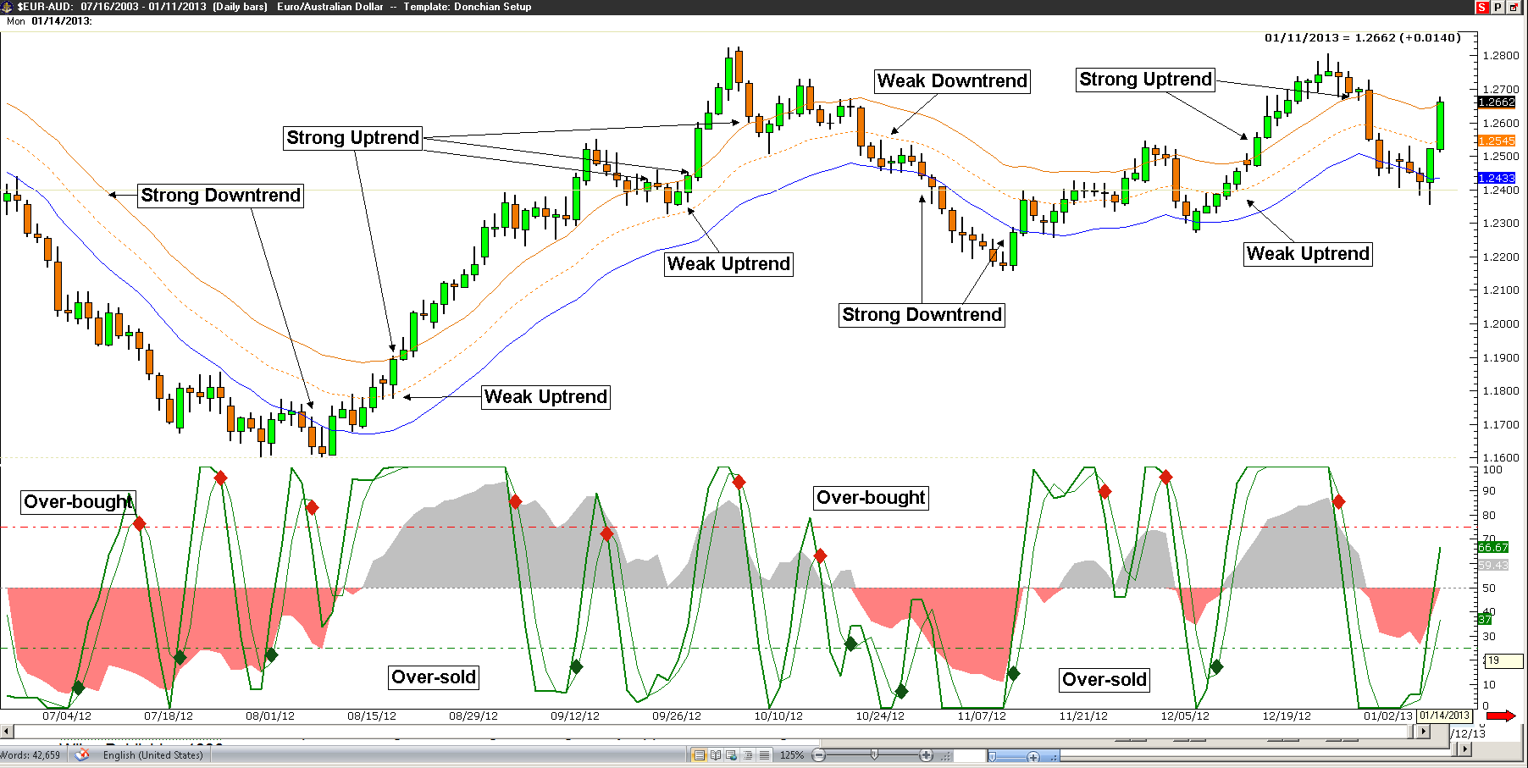

Only buy in a strong uptrend with bullish momentum (SRSI up) and only sell in a strong downtrend with bearish momentum (SRSI down) – they are your higher probability trades (even intra-day trading – based on Daily Charts). To refine this further: Buy on hourly bullish reversals (in SRSI, oversold) during strong daily trends or even 4 hour bullish reversals for that matter (the Daily-240 minute trade strategy using this principle can generate 3-6% returns per month per symbol and Weekly-Daily strategies approximately 15-25% annually per symbol with low risk per trade (2%).
In the past I have shared the complete trade rules for end of day and intraday setups and made them available to traders receiving one-on one coaching. In this latest revision of the “book” I am giving away the trade plan! I used to worry that giving away such a profitable trade plan may reduce my coaching clients, income and effectiveness of the system (too many people using it at the same time), but human nature still accounts for randomness, doubt and ultimately the inability to trust your trading results to an unproven system (one you haven’t taken the time to prove to yourself). Since the ultimate failure pattern for humans is the combination of “the desire for instant gratification” and the “unrealistic expectation that you can buy success”, giving away this trade plan will not negatively impact my trading results, nor my income.

SRSI Swing Trading Plan

Long setup conditions: Once the Dailly chart Stochastic of RSI (AvgHLC , 8 , 5 , 3 , 3) (called SRSI) is over-sold (both lines below 25 (O/S))…

Start buying 240 minute chart SRSI (AvgHLC , 8 , 5 , 3 , 3) bullish reversals (O/S - cross-over higher) until the Daily SRSI is O/B (both line above 75) or the Daily SRSI experiences a Bearish Cross-Over (fast line below slow line). ** Note: see Strong Trending Market rules for “stand-aside” conditions.

Entry: “Buy-Stop” order, 5 pips (or 2 pips plus the spread) above the SRSI “reversal” bar high.
If not triggered on the next bar, drop the Buy-Stop entry price to 5 pips above the next (lower) high until triggered (called “trailing 1 bar high”).

Initial Stop: 3 pips below the most recent swing low (lowest low prior to 240 minute bullish reversal) or the entry candle or the second to last candle (whichever is lowest). If there is no swing low within 2 days (12 candles from setup), use a default 95 pip stop (or 3 pips below the lowest candle low, whichever is lower).

Risk: If the midline of the Daily Keltner Channel (AvgHLC , 21 , 1.1) is bearish (less than the previous bar) = 1% risk, if the midline of the Daily Keltner Channel is bullish (greater than the previous bar) = 2% risk (lots based on stop sizing and risk).

Exit #1: ½ the lots at the 1st profit objective (calculated using the average daily range over the previous 5 years and the 240 minute ATR20) or 3 pips below the low of the first bar once the 240 min. SRSI is over-bought (both lines above 75) on a “trailing 1 bar low” (higher lows until limited out). Set the remainder of the open position to break-even if Exit #1 was profitable – do not move initial stop if Exit #1 is a small loss.

Exit #2: Start trailing the second half of the position’s stop – 3 pips below the trailing 1 bar low once the second 240 min. SRSI O/B condition (both lines above 75) is true (must have a 240 min. SRSI O/S swing in-between the first and second 240 min. SRSI O/B).

Strong UpTrend Condition: Price closes above both the Daily and 240 min. Upper Keltner Channel or the 240 min. Mid-Keltner is greater than the Daily Upper Keltner Band.

Strong Up-Trending Market Rules: Same entry and exit rules as outlined above, however…

** Do not take any “counter-trend” sell setups until Strong UpTrend conditions are no longer true.
_____________________________________________________________________________

Short setup conditions: once the Daily chart set-up= (SRSI) Stochastic of RSI (AvgHLC, 8 , 5 , 3 , 3) is over-bought (both lines above 75)…

Start selling 240 min. chart SRSI (AvgHLC, 8 , 5 , 3 , 3) bearsh reversals (O/B - cross-over lower) until the Daily SRSI is O/S (both line below 25) or the Daily SRSI experiences a Bullish Cross-Over (fast line above slow line). ** Note: see Strong Trending Market rules for “stand-aside” conditions.

Entry: “Sell Stop” order, 3 pips below the reversal candle low.
If not triggered on the next bar, raise the Sell Stop order entry to 3 pips below the next (higher) low until triggered (called “trailing 1 bar low”).

Initial Stop: 5 pips above the most recent swing high (highest high prior to 240 min. bearish reversal) or entry candle high or the second to last candle high (whichever is highest). ). If there is no swing high within 2 days (12 candles from setup), use a default 95 pip stop (or 5 pips above the highest candle high, whichever is higher).

Risk: If the midline of the Daily Keltner Channel (AvgHLC , 21 , 1.1) is bullish (greater than the previous bar) = 1% risk, if the midline of the Daily Keltner Channel is bearish (less than the previous bar) = 2% risk (based on stop sizing).

Exit #1: ½ the lots at the 1st profit objective or 5 pips above the high of the first bar once the 240 min. SRSI is over-sold (both lines below 25) on a trailing 1 candle high (lower highs until limited out). Set remainder of the open position to break-even.

Exit #2: Start trailing the second half (remainder of position) stop – 5 pips above the 1 bar high once the second 240 min. SRSI over-sold condition (both lines below 25) is true (must have a 240 min. SRSI O/B swing in-between the first and second 240 min. SRSI O/S).

Strong DownTrend Condition: Price closes below both the Daily and 240 min. Lower Keltner Channel or the 240 min. Mid-Keltner is less than the Daily Lower Keltner Channel.

Strong Down Trending Market Rules: Same entry and exit rules as outlined above, however…

** Do not take any “counter-trend” buy setups until Strong DownTrend conditions are no longer true.

Note: I have added momentum reversal entries and exit rules to get out of reversing swings faster and to get into fake-out reversals faster. This is not the complete set of rules, just the basics of the strategy. Also important to note that this strategy would require several accounts in the United States due to regulation changes (FIFO and no hedging) or outside of the US as outlined.

This strategy can be used to trade Stocks or even ETF’s (outright purchases or options) with similar positive results, so this strategy is not optimized to a specific market. I do use a lower time frame in “day-traded” markets, down from 4 hours to 98 minutes (to effectively plot 4 equal candles per day).

Fig. 25.2 shows an example of a Daily chart trade result from trading a strong trending USD-JPY (Japanese Yen) with multiple entries and exits. The month and a half gains on just 3 trades are 2 wins and 1 loss for a net of 14.06% trading end of day (that net is return on account).

Fig. 25.2
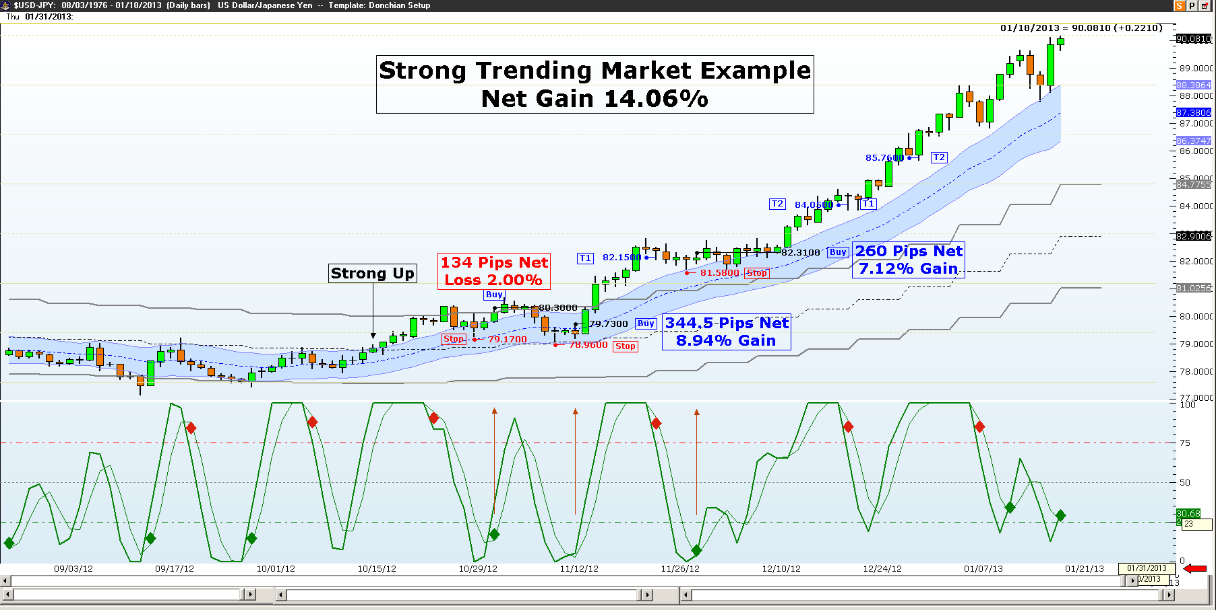

Fig.25.3 shows an example of the 240 minute trade chart results during that same time. Trading intraday 240 min. charts with the strategy outlined above. The Yen resulted in 8 wins and 1 loss with double digit gains of 22.26% during the same as the Daily chart above. Note: maximum risk at any one time was 2% of account balance.
The chart below doesn’t display the actual trade results (available upon request) but clearly shows the benefit of identifying strong trending markets and only trading in the direction of the trend (note that there are only “Buy Setups” displaying. The 3 month total from mid-October to mid-February was 16 wins – 7 losses for a total return on account of 39.98%.
I have programmed the setup conditions into Trade Navigator, and they are available for coaching clients. I am also in the process of having “low frequency auto-trading” programs (LoFAT ) written in trading platforms for personal use and will be available once extensive testing validates precision execution.

Fig. 25.3
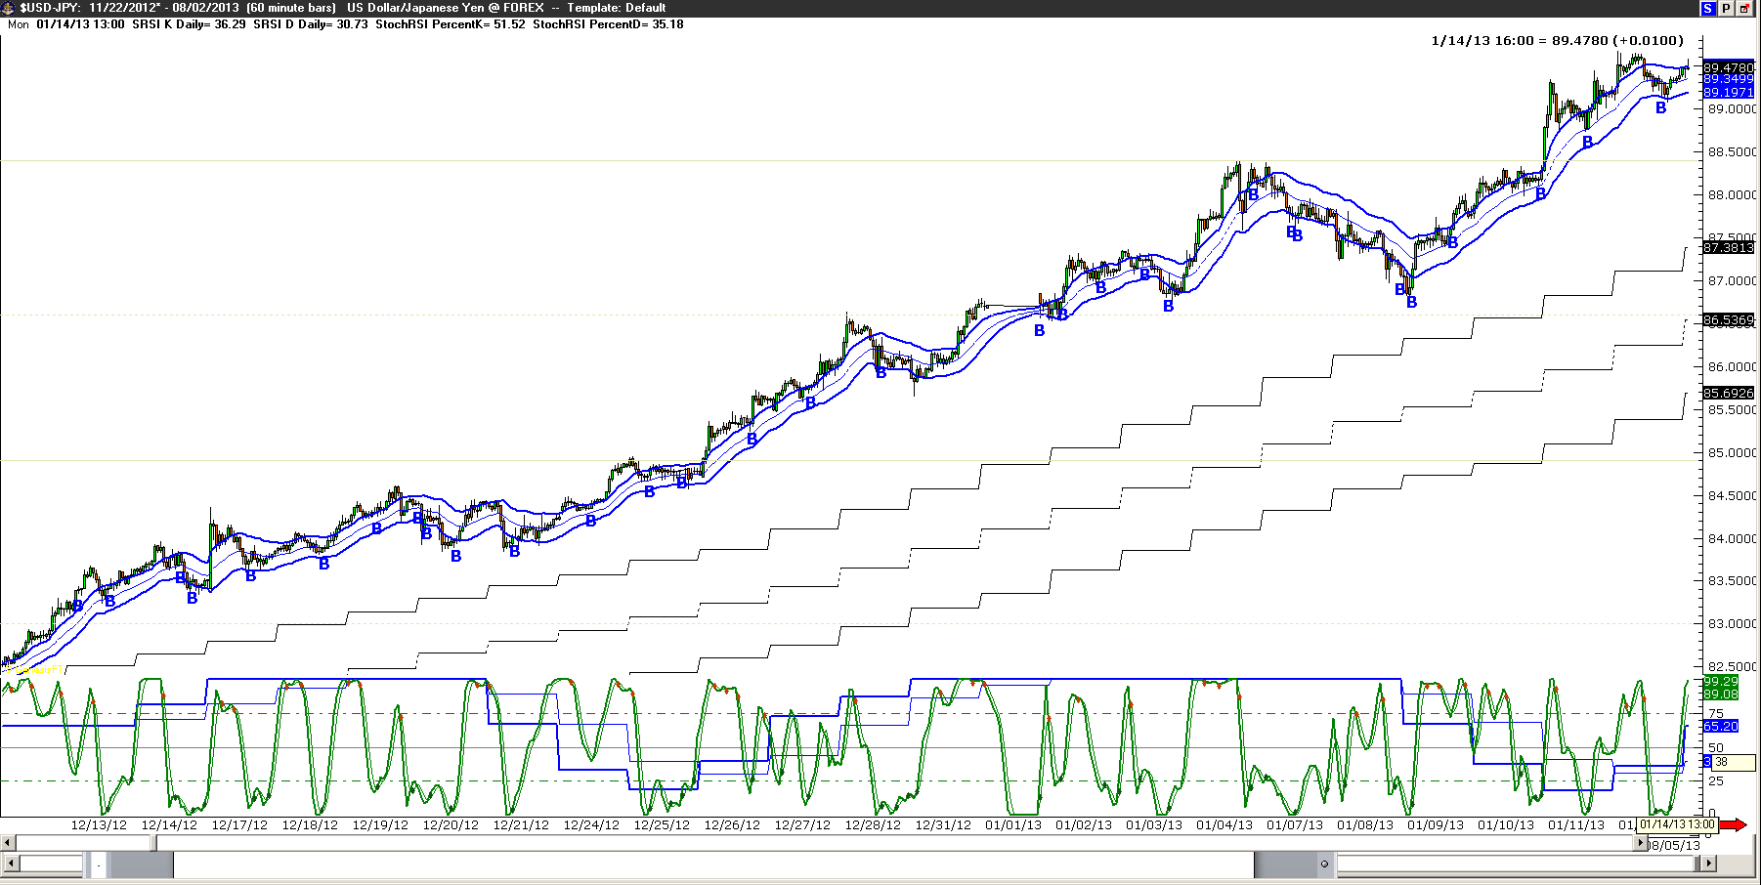

Over the last year, tracking the results of 9 different currency pairs (6 majors and 3 cross currencies), the average trades per month are 11 per pair. The win to loss ratio range YTD is 52.6% to 76.7% (the low end during consolidation and the upper end during strong trends) and the average “return on account” range is between 2.28% per month (EUR-USD) to 6.50% per month (EUR-AUD).
Maximum risk per trade is 2% risk and trading many pairs is a higher risk strategy and as such, the worst draw-down so far has been 14% over the last year. The poorest monthly performance in any moth over all 6 pairs is a 14.38% net loss. The best monthly performance in any one pair is 34.88% (GBP-USD) and over all 6 pairs a 91.04% net gain (again these statistics are return on account).
The risk to reward ratio and the win to loss ratio proves the mechanics are profitable over time, however there is a downside to trading such a strategy – it requires the trader to be “at the charts” every 4 hours for entry, exit or stop adjustments.

The next two chart examples are the latest (updated 5/18/2022) results on the Aussie Dollar and the British Pound (Cable). There are not always profitable months per pair or even in the basket. Using 2% account balance maximum risk per pair, trading all set-ups in the 6 pairs, limits the maximum exposure to 12% or less at any one time.

Fig. 25.4
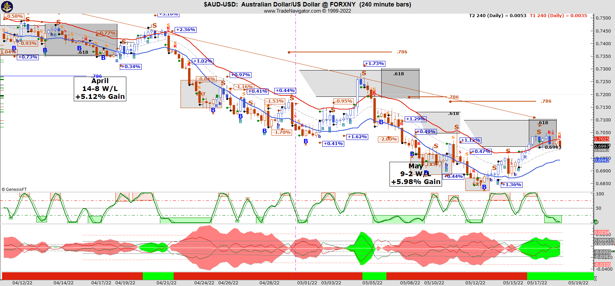

Fig. 25.5

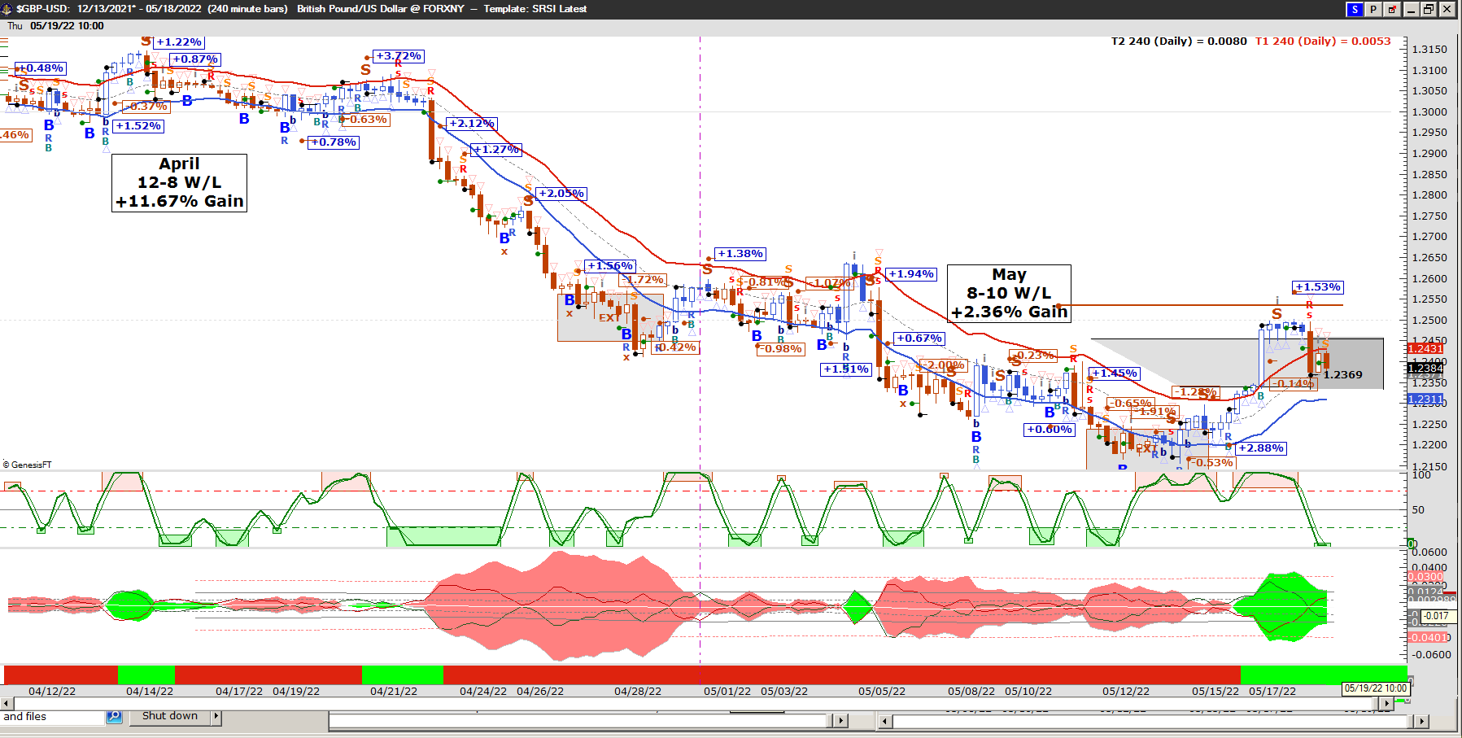

"Rolling Spreads" Strategy

This strategy has a growth objective with conservative risk rules, rolling short dated debit spreads up and out in strong trending very liquid markets. Ideally, the scan basket includes stocks and etf’s with high volume, high open interest, low bid/ask spread with weekly options available (easy to get in - easy to roll - easy to get out).
The objective is to scan for options that will cost less and may make more, in the same time or less than trading weekly setups. Based on results from back-testing over a 10 year period, the overall results favored trading shorter dated debits spreads with roll-over rules as they exhibited an acceptable positive win to loss and profit to loss ratios most of the time during the trend!
**A special thanks to CML TradeMachine Pro for the test results

This test covers a 10 years period starting 2011-09-06 and ending 2021-09-04. Buying 35 “days to expiration” in this case (remember this strategy does not “buy time” to let a trade play out, it positions you early in the normal range of a trend. As the trend continues, this allows you to take profit quickly, even during “smaller moves”, to reduce risk and get to break even as soon as possible)!

The test results included here show more than a 60% win rate and better than 1 to 1 profit to loss ratio over the past 10 years:
CML TradeMachine Pro

Yes, this test is during a 10 year uptrend, however it has also included 10, 20 and even 30+% sell-offs (down trends) that we would not have traded due to “trade in the direction of the trend” rules. We can immediately start with a net winning option strategy and improve upon it!
In general, the overall test results were acceptable within a 70/30, 70/20, 60/30, 60/20 to 50/20 range of choices on strike selection and 21 to 42 “days to expiration” acceptable time range of choices, most of the time. Your choices depend on whether you are conservative up to aggressive with your risk taking and exposure to draw down.
-----------------------------------------------------------------------------------------------------------------------
Use weekly charts to define the trend direction, strength and entry setups. Use a 20 period Keltner Channel with a 1.0 factor Average True Range to define the trend direction and the normal to range. Use Stochastic of RSI (AvgHLC,8,4,2) settings to define the weekly over-bought and over-sold “buy/sell” setups.
Since this is a “hold and roll” strategy “as long as” the trend remains strong, there is no need for a stop loss, 100% of the premium should be a small acceptable loss (i.e. 2% of acct. balance). Nor are trailing stops necessary (3 take profit rules and rolling up and out will take care of risk reduction and “adding” to your winning trades is a very powerful profit maximization rule – for aggressive traders).

Starting Suggestions:
Conservative: buy a 70 delta and sell a 30 delta Call debit spread in a strong uptrend for 35 to 42 days
Aggressive: buy a 50 delta and sell a 20 delta Call debit spread in a strong uptrend for 21 to 28 days
In a strong trend we will roll losing trades and winning trades prior to expiration Friday’s close as long as the stock/etf continues to trend strongly.
Losing trades - stay with the original strikes and roll out another 3 to 6 weeks.
Winner trades – roll up to at the money for the same width or wider and out 3-6 weeks.
Profit taking rules: if you can cover the original risk in the trade by rolling up to “at the money” and keeping the same strike difference (or wider) prior to expiration week, then roll the trade out the least time (one week) and stay in the trade. An aggressive rule once you are “break-even” would be to add another position (same risk or less) to the winning trade.
Big move rule: if a stock/etf moves greater than 5% during a trading day, then roll up to ATM for the least amount of time, 15 minutes prior to the day’s close.
Rolling the trade by expiration Friday if you are up or “take profit” rules will quickly reduce your exposure to loss and act as a trailing stop would – reduce risk initially and then lock in profit.
Reversal setups will be treated as a hedge, in other words – stay in your current position and add your preferred delta ratio debit spread in the opposite direction. Your objective by hedging on reversal setups is to “keep what you have or make more” if the trend continues or even if it reverses. Yes you do lose to time value if the trade goes “sideways”.
Overview:
“Buy to get in (with a back-tested edge) – hold (as long as the trend is strong) – roll (to take logical profits and to stay in the trend) – add to winning trades (after B/E with the same risk or less) – hedge to keep what you’ve got or to make more (on reversal set-ups that trigger).”
So, I boiled it down to the phrase “Rolling Spreads” – for the trading “style”.
The following pages depict a back-test result of the examples on Google chart since the weekly trend turned bullish using 28 days to expiration debit spreads (including every trade from the test period)…

This is the first trade in the chart above with a grey box showing the spread (height) and time (length).
Roll-up to “at-the-money” and out another 28 days; keep the same spread (or wider if expected move is expanding). This trade covered the original risk on the first roll at expiration. Free trade!
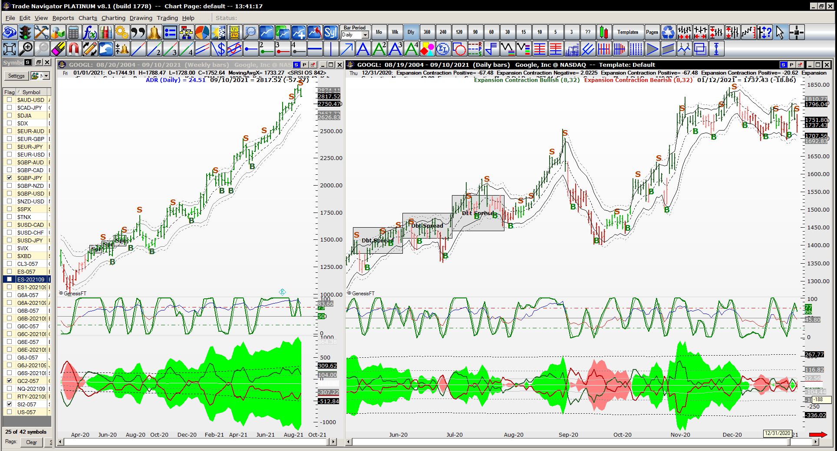
Roll again – same rules…
…next roll.

The last call debit is a full loss (of unrealized gains). Since the trend is strong up, stay in and roll to at the money, same original design.
The “Big Move” rule will take effect on some of these trades (Roll up to at the money and buy the smallest amount of time available).
Another big move…
Big move rule again…
Big move rule again.
Big move rule.
Big move rule again.

The present position is down, and the trend is still strong up, in other words “we are short term bearish (over the next few days or more) and long term bullish (strong uptrend). Stay in “as long as” the trend meets the rules!

Hopefully you are starting to get the general idea – stay in winners and losers “as long as” the strong trend rules are true.

Profit maximizing rules dictate that you should add to winning trades once you have break-even gains; if you do not exceed an acceptable risk per individual trade rule.
Here’s the summary of the previous back-test:
CML TradeMachine Pro

The “rolling range” strategy accumulates acceptable results by itself and we can still do better than that! Note: adding to winning trades is aggressive, at least we continue with conservation risk, worst case scenario – small loss. Hedging winning trades on major reversal setups is another strategy we can use to keep unrealized gains and never miss a major top or bottom
And here’s every trade from the back-test for verification (CML TradeMachine Pro):
Date | Description | Size | Expiration | Strike | Type | Trade Price | Profit/Loss
5/11/20 | Open DaysToDate:Long Calls | 1 | 5-Jun-20 | 1380 | Call | $52.90
5/11/20 | Open DaysToDate:Short Calls | -1 | 5-Jun-20 | 1450 | Call | $17.55
6/5/20 | Roll-Close DaysToExpiration:Long Calls | -1 | 5-Jun-20 | 1380 | Call | $58.10 | $518.70
6/5/20 | Roll-Close DaysToExpiration:Short Calls | 1 | 5-Jun-20 | 1450 | Call | $0.02 | $1,751.70
6/5/20 | Roll-Open 28DaysToExpiration:Long Calls | 1 | 2-Jul-20 | 1420 | Call | $47.55
6/5/20 | Roll-Open 28DaysToExpiration:Short Calls | -1 | 2-Jul-20 | 1490 | Call | $15.20
7/2/20 | Roll-Close DaysToExpiration:Long Calls | -1 | 2-Jul-20 | 1420 | Call | $51.20 | $363.70
7/2/20 | Roll-Close DaysToExpiration:Short Calls | 1 | 2-Jul-20 | 1490 | Call | $0.02 | $1,516.70
7/2/20 | Roll-Open 28DaysToExpiration:Long Calls | 1 | 31-Jul-20 | 1440 | Call | $72.25
7/2/20 | Roll-Open 28DaysToExpiration:Short Calls | -1 | 31-Jul-20 | 1540 | Call | $24.80
7/31/20 | Roll-Close DaysToExpiration:Long Calls | -1 | 31-Jul-20 | 1440 | Call | $45.75 | ($2,651.30)
7/31/20 | Roll-Close DaysToExpiration:Short Calls | 1 | 31-Jul-20 | 1540 | Call | $0.02 | $2,476.70
7/31/20 | Roll-Open 28DaysToExpiration:Long Calls | 1 | 28-Aug-20 | 1465 | Call | $57.15
7/31/20 | Roll-Open 28DaysToExpiration:Short Calls | -1 | 28-Aug-20 | 1550 | Call | $19.60
8/28/20 | Roll-Close DaysToExpiration:Long Calls | -1 | 28-Aug-20 | 1465 | Call | $174.40 | $11,723.70
8/28/20 | Roll-Close DaysToExpiration:Short Calls | 1 | 28-Aug-20 | 1550 | Call | $88.85 | ($6,926.30)
8/28/20 | Roll-Open 28DaysToExpiration:Long Calls | 1 | 25-Sep-20 | 1605 | Call | $81.75
8/28/20 | Roll-Open 28DaysToExpiration:Short Calls | -1 | 25-Sep-20 | 1730 | Call | $27.25
9/25/20 | Roll-Close DaysToExpiration:Long Calls | -1 | 25-Sep-20 | 1605 | Call | $2.45 | ($7,931.30)
9/25/20 | Roll-Close DaysToExpiration:Short Calls | 1 | 25-Sep-20 | 1730 | Call | $2.50 | $2,473.70
9/25/20 | Roll-Open 28DaysToExpiration:Long Calls | 1 | 23-Oct-20 | 1410 | Call | $72.60
9/25/20 | Roll-Open 28DaysToExpiration:Short Calls | -1 | 23-Oct-20 | 1515 | Call | $23.85
10/23/20 | Roll-Close DaysToExpiration:Long Calls | -1 | 23-Oct-20 | 1410 | Call | $222.30 | $14,968.70
10/23/20 | Roll-Close DaysToExpiration:Short Calls | 1 | 23-Oct-20 | 1515 | Call | $117.30 | ($9,346.30)
10/23/20 | Roll-Open 28DaysToExpiration:Long Calls | 1 | 20-Nov-20 | 1600 | Call | $88.25
10/23/20 | Roll-Open 28DaysToExpiration:Short Calls | -1 | 20-Nov-20 | 1730 | Call | $32.10
11/20/20 | Roll-Close DaysToExpiration:Long Calls | -1 | 20-Nov-20 | 1600 | Call | $138.95 | $5,068.70
11/20/20 | Roll-Close DaysToExpiration:Short Calls | 1 | 20-Nov-20 | 1730 | Call | $9.10 | $2,298.70
11/20/20 | Roll-Open 28DaysToExpiration:Long Calls | 1 | 18-Dec-20 | 1710 | Call | $66.85
11/20/20 | Roll-Open 28DaysToExpiration:Short Calls | -1 | 18-Dec-20 | 1810 | Call | $21.95
12/18/20 | Roll-Close DaysToExpiration:Long Calls | -1 | 18-Dec-20 | 1710 | Call | $21 | ($4,586.30)
12/18/20 | Roll-Close DaysToExpiration:Short Calls | 1 | 18-Dec-20 | 1810 | Call | $0.02 | $2,191.70
12/18/20 | Roll-Open 28DaysToExpiration:Long Calls | 1 | 15-Jan-21 | 1695 | Call | $76.15
12/18/20 | Roll-Open 28DaysToExpiration:Short Calls | -1 | 15-Jan-21 | 1805 | Call | $25.60
1/15/21 | Roll-Close DaysToExpiration:Long Calls | -1 | 15-Jan-21 | 1695 | Call | $32.40 | ($4,376.30)
1/15/21 | Roll-Close DaysToExpiration:Short Calls | 1 | 15-Jan-21 | 1805 | Call | $0.02 | $2,556.70
1/15/21 | Roll-Open 28DaysToExpiration:Long Calls | 1 | 12-Feb-21 | 1695 | Call | $82.60
1/15/21 | Roll-Open 28DaysToExpiration:Short Calls | -1 | 12-Feb-21 | 1820 | Call | $27.30
2/12/21 | Roll-Close DaysToExpiration:Long Calls | -1 | 12-Feb-21 | 1695 | Call | $402.50 | $31,988.70
2/12/21 | Roll-Close DaysToExpiration:Short Calls | 1 | 12-Feb-21 | 1820 | Call | $275.90 | ($24,861.30)
2/12/21 | Roll-Open 28DaysToExpiration:Long Calls | 1 | 12-Mar-21 | 2062.5 | Call | $78.30
2/12/21 | Roll-Open 28DaysToExpiration:Short Calls | -1 | 12-Mar-21 | 2180 | Call | $26.60
3/12/21 | Roll-Close DaysToExpiration:Long Calls | -1 | 12-Mar-21 | 2062.5 | Call | $0.12 | ($7,819.30)
3/12/21 | Roll-Close DaysToExpiration:Short Calls | 1 | 12-Mar-21 | 2180 | Call | $0.02 | $2,656.70
3/12/21 | Roll-Open 28DaysToExpiration:Long Calls | 1 | 9-Apr-21 | 2015 | Call | $87.05
3/12/21 | Roll-Open 28DaysToExpiration:Short Calls | -1 | 9-Apr-21 | 2140 | Call | $27.45
4/9/21 | Roll-Close DaysToExpiration:Long Calls | -1 | 9-Apr-21 | 2015 | Call | $255.90 | $16,883.70
4/9/21 | Roll-Close DaysToExpiration:Short Calls | 1 | 9-Apr-21 | 2140 | Call | $130.90 | ($10,346.30)
4/9/21 | Roll-Open 28DaysToExpiration:Long Calls | 1 | 7-May-21 | 2230 | Call | $98.05
4/9/21 | Roll-Open 28DaysToExpiration:Short Calls | -1 | 7-May-21 | 2380 | Call | $32.50
5/7/21 | Roll-Close DaysToExpiration:Long Calls | -1 | 7-May-21 | 2230 | Call | $122.50 | $2,443.70
5/7/21 | Roll-Close DaysToExpiration:Short Calls | 1 | 7-May-21 | 2380 | Call | $0.02 | $3,246.70
5/7/21 | Roll-Open 28DaysToExpiration:Long Calls | 1 | 4-Jun-21 | 2320 | Call | $73.05
5/7/21 | Roll-Open 28DaysToExpiration:Short Calls | -1 | 4-Jun-21 | 2420 | Call | $23.95
6/4/21 | Roll-Close DaysToExpiration:Long Calls | -1 | 4-Jun-21 | 2320 | Call | $74.85 | $178.70
6/4/21 | Roll-Close DaysToExpiration:Short Calls | 1 | 4-Jun-21 | 2420 | Call | $0.02 | $2,391.70
6/4/21 | Roll-Open 28DaysToExpiration:Long Calls | 1 | 2-Jul-21 | 2362.5 | Call | $73.60
6/4/21 | Roll-Open 28DaysToExpiration:Short Calls | -1 | 2-Jul-21 | 2470 | Call | $25.15
7/2/21 | Roll-Close DaysToExpiration:Long Calls | -1 | 2-Jul-21 | 2362.5 | Call | $142.90 | $6,928.70
7/2/21 | Roll-Close DaysToExpiration:Short Calls | 1 | 2-Jul-21 | 2470 | Call | $34.50 | ($936.30)
7/2/21 | Roll-Open 28DaysToExpiration:Long Calls | 1 | 30-Jul-21 | 2467.5 | Call | $89.30
7/2/21 | Roll-Open 28DaysToExpiration:Short Calls | -1 | 30-Jul-21 | 2600 | Call | $31.35
7/30/21 | Roll-Close DaysToExpiration:Long Calls | -1 | 30-Jul-21 | 2467.5 | Call | $223.15 | $13,383.70
7/30/21 | Roll-Close DaysToExpiration:Short Calls | 1 | 30-Jul-21 | 2600 | Call | $91.80 | ($6,046.30)
7/30/21 | Roll-Open 28DaysToExpiration:Long Calls | 1 | 27-Aug-21 | 2665 | Call | $72.80
7/30/21 | Roll-Open 28DaysToExpiration:Short Calls | -1 | 27-Aug-21 | 2770 | Call | $25.70
8/27/21 | Roll-Close DaysToExpiration:Long Calls | -1 | 27-Aug-21 | 2665 | Call | $214.40 | $14,158.70
8/27/21 | Roll-Close DaysToExpiration:Short Calls | 1 | 27-Aug-21 | 2770 | Call | $109.65 | ($8,396.30)
8/27/21 | Roll-Open 28DaysToExpiration:Long Calls | 1 | 24-Sep-21 | 2850 | Call | $71.85
8/27/21 | Roll-Open 28DaysToExpiration:Short Calls | -1 | 24-Sep-21 | 2950 | Call | $25.20
9/10/21 | ClosingMark:Long Calls | -1 | 24-Sep-21 | 2850 | Call | $26.50 | ($4,535.65)
9/10/21 | ClosingMark:Short Calls | 1 | 24-Sep-21 | 2950 | Call | $4.20 | $2,099.35

DISCLAIMER AND RISK DISCLOSURE: THE CFTC REQUIRES WE STATE THAT — NOTICE: HYPOTHETICAL OR SIMULATED PERFORMANCE RESULTS HAVE CERTAIN LIMITATIONS. UNLIKE AN ACTUAL PERFORMANCE RECORD, SIMULATED RESULTS DO NOT REPRESENT ACTUAL TRADING. ALSO SINCE THE TRADES HAVE NOT ACTUALLY BEEN EXECUTED THE RESULTS MAY HAVE UNDER OR OVER COMPENSATED FOR THE IMPACT, IF ANY, OF CERTAIN MARKET FACTORS, SUCH AS LACK OF LIQUIDITY. SIMULATED TRADING PROGRAMS IN GENERAL ARE ALSO SUBJECT TO THE FACT THAT THEY ARE DESIGNED WITH THE BENEFIT OF HINDSIGHT. NO REPRESENTATION IS BEING MADE THAT ANY ACCOUNT WILL OR IS LIKELY TO ACHIEVE PROFITS OR LOSSES SIMILAR TO THOSE SHOWN. THE RISK OF LOSS IN FUTURES TRADING CAN BE SUBSTANTIAL. YOU SHOULD CAREFULLY CONSIDER WHETHER SUCH TRADING IS SUITABLE FOR YOU IN LIGHT OF YOUR FINANCIAL CONDITION. PAST PROFITS ARE NOT NECESSARILY INDICATIVE OF FUTURE PERFORMANCE. THERE IS A RISK OF LOSS IN FUTURES TRADING.THE INFORMATION CONTAINED HEREIN HAS BEEN OBTAINED FROM SOURCES BELIEVED TO BE RELIABLE, HOWEVER IT CANNOT BE GUARANTEED AS TO ACCURACY OR COMPLETENESS, AND IT IS SUBJECT TO CHANGE WITHOUT NOTICE. IT SHOULD NOT BE ASSUMED THAT THE SEASONAL PRICE TENDENCIES SHOWN HEREIN OR THAT THE SUGGESTIONS REGARDING THEIR USE WILL BE PROFITABLE OR THAT THEY WILL NOT RESULT IN LOSSES. NETWORK PRESS, ITS DIRECTORS, SHAREHOLDERS OR EMPLOYEES ASSUME NO LIABILITY IN CONNECTION WITH THE USE OF THE INFORMATION CONTAINED HEREIN.

** Since you’re likely asking, “does this work with credit spreads?” – Here are those 10 year test results on the next page:
CML TradeMachine Pro

I was originally searching for “costs less – makes more – in the same time or less” than other basic options strategies, so the debit spreads did meet those conditions. Of course, who could resist the income structure of “get paid to trade” that credit spreads offer, especially if you “knew” in advance what to expect most of the time trading in the direction of the trend using option strategies proven to have a statistical edge.

Latest S&P E-mini Trade Strategy
This is a breakout strategy – strong up or strong down using price action (tick charts) instead of time. The latest revision uses 16 tick charts (4 point bars) on the E-Mini S&P500 futures day session, use 14 pt. stops on 2 contracts and triggers an entry to go long now when the 8 period exponential average of the close is greater than or equal to the Keltner Upper Band (32 , 1) (based on a simple moving average and a 32 period Average True Range). Or triggers an entry to go short now when the 8 period exponential average of the close is less than or equal to the Keltner Lower Band (32 , 1) (simple moving average and a 32 period Average True Range).

Exit long positions when the 8 period exponential average of the close crosses below the Keltner Upper Band (32 , 1) or on the second close back below the Keltner Upper Band (32 , 1), after T1 (whatever happens first) or at a profit target and Exit short positions when the 8 period exponential average of the close crosses above the Keltner Lower Band (32 , 1) or on the second close back above the Keltner Lower Band (32 , 1), after T1 (whatever happens first) or at a profit target.

Initial Risk = 14 Pts. On 2 contracts (28 pts./$1400 risk per trade)

1st PT = 7.5 pts. close 1 contract & set stop to breakeven when you are up 7 pts.
2nd PT = 26 pts. or an exit trigger – close the remaining contract - re-entry OK on the next setup
Exit all when either the 8 period exponential average closes back inside the Keltner Channel Upper or Lower Band (latest exit) or the close is back inside the Keltner Channel Upper or Lower Bands for the second time (after T1).
Note: results do not account for slippage in volatility or commissions, so I used AI to include estimates for commissions and slippage and then re-ran 10,000 stress tests (Monte Carlo).

AI - Overall Assessment of the Trade Strategy After Adjustments (as of 7/17/26)
“The strategy demonstrates excellent robustness even after incorporating realistic transaction costs and conservative slippage assumptions. The combination of:
- High win rate (68.5%)
- Strong per-trade expectancy (+0.34%)
- Consistent daily performance
- Low drawdown risk
…makes the edge resilient. Costs and normal slippage reduce returns but do not come close to eliminating the profitability.”
Link to all the testing: https://x.com/i/grok/share/486b4606d4da49ce9e6678241547217f
Benefits from the test results:
Worst case scenario – the largest potential test draw-down (bad luck) was only 8-10%
Why the strategy passed 10,000 tests:
- A larger stop was rarely hit, and the average loss was less than half of the maximum risk
- Some bigger winners – 12% of the total trades gained more than the maximum risk (12% of the trades gained more than the sum of all the losing trades).
- The win rate was a “two wins for every one loss” and the average gain was greater than the average loss. (Wins more often, makes more on average than it loses).
- The tests also revealed what to adjust right now, improving the current results without breaking the strategy!
Rule adjustments (as of 7/17/26): 7.5 pt. first target (up from 7 pts.) but set your stop for both contracts to break-even at 7 pts. up. (Keep the higher win rate, make more minimum).

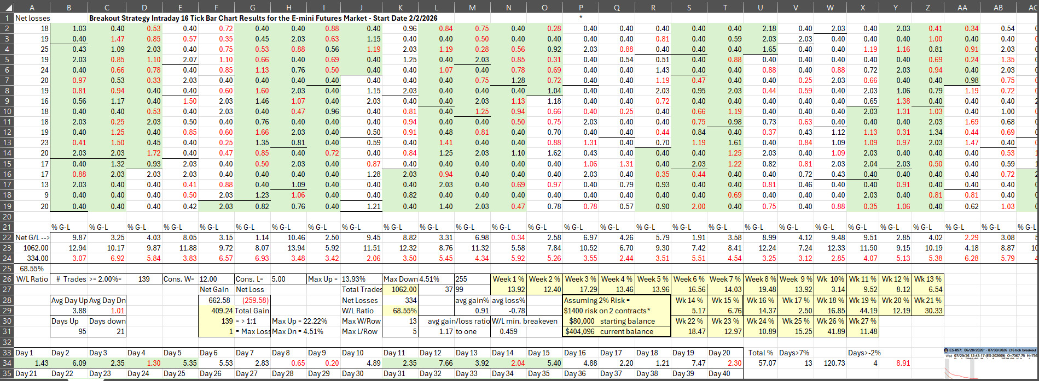

The test results so far are positive with 1062 consecutive trades: 68.55% W/L ratio, an average loss to average gain ratio of 1.17 to 1 and a net profit to net loss ratio of 2.55 to 1 as of 8/7.
Here are two chart examples:

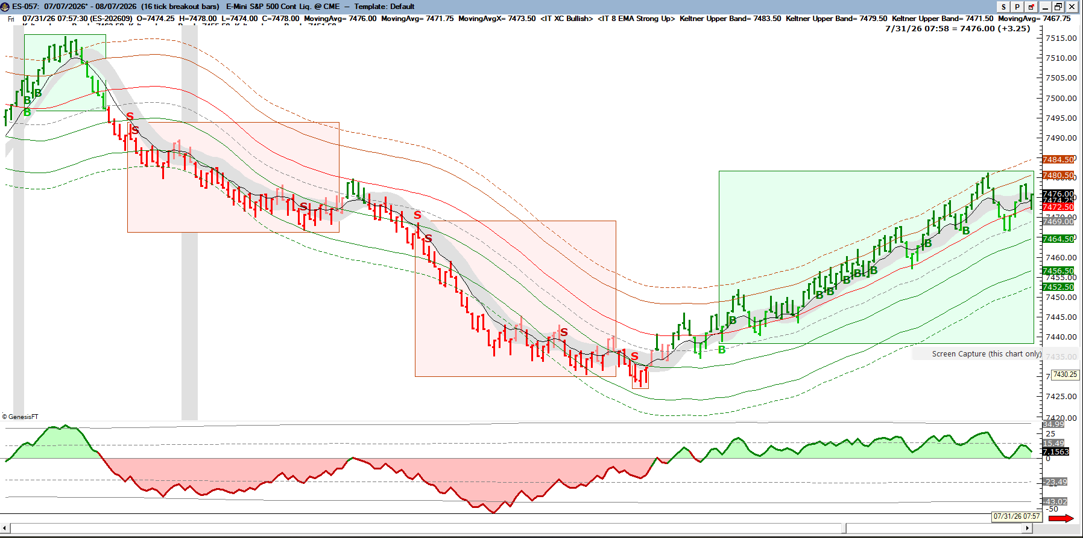

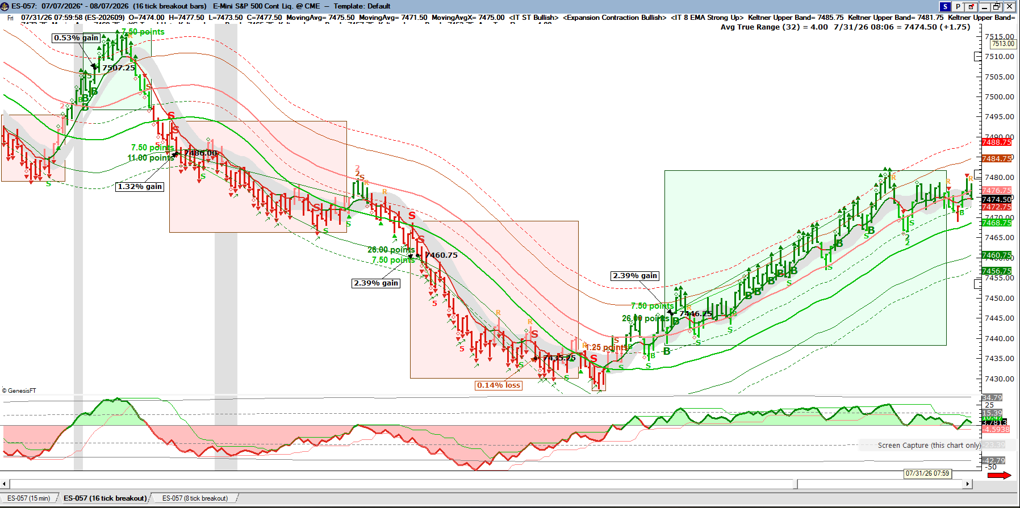

There are additional setups displayed in the chart for additional trade strategies.

One final word on results – past performance is not a guarantee of future results (required statement by the regulatory agencies) and trading on margin has inherent risks not limited to losing all your investment capital. So, I believe that trading without a clearly defined trading strategy that has validated results is a disaster waiting to happen and it’s no wonder that most traders lose money.
And a final word on trading psychology – just because you are trading a “proven” strategy, it does not guarantee you will be profitable. It’s human nature to doubt, second guess or even fear the outcome of any monetary investment because of the non-conscious perception of “risk to personal security”.
The best at any endeavor are educated and coached, they train endlessly, they fall down and they get right back up again, they learn when to be cautiously optimistic and when to be fearlessly aggressive and they achieve their dream quickly because they plan the future out every step of the way, they think “two steps ahead”, they are quick to let go of failures and adapt “on the fly”.
By now, you have now come to the realization that you are the difference. If you don’t have want you want – “make it so”. If you are still looking “out there” for the answer, you’ve missed the point, start again - don’t give up. If you are looking for trading to solve a problem it will only create another one, start again - don’t give up. The “Secret Language” is likely the one you’re not listening to. We experience the world through sight, sound and feelings; it’s likely that you have been blind and are not listening to what you feel
Dr. Hogan’s “influence” states: persuade yourself to write the story of your own future in full detail, leave out nothing, make so real that you can feel it and see it happening and it sounds exactly as if you could tell the future. That feels right! The solution is simple – the work is hard – and the reward is stunning!

Direction

I started out infatuated with trading and ended up loving trade strategy development. The direction I started out with changed as I “listened”. I’ve fallen short of becoming one of the world’s top traders; however, I have created 5 third-party verified trade strategies.
Until I “wrote the book”, I lacked direction in my trading. After trading for a few hours a day, I fill the rest of my time with my second passion – helping others “get it”. Trading is not hard, but most everyone struggles and makes it so (I know I did!). Those determined to follow their “story” make it with help (personal coaching), someone to look over their shoulder, someone to direct them back on target when they wander (an appropriate alternative perspective always eases the temporary blindness).
I have relied heavily on and would like to express my gratitude to Jake Bernstein of (Trade-Futures and Seasonal Trader), Robert Miner of Dynamic Traders (High Probability Trading Strategies), Dr. Alexander Elder (The Complete Trading for a Living), Brett Steenbarger (The Psychology of Trading and Enhancing Trader Performance), Steve Nison of CandleCharting, Van Tharp (SuperTrader), Robert Koppel (The Intuitive Trader and Investing and the Irrational Mind), Peterson and Murtha (Inside the Investor’s Mind), Norman Hallett of The Disciplined Trader, Welles Wilder and Dr. Kevin Hogan. The efforts and hard work of these influential individuals have made the future very clear and feel predetermined.
I cannot help, if you are not going to start… So, the question is not “if” you are going to get started, but “when”? And the answer better be “right now”. Life is short; time is not on your side, however better late than never!

Bibliography:

Bernstein, Jake. The Compleat Day Trader McGraw Hill 2011

Covel, Michael W. Trend Following: How Great Traders Make Millions in Up or Down Markets Prentice Hall 2006

Elder, Dr. Alexander. The Complete Trading for a Living: The Legendary Approach to Trading Wiley Publishing 1996

Farber, Steve. The Radical Leap: A Personal Lesson in Extreme Leadership Kaplan Professional 2004

Farber, Steve. The Radical Edge: Stoke Your Business, Amp Your Life and Change the World Kaplan Professional 2006

Gladwell, Malcolm. The Tipping Point: How Little Things Can Make a Big Difference Boston, Little, Brown & Co. 2000

Gladwell, Malcolm. Blink: The Power of Thinking Without Thinking Little, Brown & Co. 2005

Hogan, Kevin. The 168 Hour Week: Live Life Your Way 24/7 Network 3000 Publishing 2010

Kiev, Ari. Hedge Fund Masters: How Top Hedge Fund Masters Set Goals, Overcome Barriers and Achieve Peak Performance Wiley Publishing 2005

Klein, Gary. Intuition at Work: Why Developing Your Gut Instincts Will Make You Better at What You Do Doubleday 2004

Koppel, Robert. The Intuitive Trader Wiley Publishing 1996

Koppel, Robert. Investing and the Irrational Mind McGraw Hill 2011

Miner, Robert C. High Probability Trading Strategies Wiley Publishing 2009

Miner, Robert C. Dynamic Trading: Dynamic Concepts in Time, Price & Pattern Analysis With Practical Strategies for Traders & Investors Traders Press Inc. 2006

Nison, Steve. Japanese Candlestick Charting Techniques 2nd Edition Prentice Hall 2001

Nison, Steve. Beyond Candlesticks: New Japanese Charting Techniques Revealed Wiley Finance 1994

Rockefeller, Barbara. Technical Analysis for Dummies Wiley Publishing 2004

Schwager, Jack D. Market Wizards: Interviews With Top Traders Marketplace Books 2006

Shull, Denise. Market Mind Games McGraw Hill 2012

Steenbarger, Brett N, PhD. The Psychology of Trading: Tools and Techniques for Minding the Markets Wiley Publishing 2003

Steenbarger, Brett N, PhD. Enhancing Trader Performance: Proven Strategies From the Cutting Edge of Trading Psychology Wiley Publishing 2007

Tharp, Van K. Super Trader: Make Consistent Profits in Good and Bad Markets McGraw Hill 2009

Tharp, Van K. Super Trader: Make Consistent Profits in Good and Bad Markets McGraw Hill 2009

Williams, Alan M., Jeppson, Peter J. and Botkin, Sanford C. Money: What the Financial “Experts” Will Never Tell You Utah, 2006

Wilson, Timothy D. Strangers to Ourselves: Discovering the Adaptive Unconscious Belknap Press 2002

